FACULTY OF SCIENCE AND TECHNOLOGYFOR
SIDE
MASTER’S THESIS
Study programme/specialization:  Master of Science in Petroleum Engineering/  Drilling Engineering | Spring semester, 2020.  Confidential Access
Author:  Santiago Alexander Aguayo Félix | _________________________________  (Author’s signature)
Supervisor(s):
Dr. Mahmoud Khalifeh
Dr. Jostein Djuve
Senior Research Scientist Anders Grinrød
Title of master’s thesis:
Formulation Development of Drilling Fluids with DOE Mixture Model Design Technique.
Credits: 30 ECTS
Keywords:  Drilling Fluids.  Mixture Model Design  Rheology  Design Expert  Shear Rate  Shear Stress | Number of pages: XI + 104  + supplemental material/other: 35  Stavanger, 15th July 2020
Formulation Development of Drilling Fluids with DOE Mixture Model Design Technique.

By
Santiago Alexander Aguayo Félix

Master’s Thesis

Presented to the Faculty of Science and Technology
The University of Stavanger

The University of Stavanger
JuLY 2020

Acknowledgement

I would like to thank Schlumberger MI-SWACO Research and Development Center for providing the facilities to complete this investigation, and Anders Grinrød for his direction and support by sharing with me his knowledge and experience to develop this project.
Thanks are also to Mahmoud Khalifeh for his reviewing and useful suggestions along the development of this thesis.
Thanks to the University of Stavanger for preparing me to face the new challenges of the industry.
Finally I would like to thank to my parents and my sister, for all the support during the development of this project.

Abstract

The aim of this thesis study is to investigate the effect of three components of a formulation of an oil-based drilling fluid, and how the variation of the percentage of each component affects the rheological behavior of the drilling fluid. By using statistic tools, the Mixture Design concept, and Design Expert software, a first design with 14 runs that vary the percentage of the components was created. After analyzing the results of this first design, data corrections and tests repetitions, more designs were developed. After the two first designs, a contaminant was introduced to the study as another component and its effect in three levels: low, medium and high. At this point the study turned to a Combined design, since we have a Mixture and Level design.
To achieve the goal of the study, laboratory experiments and tests of various drilling fluid samples were conducted. These experiments were done at a constant temperature to study the following attributes: shear stress at different shear rates, the viscosity and the electrical stability. The experiments show that higher temperature has a more significant effect on the drilling fluid behavior, also the effect of the contaminant increases within the temperature.
In addition, diagnostics plots of each component variation were studied to validate the model for each attribute. It was observed that the electrical stability does not have any relation with the components studied since no model fitted the data.

Acronyms

ANOVA | Analysis of Variance
AV | Apparent viscosity
C.V. | Coefficient of variation
Dev. | Deviation
Df | Degrees of freedom
DOE | Design of Experiments
ES | Electrical Stability
LWD | Logging while drilling
Min | Minutes
Ml | Milliliters
MWD | Measurement while drilling
Psi | Pounds per Square Inch
PV | Plastic viscosity
ROP | Rate of penetration
RPM | Revolutions per minute
Sec | Seconds
Std. | Standard
YP | Yield Point

List of Contents
Acknowledgement III
Abstract IV
Acronyms V
List of Figures VIII
List of Tables X
1. CHAPTER 1: INTRODUCTION AND JUSTIFICATION 1
1.1. Introduction 1
1.2. Problem Statement 3
1.3. Objectives 4
1.3.1. Objective 4
1.3.2. Sub-objectives 4
1.4. Justification and Importance of this study 4
2. CHAPTER 2: DRILLING FLUIDS 6
2.1. Introduction 6
2.1.1. Mud Circulation System 6
2.1.2. Composition of drilling fluids 7
2.2. Functions of Drilling Fluids 8
2.2.1. Remove cuttings from the well 9
2.2.2. Control Formation Pressure 10
2.2.3. Suspend and release cuttings 11
2.2.4. Seal permeable formations 11
2.2.5. Maintain Wellbore stability 12
2.2.6. Minimize Reservoir Damage 12
2.2.7. Cool, lubricate and support the bit and drilling assembly 12
2.2.8. Transmit hydraulic energy to tools and bit 13
2.2.9. Ensure adequate formation evaluation 13
2.2.10. Control corrosion 14
2.2.11. Facilitate cementing and completion 14
2.2.12. Minimize impact in the environment. 14
2.3. The Rheology of Drilling Fluids 15
2.3.1. Viscosity 16
2.3.2. Yield Point 18
2.3.3. Trixotropy and Gel Strengths 19
2.3.4. Fluid types 20
2.4. Drilling Fluids Components 22
2.4.1. Additives used for this project 23
2.5. Testing of Drilling Fluids (Only the tests developed for this project) 24
2.5.1. Viscosity 24
2.5.2. Electrical stability 25
3. CHAPTER 3: EXPERIMENTAL DESIGN 27
3.1. DoE 27
3.2. Software Design-Expert 27
3.3. The Mixture Model 28
3.3.1. Models Used in Mixture Design 29
3.4. Methodology 30
3.4.1. Methodology Description 31
3.5. Methodology Application for the First Design. 40
3.5.1. Data Acquisition. 40
3.5.2. Modelling 42
3.5.3. Model validation 46
3.5.4. Final Model 72
4. CHAPTER 4: RESULTS AND DISCUSSION 78
4.1. Experiment and Designs 78
4.1.1. First Experiment: Components Mixture Designs. 78
4.1.2. Second Experiment: Combined Design (Mixture and Level). 81
4.2. Data Analysis 84
4.2.1. First Design 84
4.2.2. Second Design 85
4.2.3. Third Design 87
4.2.4. Fourth Design 89
4.2.5. Fifth Design 91
4.3. Results Interpretation 93
4.3.1. First Design 93
4.3.2. Second Design 93
4.3.3. Third Design 95
4.3.4. Fourth Design 97
4.3.5. Fifth Design 99
5. CHAPTER 5: CONCLUSIONS 103
REFERENCES 105
ANNEXES 107

List of Figures

Figure 1 – Mud circulating system. 6
Figure 2. - Simplex centroid plot of the Mixture model Design. 28
Figure 3 - Methodology Diagram. 29
Figure 4.- Normal Probability considering all the points for 600 RPM 45
Figure 5. -Normal Probability ignoring Run #4. For 600 RPM 45
Figure 6. - Normal Probability considering all the points for 6 RPM 46
Figure 7. - Normal Probability ignoring Run #12. For 6 RPM 46
Figure 8. - Normal Probability considering all the points for ES. 47
Figure 9. - Normal Probability ignoring Run #8. For ES 47
Figure 10. - Residual vs. Predicted considering all the points for 600 RPM 47
Figure 11. - Residual vs. Predicted ignoring Run #4. For 600 RPM 47
Figure 12. - Residual vs. Predicted considering all the points for 6 RPM 48
Figure 13. - Residual vs. Predicted ignoring Run #12. For 6 RPM 48
Figure 14. - Residual vs. Predicted considering all the points for ES 49
Figure 15. - Residual vs. Predicted ignoring Run #8. For ES 49
Figure 16. - Residual vs. Run considering all the points for 600 RPM 49
Figure 17. - Residual vs. Run ignoring Run #4. For 600 RPM 49
Figure 18. - Residual vs. Run considering all the points for 6 RPM 50
Figure 19. - Residual vs. Run ignoring Run #12. For 6 RPM 50
Figure 20. - Residual vs. Run considering all the points for ES 50
Figure 21. - Residual vs. Run ignoring Run #8. For ES 50
Figure 22. - Predicted vs. Actual considering all the points for 600 RPM 51
Figure 23. - Predicted vs. Actual ignoring Run #4. For 600 RPM 51
Figure 24. - Predicted vs. Actual considering all the points for 6 RPM 52
Figure 25. - Predicted vs. Actual ignoring Run #12. For 6 RPM 52
Figure 26. - Predicted vs. Actual considering all the points for ES 52
Figure 27. - Predicted vs. Actual ignoring Run #8. For ES 52
Figure 28. - Residual vs. A: VG Supreme considering all the points for 600 RPM 52
Figure 29. - Residual vs. A: VG Supreme ignoring Run #4. For 600 RPM 52
Figure 30. - Residual vs. B: Versamod considering all the points for 600 RPM 53
Figure 31. - Residual vs. B: Versamod ignoring Run #4. For 600 RPM 53
Figure 32. - Residual vs. C: EMI-1945 considering all the points for 600 RPM 53
Figure 33. - Residual vs. C: EMI-1945 ignoring Run #4. For 600 RPM 53
Figure 34. - Residual vs. A: VG Supreme considering all the points for 6 RPM 54
Figure 35. -Residual vs. A: VG Supreme ignoring Run #12. For 6 RPM 54
Figure 36. - Residual vs. B: Versamod considering all the points for 6 RPM 54
Figure 37. -Residual vs. B: Versamod ignoring Run #12. For 6 RPM 54
Figure 38. - Residual vs. C: EMI-1945 considering all the points for 6 RPM 55
Figure 39. - Residual vs. C: EMI-1945 ignoring Run #12. For 6 RPM 55
Figure 40. - Residual vs. A: VG Supreme considering all the points for ES 55
Figure 41. - Residual vs. A: VG Supreme ignoring Run #8. For ES 55
Figure 42. - Residual vs. B: Versamod considering all the points for ES 56
Figure 43. - Residual vs. B: Versamod ignoring Run #8. For ES 56
Figure 44. - Residual vs. C: EMI-1945 considering all the points for ES 56
Figure 45. - Residual vs. C: EMI-1945 ignoring Run #8. For ES 56
Figure 46. - Cook’s distance considering all the points for 600 RPM 57
Figure 47. - Cook’s distance ignoring Run #4. For 600 RPM 57
Figure 48. - Cook’s distance considering all the points for 6 RPM 58
Figure 49. - Cook’s distance ignoring Run #12. For 6 RPM 58
Figure 50. - Cook’s distance considering all the points for ES 58
Figure 51. - Cook’s distance ignoring Run #8. For ES 58
Figure 52. - Leverage considering all the points for 600 RPM 59
Figure 53. - Leverage ignoring Run #4. For 600 RPM 59
Figure 54. - Leverage considering all the points for 6 RPM 60
Figure 55. - Leverage ignoring Run #12. For 6 RPM 60
Figure 56. - Leverage considering all the points for ES 60
Figure 57. - Leverage ignoring Run #8. For ES 60
Figure 58. - DFFITS considering all the points for 600 RPM 61
Figure 59. - DFFITS ignoring Run #4. For 600 RPM 61
Figure 60. - DFFITS considering all the points for 6 RPM 61
Figure 61. - DFFITS ignoring Run #12. For 6 RPM 61
Figure 62. - DFFITS considering all the points for ES 62
Figure 63. - DFFITS ignoring Run #8. For ES 62
Figure 64. - DFBETAS for A: VG Supreme considering all the points for 600 RPM 62
Figure 65. - DFBETAS for A:VG Supreme ignoring Run #4. For 600 RPM 62
Figure 66. - DFBETAS for B: Versamod considering all the points for 600 RPM 63
Figure 67. - DFBETAS for B: Versamod ignoring Run #4. For 600 RPM 63
Figure 68. - DFBETAS for C: EMI-1945 considering all the points for 600 RPM 63
Figure 69. - DFBETAS for C: EMI-1945 ignoring Run #4. For 600 RPM 63
Figure 70. - DFBETAS for A: VG Supreme considering all the points for 6 RPM 64
Figure 71. - DFBETAS for A: VG Supreme ignoring Run #12. For 6 RPM 64
Figure 72. - DFBETAS for B:Versamod considering all the points for 6 RPM 64
Figure 73. - DFBETAS for B: Versamod ignoring Run #12. For 6 RPM 64
Figure 74. - DFBETAS for C: EMI-1945 considering all the points for 6 RPM 64
Figure 75. - DFBETAS for C: EMI-1945 ignoring Run #12. For 6 RPM 64
Figure 76. - DFBETAS for A: VG Supreme considering all the points for ES 65
Figure 77. - DFBETAS for A: VG Supreme ignoring Run #8. For ES 65
Figure 78. - DFBETAS for B: Versamod considering all the points for ES 65
Figure 79. - DFBETAS for B: Versamod ignoring Run #8. For ES 65
Figure 80. - DFBETAS for C: EMI-1945 considering all the points for ES 66
Figure 81. - DFBETAS for C: EMI-1945 ignoring Run #8. For ES 66
Figure 82. - Box-Cox considering all the points for 600 RPM 66
Figure 83. - Box-Cox ignoring Run #4. For 600 RPM 66
Figure 84. - Box-Cox considering all the points for 6 RPM 67
Figure 85. - Box-Cox ignoring Run #12. For 6 RPM 67
Figure 86. - Box-Cox considering all the points for ES 68
Figure 87. - Box-Cox ignoring Run #8. For ES 68
Figure 88. - Contour Plot for 600 RPM 71
Figure 89. - Contour Plot for 6 RPM 71
Figure 90. - Contour Plot for ES 71
Figure 91. - 3D Surface Plot for 600 RPM 72
Figure 92. - 3D Surface Plot for 6 RPM 72
Figure 93. - 3D Surface Plot for 6 RPM 73
Figure 94. - Rheological profile Plot for the first design. 75
Figure 95. - Contour Plots of the Designs 1 -5. 77
Figure 96. - Rheology Profile for the Second Design. 93
Figure 97. - Rheology Profile at 50°C for the Third Design. 94
Figure 98. - Rheology Profile at 80°C for the Third Design. 95
Figure 99. - Rheology Profile at 50°C for the Fourth Design. 96
Figure 100. - Rheology Profile at 80°C for the Fourth Design. 97
Figure 101. - Rheology Profile at 50°C for the Fifth Design. 98
Figure 102. - Rheology Profile at 80°C for the Fifth Design. 100

List of Tables

Table 1 - Classification of drilling muds 14
Table 2. - Summary of Additives 28
Table 3. - Additives used in this project. 29
Table 4. - Factors and Responses. 40
Table 5. - Base mud Formulation for 3 liters. 41
Table 6. - First design runs. 49
Table 7. - Lab. Data for the first design. 50
Table 8.- Fit summary for Response 1, 600 RPM. 51
Table 9. - Fit summary for Response 2, 6 RPM. 51
Table 10. - Fit summary for Response 3, Electrical Stability. 51
Table 11. - ANOVA for Response 1, 600 RPM. 52
Table 12. - Fit Statistics for Response 1, 600 RPM. 52
Table 13. - ANOVA for Response 2, 6 RPM. 53
Table 14. - Fit Statistics for Response 2, 6 RPM. 53
Table 15. - ANOVA for Response 3, Electrical Stability. 54
Table 16. - Fit Statistics for Response 3, Electrical Stability. 54
Table 17. - Report for Response 1, 600 RPM. 79
Table 18. - Report for Response 2, 6 RPM. 79
Table 19. - Report for Response 3, ES. 80
Table 20. - Components and Attributes for the first design. 88
Table 21. - First Design Runs formulation. 88
Table 22. - Components and Attributes for the Second design. 89
Table 23. - Second Design runs formulation 89
Table 24. - Components and Attributes for the third design. 90
Table 25. - Third design runs formulation 90
Table 26. - Components and Attributes for the fourth design. 91
Table 27. - Fourth design runs formulation 91
Table 28. - Components and Attributes for the fifth design. 92
Table 31. - First Design Responses. 93
Table 32. - Fit statistics for the First Design. 94
Table 33. - Second Design Responses. 94
Table 34. - Fit statistics for the Second Design. 95
Table 35. - Third Design Responses at 50°C. 96
Table 36. - Third Design Responses at 80°C. 96
Table 37. - Fit statistics for the third Design, responses at 50°C. 97
Table 38. - Fit statistics for the third Design, responses at 80°C. 97
Table 39. - Fourth Design Responses at 50°C. 98
Table 41. - Fourth Design Responses at 80°C. 98
Table 40. - Fit statistics for the Fourth Design, responses at 50°C. 99
Table 42. - Fit statistics for the Fourth Design, responses at 80°C. 100
Table 43.- Fifth Design Responses at 50°C. 100
Table 45. - Fifth Design Responses at 80°C. 100
Table 44. - Fit statistics for the Fifth Design, responses at 50°C. 101
Table 46. - Fit statistics for the Fifth Design, responses at 80°C. 101
Table 47. - First design results at 50°C. 102
Table 48. - Second design results at 50°C. 102
Table 49. - Third design results at 50°C. 104
Table 50. - Third design results at 80°C. 105
Table 51. - Fourth design results at 50°C. 106
Table 52. - Fourth design results at 80°C. 107
Table 53. - Fifth design results at 50°C. 108
Table 54. - Fifth design results at 80°C. 109

CHAPTER 1: INTRODUCTION AND JUSTIFICATION

Introduction
Drilling fluids are one of the most important components during the operations of a well, since it is the fundamental part of the circulation system. This system ensures that the drilling fluid travels through the perforation string to the drilling bit and returns to the surface, trough the annular space. Nowadays it is still impossible to perforate a well without this concept of a circulating fluid (Villaroel, 2014).
Drilling fluids have several functions that vary from cuttings transportation to maintain wellbore stability, which is why these fluids are very versatile. However, as its functions are beneficial during perforation, they may turn into not desirable ones and will affect the drilling operations.
In drilling operations, the drilling fluid design is required to be adequate and its properties as well need to be optimum in order to reduce the filtration lose and the filter cake thickness to avoid the instability of the well and skin factor. A proper drilling fluid is obtained by mixing a fluid base (water base or oil base) with the right additives. The most common additives are polymers, densifiers, salts, tensioners, and lubricators. Depending on the drilling formation, the additives and the fluid base will change. Oil-base fluids are used to drill shale formations since there is not a significant interaction between the shales and the fluid. However, a big interest in the Water-base fluids has increased the last years and the main objective is to design a water-base fluid as efficient as an oil-base one. Drilling fluids in general must have a low toxicity level, reach the environmental requirements of each region, generate the minimum skin factor, work efficiently and must have a low cost (Gallardo, 2018).
During drilling and well operations, well control is fundamental. The only way to keep control of the pressure is with drilling fluids, which are designed depending on the well characteristics, and must be updated within the changes that the well might experience along with drilling operations. Mud engineers play a fundamental roll since they are the responsible ensuring the properties of the drilling fluid are within designed specification. The mud engineer must taste the mud at the rig and must prescribe mud treatments to maintain mud weight, properties and chemistry within recommended limits. Since it is very common that the “recipe” of a drilling fluid requires in most of the cases more than 10 ingredients and a multitude of specification, the formulation of a drilling fluid takes a lot of time that can be optimized. To achieve this optimization, it is often necessary to use statistical techniques and software tools to aid in the formulation process.
The technique that will be used is called Experimental Design or DoE (Design of Experiments). DoE is a powerful data collection and analysis tool that can be used in a variety of experimental situations. DoE can be used when more than one input factor is suspected of influencing an output and also to confirm suspected input/output relationships and to develop a predictive equation suitable for performing the correct analysis. The aim of DoE is to extract as much information as possible from the minimum number of experimental runs. By varying the amounts of the drilling fluid components simultaneously according to a pre-planned experimental scheme, a computer model of the behavior of the fluid can be built. The computer model can subsequently be used to find the optimum formulation that fulfills the desired specifications (Bower, 2020).
By developing the correct computer model, it is expected to create a tool that helps Mud engineers to optimize the formulation process of the drilling fluids, and to simplify the taking decisions process when testing the mud at the rig and a treatment is required.

Problem Statement
The formulation of a drilling fluid is a procedure that requires the use of many ingredients to meet the specifications and limits of the well for which it was designed. To reach certain specifications, the mud has to be reformulated or receive treatment. During drilling operations, it is necessary to schedule additions to the mud to maintain its properties. All those activities require time, precision, and experience.
In most of the cases, the responsibility for ensuring the good work and the properties of the drilling fluid relay in the experience of the Mud engineer, which is good, but it does not constitute a physical model to follow for non-experience engineers. When additions are required during drilling operations it would be helpful to count with a scientific model that depending on the requirements allows mud engineers to make additions based on it, and to make decisions easier.
Since drilling fluids are indispensable in the oil industry, during drilling operations, well interventions, plug and abandonment operations and more, it is necessary to optimize the process involved in the formulation and treatment of these fluids. By obtaining a tool that facilitate the work related with muds; we will see the positive impact in the whole drilling work, and other activities where drilling fluids are involved.

Objectives

Objective
- The main objective of this project is to develop drilling fluid formulations using experimental Design Techniques (DoE). The objective is achieved through experimental work and modeling of the data.

Sub-objectives
The Sub-objectives include:
- Vary the percentage of the selected components in the formulation of drilling fluids.
- Test the drilling fluids under lab conditions and obtain the rheology data for the selected attributes.
- Model the relationship between the components and attributes using Design. Expert Software applying Mixture Design and Combined Design.
- Analysis of the results to optimize the drilling fluids formulation.
- Develop a model using the Mixture Model.

Justification and Importance of this study
“There has been an active push for oil and gas companies to embrace the digital revolution, and as a result, the previously slow-to-adapt industry is now at the forefront of many types of emergent technology” (Oil & Gas Editor, 2019). Nowadays the oil industry is experiencing fundamental challenges, and it is driving digitalization innovation in its activities. When talking about drilling fluids it is a fact that new technologies are being studied to keep a step ahead within this industry transition. By developing this project, the first step to the digitalization automation is given, and the result obtained is expected to be used as a helpful tool that will lead the change in the formulation of drilling fluids.
In the current environment of change, it is necessary to do things and processes in a different way to obtain new results. “Digital transformation is no longer an option that some companies are choosing to pursue, it is rapidly becoming impossible to function without strategies in place” (Oil & Gas Editor, 2019).
The development of this project applying Experimental Design Techniques will bring a positive result that will let engineers work in a more effective way by getting things done faster and with this, an organizational evolution and improvement will be set. It is clear that digital transformation is a key part of reducing time, reducing costs, decision making and all these pros will lead to more productivity work activities.

CHAPTER 2: DRILLING FLUIDS

Introduction
Drilling fluids are used to perform drilling activities, it is impossible to perform such activities without these fluids because of all the functions and the well control provided to the well.
Drilling fluids have been also known as “Mud” or “Drilling Mud” within the industry, and both of these terms will be used in this study document. Since drilling fluids are a major factor in the success of the drilling program they deserve a carefully study that will be held through this chapter.

Mud Circulation System
The mud circulation system has two main components, which are the mud pumps and the mud as itself, the system works as follows: the mud travels from the pump through the surface facilities (pump, discharge line, standpipe) to the bit down the drillstring. Once the mud reaches the bit, the bit jets accelerate it, so it is possible to keep the bit cutters clean and keep a fresh rock surface for the bit to attack. From downhole, the mud moves upward in the annular space between the drillstring and the open hole carrying the cuttings generated by the bit. In the surface, the mud and its load of cuttings go to shale shakers where all the cuttings bigger then the shaker´s screens are separated from the system. When the mud falls through the screen it drops into the mud pits, first through the settling pit, then to the stirred mud pit and finally to the suction pit. After this process, the mud is ready for recirculation downhole (MI-SWACO, 2006).

Figure 1 – Mud circulating system.
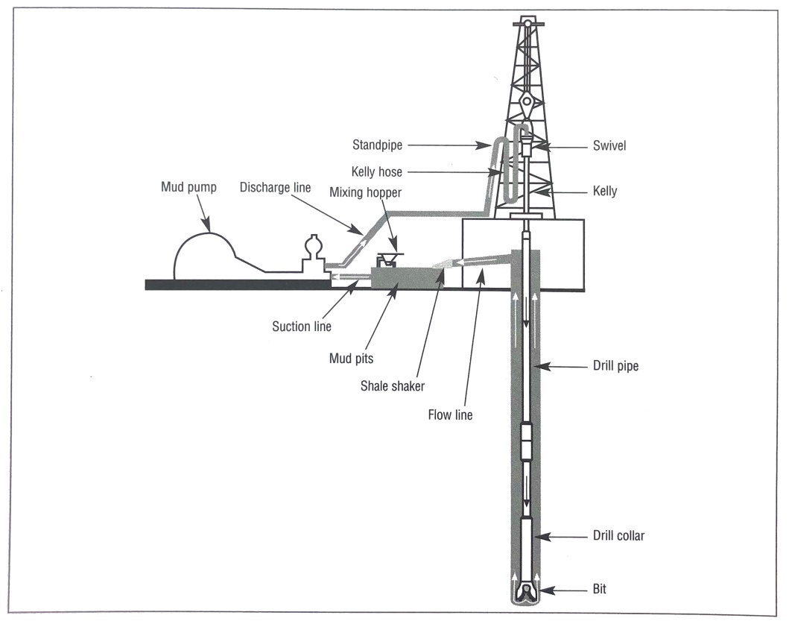
Source: (MI-SWACO, 2006)

Composition of drilling fluids
Drilling fluids classified in tree types depending on their base:
- Water-Base Drilling fluids: solid particles suspended in water or brine.
- Oil-Base Drilling fluids: solid particles suspended in oil.
- Gas: drill cuttings removed by a high-velocity stream of air or natural gas. Foaming agents are added to remove minor inflows of water.
In general, drilling fluids are divided into the two most general types, which are: Water-Base Drilling Fluids (WBM) and Oil-base drilling fluids (OBM), however it has to be said that WBMs may contain oil and OBMs may contain water (Caenn, Darley, & Gray, 2011).
A classification for the muds is given in Table 1 (Caenn, Darley, & Gray, 2011).
Table 1 - Classification of drilling muds
Class | Common Subclasses
Fresh-water muds (Dispersed System) | pH 7-9.5
 | Spud muds
 | Bentonite muds
 | Phosphate muds
 | Lignite muds
 | Lignosulfonate muds
 | Organic colloid muds
Inhibited muds (Dispersed System) | Lime Muds
 | Gypsum muds
 | Sea-Water muds
 | Saturated salt-water muds
Low-solids muds (Nondispersed system) | Less than 3%-6% solids
Emulsions | Oil in Water
 | Water in Oil
 | Reversed phase
Oil-based muds | Less than 5% water
 | Mixture of diesel fuel and asphalt
Edited by: Santiago Aguayo

Oil-based drilling fluids are the most used when drilling shale areas, due to negligible chemical interactions. The correct selection of drilling fluids components of the formulations is important to mitigate the drilling problems (Aramendiz, Imqam, & Fakher, 2019).

Functions of Drilling Fluids
Drilling fluids perform numerous functions that help to perform drilling operations, it is always necessary to work with the correct drilling mud according to the well characteristics, to succeed during the operations.
Recommending a drilling fluid system should be based in the capability of the mud to achieve the required functions for the well and to reduce anticipated well problems (MI-SWACO, 2006).
The following descriptions of the functions of the drilling fluids were all adapted from the M-I SWACO Drilling Fluids Engineering Manual. The most common drilling fluid functions are:

Remove cuttings from the well
Cuttings removal is a function of cutting size, shape and density combined with ROP; drillstring rotation; and the viscosity, density, and annular velocity of the drilling fluid.
- Viscosity: has a significant effect on hole cleaning. Cuttings settle down rapidly in low viscosity fluids and are difficult to circulate out of the well. Generally high viscosity fluids improve cuttings transport.
Fluids that are shear thinning and have elevated viscosities at low annular velocities have proven to be the best for efficient hole cleaning.
- Velocity: generally, higher annular velocity improves cuttings removal. Yet, with thinner drilling fluids, high velocities may cause turbulent flow, which helps clean the hole but may cause other drilling or wellbore problems. The rate at which a cutting settles in a fluid is called the slip velocity. The net velocity at which a cutting moves up the annulus is called the transport velocity.
Cuttings transport in in high-angle and horizontal wells is more difficult than in vertical wells.
- Density: high-density fluids aid hole cleaning by increasing the buoyancy forces acting on the cuttings, helping to remove them from the well. Compared to fluids of lower densities, high-density fluids may clean the hole adequately even with lower annular velocities and lower rheological properties. Density should never be increased for cleaning purposes. Mud weight in excess of what is needed to balance formation pressures has a negative impact on the drilling operation.
- Drillstring rotation: higher rotary speed also aid hole cleaning by introducing a circular component to the annular flow path. When possible, drillstring rotation is one of the best methods for removing cuttings beds in high-angle and horizontal wells.

Control Formation Pressure
A basic drilling fluid function is to control formation pressures to ensure a safe drilling operation. Typically, as formation pressure increase, drilling fluid density is increased with barite to balance pressures and maintain wellbore stability. This keeps formation fluids from flowing into the wellbore, prevents pressured formation fluids from flowing into the wellbore, and prevents pressured formation fluids from causing a blowout.
Keeping a well “under control” is often characterized as a set of conditions under which no formation fluid will flow into the wellbore. However, it also includes conditions where formation fluids are allowed to flow into the wellbore under controlled conditions. Well control means there is not uncontrolled flow of formation fluids into the wellbore
The mud weight used to drill a well is limited by the minimum weight needed to control formation pressures and the maximum mud weight that will not fracture the formation.

Suspend and release cuttings
Drilling muds must suspend drill cuttings, weight materials and additives under a wide range of conditions, yet allow the cuttings to be removed by the solids-control equipment. Drilling cuttings that settle during static condition can cause bridges and fill, which in turn can cause stuck pipe or lost circulation. Weight material, which settles, is referred to a sag and causes a wide variation in the density of the well fluid.
Drilling fluid properties that suspend cuttings must be balanced with those properties that aid in cuttings removal by solids-control equipment. Cuttings suspension requires high-viscosity, shear thinning thixotropic properties, while solids-removal equipment usually works more efficiently with fluids of lower viscosity.

Seal permeable formations
Drilling fluid system may be designed to deposit a thin, low-permeability filter cake on the formation to limit the invasion of mud filtrate. This improves wellbore stability and prevents a number of drilling and production problems. Potential problems related to tick filter cake and excessive filtration include “tight” hole conditions, poor log quality, increased torque and drag, stuck pipe, lost circulation, and formation damage. In highly permeable formations with large pore throats, whole mud may invade the formation, depending on the size of the mud solids. For such situations, bridging agents must be used to block the large openings so the mud solids can form a seal.
Depending on the drilling fluid system in use, a number of additives can be applied to improve the filter cake, thus limiting filtration.

Maintain Wellbore stability
Wellbore stability is a balance of mechanical and chemical factors. The chemical composition and mud properties must combine to provide a stable wellbore until casing can be run and cemented. Wellbore stability is most often identified by a sloughing formation, which causes tight hole conditions. Wellbore stability increases when the hole maintains its original size and cylindrical shape. Once the hole is eroded it becomes weaker and more difficult to stabilize.

Minimize Reservoir Damage
Any reduction in a producing formation’s natural porosity or permeability is considered to be formation damage. Frequently, formation damage is reported as a skin damage value or by the amount of pressure drop that occurs while the well is producing.
The possibility of formation damage can be determined from offset well data and studies of formation cores for return permeability.

Cool, lubricate and support the bit and drilling assembly
Large frictional heat is generated by mechanical and hydraulic forces at the bit and where the rotating drillstring rubs against the casing and wellbore. Circulation of the drilling fluid cools the bit and the drilling assembly, transferring this heat away from the source, distributing it throughout the well.
Drilling fluid circulation cools the drillstring to temperatures lower than the bottom-hole temperature. In addition to cooling, drilling fluid lubricates the drillstring, further reducing frictional heat.
Indications of poor lubrication are high torque and drag, abnormal wear, and heat checking of drillstring components.

Transmit hydraulic energy to tools and bit
Hydraulic energy can be used to maximize ROP by improving cuttings removal at the bit. It also provides power for mud motors to rotate the bit and for MWD and LWD tools. Low-solids, shear-thinning drilling fluids or those that have drag-reducing characteristics, such as polymer fluids, are more efficient at transmitting hydraulic energy to drilling tools and the bit.

Ensure adequate formation evaluation
The chemical and physical properties of the mud affect formation evaluation. During drilling, the circulation of mud and cuttings is monitored for signs of oil and gas by mud loggers.
If the cuttings disperse in the mud, there won’t be anything for the mud logger to evaluate at the surface, or if cutting transport is poor, it will be difficult for the mud logger to determinate the depth at which the cuttings originated.
Drilling fluid properties will affect the measurements of rock properties by electrical wireline tools. Muds that contain high potassium ion concentrations interfere with the logging of natural formation radioactivity. High or variable filtrate salinity can make electrical logs difficult or impossible to interpret.

Control corrosion
Drillstring and casing components that are in continual contact with the drilling fluid are susceptible to various forms of corrosion. Dissolved gasses such as oxygen, carbon dioxide and hydrogen sulfide can cause serious corrosion problems, both at the surface and downhole. Generally, low pH aggravates corrosion. Therefore, an important drilling fluid function is to keep corrosion to an acceptable level.

Facilitate cementing and completion
The drilling fluid must produce a wellbore into which casing can be run and cemented effectively and which does not impede completion operations. Cementing is critical to effective zone isolation and successful well completion. During casing runs, the mud must remain fluid and minimize pressure surges so that fracture-induced lost circulation does not occur.

Minimize impact in the environment.
Eventually, drilling fluid becomes a waste product, and must be disposed of in accordance with local environmental regulations. Fluids with low environmental impact that can be disposed of near the well are the most desirable.
Water-base, oil-base, non-aqueous and synthetic-base fluids all have different environmental considerations, and no single set of environmental characteristics is acceptable for all locations.
One of the principal sources of possible environmental damage is drilling fluid and drill solid discharge, the trend within the drilling fluids in the oil industry has focused on finding components which alone and in combination are considered to be non-toxic (Geehan, Forbes , & Moore, 1991)

The Rheology of Drilling Fluids
The science of rheology is concerned with the deformation of all forms of matter, but has had its greatest development in the study of the flow behavior of suspensions in pipes and other conduits (Caenn, Darley, & Gray, 2011).
The rheology of drilling fluids plays an important role during drilling operations, some important challenges regarding the rheology are hole cleaning and friction loss minimization at inclined sections, loss circulation zones, reservoir invasion and more (Moteiro, Brandao, Mello, & Martins, 2005). Drillings operations are strongly affected by temperature as viscosity affects the friction pressure loss and density affects the bottomhole pressure. (Sukhoboka, 2017).
The physical properties of the drilling fluids, density and rheological properties are monitored to assist in optimizing the drilling process. These physical properties contribute to several important aspects for successfully drilling a well, including:
- Provide pressure control to prevent an influx formation fluid.
- Provide energy at eh bit to maximize ROP.
- Provide wellbore stability through pressure or mechanically stressed zones.
- Suspend cuttings and weight material during static periods.
- Permit separation of drilled solids and gas at surface.
- Remove cutting from the well.
Each well is unique, therefore is important to control these properties with respect to the requirements for a specific well and fluid being used. Most of the drilling fluids currently use for drilling operations are very complex due to many conditions related to the well. The mud while circulated in the hole, experiences a gradual increase in temperature and exponential increase in shear rate. These factors alter the rheological properties if the fluid composition is not properly formulated and instantaneously conditioned (Moussa, 1988).
The rheological properties of a fluid can affect one aspect negatively while providing a significant positive impact with respect to another aspect. A balance must be attained in order to maximize hole cleaning, minimize pump pressures and avoid fluid or formation influxes, as well as prevent loss of circulation to formations being drilled (MI-SWACO, 2006).
The rheological properties of drilling fluids are usually considered to be independent of pressure and temperature. That approximation can be considered in shallow wells where the temperature changes are not large. But for deeper wells where the difference can be larger it is important to consider the effects of temperature and pressure (Rommetveit & Bjorkevoll, 1997).
Rheology is the science of deformation and flow of matter. By making certain measurements on a fluid, it is possible to determine how that fluid will flow under a variety of conditions, including temperature, pressure and shear rate (MI-SWACO, 2006).

Viscosity
It can be described as a substance’s resistance to flow. The following terms are used to describe drilling fluid viscosity and rheological properties.
- Shear stress and shear rate: viscosity can be described in terms of the ratio of shear stress to the shear rate. By definition:
$$Viscosity =\frac{shear stress}{shear rate}$$ | (Equation 1)

The concepts of shear rate and shear stress apply to all fluid flow. Within a circulating system, shear rate is dependent on the average velocity of the fluid in the geometry in which it is flowing. When a fluid is flowing, a force exists in the fluid that opposes the flow. This force is known as the shear stress. Another can think of it as a frictional force that arises when one layer of fluid slides. Since it is easier for shear to occur between layers of fluid than between the outermost layer of fluid and the wall of a pipe, the fluid in contact with the wall does not flow. The rate at which one layer is moving past the next layer is the shear rate; therefore, the shear rate is a velocity gradient.
- Shear stress: is the force required to sustain the shear rate
There are some types of viscosity.
- Effective viscosity: it is the viscosity under specific conditions. These conditions include shear rate, pressure and temperature.
- Apparent viscosity: is reported as either the mud viscometer reading at 300 RPM or one-half of the meter reading at 600 RPM. It should be noted that both of these apparent viscosity values are consistent with the viscosity formula:

$$AV\left(cp\right)=\frac{300×Θ}{ω}$$ | (Equation 2)

Where:
$Θ=$ Mud viscometer dial readings
$ω=$ Mud viscometer RPM
- Plastic viscosity: it is calculated from mud viscometer data as:
$$PV \left(cp\right)=Θ_{600}-Θ_{300}$$ | (Equation 3)

Plastic viscosity is described as that part of resistance to flow caused by mechanical friction. Primarily, it is affected by:
- Solids concentration.
- Size and shape of solids.
- Viscosity of the fluid phase.
- The presence of some long chain polymers.
- The Oil-to-water or Synthetic-to-water ratio in invert-emulsion fluids.
- Type of emulsifiers in invert emulsion fluids.
An increase in plastic viscosity can mean an increase in the volume of solids, a reduction in the size of the solids particles, a change in the shape of particles or a combination of these. Changes in plastic viscosity can result in changes in pump pressure in the field. As a rule, plastic viscosity should be kept as low as practical in all cases because a low plastic velocity can result in greater energy at the bit, greater flow in the annulus for hole cleaning, as well as less wear and tear on the equipment, and lower fuel usage. A practical upper limit for the plastic viscosity is twice the fluid weight.

Yield Point
The yield point is the second component of resistance to flow in a drilling fluid. The Yield point (YP) in pounds per 100 square feet $\left(lb/100{ft}^{2}\right)$ is calculated from Fann VG meter data as:
$YP=2×Θ_{300}-Θ_{600}$ or $YP=Θ_{300}-PV$ | (Equation 4)

Where:
$YP=$ Yield point (lb/100 ${ft}^{2}$)
$Θ=$ Mud viscometers dial reading
The yield point is a measurement of the electro-chemical or attractive forces in a fluid. These forces are a result of negative and positives charges located on or near the particle surfaces. Yield is a measure of these forces under flow conditions and it depends on:
- The surface properties of the fluid solids
- Volume concentration of the solids, and
- The electrical environment of these solids.
Yield point is that part of resistance to flow that may be controlled by proper chemical treatment. The yield point will decrease as the attractive forces are reduced by chemical treatment. Reduce of the yield point will also decrease the apparent viscosity.

Trixotropy and Gel Strengths
Thixotropy is the property exhibited by some fluids which form a gel structure while static and then become fluid again when shear is applied. Most water-base drilling fluids exhibit this property due to the presence of electrically charged particles or special polymers that link together to form a rigid matrix.
Gel strength taken at 10 secs and 10 min intervals, and in critical situations at 30 min interval, on the Fan VG meter provide a measure of the degree of thixotropy present in the fluid.
The magnitude of gelation, as well as the type of gel strength, is important in the suspension of cuttings and weight material.
- Excessive gel strengths can cause complications, such as the following:
- Entrapment of air or gas in the fluid.
- Excessive pressures when breaking circulation after a trip.
- Reduction in the efficiency of solids-removal equipment.
- Excessive swabbing while trapping out of the hole.
- Excessive pressure surges while tripping in the hole.
- Inability to get logging tools to the bottom.
Gel strength and yield point are both measures of the attractive forces in a fluid system. The initial gel strength measures the static attractive forces, while the yield point measures the dynamic attractive forces. Treatment for excessive initial gel strength is, therefore, the same as for excessive yield point

Fluid types
Based on their flow behavior, fluids can be classified into two different types: Newtonian and Non-Newtonian.

Newtonian Fluid.
This is the simplest class of fluids, the base fluid (freshwater, seawater, diesel oil, mineral oils and synthetics) of most drilling fluids are Newtonian.
In these fluids, the shear stress is directly proportional to the shear rate.
When Newtonian fluids are used for drilling, the hole should be circulated or swept clean periodically and before trips.
The shear stress at various shear rated must be measured in order to characterize the flow properties of a fluid. Only one measurement is necessary since the shear stress is directly proportional to the shear rate. From this measurement, the shear stress at any other shear rate can be calculated from the following equation:
$$τ=μ×γ$$ | (Equation 5)

This general definition is independent of units. VG meter data (converted to shear stress and shear rate) can be converted to viscosity with the following formula:
$$μ=\frac{1,0678×Θ}{1,703×ω}$$ | (Equation 6)

The viscosity as determined by this formula is in English units but the viscosity is reported in centipoise on the API Daily Mud Report. The factor for converting viscosity in English units to centipoise is 478,9. When this conversion factor is included in the formula, it becomes:
$$μ \left(cp\right)=478,9 ×\frac{1,0678}{1,703}×\frac{Θ}{ω}$$ | (Equation 7)

If the numerical values are simplified this formula becomes:
$$μ \left(cp\right)=300 ×\frac{Θ}{ω}$$ | (Equation 8)

This simple formula will be used to show that the viscosity of drilling fluids is far more complex than might be assumed.

No Newtonian Fluid.
When a fluid contains clays or colloidal particles, these particles tend to “bump” into one another, increasing the shear stress or forces necessary to maintain a given flow rate. If these particles are long compared to their thickness, the particle interference will be large when they are randomly oriented in the flow stream. However, as the shear rate is increased, the particles will “line up” in the flow stream and the effect of particle interaction is decreased. This causes the velocity profile in a pipe to be different from that of water.
The ratio of shear stress to shear ratio is not constant but different at each shear rate. This means that a non-Newtonian fluid does not have a single or constant viscosity that describes its flow behavior at all shear rates. To describe the viscosity of a non-Newtonian fluid at a particular shear rate, an “effective viscosity “is used.
Most non-Newtonian fluids exhibit “shear-thinning” behavior so that the effective viscosity decreases with increasing shear rate.

Drilling Fluids Components
Drilling fluids may comprise of an extremely complicated chemistry depending on the application. As wells are drilled, and depending on the formation characteristics it will be required more additives in order to control all the properties.
There is a large list of additives, depending on the company these additives have a name different from the other companies but the product may be the same or have the same characteristics. Each additive or product its used to solve a specific problem or situation while perforating but it is necessary to consider the adverse effect that may be produced on the mud.
Its important to note that among drilling components, the viscosifiers which are the rheology modifiers, must be critically consider since it is the responsible for perform some functions such as suspending weighting agents, hole cleaning and more (Zheng, et al, 2011).
The additives used for drilling fluids according to their function are summarized in Table 2 (Caenn, Darley, & Gray, 2011).

Table 2. - Summary of Additives

Additive Type
Viscosity control
Weighting agents
Corrosion inhibitors
Bacteria control
Shale stabilizers
Clay stabilizers
Formation damage prevention
Lost circulation additives
Lubricants
Surfactants
Emulsifiers
Defoamers
Edited by: Santiago Aguayo

Additives used for this project
For the development of this project the additives used for the formulation of the drilling fluids are specified in Table 3.
Table 3. - Additives used in this project.

Additive Type | Product | Primary Action
Base oil | EDC 95/11 | Oil base solution
Emulsifiers | OneMul NS | Primary emulsifier
Wetting agents | Versawet | Improve oil wetting of solids and emulsion stability
Viscosifier (Clays) | VG Supreme | Viscosifier and gelling agent
 | Truvis/Bentone 128 | Viscosifier
Alkalinity | Lime | Calcium source and increasing PH
Fluid Loss Additive | Versatrol M | Controls HPHT fluid loss
 | Ecotrol RD | Fluid loss control
OWR/density | CaCl2 Brine | Shale inhibition and increasing density to 11.6 lb/gal
Weighting Agent | Barita (Microbar NS) | For increasing density to 20 lb/gal
Modifier | Versamod | Increases yield point, gel strength, and carry capacity
 | EMI - 1945
Elaborated by: MI-SWACO, SCHLUMBERGER
Edited by: Santiago Aguayo

Testing of Drilling Fluids (Only the tests developed for this project)

Viscosity

Rotational viscometer
- Description
Direct-indicating viscometers are rotational types of instruments powered by an electric motor or a hand crank. Drilling fluid is contained in the annular space between two concentric cylinders. The outer cylinder or rotor sleeve is driven at a constant RPM (rotational velocity). The rotation of the rotor sleeve in the fluid produces a torque on the bob or inner cylinder. A torsion spring restrains the movement of the bob, and a dial attached to the bob indicated displacement of the bob.
Instrument constants have been adjusted so that plastic viscosity and yield point are obtained by using readings from rotor sleeve speeds of 600 and 300 RPM.
The viscometer used for this project was the 115-volt instrument, which is powered by a two-speed synchronous motor to obtain speeds of 600, 300, 200, 100, 6 and 3 RPM. The 3-RPM speed is used to determined gel strength.
- Procedure for apparent viscosity
- Place recently agitated sample in a thermos-cup and adjust surface of the mud to the scribed line on the rotor sleeve.
- Depending on the temperature required for the viscosity measurement, heat or cool the sample. (20°C, 50°C, or 80°C).
- Start the motor by placing the switch in high-speed position (600 RPM). Wait for a steady indicator dial value, and record the 600 RPM reading. Change gears only when motor is running.
- Change switch to 300 RPM speed. Wait for a steady value and record 300 RPM reading.
- For 200, 100, 6, and 3 RPM; repeat as the previous step.

- Procedure for gel strength determination
- Stir sample at 600 RPM for approximately 15 sec and slowly lift the gear assembly to the neutral position.
- Shut motor off and wait 10 sec.
- Flip switch to the low-speed position and record maximum deflection units in lb/100 ft2 as initial gel. If the dial indicator does not return to zero with motor off, do not reposition.
- Repeat I and II, but allow 10 min, then place switch in the low-speed position and read maximum deflection units’ as the 10-min gel. Report measured value.

Electrical stability
An electrical stability meter is used to measure the relative stability of a water-in-oil emulsion. This measurement is made using a pair of accurately and permanently spaced electrode plates which are immersed in a fluid sample. A DC power source is used to provide an AC voltage which is applied to the electrode at a constant rate of voltage increase. The voltage at which the emulsion becomes conductive is indicated by current flow between the electrode plates, completing the circuit will cause the numerical reading to stabilize when using a direct reading meter.
- Procedure
- Place a sample which has been passed through a 12 mesh screen in a container assuring that the fluid has been stirred well.
- Heat or cool the sample to around 50°C.
- After inspecting cleanliness of the electrode for approximately 10 sec. hold the electrode motionless and do not allow the electrode to touch the sides or bottom of the container when taking a reading.
- There are two types of stability meters available. The newer, most recent meter uses an automatic direct reading. The older manual type requires that the power source bottom is depressed manually and held during the entire test while a dial is turned. Do not move the electrode during measurements.
- Depress and hold down button until displayed value as the electrical stability (volts).

CHAPTER 3: EXPERIMENTAL DESIGN

DoE
Design of experiments (DOE) is a systematic method to determine the relationship between factors affecting a process and the output of that process. The information created by DoE is needed to manage process inputs in order to optimize the output (Sundararajan, 2020).
Design of experiments provides validated models, including interactions that make it possible to predict response measures as a function of the inputs.
DoE software has the potential to eliminate the need for statistical expertise on the part of the users by walking the user through the complete process. The software requires the user to enter the factors and responses and select the type of experiment, while providing information that will help the user pick the best type. The software then will generate a randomized list of experimental runs, as each run is completed in the order given the results are entered into the software. The software then generates tabular and graphical data that helps define the region where quality product is produced.

Software Design-Expert
Design-Expert is a software dedicated to perform design of experiments; this software allows the user to create comparative tests, screening, characterization, optimization, mixture designs and combined designs. While using the software it is possible to screen up to 50 factors. Statistical significance of these factors is established with analysis of variance (ANOVA). It is possible to study the tendency of the data through the graphical tools, which help identify the impact of each factor on the desired outcomes and reveal abnormalities in the data (Stat-Ease, 2020).
Design-Expert provides powerful tools to lay out an ideal experiment on any process, mixture or combination of factors and components that are useful when designing an experiment. It is also easy to analyze the data and model the results most precisely. Design-Expert offers a wide selection of graphs that helps users to identify standout effects and visualize the results.

The Mixture Model
Mixture experiments are a special class of response surface experiments in which the product under investigation is made up of several components or ingredients. Designs of these experiments are useful; the response is a function of the proportions of the different ingredients in the mixture. In the simplest mixture design the response depends on the relative proportions of the components, and the amount of components, measured in weights, volumes, or some other units, add up to a common total.
Mixture design is a specialized form of response surface methods (RSM). Mixture design are used when the response changes as a function of the relative proportions of the components. All components must be entered in the same units of measure and each run must sum the same total (Stat-Ease, 2020).
Mixtures can be defined as a combination of ingredients where the response is a function of the proportion of the ingredients that forms that mixture. Formulation development often focuses on determining the optimum combination of ingredients in the mixture, which can make the difference between success or failure (Fireman, 2019).
Since in mixtures proportions are what counts, it is better to use a mixture model design, because it focused on proportions and not on the absolute amounts of the ingredients as the factorial model design does.
Since the sum of all the mixture components is always the 100%, a plot gives the experiment space; this plot is shown in figure 1.
Figure 2. - Simplex centroid plot of the Mixture model Design.

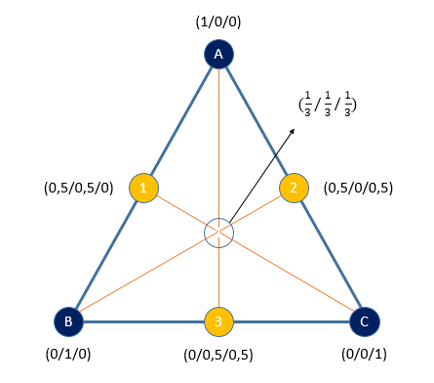
Figure 1. Each vertices of the plot (A,B and C) represent the 100% of each ingredient, the simplex plot can only visually display three ingredients, If there are more ingredients the values must be provided. The point in the center contains an equal percentage of each component.

Models Used in Mixture Design
For a design with three components, the following models are commonly used.
- Linear Model
$$\hat{y}=\sum_{i=1}^{q}{β_{i}x_{i}}$$ | (Equation 10)

- Quadratic Model
$$\hat{y}=\sum_{i=1}^{q}{β_{i}x_{i}}+\sum_{i<j}^{q-1}{\sum_{j}^{q}{β_{ij}x_{i}x_{j}}}$$ | (Equation 11)

- Special Cubic Model
$$\hat{y}=\sum_{i=1}^{q}{β_{i}x_{i}}+\sum_{i<j}^{q-1}{\sum_{j}^{q}{β_{ij}x_{i}x_{j}}}+\sum_{i<j}^{q-2}{\sum_{j<k}^{q-1}{\sum_{k}^{q}{β_{ij}x_{i}x_{j}x_{k}}}}$$ | (Equation 12)

- Full cubic Model
$$\hat{y}=\sum_{i=1}^{q}{β_{i}x_{i}}+\sum_{i<j}^{q-1}{\sum_{j}^{q}{β_{ij}x_{i}x_{j}}}+\sum_{i<j}^{q-1}{\sum_{j}^{q}{δ_{ij}x_{i}x_{j}\left(x_{i}-x_{j}\right)}}+ \sum_{i<j}^{q-2}{\sum_{j<k}^{q-1}{\sum_{k}^{q}{β_{ij}x_{i}x_{j}x_{k}}}}$$ | (Equation 13)

All this models are called Scheffe type models and can be extended to designs with more than three components. Scheffe models were specifically developed to handle the natural constraints of mixture designs.

Methodology
Figure 3 - Methodology Diagram.
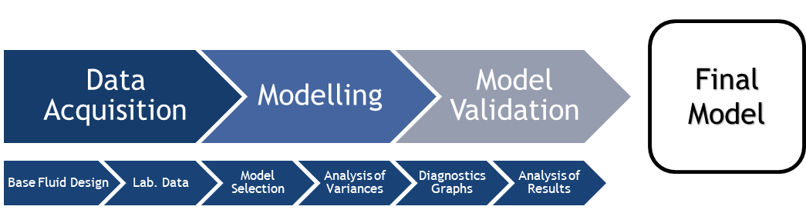
Figure 2. The methodology used along this project is represented in this figure, which is a sequence of activities to obtain the final model of each component.

Methodology Description
From figure 2, it is possible to make a detailed description about the process applied, and about the information needed to achieve the model.

Data Acquisition
The data acquisition is the first step, therefore the most important, the quality of the results are very dependent of the quality of the information used. When working with a software it is not able to determinate if, the information is adequate or not for the study, it only focuses on deliver the analysis results. It is important to identify the quality of the information before starting with the process.
The information required is the following:
- The components and responses to be studied.
It is necessary to identify responses and to figure out how to measure them. Identify the critical quantifiable responses is an important step for a successful DOE. As well is important to identify the factors and levels. The factors are the inputs to the process. Factors in the experiment are controlled and set to levels prescribed by the design.
The factors will be the same for all the designs studied, and the responses will vary depending on the design. In table 5, the factors and general responses are specified.

Table 4. - Factors and Responses.

Factors (Components) | VG Supreme
 | Versamod
 | EMI-1945
Responses (Attributes) | Rheology at 600 RPM at 50°C and 80°C
 | Rheology at 300 RPM at 50°C and 80°C
 | Rheology at 200 RPM at 50°C and 80°C
 | Rheology at 100 RPM at 50°C and 80°C
 | Rheology at 6 RPM at 50°C and 80°C
 | Rheology at 3 RPM at 50°C and 80°C
 | Electrical Stability
Elaborated by: Santiago Aguayo

- The base mud formulation: for all the designs, a base mud without the three main components to study was used. For a volume of three liters, the composition is shown in table 5.
Table 5. - Base mud Formulation for 3 liters.
Components | Amount | Units
EDC 95/11 | 1343.1 | Grams
OneMul NS | 60.0 | Grams
VersaWet | 15.0 | Grams
VG Supreme | 0 | Grams
Truvis / Bentone 128 | 15.0 | Grams
Lime | 60.0 | Grams
Versatrol M | 45.0 | Grams
Ecotrol RD | 30.0 | Grams
Fresh Water | 544.5 | Grams
CaCl2 | 226.8 | Grams
Microbar NS | 2148.3 | Grams
Versamod | 0 | Grams
EMI-1945 | 0 | Grams
Elaborated by: MI-SWACO, SCHLUMBERGER
Edited by: Santiago Aguayo

- The design formulation for each sample, provided by the software. For all the designs, the formulation must be developed in order to study how the selected attributes of the drilling fluids respond when the proportion of the three components of the formulation will vary. Depending of the design, the attributes (Rheology at different RPM and temperature, and Electrical Stability) will vary but the components (VG Supreme, Versamod, and EMI-1945) will be the same.
After introducing the information required in the Software Design-Expert, the number of runs and the percentage of each component to each run will be displayed in a table randomly. The number of runs represent the number of points distributed on the triangle.
- The laboratory Data, which is the Rheology and the Electrical Stability data of each sample after the Hot-Rolling Aging Test. After the test is completed, and the fluids are mixed again, the fluids are transfer to the rotational viscometer in order to get the values of the shear stress at different shear rate values, and a constant temperature.
The Hot Rolling Aging Test.
The procedure for running this test is the following:
- All parts of the ageing cell must be marked with the same reference number, and the stem valve and lid is not blocked.
- Transfer approximately 350 ml of fluid to an ageing cell.
- Close the cell by the two lid-parts. Insert the stem valve, if not already in place, and leave it slightly open.
- Pressurize the cell through the stem valve with nitrogen (inert gas). The cells will be pressurized at 200 psi.
- Preheat the roller oven to the desired temperature, which is at 120 °C, standard hot-rolling time is 16 hours.
- Use dry heat resistant gloves when taking the cell out of the oven.
- Cool down the cell, and carefully bleed off the pressure.
- When pressure has been removed, open the cell and transfer fluid to mixing cup.
- Sample should be stirred using the mixer after ageing to ensure a homogeneous fluid before further testing commences.

Modeling
The second step of the methodology is the Modeling part, at this point all the data must be introduced in the software (Design Expert).
- Model selection
To start the analysis the software requires some up front planning, starting by identifying the responses that need to be measured, which factor effects should be examined, and the number of runs when building the design.
Since the process is a mixture, consequently the Mixture Design was chosen. The mixture design produce runs to model the responses in terms of the relative proportions of the components. Because proportions are being used, as one component is increased the sum of the other components must decrease. For this study, the sum of the component proportions is 3 grams.
The analysis can proceed once the response data has been entered. Each response will be analyzed individually.
When choosing the model, since the design is a mixture one, the Fit Summary button displays sequential F-tests, lack-of-tests and other adequacy measures to suggest a starting point.
- Analysis of Variance
ANOVA output shows a set of tables that gives a brief description of the model being fit, followed by the type of sum of squares used for the calculations.
At this point the equation for the model is obtained too, the two important tables are the ANOVA and the Fit statistics.
Concepts and definitions.
The ANOVA Table
- Lack of fit: is the amount the model predictions miss the observations.
- Pure error: is the amount of difference between replicate runs.
- Cor total: shows the amount of variation around the mean of the observations.
- Sum of Squares: sum of the squared differences between the overall average and the amount of variation explained by the rows source.
- Df (Degrees of freedom): the number of estimated parameters used to compute the source’s sum of squares.
- Mean square: the sum of squares divided by the degrees of freedom. Also called variance.
- F-value: test for comparing the source’s mean square to the residual mean square.
- P-value: probability of seeing the observed F-value if the null hypothesis is true. Small probability values call for rejection of the null hypothesis.
Fit Statistics Table
- Std. Dev: square root of the residual mean square. Consider this to be an estimate of the standard deviation associated with the experiment.
- Mean: overall average of all the response data.
- C.V.% : coefficient of variation, the standard deviation expressed as a percentage of the mean. Calculated by dividing the standard deviation by the mean and multiplying by 100.
- R-squared: A measure of the amount of variation around the mean explained by the model, adjusted for the number of terms in the model.
- Adjusted R-squared: a measure of the amount of variation around the mean explained by the model. Adjusted for the number of terms in the model. The adjusted R-squared decreases as the number of terms in the model increases if those additional terms do not add value to the model.
- Predicted R-squared: a measure of the amount of variation in new data explained by the model.
- Adequate precision: this a signal to noise ratio. It compares the range of the predicted values at the design points to the average prediction error. Ratios greater than 4 indicate adequate model discrimination.

Model Validation
- Diagnostics Graphs
The diagnostics fall into the following categories:
- Diagnostics Plots
- Normal probability.
The normal probability plot indicates whether the residuals follow a normal distribution, thus follow the straight line. Expect some scatter even with normal data. Look only for definite patterns, like the shape of the curve. An “S-shaped” curve, which indicated that a transformation of the response might provide a better analysis.
- Residual vs. Predicted.
This is a plot of the residuals versus the ascending predicted response values. It tests the assumption of constant variance. The plot should show a random scatter, which is a constant range of residuals across the graph. Expanding variance (megaphone pattern) in this plot indicates the need for a transformation.
- Residual vs. Run.
This is a plot of the residual versus the experimental run order. It checks for lurking variables that may have influenced the response during the experiment. The plot should a random scatter. Trends indicate a time-related variable lurking in the background. Blocking and randomization provide insurance against trends ruining the analysis.
- Predicted vs. Actual.
A graph of the predicted response values versus the actual response values. The purpose is to detect a value, or a group of values, that are not easily predicted by the model.
- Residual vs. Factor.
This is a plot of the residual versus any factor of your choosing, it checks whether the variance not accounted for by the model is different for different levels of a factor. If everything is okay, the plot should exhibit a random scatter. Pronounced curvature may indicate a systematic contribution of the independent factor that is not accounted for by the model.
- Influence Plots
- Cook’s distance.
A measure of how much the entire regression function changes when the $i^{th}$ point is not included for fitting the model. It is essentially the sum of differences in predictions at every point caused by leaving a point out for fitting the model.
- Leverage.
A measure of how much each point influences the model fit. If a point has a leverage of 1.0, then the model exactly fits the observation at that point. That point controls the model. The average leverage is the number of terms in the model divided by the number of runs in the design.
- DFFITS.
A measure of how much the prediction changes at the $i^{th}$ point when the $i^{th}$ point is not included for fitting the model.
- DFBETAS.
A measure of how much a coefficient estimate changes when the $i^{th}$ point is not used to fit the model. There are separate DFBETA plots for each term in the model.
- Box-Cox Plot
This plot provides a guideline for selecting the correct power law transformation. A recommended transformation is listed, based on the best lambda value, which is found at the minimum point of the curve generated by the natural log of the sum of squares of the residuals. If the 95% confidence interval around this lambda includes one, then the software does not recommend a specific transformation. This plot is not displayed when either the logit or the arcsine square root transformation has been applied.
- Diagnostic Report
This section contains descriptions of each case statistic. A table of the numbers used to generate the Diagnostic and influence plots.
- Analysis of Results
After going through the analysis plots, it is necessary to check the data and if it is necessary repeat some experiments in order to fit better the model. In this stage some points (runs) will be ignored if they are out of the trend or out of the limits of each plots. A comparison between the plot considering all the points and the plot without the ignored points will be done.

Final Model
- Model Graphs
- Contour plot.
The contour plot is a two-dimensional representation of the response plotted against combinations of numeric factors and/or mixture components. It can show the relationship between the responses, mixture components and/or numeric factors.
- 3D Surface.
The 3D surface plot is a projection of the contour plot giving shape in addition to the color and contour. This plot can be rotated.
- Final Model Equation
The equation in can be used to make predictions about the response for given levels of each factor. It is useful for identifying the relative impact of the factors by comparing the factor coefficients.
- Rheological Profile Plot

Methodology Application for the First Design.

Data Acquisition.

Base Fluid Design.
The base formulation fluid used for this design is the same described in table 4. As explained before the formulation will not contain any percentage of the components to be studied.
The volume of the base formulation must be according to the number of runs that the software will create once the data is introduced in it. Each run have a different formulation, for the first design there are 14 runs to study. Table 6 shows the formulation for each run.
Table 6. - First design runs.

Run | Component 1  A: VG-Supreme | Component 2  B: Versamod | Component 3  C: EMI-1945
1 | 3 | 0 | 0
2 | 0 | 0 | 3
3 | 1 | 1 | 1
4 | 0 | 3 | 0
5 | 0 | 0 | 3
6 | 2 | 0.5 | 0.5
7 | 1.5 | 1.5 | 0
8 | 3 | 0 | 0
9 | 1.5 | 1.5 | 0
10 | 1.5 | 0 | 1.5
11 | 0.5 | 0.5 | 2
12 | 0 | 1.5 | 1.5
13 | 0.5 | 2 | 0.5
14 | 0 | 3 | 0
Elaborated by: Design-Expert Software.
Edited by: Santiago Aguayo

Laboratory Data.
Since there are 14 runs to study, 3 liters of the base formulation will be prepared and then divided in 7 equal parts (Runs 1 – 7) of 350 ml, for the next 7 runs (Runs 8 – 14) the procedure will be repeated. The base formulations use for the 14 runs, will be tested to ensure no difference between them.
Once both base formulations has been prepared and divided each into seven equal parts the percentage of the components was added to obtain the final fluid samples.
The Hot-Rolling Test must be run for all the 14 fluid samples. After this test is completed and the samples are mixed again, the fluids are transfer to the rotational viscometer, in order to get the values of the shear stress at different shear rates, and at 50°C.
The data for the first design is shown in table 7.
Table 7. - Lab. Data for the first design.

Run | Response 1  600 RPM | Response 2  6 RPM | Response 3  Electrical Stability
1 | 78 | 7 | 535
2 | 55 | 5.5 | 382
3 | 63 | 6 | 424
4 | 52 | 4.5 | 384
5 | 58 | 4.5 | 441
6 | 73 | 7.5 | 514
7 | 72 | 7 | 476
8 | 81 | 6.5 | 748
9 | 77 | 8.5 | 578
10 | 72 | 9.5 | 674
11 | 62 | 7 | 510
12 | 60 | 4.5 | 523
13 | 68 | 5.5 | 471
14 | 68 | 5 | 396
Elaborated by: Design-Expert Software.
Edited by: Santiago Aguayo

Modelling
Once the data has been introduced in the software, a complete analysis for each response (Attribute) is done. Each response must be analyzed individually.

Model Selection
The analysis of this response starts with the Fit Summary, which is a statistical table used to identify the model that suits the best the criteria and labels as “suggested” the full-order model chosen. This suggested model should be considered a good starting point for the model fitting (Stat-Ease, 2020).
Tables 8, 9 and 10 describe the fit summary for each response.
Table 8.- Fit summary for Response 1, 600 RPM.

Source | Sequential  p-value | Lack of fit  p-value | Adjusted $R^{2}$ | Predicted $R^{2}$
Linear | 0.0002 | 0.9422 | 0.7542 | 0.5999 | Suggested
Quadratic | 0.8314 | 0.8580 | 0.6952 | 0.3141
Special Cubic | 0.3593 | 0.8893 | 0.6938 | 0.2202
Cubic | 0.8092 | 0.6829 | 0.6061 | -0.5749 | Aliased
Sp Quartic vs Quadratic | 0.7616 | 0.6529 | 0.6061 | -0.5749
Quartic vs Cubic | 0.6529 |  | 0.5350 |  | Aliased
Quartic vs Sp Quartic | 0.6529 |  | 0.5350 |  | Aliased
Elaborated by: Design-Expert Software.
Edited by: Santiago Aguayo
For this response, the model selected is the Linear

Table 9. - Fit summary for Response 2, 6 RPM.

Source | Sequential  p-value | Lack of fit  p-value | Adjusted $R^{2}$ | Predicted $R^{2}$
Linear | 0.0550 | 0.0702 | 0.3025 | 0.0469
Quadratic | 0.0115 | 0.3277 | 0.7417 | 0.4358
Special Cubic | 0.0471 | 0.6623 | 0.8384 | 0.4732 | Suggested
Cubic | 0.5142 | 0.5695 | 0.8266 | 0.0633 | Aliased
Sp Quartic vs Quadratic | 0.1941 | 0.5695 | 0.8266 | 0.0633
Quartic vs Cubic | 0.5695 |  | 0.8022 |  | Aliased
Quartic vs Sp Quartic | 0.5695 |  | 0.8022 |  | Aliased
Elaborated by: Design-Expert Software.
Edited by: Santiago Aguayo
For this response, the model selected is the Special Cubic.
Table 10. - Fit summary for Response 3, Electrical Stability.

Source | Sequential  p-value | Lack of fit  p-value | Adjusted $R^{2}$ | Predicted $R^{2}$
Linear | 0.0145 | 0.6523 | 0.4525 | 0.2113 | Suggested
Quadratic | 0.6943 | 0.5180 | 0.3655 | -0.6776
Special Cubic | 0.0621 | 0.8940 | 0.5741 | -0.1814 | Suggested
Cubic | 0.7303 | 0.8399 | 0.4742 | -0.0711 | Aliased
Sp Quartic vs Quadratic | 0.3110 | 0.8399 | 0.4742 | -0.0711
Quartic vs Cubic | 0.8399 |  | 0.3503 |  | Aliased
Quartic vs Sp Quartic | 0.8399 |  | 0.3503 |  | Aliased
Elaborated by: Design-Expert Software.
Edited by: Santiago Aguayo
For this response, the model selected is the Special Cubic.

Analysis of Variance (ANOVA)
The analysis of variance provides important information regarding the model, the ANOVA table, Fit statistics table and the Model equation, are the most relevant data from this stage of the analysis.
Table 11. - ANOVA for Response 1, 600 RPM.

Source | Sum of Squares | dlf | Mean Square | F-value | p-value
Model | 827.63 | 2 | 413.81 | 20.95 | 0.0002 | Significant
Linear Mixture | 827.63 | 2 | 413.81 | 20.95 | 0.0002
Residual | 217.30 | 11 | 19.75
Lack of fit | 67.80 | 7 | 9.69 | 0.2591 | 0.9422 | Not significant
Pure Error | 149.50 | 4 | 37.38
Cor Total | 1044.93 | 13
Elaborated by: Design-Expert Software.
Edited by: Santiago Aguayo
From table 11, the model F-value of 20.95 implies the model is significant. There is only a 0.02% chance that an F-value this large could occur due to noise.
P-values less than 0.0500 indicate model terms are significant. Values greater than 0.1000 indicate the model terms are not significant. If there are many insignificant model terms.
The lack of Fit F-value of 0.26 implies the lack of fit is not significant, that is good since the goal is the model to fit.
Table 12. - Fit Statistics for Response 1, 600 RPM.

Standard Deviation | 4.44
Mean | 67.07
C.V. % | 6.63
$$R^{2}$$ | 0.7920
Adjusted $R^{2}$ | 0.7542
Predicted $R^{2}$ | 0.5999
Adeq. Precision | 11.7052
Elaborated by: Design-Expert Software.
Edited by: Santiago Aguayo
From table 12, the most important data is the R-squared data.
The predicted R-square of 0.5999 is in reasonable agreement with the adjusted R-squared of 0.7542, it is important to consider that the difference between the predicted and adjusted R-squared must be less than 0.2. Otherwise there may be a problem with either the data or the model.
Adeq. Precision measures the signal to noise ratio. A ratio greater than 4 is desirable, the ratio of 11.7052 indicated an adequate signal.
Table 13. - ANOVA for Response 2, 6 RPM.

Source | Sum of Squares | dlf | Mean Square | F-value | p-value
Model | 28.12 | 6 | 4.69 | 12.24 | 0.0021 | Significant
Linear Mixture | 12.62 | 2 | 6.31 | 16.48 | 0.0022
AB | 5.19 | 1 | 5.19 | 13.55 | 0.0078
AC | 11.41 | 1 | 11.41 | 29.80 | 0.0009
BC | 0.0413 | 1 | 0.0413 | 0.1077 | 0.7523
ABC | 2.22 | 1 | 2.22 | 5.78 | 0.0471
Residual | 2.68 | 7 | 0.3830
Lack of fit | 0.8058 | 3 | 0.2686 | 0.5730 | 0.6623 | Not significant
Pure Error | 1.88 | 4 | 0.4688
Cor Total | 30.80 | 13
Elaborated by: Design-Expert Software.
Edited by: Santiago Aguayo

Table 14. - Fit Statistics for Response 2, 6 RPM.

Standard Deviation | 0.6188
Mean | 6.32
C.V. % | 9.79
$$R^{2}$$ | 0.9130
Adjusted $R^{2}$ | 0.8384
Predicted $R^{2}$ | 0.4732
Adeq. Precision | 11.2085
Elaborated by: Design-Expert Software.
Edited by: Santiago Aguayo
Table 14, shows the relationship between the R-squared. The adjusted and predicted R-squared have a significant difference, bigger than the 0,20 recommended difference. This difference is a sight that there might be some data input that may not be following the trend, or that the model is not adjusting itself to the data. It is necessary to check the diagnostic plots to see the dispersion of the data and find the possible points out of trend. It would be necessary to test the model by doing confirmation runs.
Table 15. - ANOVA for Response 3, Electrical Stability.

Source |  | Sum of Squares | dlf | Mean Square | F-value |  | p-value
Model | 1.145E+05 |  | 6 | 19081.97 | 3.92 | 0.0484 |  | Significant
Linear Mixture | 79734.59 |  | 2 | 39867.30 | 8.19 | 0.0147
AB | 148.51 |  | 1 | 148.51 | 0.0305 | 0.8663
AC | 16694.33 |  | 1 | 16694.33 | 3.43 | 0.1064
BC | 15375.23 |  | 1 | 15375.23 | 3.16 | 0.1187
ABC | 23939.81 |  | 1 | 23939.81 | 4.92 | 0.0621
Residual | 34068.15 |  | 7 | 4866.88
Lack of fit | 4369.15 |  | 3 | 1456.38 | 0.1962 | 0.8940 |  | Not significant
Pure Error | 29699.00 |  | 4 | 7424.75
Cor Total | 1.486E+0,5 |  | 13
Elaborated by: Design-Expert Software.
Edited by: Santiago Aguayo

Table 16. - Fit Statistics for Response 3, Electrical Stability.

Standard Deviation | 69.76
Mean | 504.00
C.V. % | 13.84
$$R^{2}$$ | 0.7707
Adjusted $R^{2}$ | 0.5741
Predicted $R^{2}$ | -0.1814
Adeq. Precision | 5.4839
Elaborated by: Design-Expert Software.
Edited by: Santiago Aguayo
Table 16, shows the values of the different R-squared, the negative predicted R-squared implies that the overall mean may be a better predictor of the response than the actual model. The difference between the adjusted and predicted R-squared must be less than 0,2, in this model the difference is much higher which is a clear sign that the model is not adjusted to the data.

Model validation

Diagnostics Graphs
- Diagnostics Plots
- Normal Probability
Response 1, 600 RPM
Figure 4.- Normal Probability considering all the points for 600 RPM  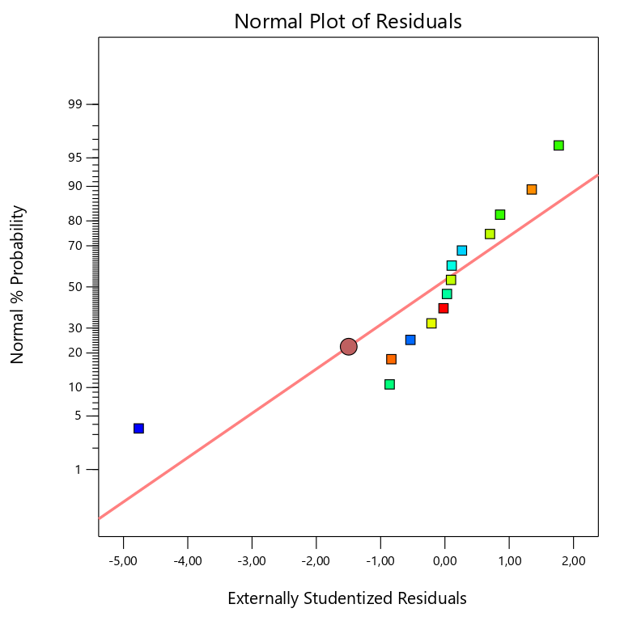 | Figure 5. -Normal Probability ignoring Run #4. For 600 RPM  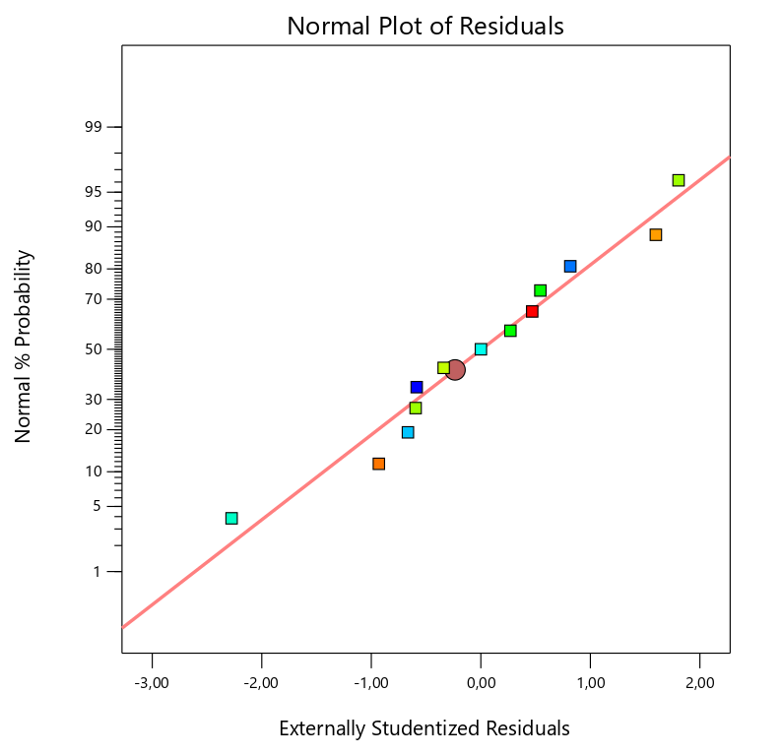
Figure 3. Shows the normal probability considering all the data, the distribution is affected by one point, the shape of the distribution tends to be an “S”, which is not a good sign since a transformation might be needed | Figure 4. Shows the distribution tendency tends to follow a straight line after ignoring run #4. It is always possible to ignore the data that might cause a disturbance in the distribution, but it is necessary to check if there is a mistake regarding the reading or the typing. It is not recommendable to ignore too many points since at the end it will not be possible to appreciate the real distribution.

Response 2, 6 RPM
Figure 6. - Normal Probability considering all the points for 6 RPM  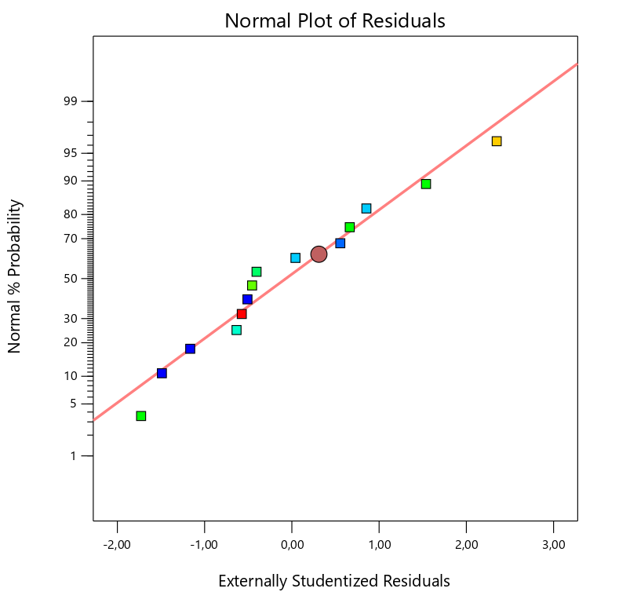 | Figure 7. - Normal Probability ignoring Run #12. For 6 RPM  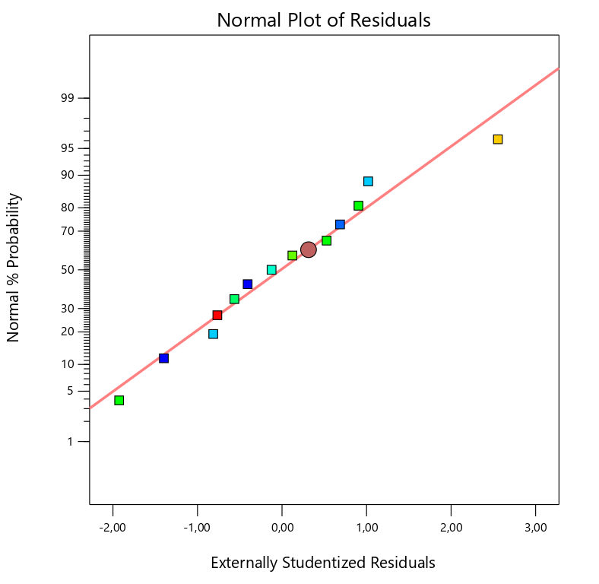
Figure 5. Shows a good distribution of the data, it is following a clear trend, this is a positive sign for the plots. | Figure 6. Shows the distribution ignoring Run #12 since for the next plots it was necessary to ignore that point for better results.

Response 3, Electrical Stability

Figure 8. - Normal Probability considering all the points for ES.  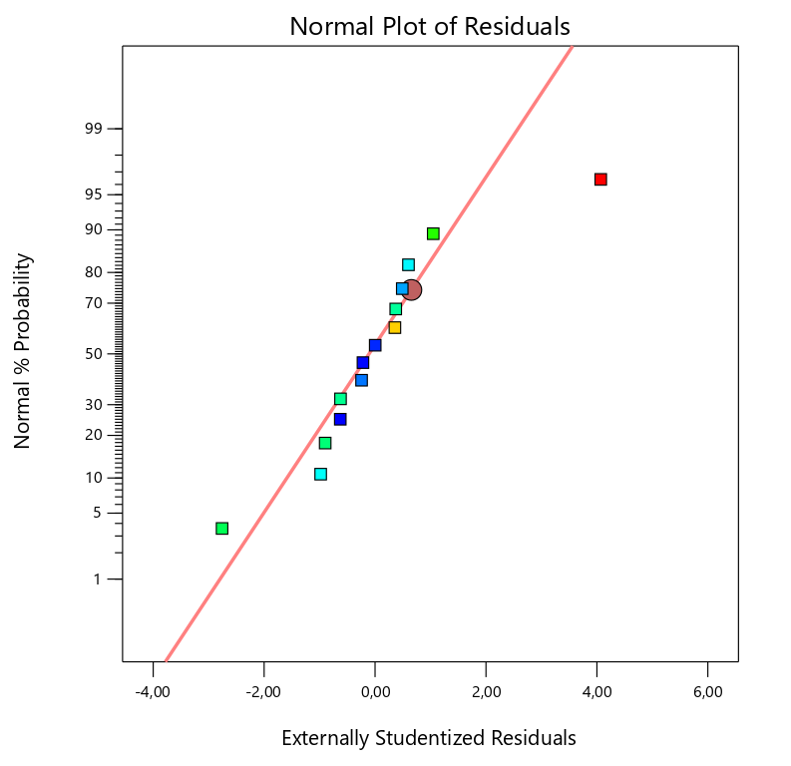 | Figure 9. - Normal Probability ignoring Run #8. For ES  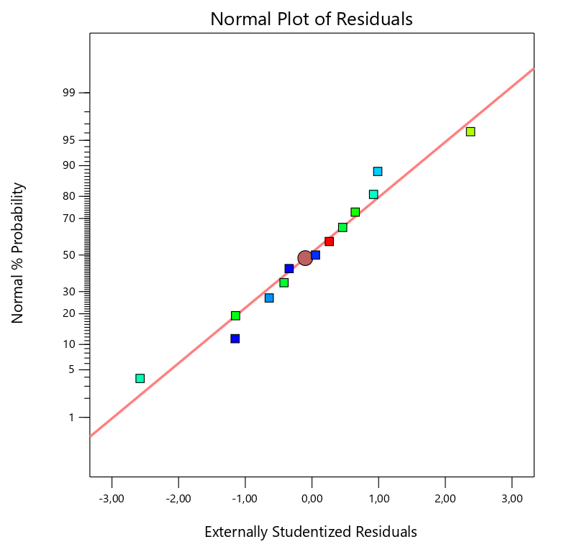
Figure 7. Shows how the distribution is affected by run #8. It has a “S” shape, which is not a good signal. | Figure 8. Shows the distribution ignoring Run #8 since for the next plots it was necessary to ignore that point for better results.

- Residual vs. Predicted
Response 1, 600 RPM
Figure 10. - Residual vs. Predicted considering all the points for 600 RPM  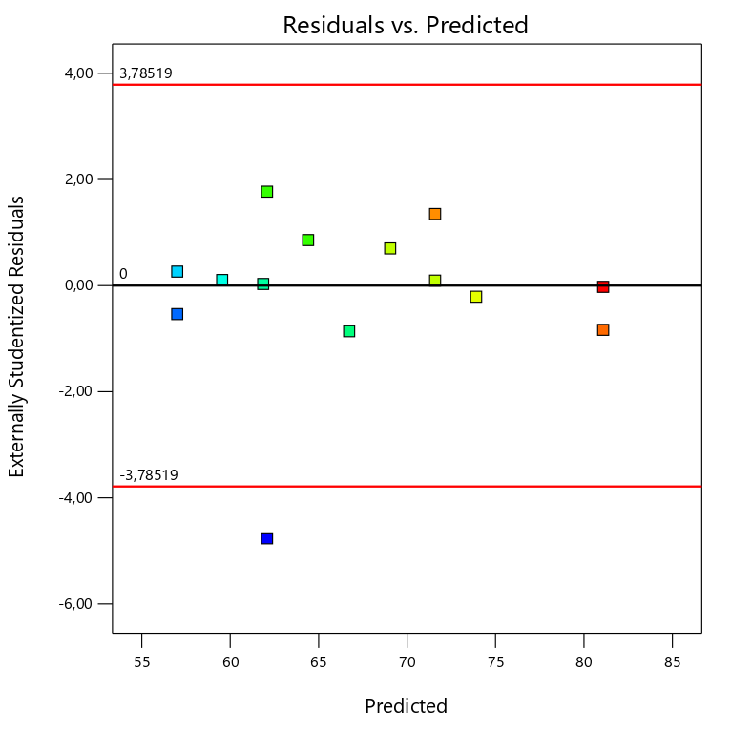 | Figure 11. - Residual vs. Predicted ignoring Run #4. For 600 RPM  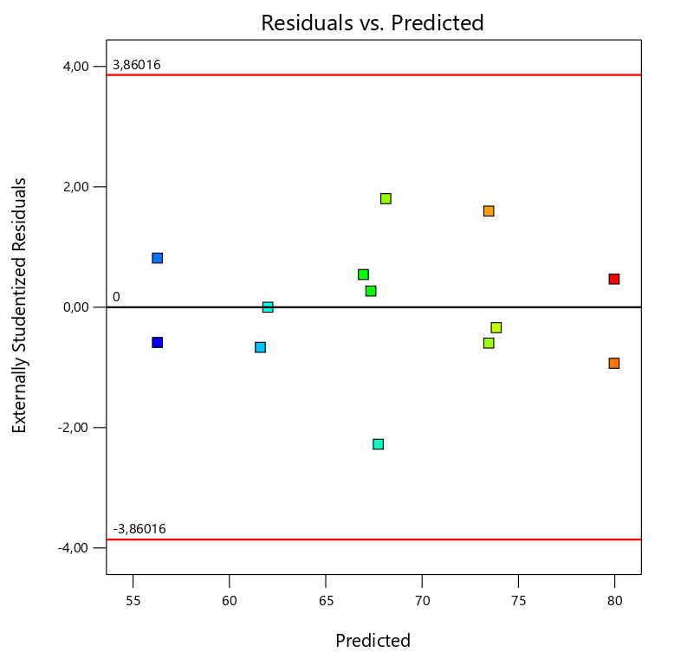
Figure 9. Shows a random scatter across the graph. All the values except for run #4 are in between the limits. | Figure 10. Shows a better distribution within the limits by ignoring run #4.

Response 2, 6 RPM
Figure 12. - Residual vs. Predicted considering all the points for 6 RPM  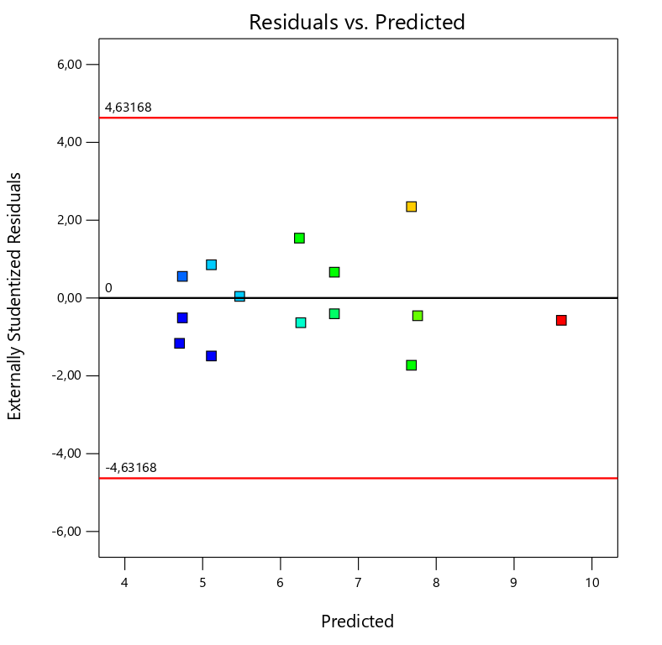 | Figure 13. - Residual vs. Predicted ignoring Run #12. For 6 RPM  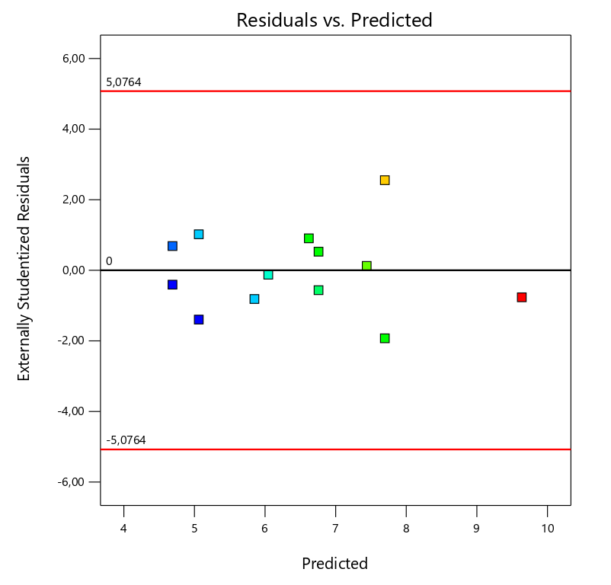
Figure 11. Shows a random scatter. It is important to notice that all the points are between the limits of the plot. | Figure 12. Shows a better distribution by ignoring run #12.

Response 3, Electrical Stability
Figure 14. - Residual vs. Predicted considering all the points for ES  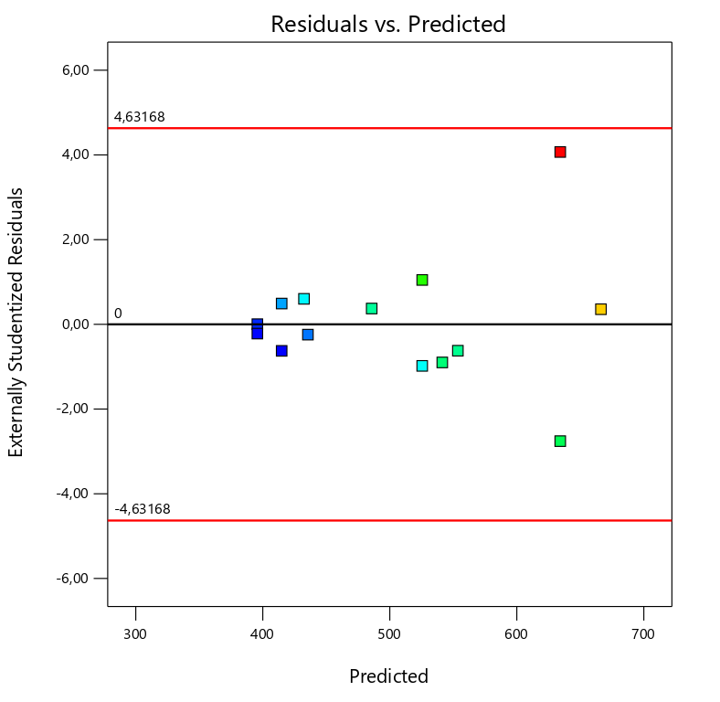 | Figure 15. - Residual vs. Predicted ignoring Run #8. For ES  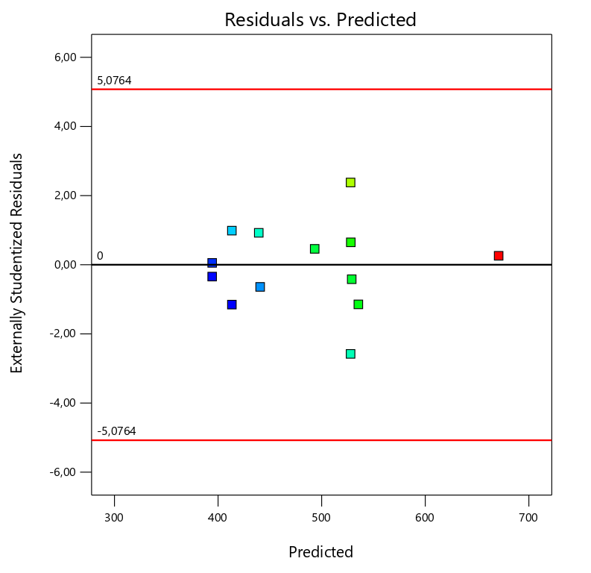
Figure 13. Shows a random scatter. It is important to notice that all the points are between the limits of the plot. | Figure 14. Shows a better distribution by ignoring run #8.

- Residual vs. Run
Response 1, 600 RPM
Figure 16. - Residual vs. Run considering all the points for 600 RPM  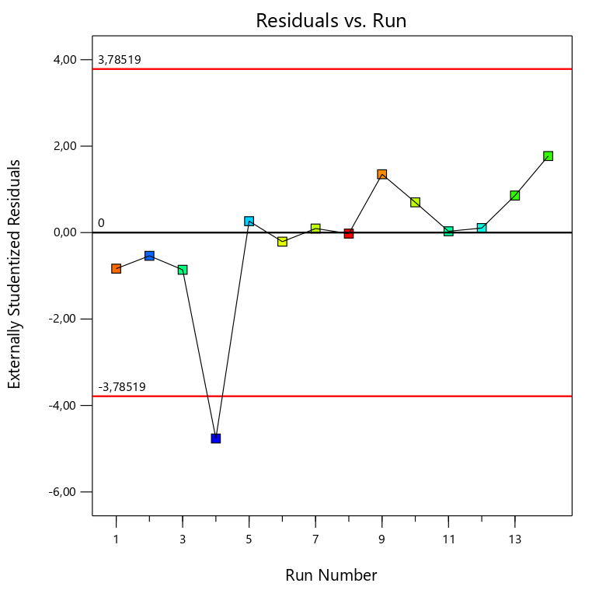 | Figure 17. - Residual vs. Run ignoring Run #4. For 600 RPM  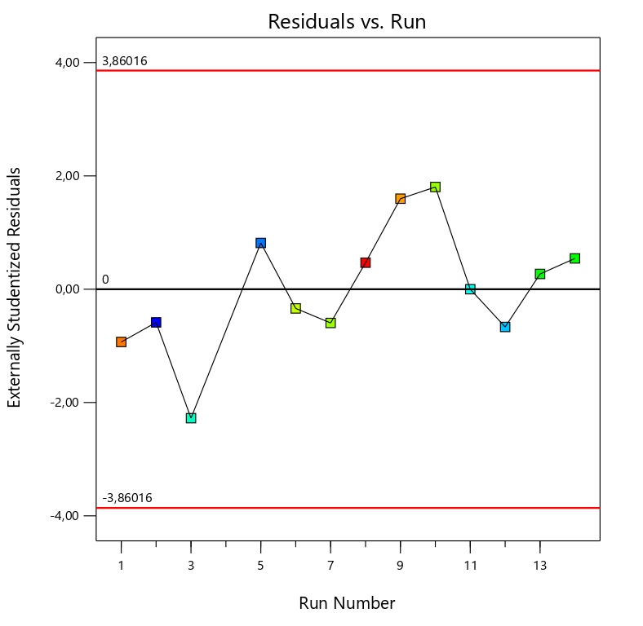
Figure 15. Shows an increasing trend, run #4 is out of the limits | Figure 16. Shows a better distribution. This trend indicated a time-related variable lurking in the background.

Response 2, 6 RPM
Figure 18. - Residual vs. Run considering all the points for 6 RPM  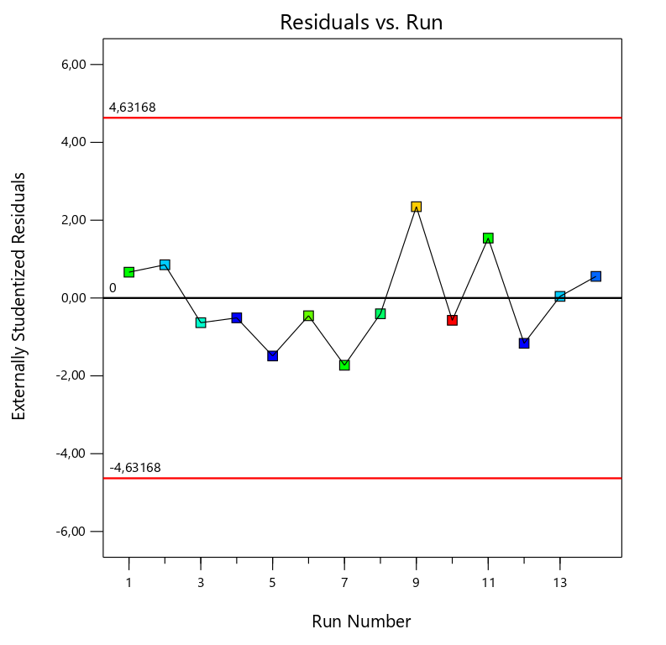 | Figure 19. - Residual vs. Run ignoring Run #12. For 6 RPM  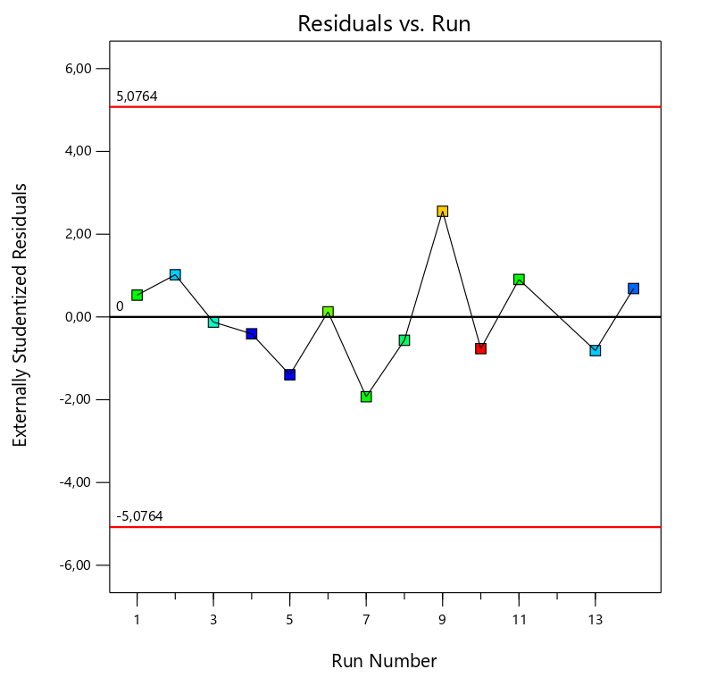

Response 3, Electrical Stability
Figure 20. - Residual vs. Run considering all the points for ES  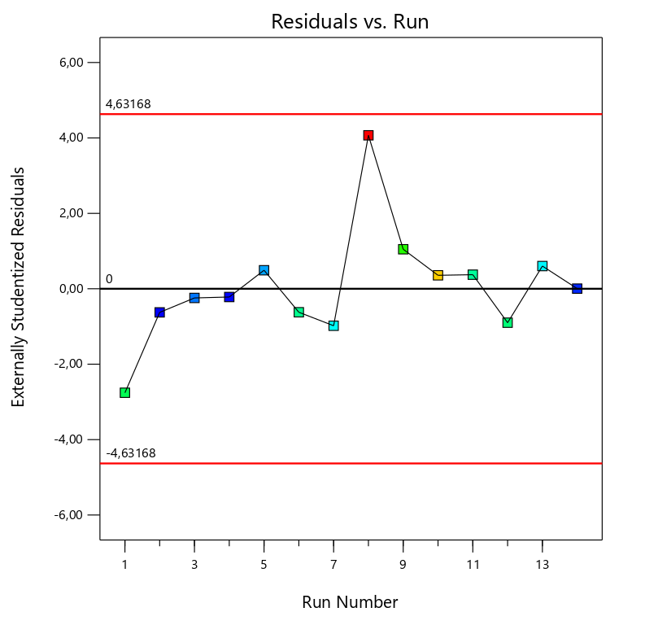 | Figure 21. - Residual vs. Run ignoring Run #8. For ES  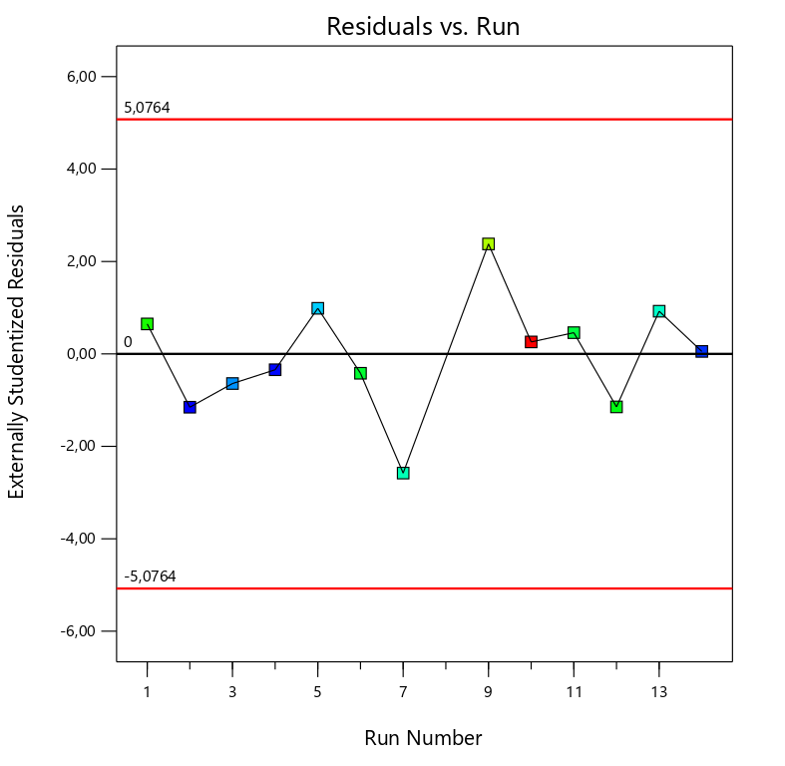

- Predicted vs. Actual
Response 1, 600 RPM
Figure 22. - Predicted vs. Actual considering all the points for 600 RPM  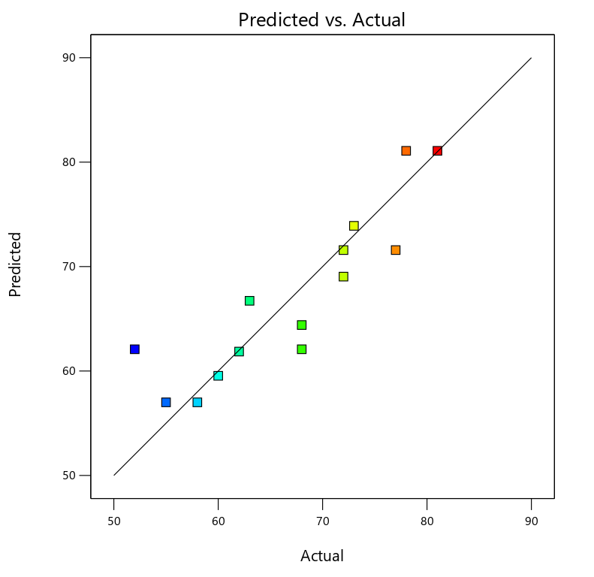 | Figure 23. - Predicted vs. Actual ignoring Run #4. For 600 RPM  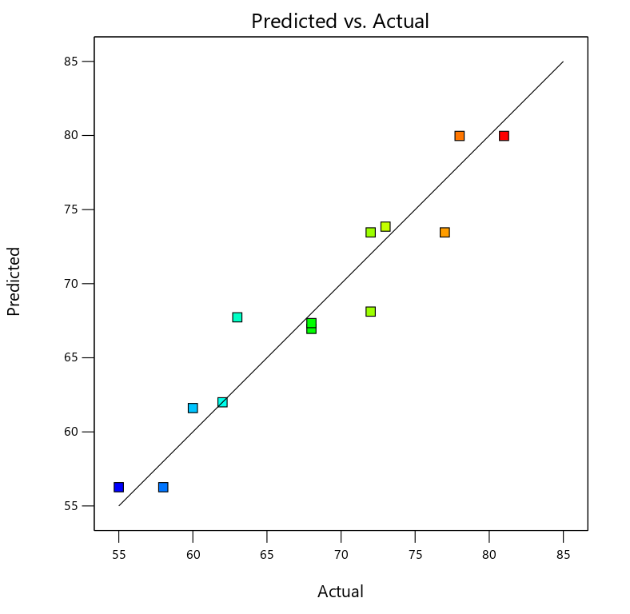
Figure 21. Shows the group of values that are not easy to predict by the model. Run #4 is the furthest value and the hardest to predict. | Figure 22. Shows a better distribution after ignoring run #4.

Response 2, 6 RPM
Figure 24. - Predicted vs. Actual considering all the points for 6 RPM  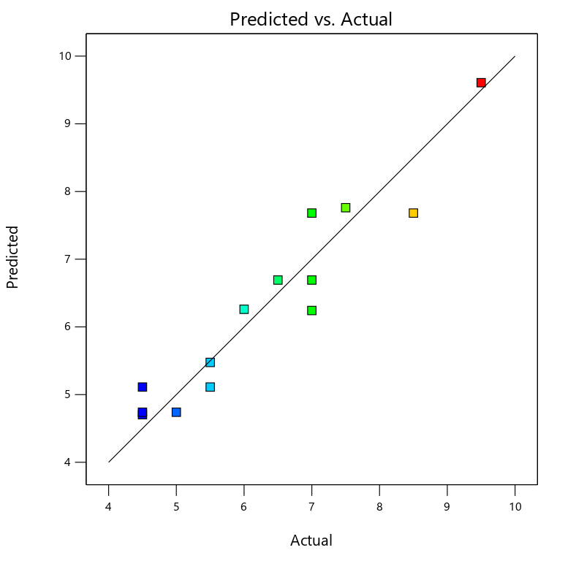 | Figure 25. - Predicted vs. Actual ignoring Run #12. For 6 RPM  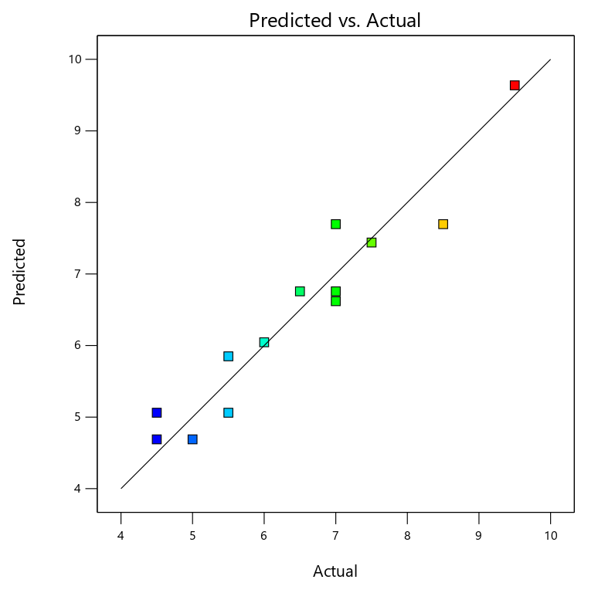

Response 3, Electrical Stability
Figure 26. - Predicted vs. Actual considering all the points for ES  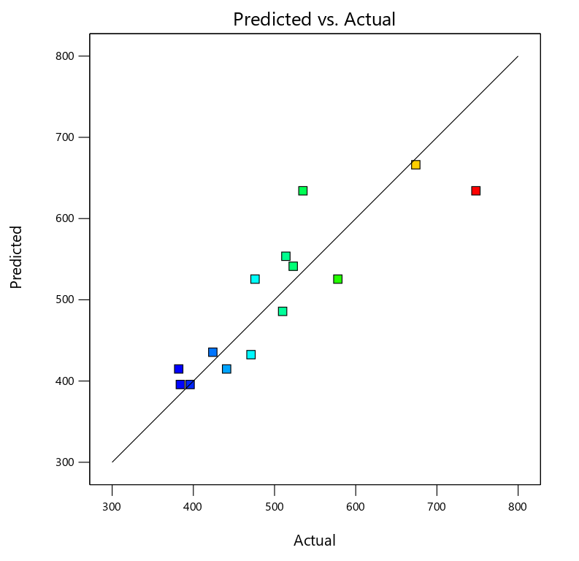 | Figure 27. - Predicted vs. Actual ignoring Run #8. For ES  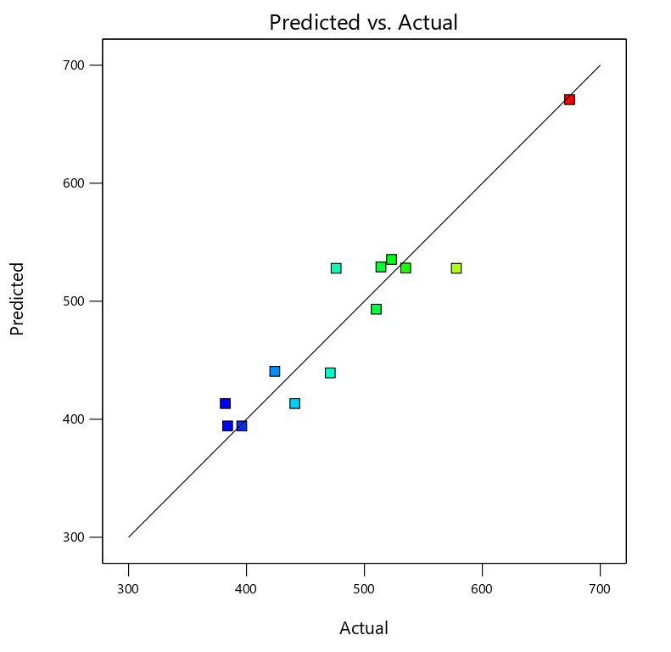
- Residual vs. Factor
Response 1, 600 RPM
Figure 28. - Residual vs. A: VG Supreme considering all the points for 600 RPM  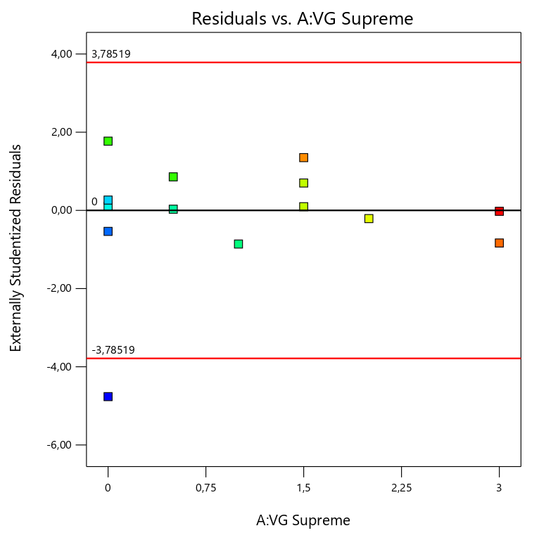 | Figure 29. - Residual vs. A: VG Supreme ignoring Run #4. For 600 RPM  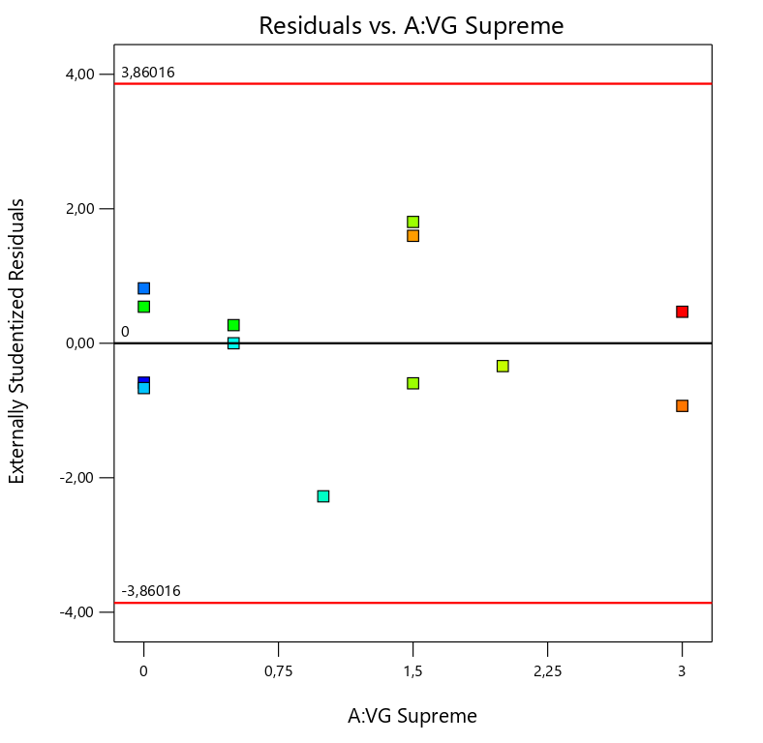
Figure 27. Shows a random scatter which is a good indicator, except for the point that is not in between the limits | Figure 28. Shows a better distribution after ignoring run #4.

Figure 30. - Residual vs. B: Versamod considering all the points for 600 RPM  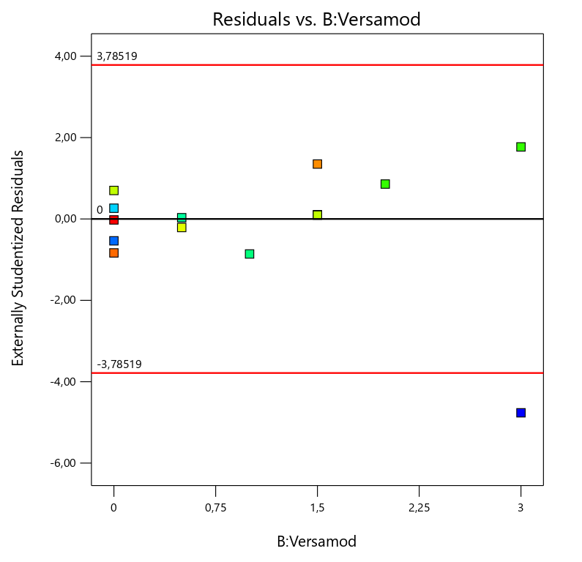 | Figure 31. - Residual vs. B: Versamod ignoring Run #4. For 600 RPM  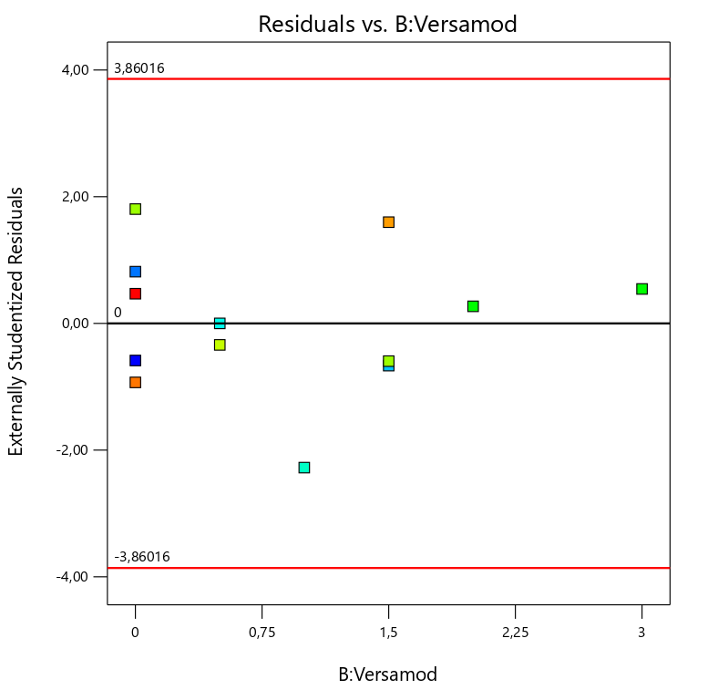

Figure 32. - Residual vs. C: EMI-1945 considering all the points for 600 RPM  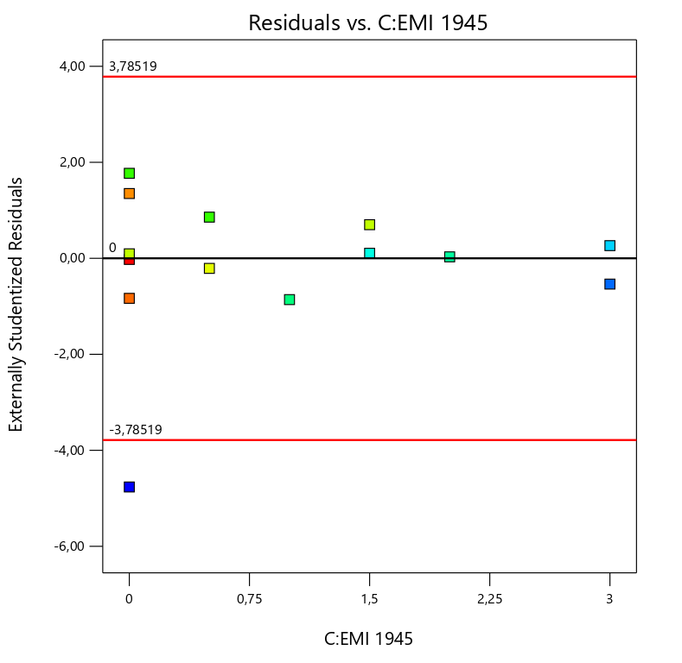 | Figure 33. - Residual vs. C: EMI-1945 ignoring Run #4. For 600 RPM  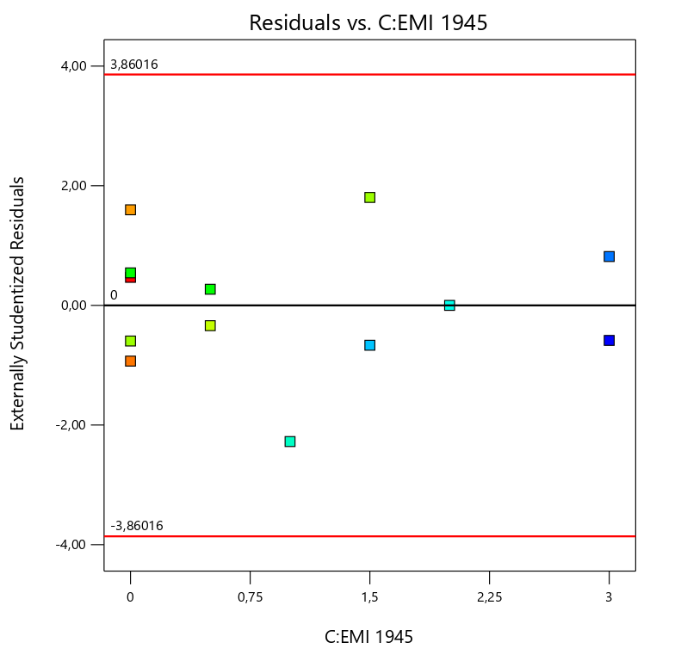

Response 2, 6 RPM
Figure 34. - Residual vs. A: VG Supreme considering all the points for 6 RPM  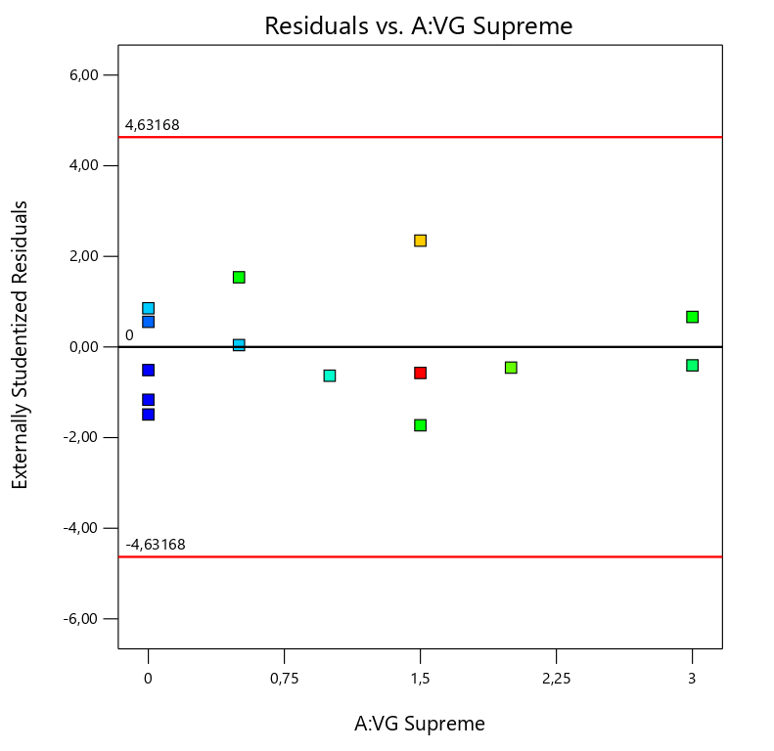 | Figure 35. -Residual vs. A: VG Supreme ignoring Run #12. For 6 RPM  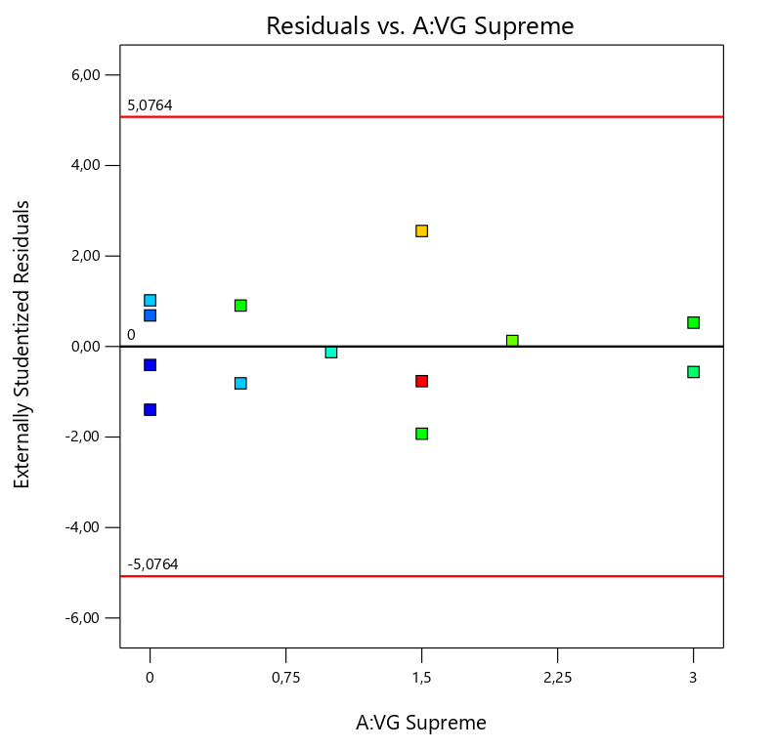

Figure 36. - Residual vs. B: Versamod considering all the points for 6 RPM  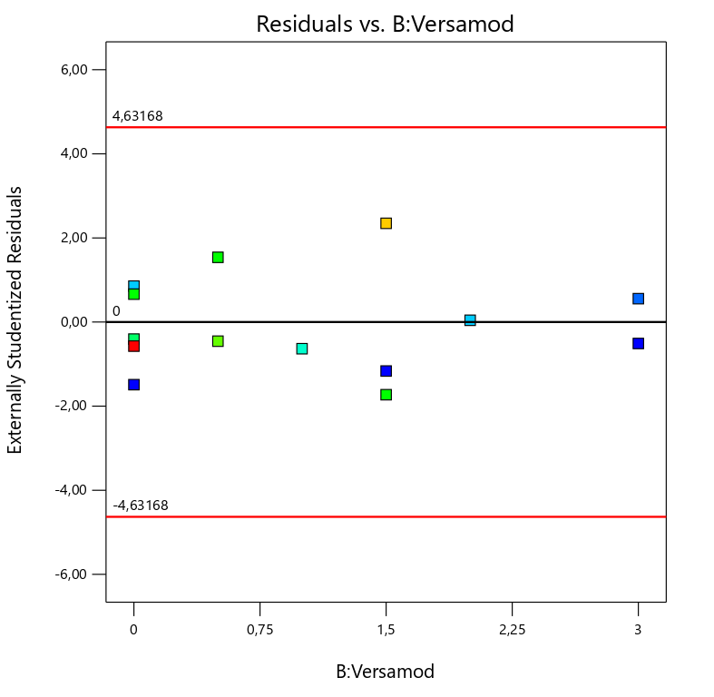 | Figure 37. -Residual vs. B: Versamod ignoring Run #12. For 6 RPM  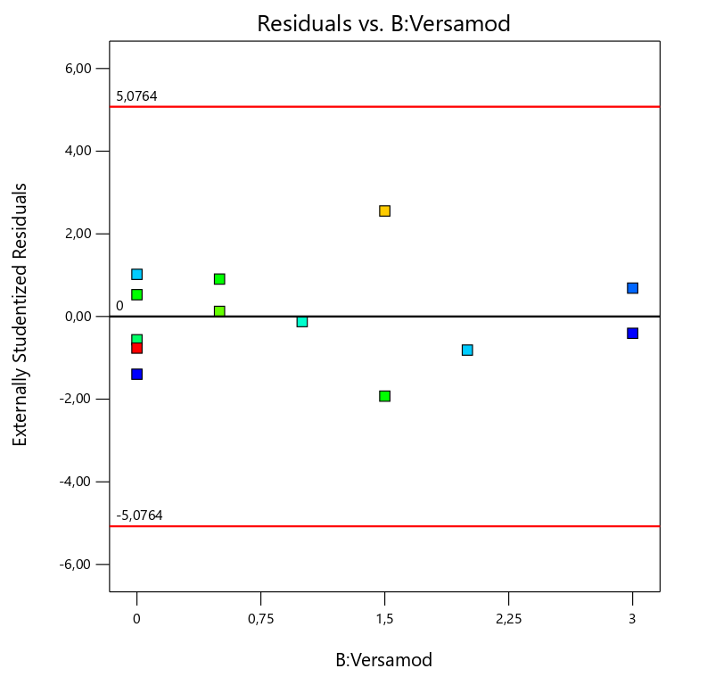

Figure 38. - Residual vs. C: EMI-1945 considering all the points for 6 RPM  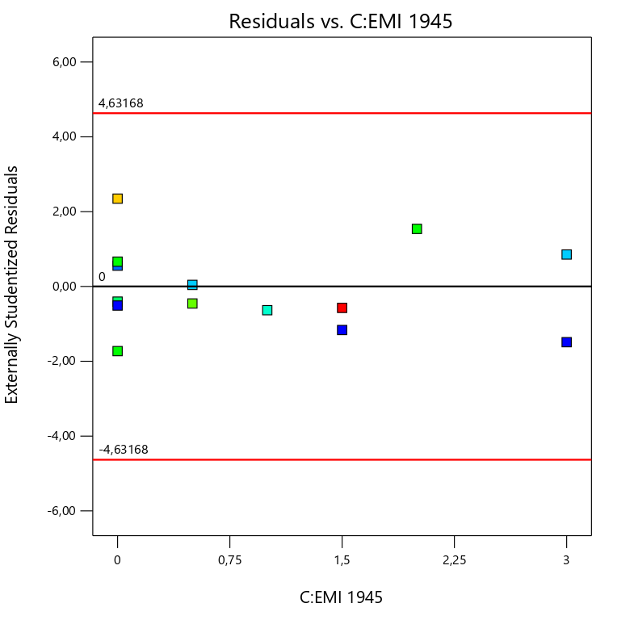 | Figure 39. - Residual vs. C: EMI-1945 ignoring Run #12. For 6 RPM  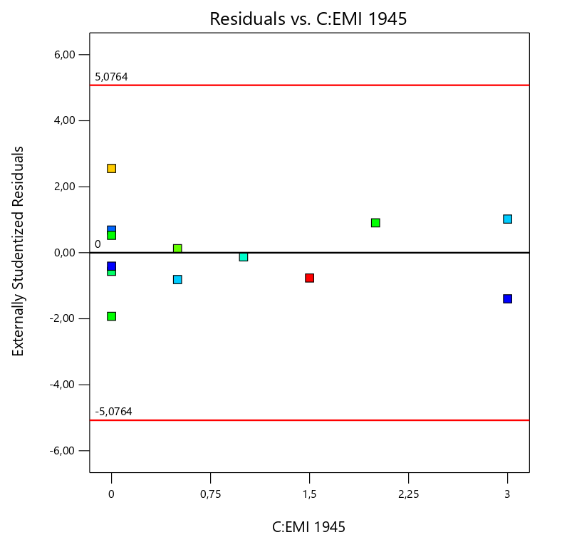

Response 3, Electrical Stability
Figure 40. - Residual vs. A: VG Supreme considering all the points for ES  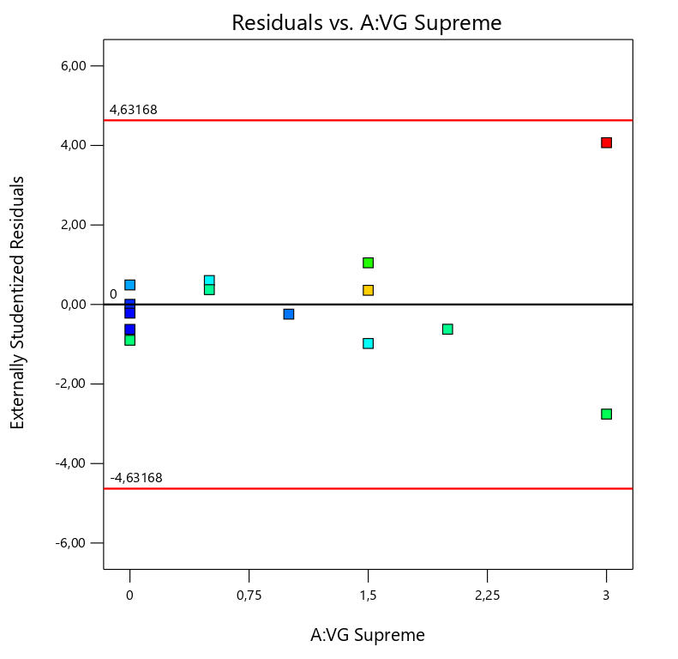 | Figure 41. - Residual vs. A: VG Supreme ignoring Run #8. For ES  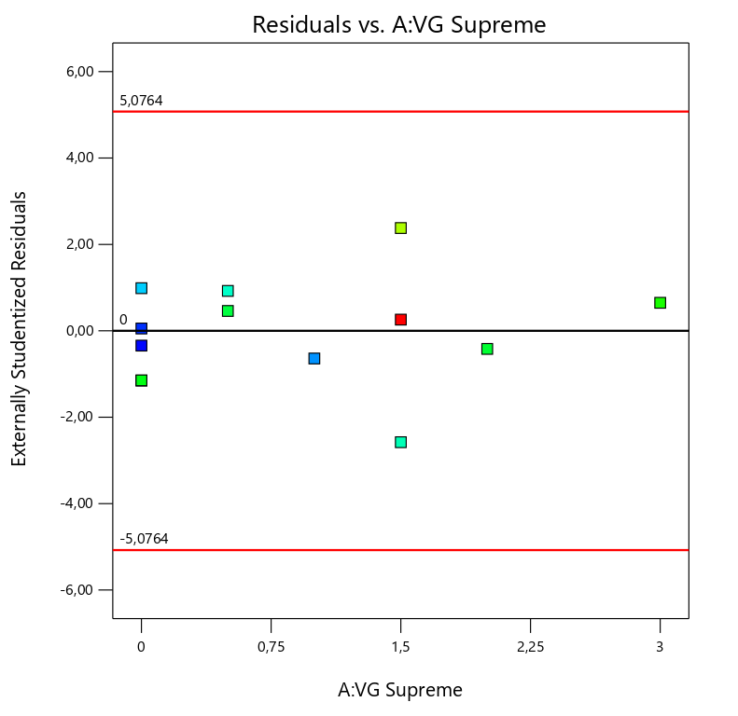

Figure 42. - Residual vs. B: Versamod considering all the points for ES  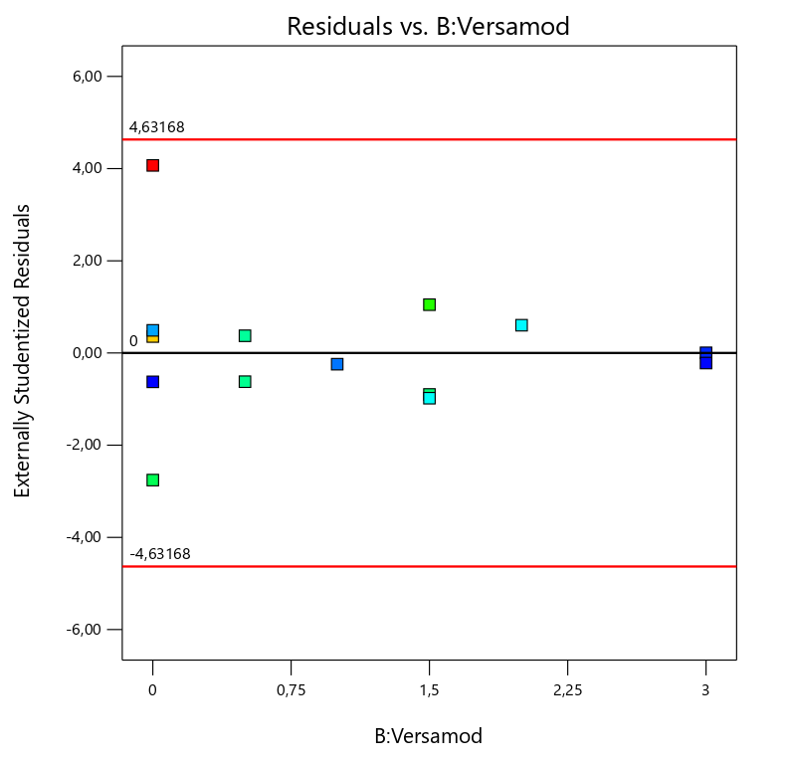 | Figure 43. - Residual vs. B: Versamod ignoring Run #8. For ES  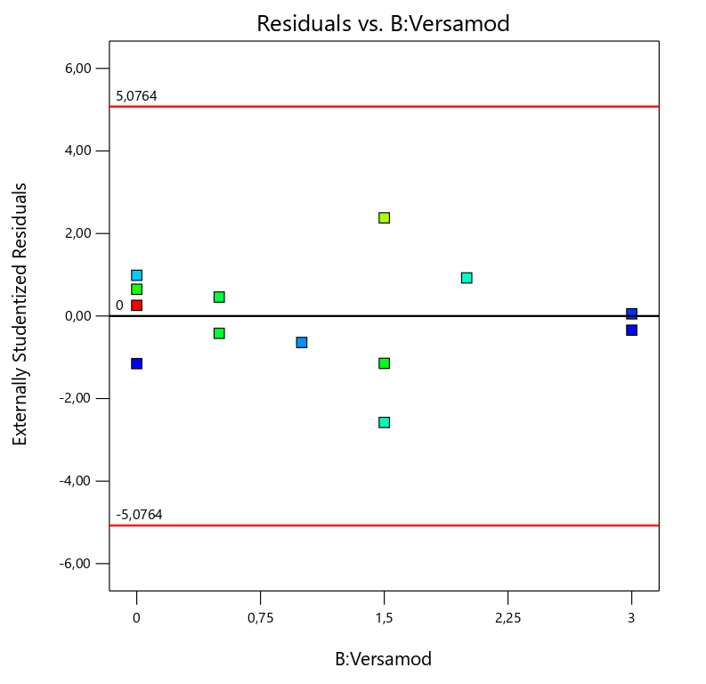

Figure 44. - Residual vs. C: EMI-1945 considering all the points for ES  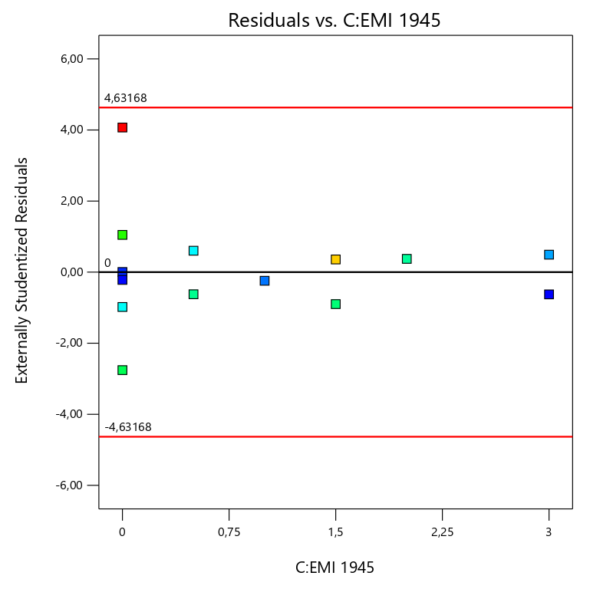 | Figure 45. - Residual vs. C: EMI-1945 ignoring Run #8. For ES  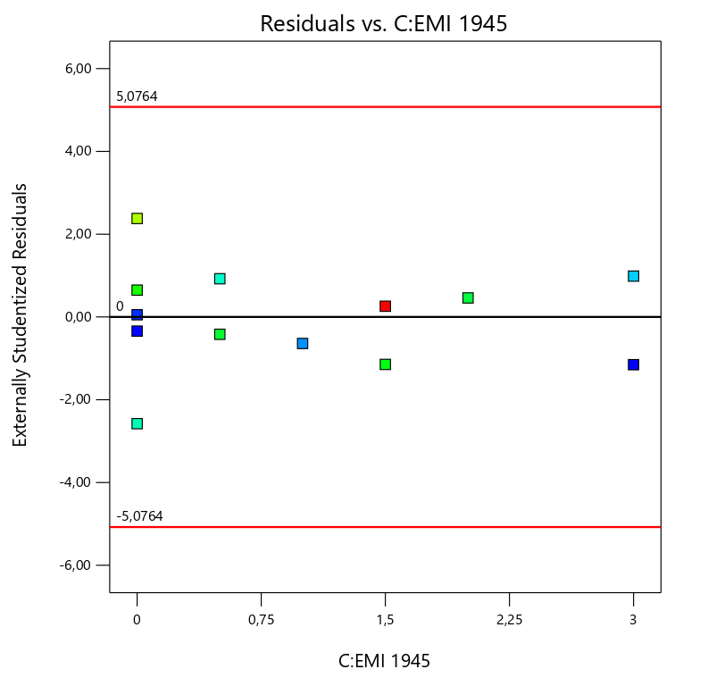

- Influence Plots
- Cook’s distance
Response 1, 600 RPM
Figure 46. - Cook’s distance considering all the points for 600 RPM  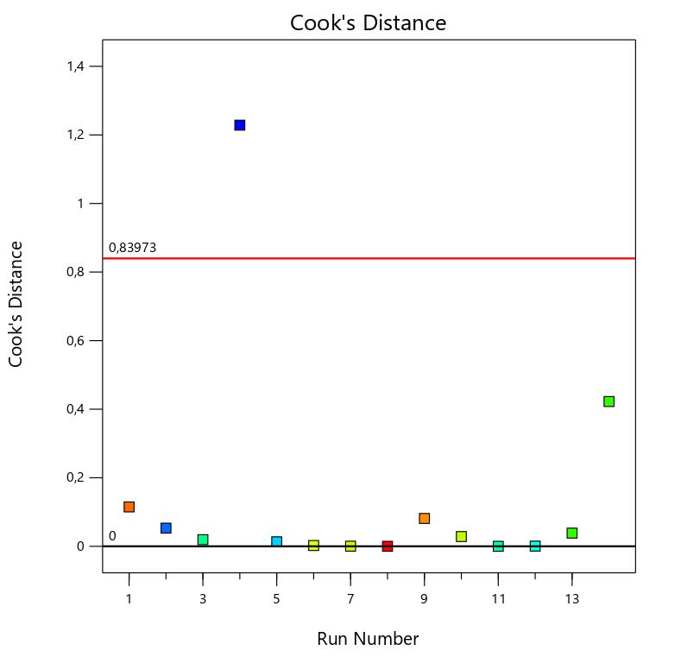 | Figure 47. - Cook’s distance ignoring Run #4. For 600 RPM  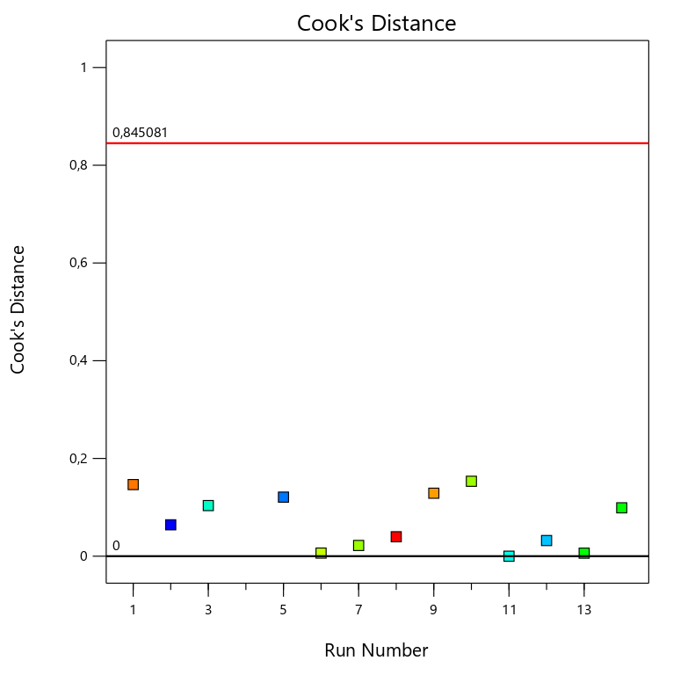
Figure 45. It is the sum of differences in predictions at every point caused by leaving a point out for fitting the model. Run #4 is the only point out of the limits. | Figure 46. Shows a better distribution after ignoring run #4.

Response 2, 6 RPM
Figure 48. - Cook’s distance considering all the points for 6 RPM  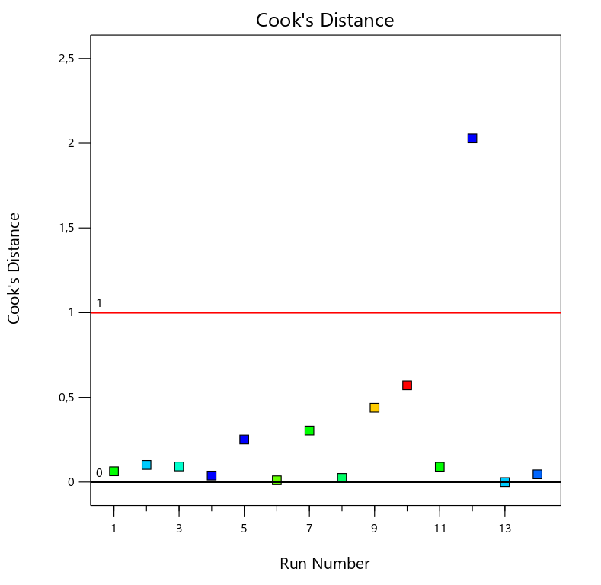 | Figure 49. - Cook’s distance ignoring Run #12. For 6 RPM  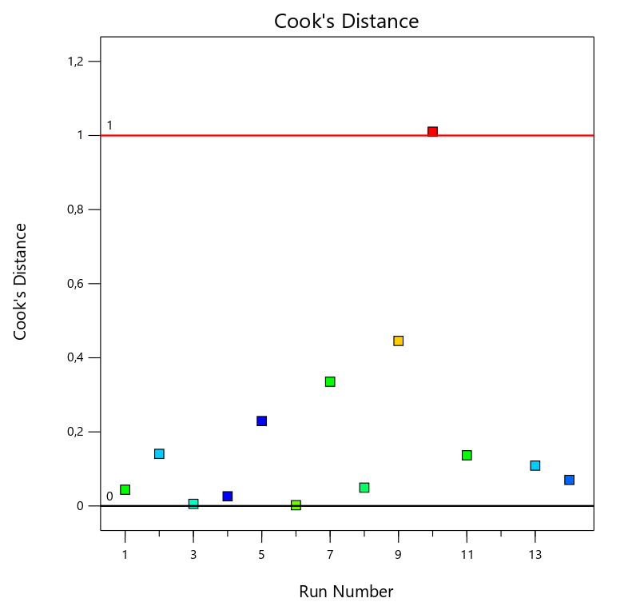
Figure 47. It is the sum of differences in predictions at every point caused by leaving a point out for fitting the model. Run #12 is the only point out of the limits. | Figure 48. Shows a better distribution after ignoring run #12.

Response 3, Electrical Stability
Figure 50. - Cook’s distance considering all the points for ES  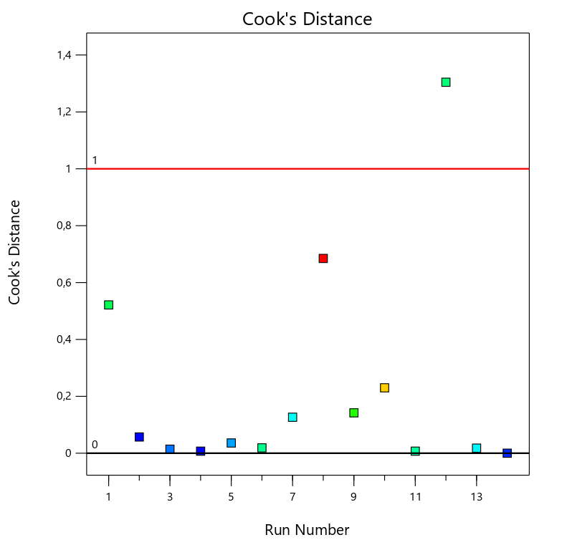 | Figure 51. - Cook’s distance ignoring Run #8. For ES  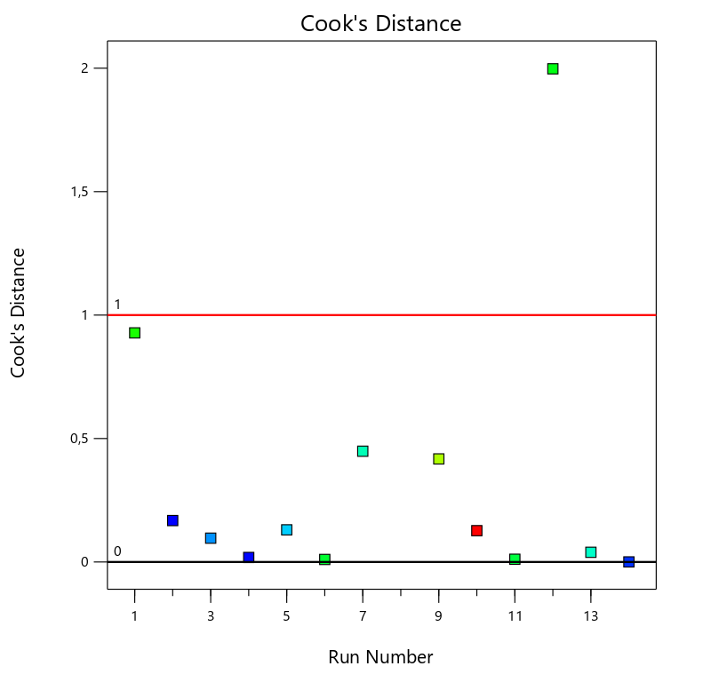

- Leverage
Response 1, 600 RPM
Figure 52. - Leverage considering all the points for 600 RPM  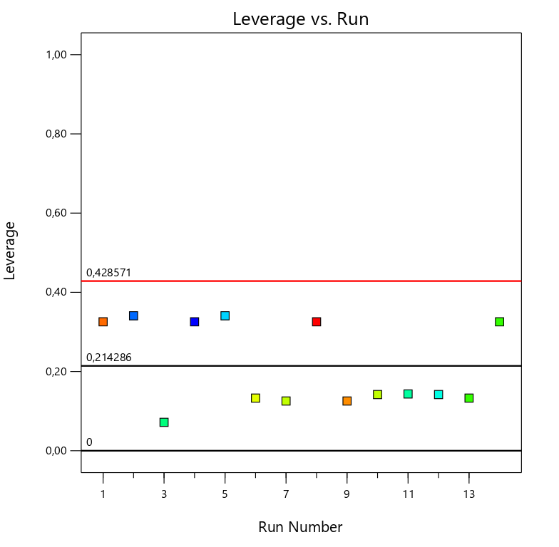 | Figure 53. - Leverage ignoring Run #4. For 600 RPM  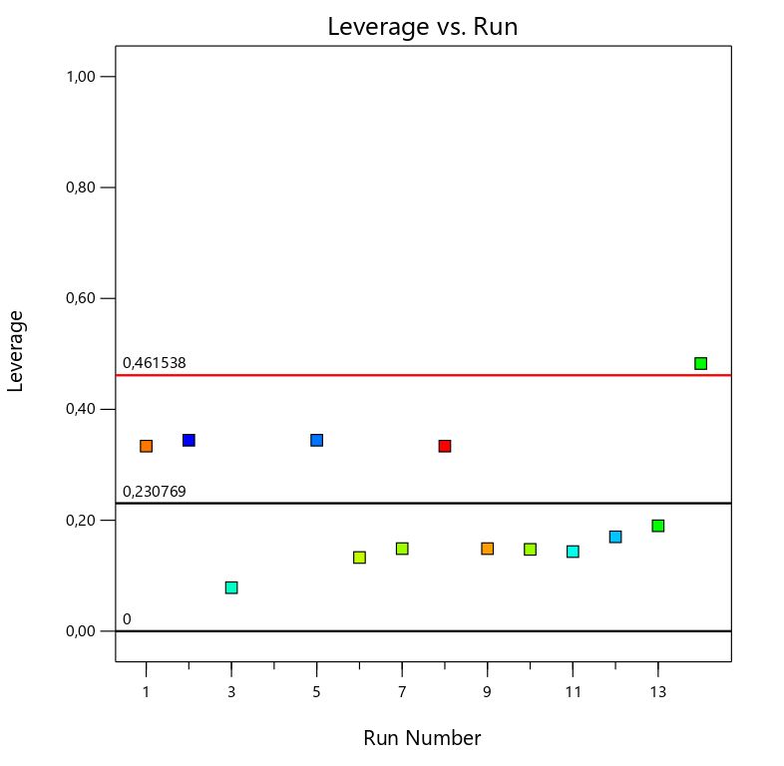
Figure 51. Is a plot that measures how much each point influence the model fit. The average level is the number of terms in the model divided by the number of runs in the design. | Figure 52.. Shows a better distribution after ignoring run #4.

Response 2, 6 RPM
Figure 54. - Leverage considering all the points for 6 RPM  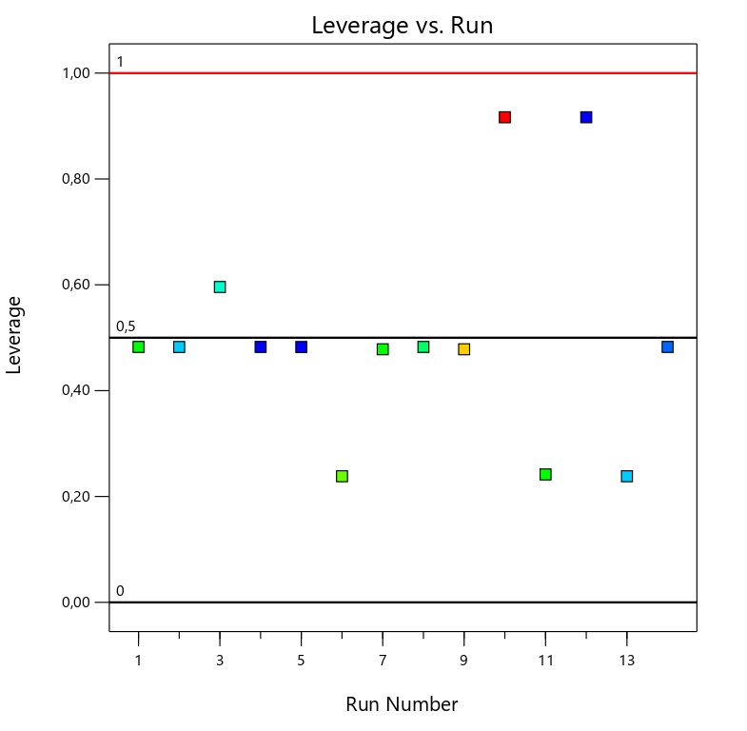 | Figure 55. - Leverage ignoring Run #12. For 6 RPM  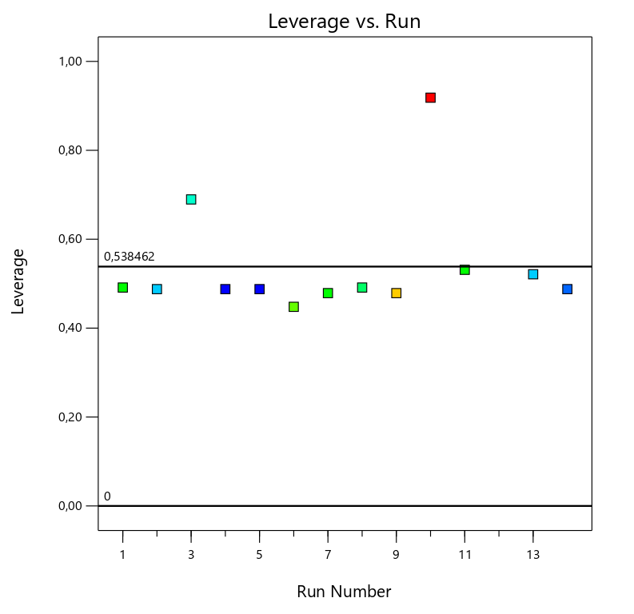
Figure 53. Shows a distribution disperse but within the limits. | Figure 54. Shows a better distribution after ignoring run #12.

Response 3, Electrical Stability
Figure 56. - Leverage considering all the points for ES  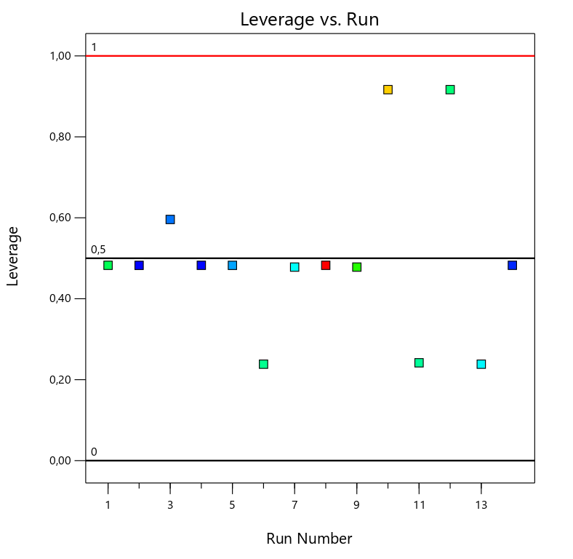 | Figure 57. - Leverage ignoring Run #8. For ES  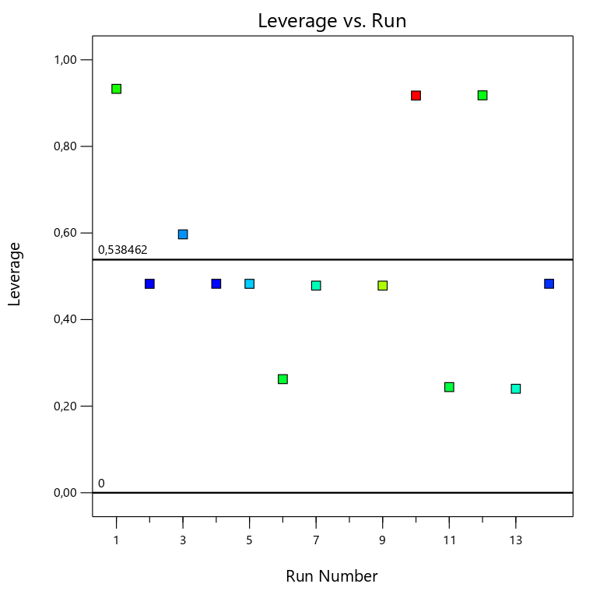

- DFFITS
Response 1, 600 RPM
Figure 58. - DFFITS considering all the points for 600 RPM  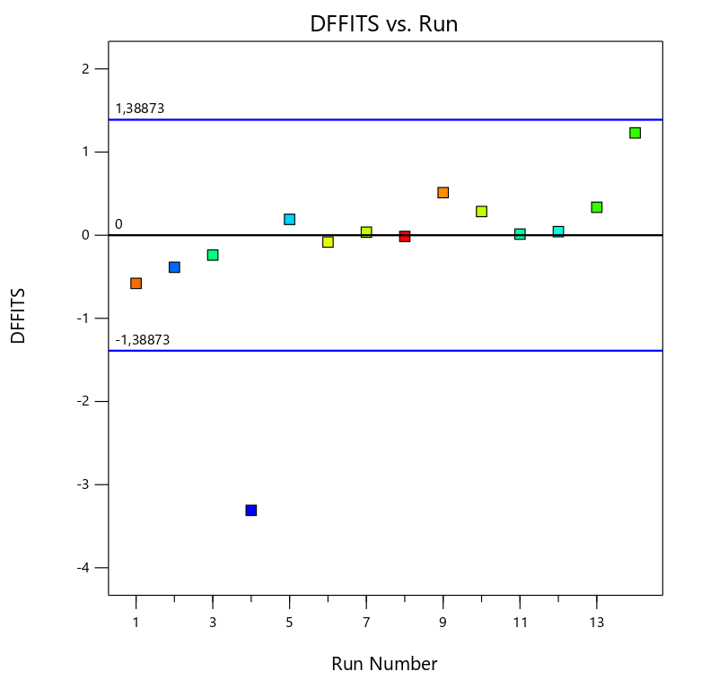 | Figure 59. - DFFITS ignoring Run #4. For 600 RPM  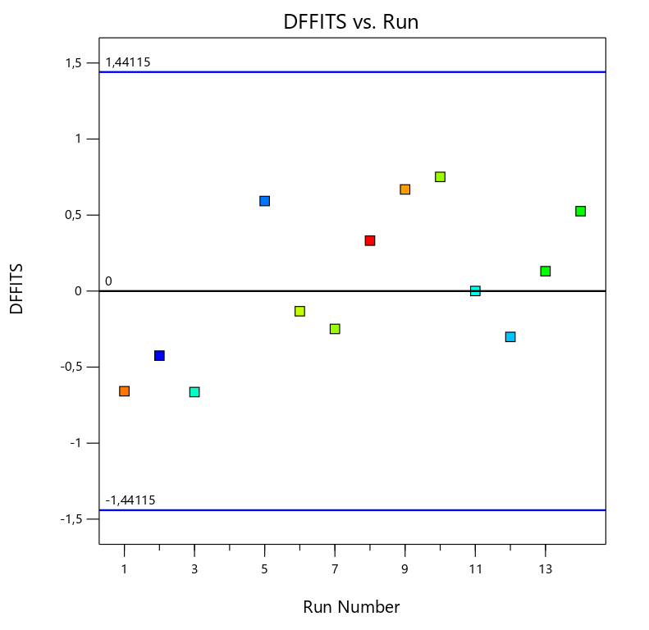
Figure 57. Shows that run #4 is not in between the limits. The limits on these plots vary depending on the data provided. | Figure 58. Shows a better distribution after ignoring run #4.

Response 2, 6 RPM
Figure 60. - DFFITS considering all the points for 6 RPM  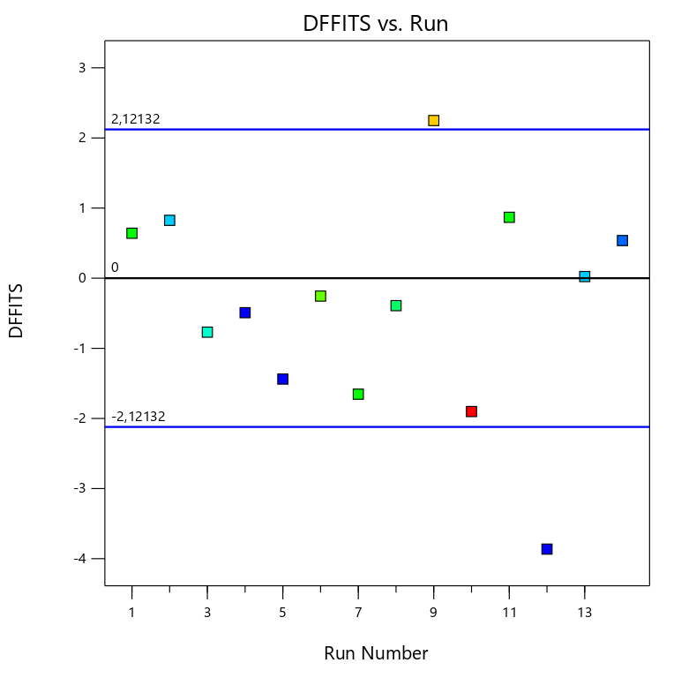 | Figure 61. - DFFITS ignoring Run #12. For 6 RPM  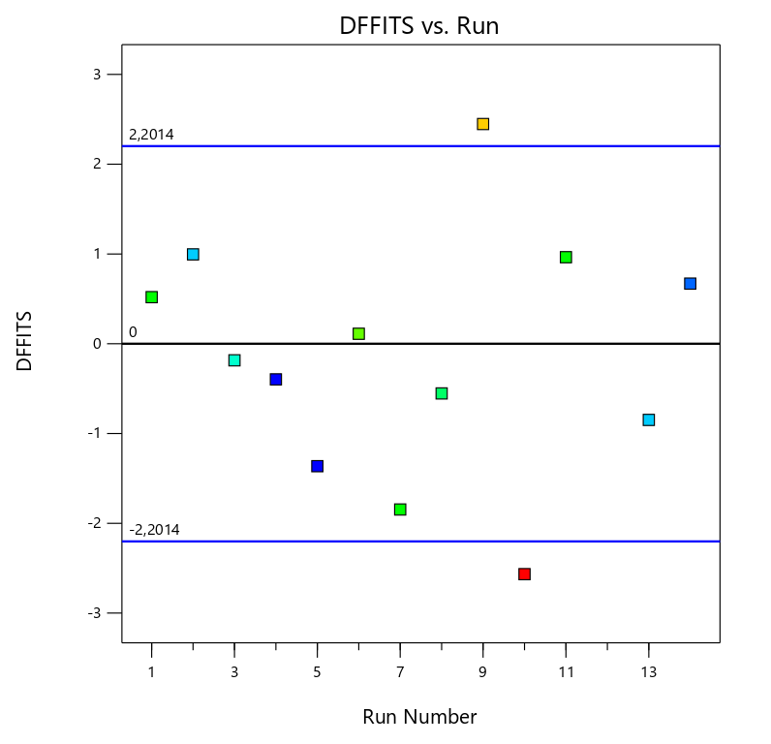
Figure 59. Shows that run #12 is not included for fitting the model. | Figure 60. Shows a better distribution after ignoring run #4.

Response 3, Electrical Stability
Figure 62. - DFFITS considering all the points for ES  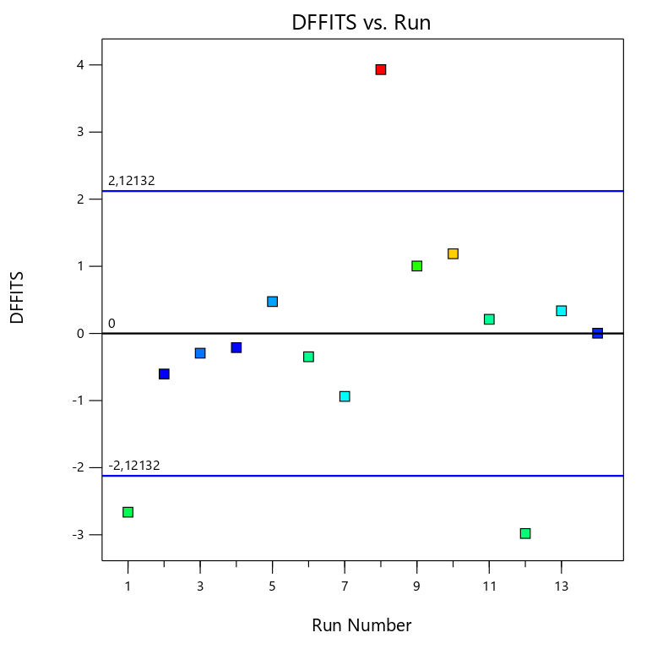 | Figure 63. - DFFITS ignoring Run #8. For ES  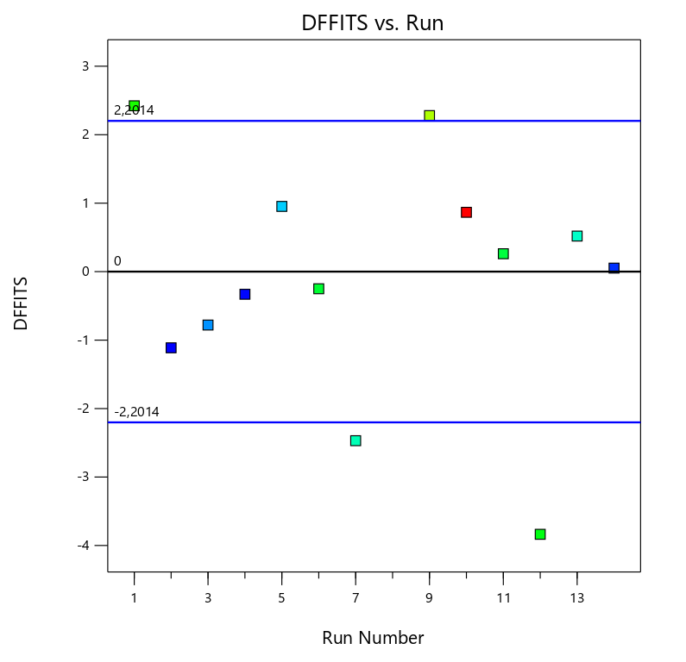

- DFBETAS
Response 1, 600 RPM
Figure 64. - DFBETAS for A: VG Supreme considering all the points for 600 RPM  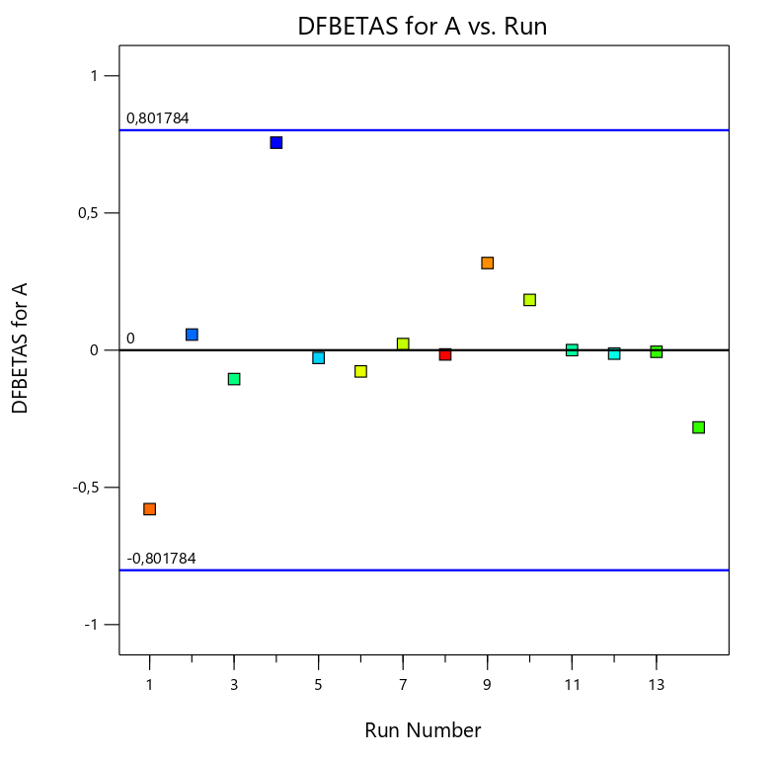 | Figure 65. - DFBETAS for A:VG Supreme ignoring Run #4. For 600 RPM  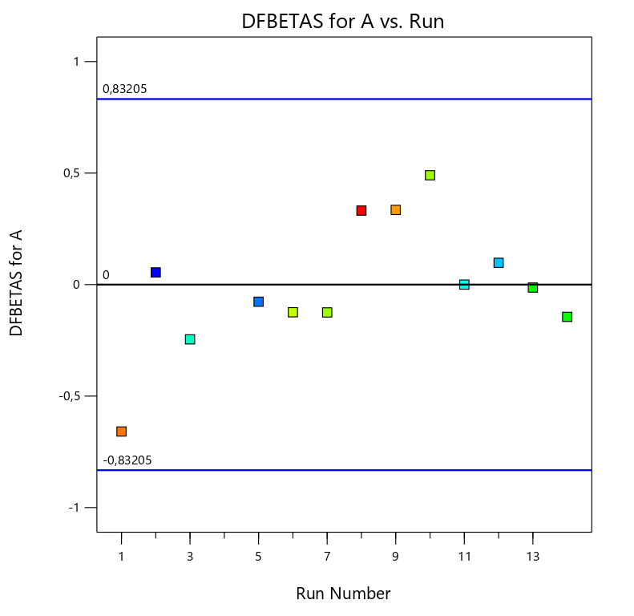
.

Figure 66. - DFBETAS for B: Versamod considering all the points for 600 RPM  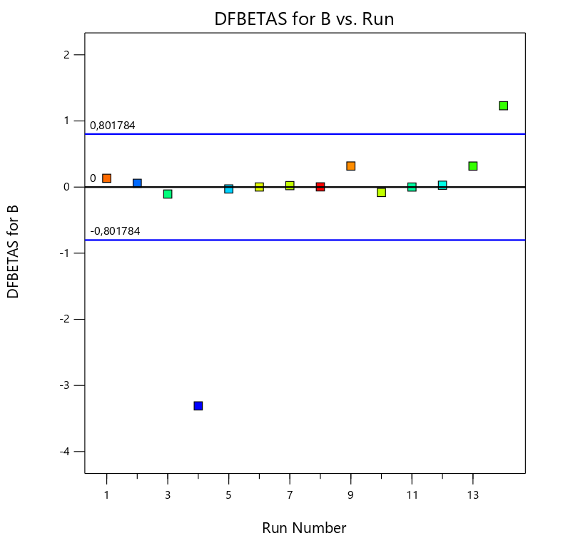 | Figure 67. - DFBETAS for B: Versamod ignoring Run #4. For 600 RPM  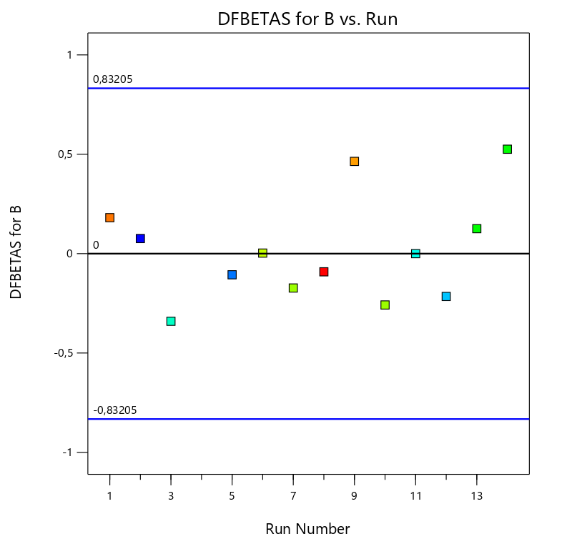
.

Figure 68. - DFBETAS for C: EMI-1945 considering all the points for 600 RPM  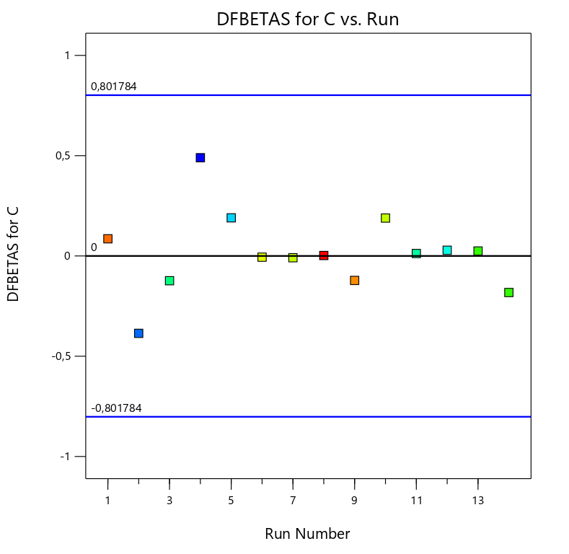 | Figure 69. - DFBETAS for C: EMI-1945 ignoring Run #4. For 600 RPM  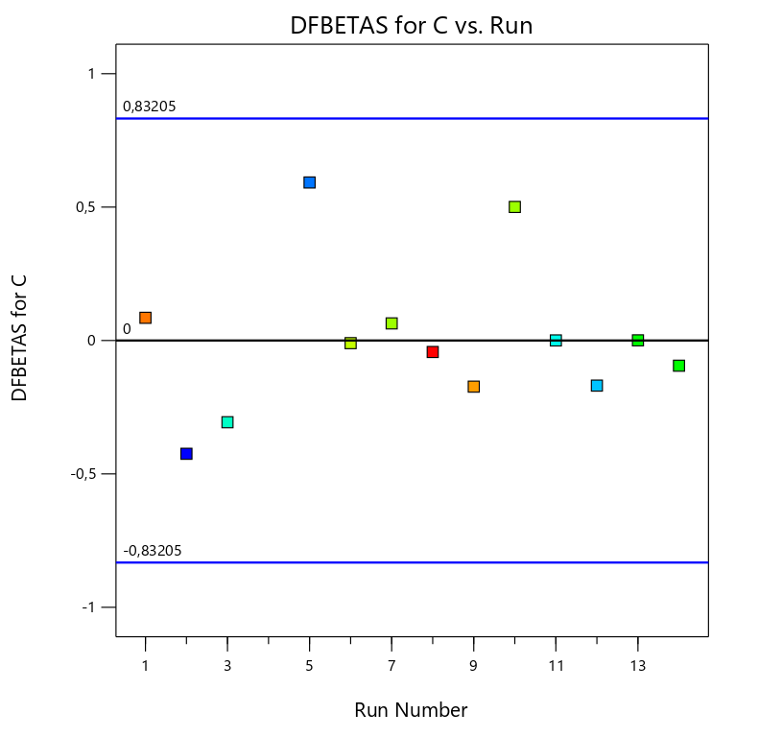
.

Response 2, 6 RPM
Figure 70. - DFBETAS for A: VG Supreme considering all the points for 6 RPM  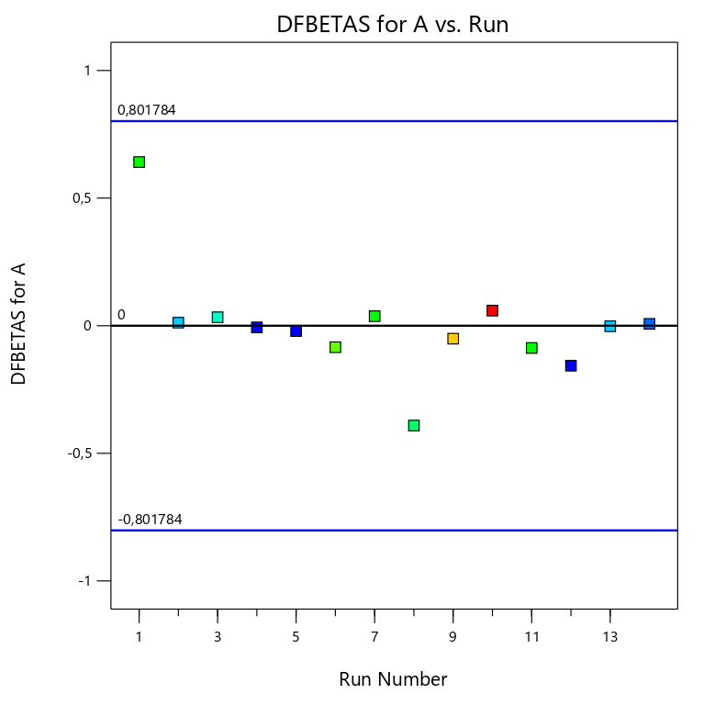 | Figure 71. - DFBETAS for A: VG Supreme ignoring Run #12. For 6 RPM  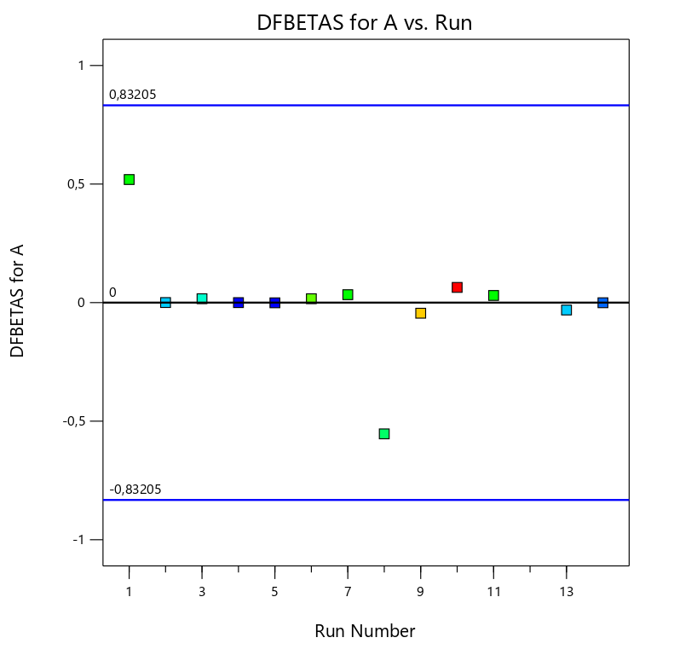
.

Figure 72. - DFBETAS for B:Versamod considering all the points for 6 RPM  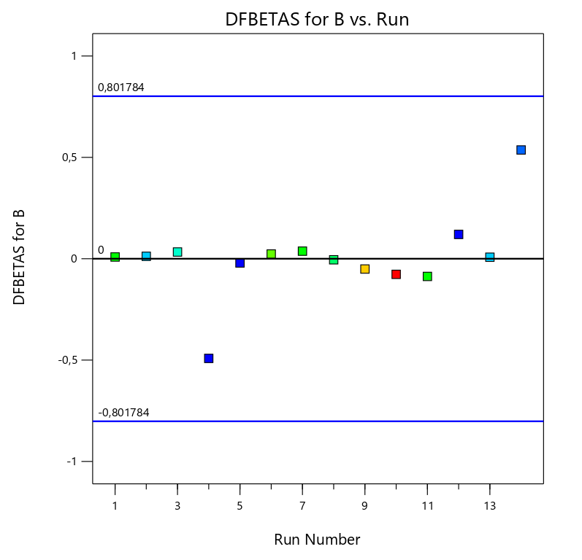 | Figure 73. - DFBETAS for B: Versamod ignoring Run #12. For 6 RPM  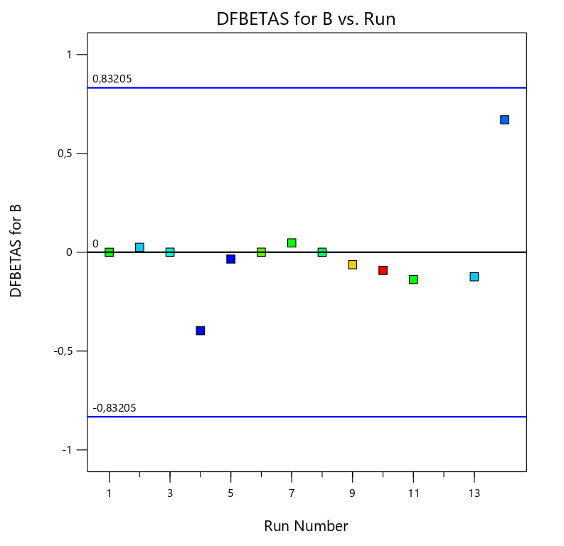
.

Figure 74. - DFBETAS for C: EMI-1945 considering all the points for 6 RPM  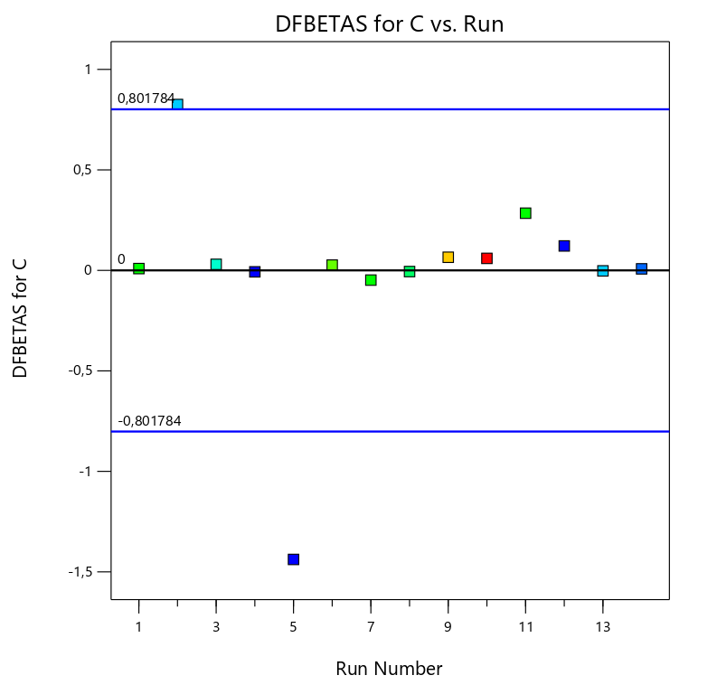 | Figure 75. - DFBETAS for C: EMI-1945 ignoring Run #12. For 6 RPM  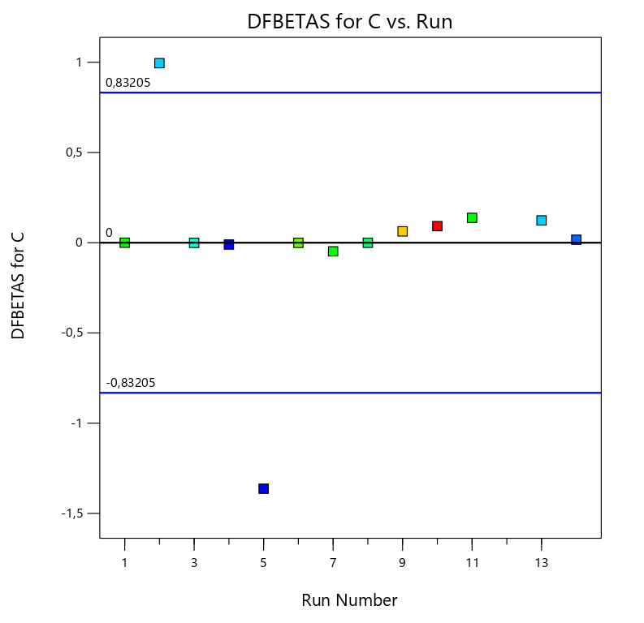
.

Response 3, Electrical Stability
Figure 76. - DFBETAS for A: VG Supreme considering all the points for ES  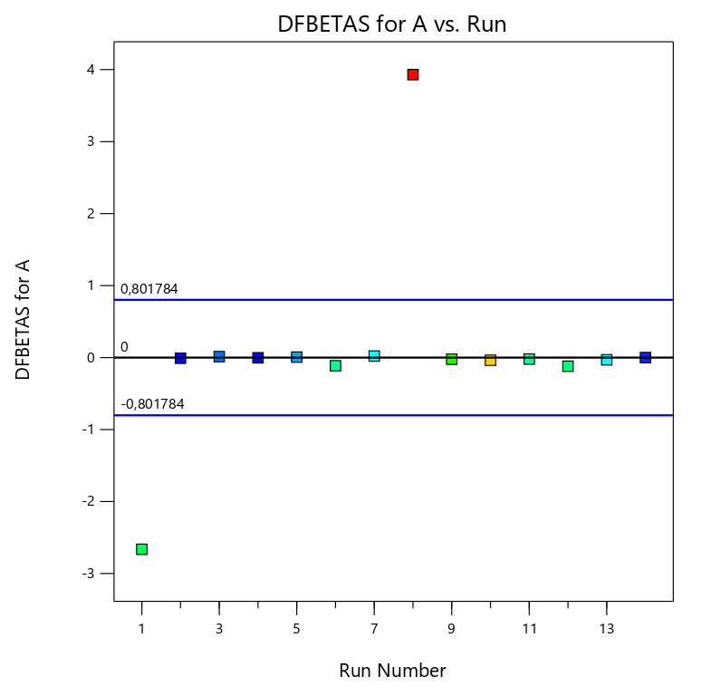 | Figure 77. - DFBETAS for A: VG Supreme ignoring Run #8. For ES  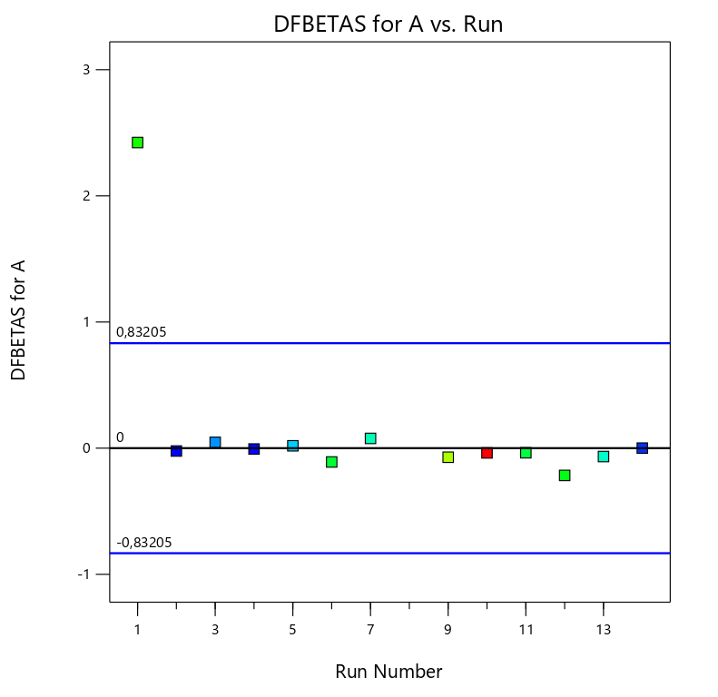
.

Figure 78. - DFBETAS for B: Versamod considering all the points for ES  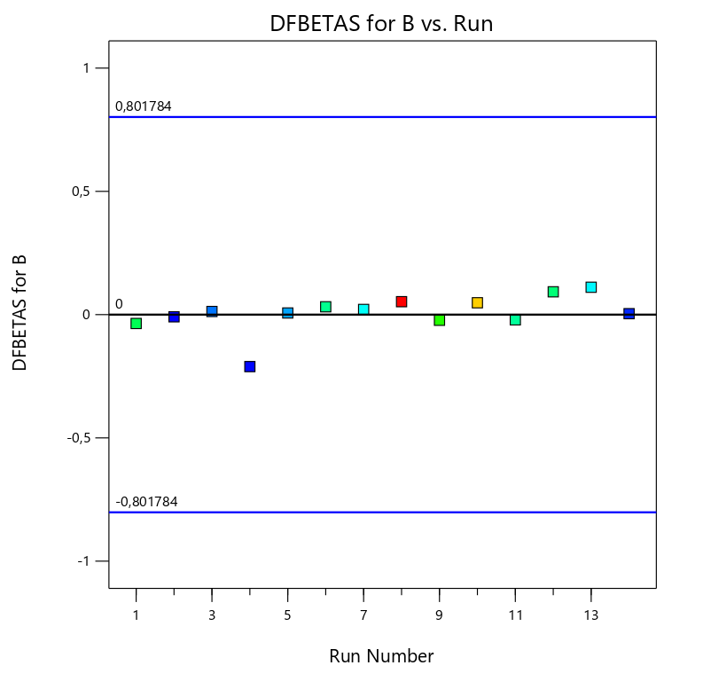 | Figure 79. - DFBETAS for B: Versamod ignoring Run #8. For ES  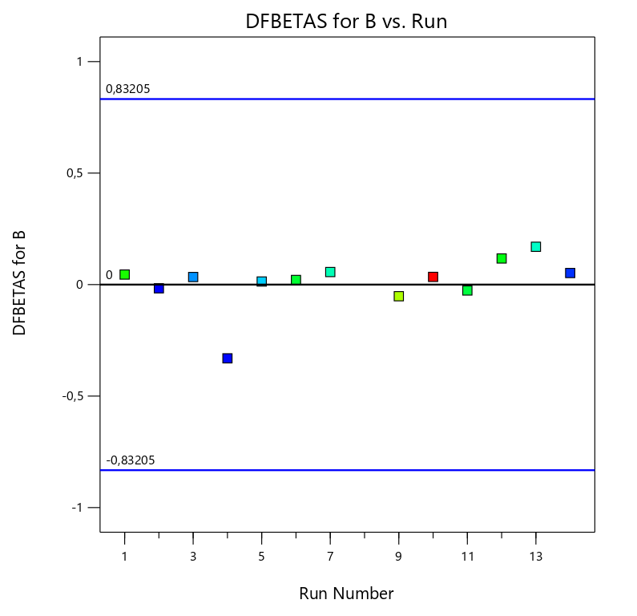
.

Figure 80. - DFBETAS for C: EMI-1945 considering all the points for ES  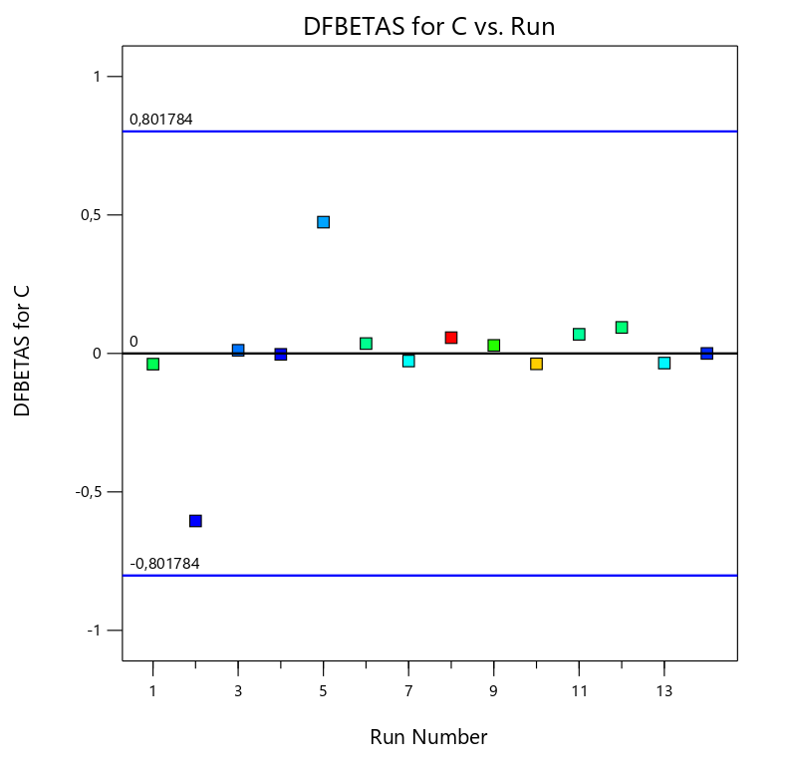 | Figure 81. - DFBETAS for C: EMI-1945 ignoring Run #8. For ES  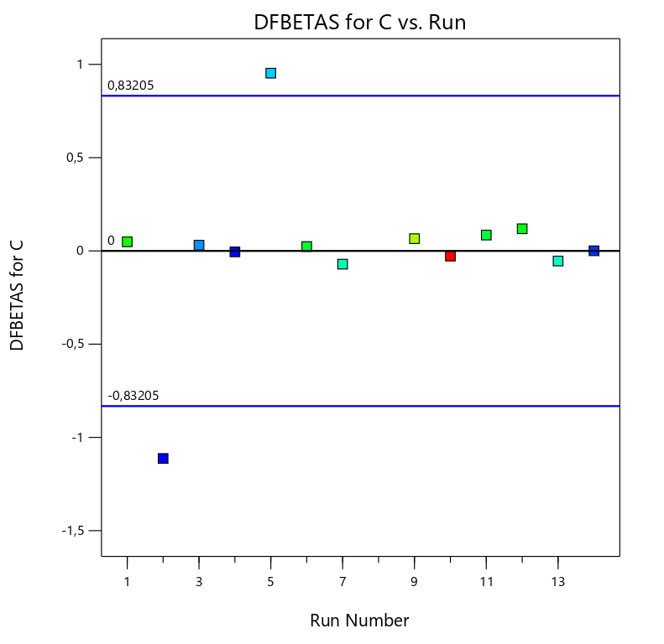
.

- Box – Cox Plot
Response 1, 600 RPM
Figure 82. - Box-Cox considering all the points for 600 RPM  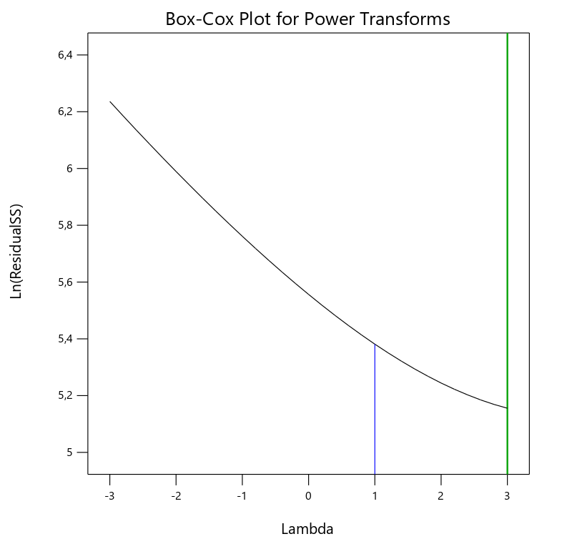 | Figure 83. - Box-Cox ignoring Run #4. For 600 RPM  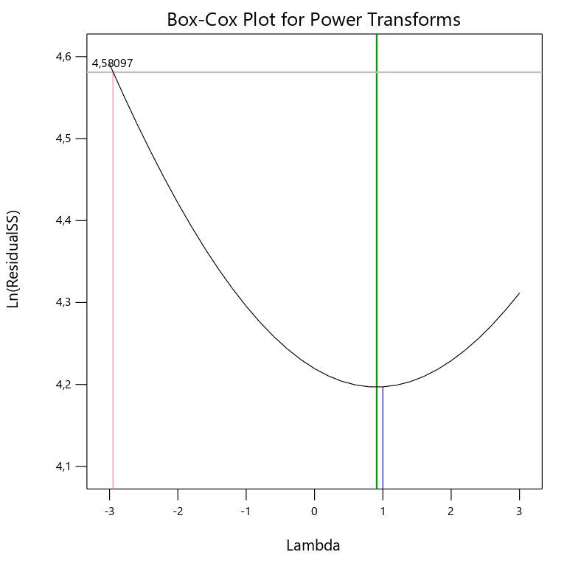
Figure 81. Shows that best lambda is 3, and there is not a recommended transform. | Figure 82. Shows that the best lambda is 0,91after ignoring run #4.

Response 2, 6 RPM
Figure 84. - Box-Cox considering all the points for 6 RPM  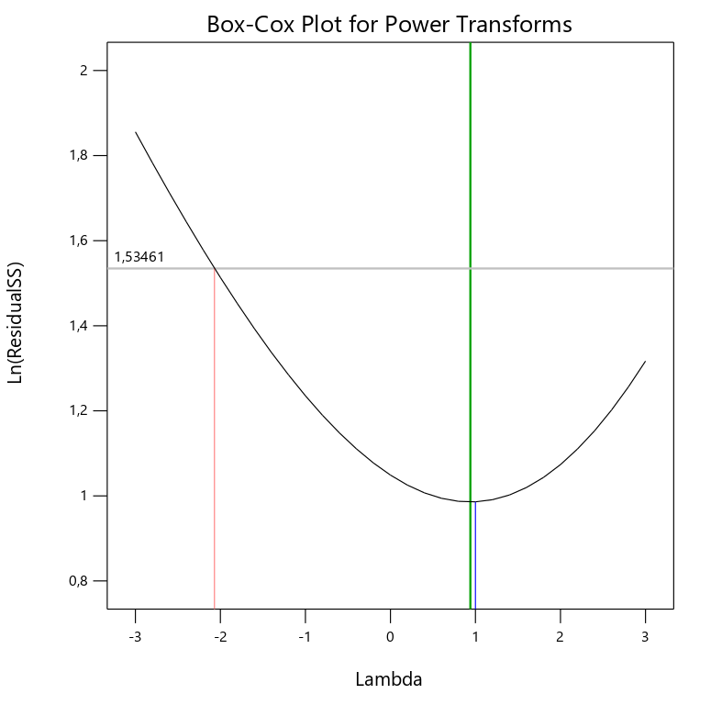 | Figure 85. - Box-Cox ignoring Run #12. For 6 RPM  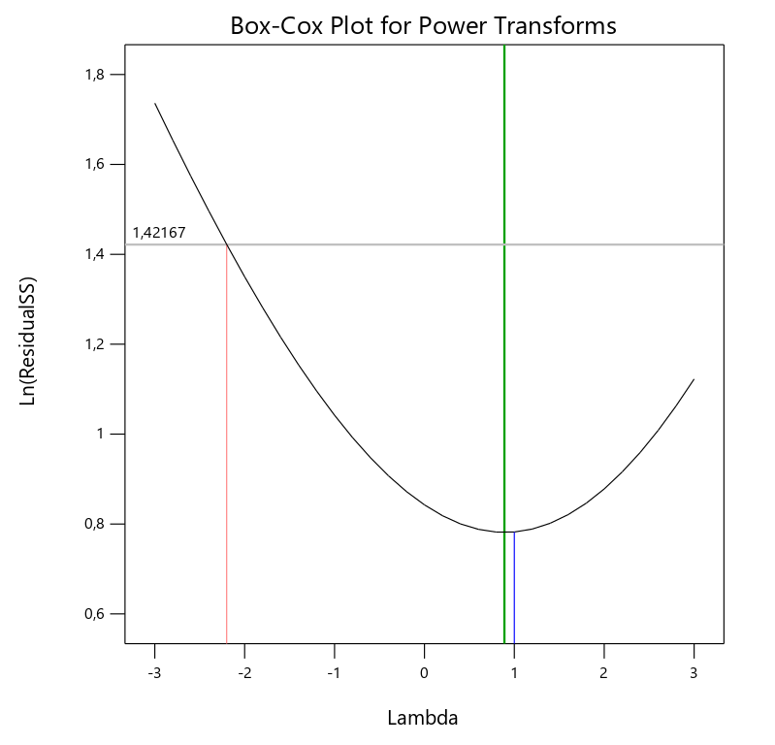
Figure 83. Shows that best lambda is 0,94, and there is not a recommended transform. | Figure 84. Shows that the best lambda is 0,89 after ignoring run #12.

Response 3, Electrical Stability
Figure 86. - Box-Cox considering all the points for ES  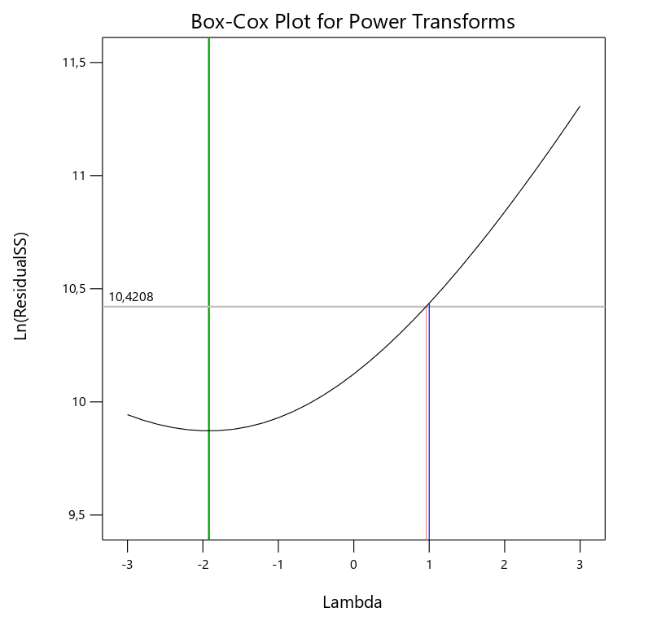 | Figure 87. - Box-Cox ignoring Run #8. For ES  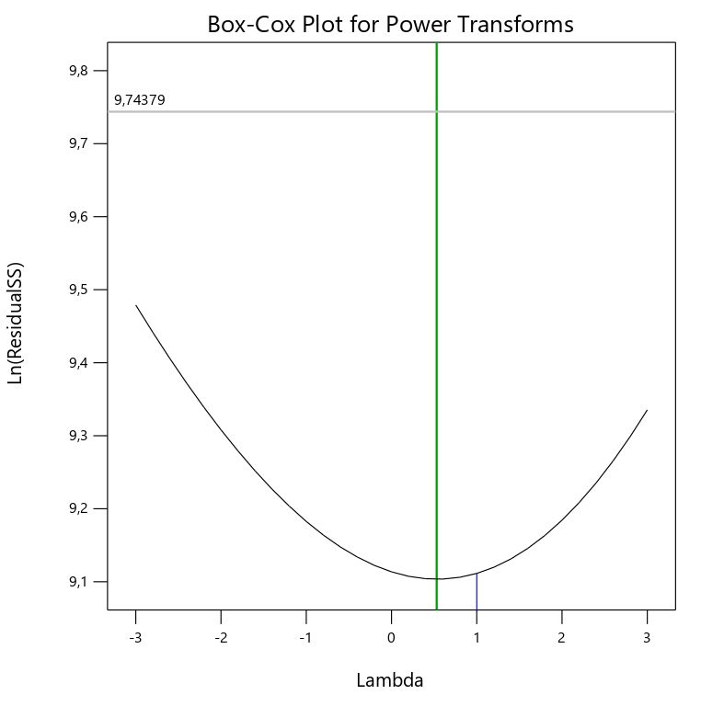
Figure 85. Shows that best lambda is -1,92, and there is not a recommended transform. | Figure 86. Shows that the best lambda is 0,53 after ignoring run #12.

- Diagnostic Report
Response 1, 600 RPM
Table 17. - Report for Response 1, 600 RPM.

Run Order | Actual Value | Predicted Value | Residual | Leverage | Internally Studentized Residuals | Externally Studentized Residuals | Cook’s Distance | Influence on Fitted Value DFFITS | Standard Order
1 | 78.00 | 81.09 | -3.09 | 0.326 | -0.845 | -0.833 | 0.115 | -0.579 | 11
2 | 55.00 | 57.00 | -2.00 | 0.341 | -0.555 | -0.537 | 0.053 | -0.386 | 3
3 | 63.00 | 66.72 | -3.72 | 0.072 | -0.870 | -0.859 | 0.019 | -0.239 | 10
4 | 52.00 | 62.09 | -10.09 | 0.326 | -2.763 | -4.762 | 1.228 | -3.309 | 12
5 | 58.00 | 57.00 | 0.9978 | 0.341 | 0.276 | 0.265 | 0.013 | 0.190 | 13
6 | 73.00 | 73.90 | -0.9047 | 0.133 | -0.219 | -0.209 | 0.002 | -0.082 | 7
7 | 72.00 | 71.59 | 0.4148 | 0.126 | 0.100 | 0.095 | 0.000 | 0.036 | 14
8 | 81.00 | 81.09 | -0.0852 | 0.326 | -0.023 | -0.022 | 0.000 | -0.015 | 1
9 | 77.00 | 71.59 | 5.41 | 0.126 | 1.303 | 1.351 | 0.081 | 0.512 | 4
10 | 72.00 | 69.04 | 2.96 | 0.142 | 0.718 | 0.701 | 0.028 | 0.285 | 5
11 | 62.00 | 61.86 | 0.1368 | 0.143 | 0.033 | 0.032 | 0.000 | 0.013 | 9
12 | 60.00 | 59.54 | 0.4563 | 0.142 | 0.111 | 0.106 | 0.001 | 0.043 | 6
13 | 68.00 | 64.40 | 3.60 | 0.133 | 0.869 | 0.858 | 0.039 | 0.336 | 8
14 | 68.00 | 62.09 | 5.91 | 0.326 | 1.620 | 1.771 | 0.423 | 1.230 | 2
Elaborated by: Design-Expert Software.
Edited by: Santiago Aguayo
As is possible to see on table 16, for Run #4, the value of Cook’s distance and the value of Influence on Fitted value DFFITS, exceeds limits
Response 2, 6 RPM
Table 18. - Report for Response 2, 6 RPM.

Run Order | Actual Value | Predicted Value | Residual | Leverage | Internally Studentized Residuals | Externally Studentized Residuals | Cook’s Distance | Influence on Fitted Value DFFITS | Standard Order
1 | 7.00 | 6.69 | 0.3080 | 0.483 | 0.692 | 0.664 | 0.064 | 0.641 | 11
2 | 5.50 | 5.11 | 0.3881 | 0.483 | 0.872 | 0.855 | 0.101 | 0.826 | 3
3 | 6.00 | 6.26 | -0.2606 | 0.596 | -0.662 | -0.633 | 0.092 | -0.769 | 10
4 | 4.50 | 4.74 | -0.2396 | 0.483 | -0.538 | -0.509 | 0.039 | -0.492 | 12
5 | 4.50 | 5.11 | -0.6119 | 0.483 | -1.374 | -1.489 | 0.252 | -1.438 | 13
6 | 7.50 | 7.76 | -0.2614 | 0.238 | -0.484 | -0.456 | 0.010 | -0.255 | 7
7 | 7.00 | 7.68 | -0.6815 | 0.478 | -1.525 | -1.727 | 0.304 | -1.654 | 14
8 | 6.50 | 6.69 | -0.1920 | 0.483 | -0.431 | -0.405 | 0.025 | -0.391 | 1
9 | 8.50 | 7.68 | 0.8185 | 0.478 | 1.831 | 2.348 | 0.439 | 2.249 | 4
10 | 9.50 | 9.61 | -0.1077 | 0.917 | -0.603 | -0.573 | 0.571 | -1.901 | 5
11 | 7.00 | 6.24 | 0.7582 | 0.242 | 1.407 | 1.538 | 0.090 | 0.869 | 9
12 | 4.50 | 4.70 | -0.2029 | 0.917 | -1.136 | -1.165 | 2.029 | -3.863 | 6
13 | 5.50 | 5.48 | 0.0243 | 0.238 | 0.045 | 0.042 | 0.000 | 0.023 | 8
14 | 5.00 | 4.74 | 0.2604 | 0.483 | 0.585 | 0.555 | 0.046 | 0.536 | 2
Elaborated by: Design-Expert Software.
Edited by: Santiago Aguayo

Response 3, Electrical Stability
Table 19. - Report for Response 3, ES.

Run Order | Actual Value | Predicted Value | Residual | Leverage | Internally Studentized Residuals | Externally Studentized Residuals | Cook’s Distance | Influence on Fitted Value DFFITS | Standard Order
1 | 535.00 | 634.25 | -99.25 | 0.483 | -1.978 | -2.758 | 0.521 | -2.664 | 11
2 | 382.00 | 414.90 | -32.90 | 0.483 | -0.655 | -0.626 | 0.057 | -0.605 | 3
3 | 424.00 | 435.56 | -11.56 | 0.596 | -0.261 | -0.242 | 0.014 | -0.294 | 10
4 | 384.00 | 395.78 | -11.78 | 0.483 | -0.235 | -0.218 | 0.007 | -0.211 | 12
5 | 441.00 | 414.90 | 26.10 | 0.483 | 0.520 | 0.491 | 0.036 | 0.474 | 13
6 | 514.00 | 553.62 | -39.62 | 0.238 | -0.651 | -0.622 | 0.019 | -0.348 | 7
7 | 476.00 | 525.53 | -49.53 | 0.478 | -0.983 | -0.980 | 0.127 | -0.939 | 14
8 | 748.00 | 634.25 | 113.75 | 0.483 | 2.267 | 4.070 | 0.685 | 3.931 | 1
9 | 578.00 | 525.53 | 52.47 | 0.478 | 1.041 | 1.049 | 0.142 | 1.004 | 4
10 | 674.00 | 666.30 | 7.70 | 0.917 | 0.382 | 0.358 | 0.230 | 1.187 | 5
11 | 510.00 | 485.78 | 24.22 | 0.242 | 0.399 | 0.373 | 0.007 | 0.211 | 9
12 | 523.00 | 541.35 | -18.35 | 0.917 | -0.911 | -0.898 | 1.304 | -2.980 | 6
13 | 471.00 | 432.48 | 38.52 | 0.238 | 0.633 | 0.603 | 0.018 | 0.337 | 8
14 | 396.00 | 395.78 | 0.2225 | 0.483 | 0.004 | 0.004 | 0.000 | 0.004 | 2
Elaborated by: Design-Expert Software.
Edited by: Santiago Aguayo

Analysis of results
- Response 1, 600 RPM
After performing the first experiment, Run #4, appears to deviate from the other data points, the information acquired from the laboratory for this point was checked and after reviewing there is not a possible or at least visible mistake. For that reason, a second experiment will be required in order to repeat Run #4, and check the results.
- Response 2, 6 RPM
During the analysis of this response, it was necessary to ignore Run #12, by ignoring that input, the difference between the R-squared adjusted and predicted decreased as the standard deviation.
It will be necessary to run a second experiment, adding more points to ensure that the curves of the 3D surface plot are correct.
- Response 3, Electrical Stability
After performing the first experiment, and being through the analysis of this response, it is possible to conclude that run #8 was critical and that is why it was ignored, so the plots can have a better trend distribution of the data. It will be necessary to repeat run #8 in a second experiment.
It is necessary to point that because of the high value of the standard deviation, and the difference between the predicted and adjusted R-squared, which is higher than 0,2 this may indicate a large block effect or a possible problem with the data, better known like overfitting.

Final Model

Model graphs
- Contour Plot
- Response 1, 600 RPM
Figure 88. - Contour Plot for 600 RPM
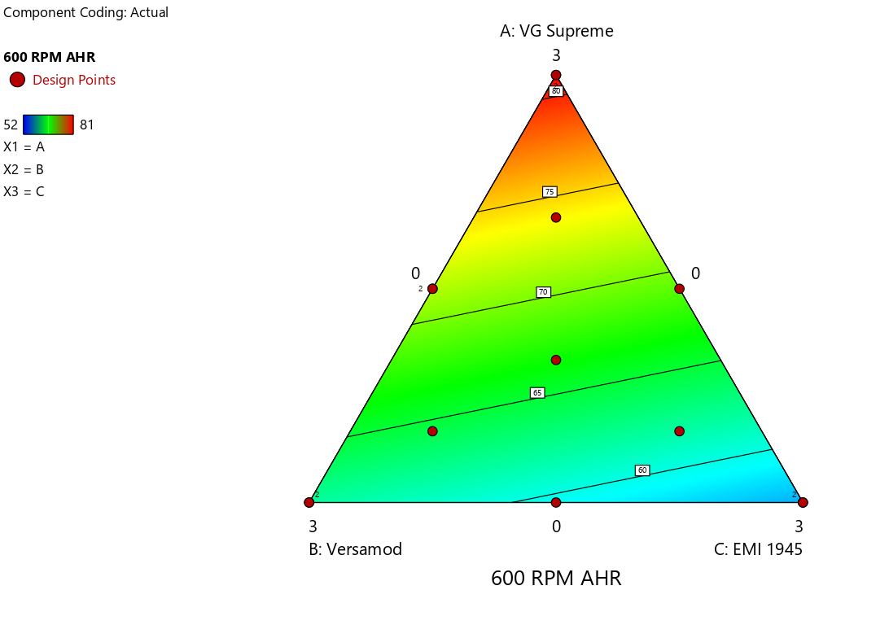

- Response 2, 6 RPM
Figure 89. - Contour Plot for 6 RPM

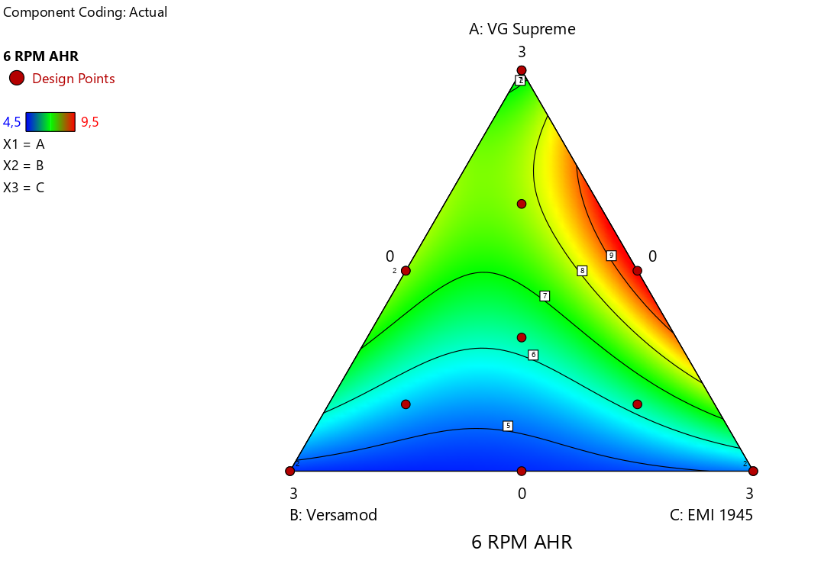

- Response 3, Electrical Stability
Figure 90. - Contour Plot for ES

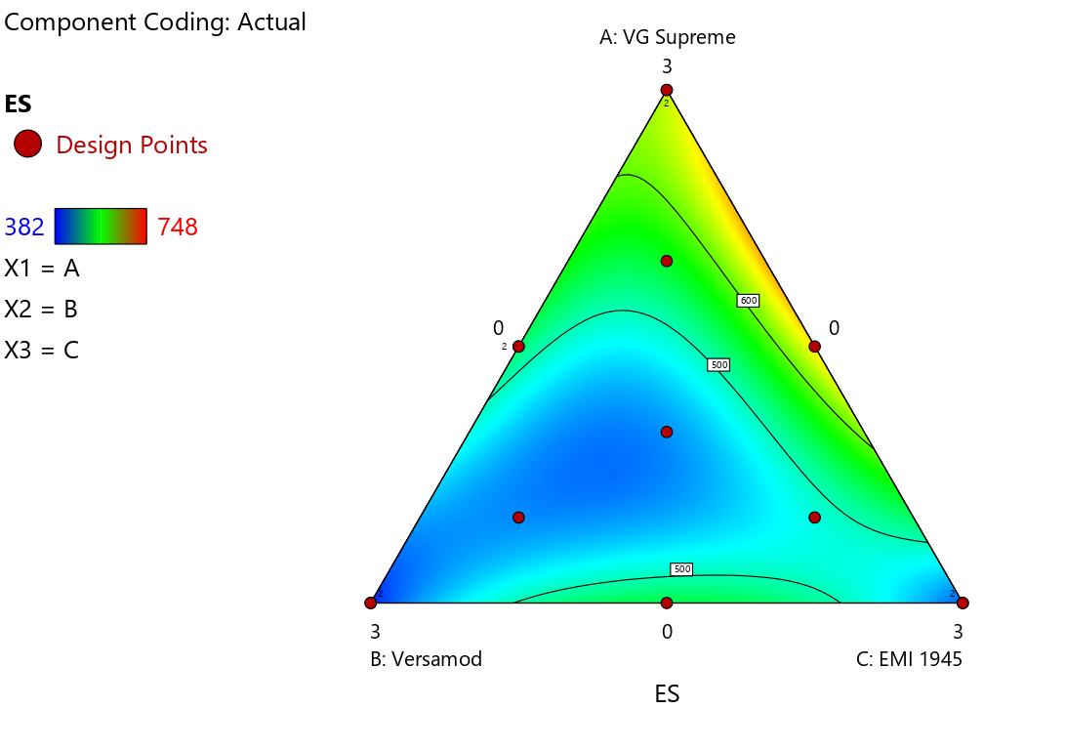

- 3D Surface
- Response 1, 600 RPM
Figure 91. - 3D Surface Plot for 600 RPM
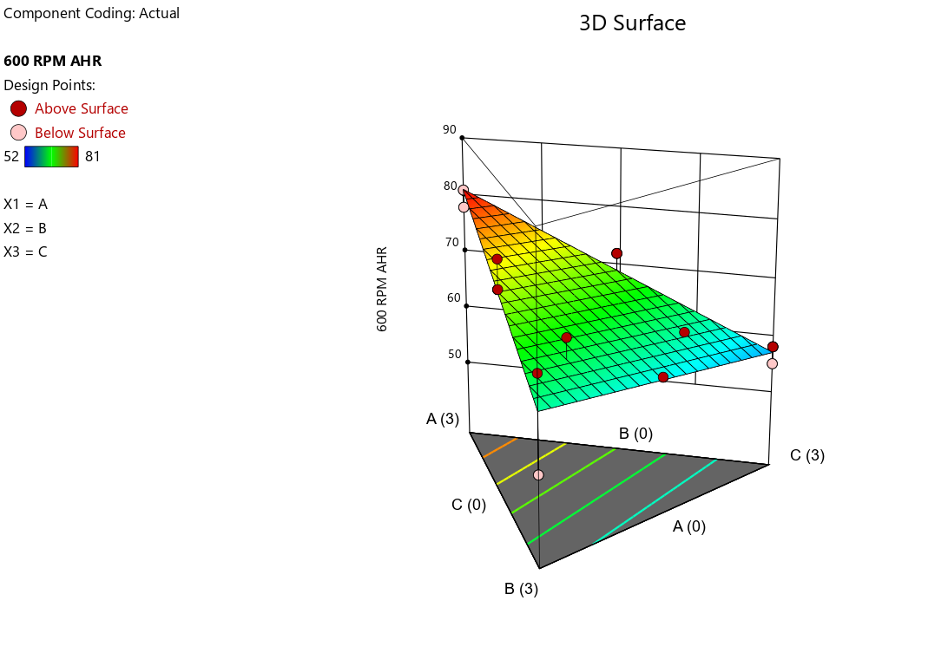

- Response 2, 6 RPM
Figure 92. - 3D Surface Plot for 6 RPM

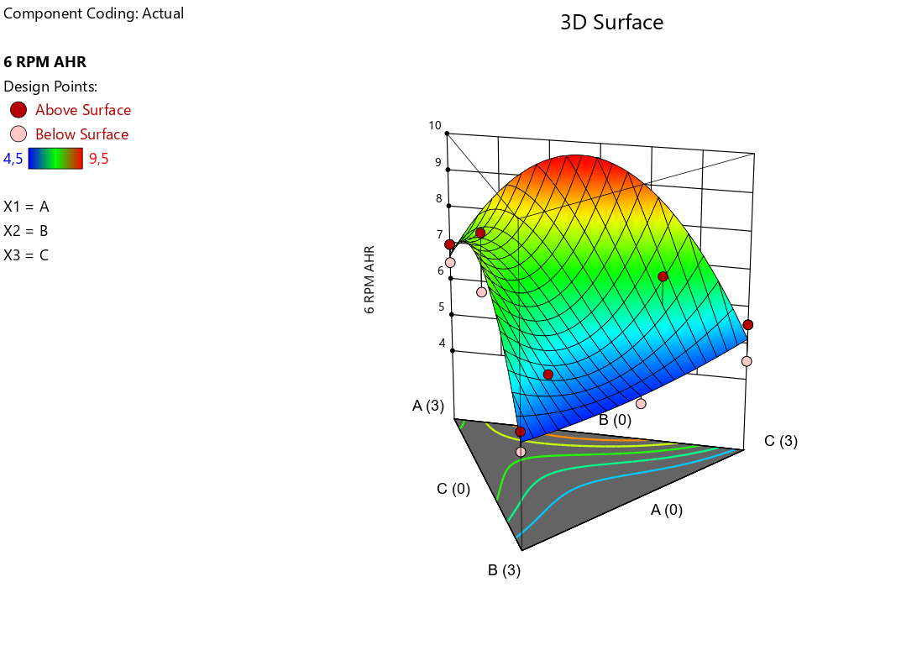

- Response 3, Electrical Stability
Figure 93. - 3D Surface Plot for 6 RPM
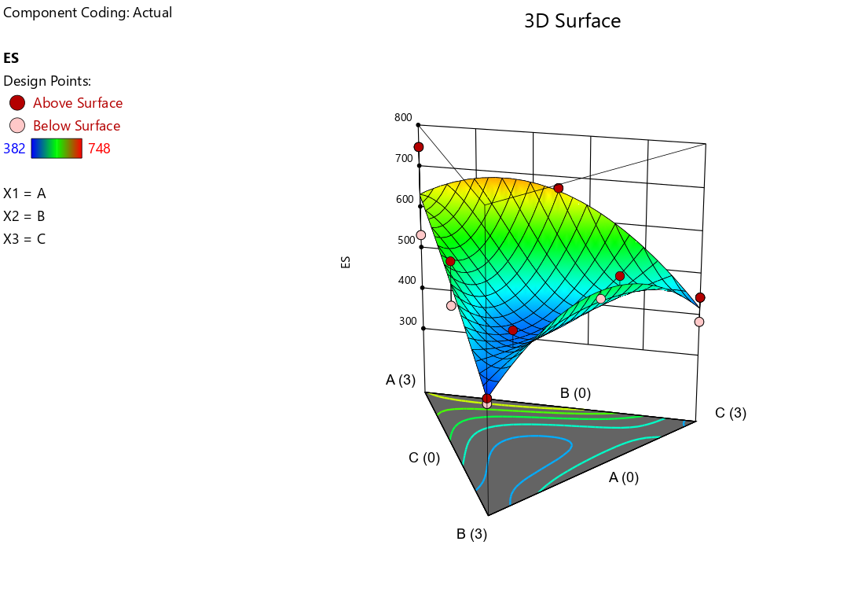

Final Model Equation
- Response 1, 600 RPM
For this first analysis the model obtained is the Linear Mixture model. The general equation of the model is the following:
$$\hat{y}=\sum_{i=1}^{q}{β_{i}x_{i}}$$ | (Equation 14)

The final equation for 600 RPM is the following:

$$600 RPM=79,97A+66,95B+56,26C$$ | (Equation 15)

Where:
- A= VG Supreme (Viscocifier)
- B= Versamod (Modifier 1)
- C= EMI-1945 (Modifier 2)

- Response 2, 6 RPM
The final model for this analysis is the Special Cubic Model. The general equation for this model is the following
$$\hat{y}=\sum_{i=1}^{q}{β_{i}x_{i}}+\sum_{i<j}^{q-1}{\sum_{j}^{q}{β_{ij}x_{i}x_{j}}}+\sum_{i<j}^{q-2}{\sum_{j<k}^{q-1}{\sum_{k}^{q}{β_{ijk}x_{i}x_{j}x_{k}}}}$$ | (Equation 16)

The final model equation for the 6 RPM analysis is the following:
$$6 RPM=6,76A+4,69B+5,06C+7,89AB+14,91AC+8,24BC-78,48ABC$$ | (Equation 17)

Where:
- A= VG Supreme (Viscocifier)
- B= Versamod (Modifier 1)
- C= EMI-1945 (Modifier 2)

- Response 3, Electrical Stability
The analysis of the electrical stability shows that the data fits better the Linear Mixture Model, which follows the following general equation:
$$\hat{y}=\sum_{i=1}^{q}{β_{i}x_{i}}$$ | (Equation 18)

The final equation for the electrical stability is the following:
$$Electrical Stability=644,53A+400,48B+458,04C$$ | (Equation 19)

Where:
- A= VG Supreme (Viscocifier)
- B= Versamod (Modifier 1)
- C= EMI-1945 (Modifier 2)

Rheological Profile Plot

Figure 94. - Rheological profile Plot for the first design.

CHAPTER 4: RESULTS AND DISCUSSION

Experiment and Designs
Two main experiments were done during the development of this project. For each experiment, different designs were studied; all the designs of both experiments are connected and related between them.

First Experiment: Components Mixture Designs.
For this experiment the components were 1 Viscosifier and 2 Modifiers, and the responses studied were the Shear Stress at different RPM and the Electrical Stability, at a constant temperature. Depending on the results each design was done in order to study more attributes and obtain a better model.
Figure 95. - Contour Plots of the Designs 1 -5.

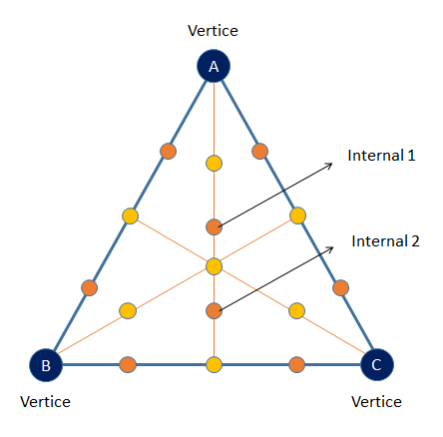
Figure 94. Plot in the left represents the contour plot of the designs. The orange points represents the 8 runs added in the second design, and studied through the coming designs.

First Design

Table 20. - Components and Attributes for the first design.

Mixture Components | Viscosifier 1 – VG Supreme
 | Modifier 1 – Versamod
 | Modifier 2 – EMI-1945
Attributes / Responses | Shear Stress at 600 RPM
 | Shear Stress at 6 RPM
 | Electrical Stability
Elaborated by: Santiago Aguayo

Table 21. - First Design Runs formulation.

Run | Component 1  A: Viscosifier 1  VG Supreme | Component 2  B: Modifier 1  Versamod | Component 3  C: Modifier 2  EMI-1945
1 | 3 | 0 | 0
2 | 0 | 0 | 3
3 | 1 | 1 | 1
4 | 0 | 3 | 0
5 | 0 | 0 | 3
6 | 2 | 0.5 | 0.5
7 | 1.5 | 1.5 | 0
8 | 3 | 0 | 0
9 | 1.5 | 1.5 | 0
10 | 1.5 | 0 | 1.5
11 | 0.5 | 0.5 | 2
12 | 0 | 1.5 | 1.5
13 | 0.5 | 2 | 0.5
14 | 0 | 3 | 0
Elaborated by: Design-Expert
Modified by: Santiago Aguayo

- The amount of component mixture is held static at 3 grams. Ratios of components are varied.
- The different component mixtures are added to a base formulation.
- 14 experimental runs generated by Design Expert. All the points are distributed across the contour plot of the Mixture Design. See figure 94 (Plot in the left).
- The Rheology and electrical stability data was taken at 50°C.

Second Design
Table 22. - Components and Attributes for the Second design.

Mixture Components | Viscosifier 1 – VG Supreme
 | Modifier 1 – Versamod
 | Modifier 2 – EMI-1945
Attributes / Responses | Shear Stress at 600 RPM
 | Shear Stress at 300 RPM
 | Shear Stress at 200 RPM
 | Shear Stress at 100 RPM
 | Shear Stress at 6 RPM
 | Shear Stress at 3 RPM
 | Electrical Stability
Elaborated by: Santiago Aguayo

Table 23. - Second Design runs formulation

Run | Component 1  A: Viscosifier 1  VG Supreme | Component 2  B: Modifier 1  Versamod | Component 3  C: Modifier 2  EMI-1945
1 | 3 | 0 | 0
2 | 0 | 0 | 3
3 | 1 | 1 | 1
4 | 0 | 3 | 0
5 | 0 | 0 | 3
6 | 2 | 0.5 | 0.5
7 | 1.5 | 1.5 | 0
8 | 3 | 0 | 0
9 | 1.5 | 1.5 | 0
10 | 1.5 | 0 | 1.5
11 | 0.5 | 0.5 | 2
12 | 0 | 1.5 | 1.5
13 | 0.5 | 2 | 0.5
14 | 0 | 3 | 0
15 | 2.15 | 0.85 | 0
16 | 0.7 | 2.3 | 0
17 | 0 | 2.3 | 0.7
18 | 0 | 0.8 | 2.2
19 | 0.8 | 0 | 2.2
20 | 2.15 | 0 | 0.85
21 | 1.4 | 0.8 | 0.8
22 | 0.5 | 1.25 | 1.25
Elaborated by: Design-Expert
Modified by: Santiago Aguayo

- The different component mixtures are added to a base formulation.
- Repeat three runs from the First Design (Run #4, Run #8, and Run #12).
- 8 new runs added. This runs where added in order to cover the most of the area of the Triangle (Contour Plot) of the Mixture Design Model as figure 94 Plot in the right) shows.
- Rheology and electrical stability readings were taken at 50°C.

Second Experiment: Combined Design (Mixture and Level).

Third Design
Table 24. - Components and Attributes for the third design.

Mixture Components | Viscosifier 1 – VG Supreme
 | Modifier 1 – Versamod
 | Modifier 2 – EMI-1945
 | Contaminant - HPC (Hymod Prima Clay)
Attributes / Responses | Shear Stress at 600 RPM
 | Shear Stress at 300 RPM
 | Shear Stress at 200 RPM
 | Shear Stress at 100 RPM
 | Shear Stress at 6 RPM
 | Shear Stress at 3 RPM
 | Electrical Stability
Elaborated by: Santiago Aguayo

Table 25. - Third design runs formulation

Run | Component 1  A: Viscosifier 1  VG Supreme | Component 2  B: Modifier 1  Versamod | Component 3  C: Modifier 2  EMI-1945 | Component 4  D: Contaminant  Clay (HPC)
1 | 3 | 0 | 0 | 0
2 | 0 | 3 | 0 | 0
3 | 0 | 0 | 3 | 0
4 | 3 | 0 | 0 | 0
5 | 0 | 3 | 0 | 0
6 | 3 | 0 | 0 | 10
7 | 0 | 3 | 0 | 10
8 | 0 | 0 | 3 | 10
9 | 3 | 0 | 0 | 35
10 | 0 | 3 | 0 | 35
11 | 0 | 0 | 3 | 35
Elaborated by: Design-Expert
Modified by: Santiago Aguayo

- Combined design, mixture and Level. A new component is added which is a contaminant.
- Two levels of contamination: low (10 grams) and High (35 grams).
- The point selected for the study are the vertices of the Contour plot from the second design. See figure 94.
- Rheology and electrical stability readings were taken at 50°C and at 80°C.

Fourth Design
Table 26. - Components and Attributes for the fourth design.

Mixture Components | Viscosifier 1 – VG Supreme
 | Modifier 1 – Versamod
 | Modifier 2 – EMI-1945
 | Contaminant - HPC (Hymod Prima Clay)
Attributes / Responses | Shear Stress at 600 RPM
 | Shear Stress at 300 RPM
 | Shear Stress at 200 RPM
 | Shear Stress at 100 RPM
 | Shear Stress at 6 RPM
 | Shear Stress at 3 RPM
 | Electrical Stability
Elaborated by: Santiago Aguayo

Table 27. - Fourth design runs formulation

Run | Component 1  A: Viscosifier 1  VG Supreme | Component 2  B: Modifier 1  Versamod | Component 3  C: Modifier 2  EMI-1945 | Component 4  D: Contaminant  Clay (HPC)
1 | 3 | 0 | 0 | 0
2 | 0 | 3 | 0 | 0
3 | 0 | 0 | 3 | 0
4 | 3 | 0 | 0 | 0
5 | 0 | 3 | 0 | 0
6 | 0 | 0 | 3 | 0
7 | 1.4 | 0.8 | 0.8 | 0
8 | 0.5 | 1.25 | 1.25 | 0
9 | 3 | 0 | 0 | 10
10 | 0 | 3 | 0 | 10
11 | 0 | 0 | 3 | 10
12 | 1.4 | 0.8 | 0.8 | 10
13 | 0.5 | 1.25 | 1.25 | 10
14 | 3 | 0 | 0 | 17.5
15 | 0 | 3 | 0 | 17.5
16 | 0 | 0 | 3 | 17.5
17 | 1.4 | 0.8 | 0.8 | 17.5
18 | 0.5 | 1.25 | 1.25 | 17.5
19 | 3 | 0 | 0 | 35
20 | 0 | 3 | 0 | 35
21 | 0 | 0 | 3 | 35
22 | 1.4 | 0.8 | 0.8 | 35
23 | 0.5 | 1.25 | 1.25 | 35
Elaborated by: Design-Expert
Modified by: Santiago Aguayo

- Same components and attributes from the third experiment.
- A new level of contamination, medium level: 17.5 grams.
- The points selected for the study are the vertices of the Contour Graph from the second design and two internal points. See figure 94.
- Vertices where studied at the medium level of contamination.
- The internal points where studied at the three levels of contamination.
- Rheology and electrical stability readings were taken at 50°C and 80°C.

Fifth Design
Table 28. - Components and Attributes for the fifth design.

Mixture Components | Viscosifier 1 – VG Supreme
 | Modifier 1 – Versamod
 | Modifier 2 – EMI-1945
 | Contaminant - HPC (Hymod Prima Clay)
Attributes / Responses | Shear Stress at 600 RPM
 | Shear Stress at 300 RPM
 | Shear Stress at 200 RPM
 | Shear Stress at 100 RPM
 | Shear Stress at 6 RPM
 | Shear Stress at 3 RPM
 | Electrical Stability
Elaborated by: Santiago Aguayo

- Same components and attributes from the fourth experiment.
- Repeat runs:
- 9 (Vertice A, Low contaminated)
- 14 (Vertice A, Medium contaminated)
- 19 (Vertice A, High contaminated)
- 20 (Vertice B, High contaminated). A duplicate of run 20 was tested.
- 21 (Vertice C, High contaminated)
- Rheology and electrical stability readings were taken at 50°C and 80°C

Data Analysis

First Design
Table 29. - First Design Responses.

Run | Response 1  600 RPM AHR | Response 2  6 RPM AHR | Response 3  Electrical Stability
1 | 78 | 7 | 535
2 | 55 | 5.5 | 382
3 | 63 | 6 | 424
4 | 52 | 4.5 | 384
5 | 58 | 4.5 | 441
6 | 73 | 7.5 | 514
7 | 72 | 7 | 476
8 | 81 | 6.5 | 748
9 | 77 | 8.5 | 578
10 | 72 | 9.5 | 674
11 | 62 | 7 | 510
12 | 60 | 4.5 | 523
13 | 68 | 5.5 | 471
14 | 68 | 5 | 396
Elaborated by: Design-Expert
Modified by: Santiago Aguayo

Table 31, shows the value of each response value after the Hot-rolling aging test was applied. After interpreting the analysis of variance and the diagnostic plots, it was necessary to ignore run #4 for response 1, run #12 for response 2 and, run #8 for response 3; since in most of the plots, these runs were not following the trend, and were outside the limits. After ignoring them, the values of the R-squared are shown in table 32.

Table 30. - Fit statistics for the First Design.

 | Response 1  600 RPM | Response 2  6 RPM | Response 3  Electric Stability
$$R^{2}$$ | 0.9169 | 0.9197 | 0.8927
Adjusted $R^{2}$ | 0.9003 | 0.8394 | 0.7855
Predicted $R^{2}$ | 0.8767 | 0.5919 | 0.2256
Elaborated by: Design-Expert
Modified by: Santiago Aguayo

It is important to notice that the difference between the values of the adjusted and predicted R-squared must be less than 0,2. That means that the data of this design fits well the model.
This model can be used to navigate the design space.

Second Design
Table 31. - Second Design Responses.

Run | Response 1  600 RPM AHR | Response 2  300 RPM AHR | Response 3  200 RPM AHR | Response 4  100 RPM AHR | Response 5  6 RPM AHR | Response 6  3 RPM AHR | Response 7  Electrical Stability
1 | 78 | 47 | 35 | 23 | 7 | 5,5 | 535
2 | 55 | 33 | 25 | 17 | 5,5 | 4 | 382
3 | 63 | 38 | 29 | 19 | 6 | 5 | 424
4 | 65.6 | 40.3 | 31.3 | 21 | 6.4 | 5.9 | 624
5 | 58 | 35 | 26 | 17 | 4.5 | 3.5 | 441
6 | 73 | 44 | 33 | 23 | 7,5 | 6 | 514
7 | 72 | 44 | 34 | 22 | 7 | 5,5 | 476
8 | 72 | 41.9 | 31.6 | 20.5 | 6 | 5.4 | 592
9 | 77 | 48 | 37 | 25 | 8.5 | 7 | 578
10 | 72 | 45 | 35 | 24 | 9.5 | 8 | 674
11 | 62 | 39 | 30 | 21 | 7 | 5.5 | 510
12 | 60 | 35 | 27 | 18 | 4.2 | 3.6 | 503
13 | 68 | 42 | 32 | 21 | 5.5 | 4 | 471
14 | 68 | 40 | 30 | 20 | 5 | 4 | 396
15 | 72.4 | 43.2 | 33 | 21.4 | 6.6 | 6 | 993
16 | 66 | 37.2 | 26.9 | 16 | 2.1 | 2 | 609
17 | 62.6 | 34.6 | 24.3 | 13.7 | 1.6 | 1.2 | 652
18 | 56.1 | 30 | 20.7 | 11.6 | 1.1 | 0.9 | 540
19 | 63.4 | 35 | 24.6 | 13.9 | 1.7 | 1.4 | 575
20 | 82.3 | 48.6 | 36.2 | 23.9 | 8.5 | 7.6 | 433
21 | 67.8 | 39.9 | 30.5 | 20.5 | 6.8 | 6.1 | 458
22 | 66.3 | 38.6 | 29.1 | 18.6 | 5 | 4.1 | 514
Elaborated by: Design-Expert
Modified by: Santiago Aguayo

Second experiment responses are shown in table 33, after analyzing the diagnostic plots for each response, some values were ignored in order to get a better trend. The values ignored are the following ones:
- Response 1 (Shear Stress at 600 RPM), run #20 and #8.
- Response 2 (Shear Stress at 300 RPM), run #1 and #8.
- Response 3 (Shear Stress at 200 RPM), run #1 and #8.
- Response 4 (Shear Stress at 100 RPM), run #1 and #8.
- Response 5 (Shear Stress at 6 RPM), run #16, #17, #18, #19.
- Response 6 (Shear Stress at 3 RPM), run #16, #17, #18, #19.
For Responses 4, 5 and 6 there are 4 runs that are not following the trend, and as shown in the analysis plots it was necessary to ignore. The reason for this point to out of the limits might be due to the transition to another measurement instrument. Since for this design the reading were taken form a manual viscometer.
For the coming designs the same electronic viscometer was use in order to avoid any data reading mistake.
Is important to notice that for the Response 7, that is the Electrical Stability, it is not necessary to ignore any run, since it is very clear that it is not possible to have a model. There is not any interaction between the components and the Electrical Stability.
Table 32. - Fit statistics for the Second Design.

 | Response 1  600 RPM AHR | Response 2  300 RPM AHR | Response 3  200 RPM AHR | Response 4  100 RPM AHR | Response 5  6 RPM AHR | Response 6  3 RPM AHR | Response 7  Electrical Stability
$$R^{2}$$ | 0,8695 | 0,7159 | 0,6395 | 0,4900 | 0,7999 | 0,8627 | 0,8710
Adjusted $R^{2}$ | 0,8542 | 0,6825 | 0,5971 | 0,4300 | 0,7165 | 0,7878 | 0,6130
Predicted $R^{2}$ | 0,8287 | 0,6029 | 0,5018 | 0,2939 | 0,4836 | 0,6059 | -2,0110
Elaborated by: Design-Expert
Modified by: Santiago Aguayo

Table 34, shows the values of the R-squared. Response 7, shows a negative predicted R-squared which implies that the overall mean may be a better predictor for this response than the current model. As explained before the difference between the values of the adjusted and predicted R-Squared has to be less than 0.2. For all the responses except the Electrical Stability the values of the predicted R-Squared are in reasonable agreement with the Adjusted R-Squared.

Third Design
Table 33. - Third Design Responses at 50°C.

Run | Response 1  600 RPM AHR | Response 2  300 RPM AHR | Response 3  200 RPM AHR | Response 4  100 RPM AHR | Response 5  6 RPM AHR | Response 6  3 RPM AHR | Response 7  Electrical Stability
1 | 72 | 41.9 | 31.6 | 20.5 | 6 | 5.4 | 592
2 | 68 | 40 | 30 | 20 | 5 | 4 | 396
3 | 55 | 33 | 25 | 17 | 5.5 | 4 | 382
4 | 78 | 47 | 35 | 23 | 7 | 5.5 | 535
5 | 65.6 | 40.3 | 31.3 | 21 | 6.4 | 5.9 | 624
6 | 106 | 61 | 46 | 29 | 8.3 | 7.1 | 889
7 | 86 | 48 | 35 | 21 | 4.3 | 3.5 | 480
8 | 80 | 45 | 33 | 20 | 4.2 | 3.4 | 644
9 | 145 | 83 | 62 | 40 | 13.2 | 11 | 697
10 | 111 | 62 | 46 | 28 | 7.5 | 6.9 | 516
11 | 98 | 61 | 48 | 33 | 11.3 | 10.9 | 860
Elaborated by: Design-Expert
Modified by: Santiago Aguayo

Table 34. - Third Design Responses at 80°C.

Run | Response 8  600 RPM AHR | Response 9  300 RPM AHR | Response 10  200 RPM AHR | Response 11  100 RPM AHR | Response 12  6 RPM AHR | Response 13  3 RPM AHR | Response 14  Electrical Stability
1 | 57 | 34 | 27 | 17 | 5 | 4.1 | 1045
2 | 65 | 46 | 38 | 28 | 10.8 | 9.4 | 843
3 | 59 | 41 | 33 | 24 | 9.4 | 8.5 | 791
4 | 57 | 34 | 26 | 17 | 4.4 | 3.6 | 920
5 | 68 | 49 | 41 | 31 | 13.9 | 12.3 | 1009
6 | 69 | 41 | 31 | 20 | 6.5 | 5.7 | 909
7 | 53.3 | 31 | 23 | 14 | 3.4 | 2.9 | 560
8 | 47 | 28 | 21 | 13 | 3.4 | 2.9 | 484
9 | 96 | 58 | 44 | 30 | 9.6 | 8.4 | 1067
10 | 67 | 39 | 30 | 19 | 6.4 | 6 | 654
11 | 68 | 43 | 35 | 24 | 9.8 | 8.4 | 860
Elaborated by: Design-Expert
Modified by: Santiago Aguayo

For the third design, a new component was added; this component is a contaminant which is a Clay. All the responses were analyzed at two temperatures, 50°C and 80°C.
For this design, all the runs were considered.
Table 35. - Fit statistics for the third Design, responses at 50°C.

 | Response 1  600 RPM AHR | Response 2  300 RPM AHR | Response 3  200 RPM AHR | Response 4  100 RPM AHR | Response 5  6 RPM AHR | Response 6  3 RPM AHR | Response 7  Electrical Stability
$$R^{2}$$ | 0.9629 | 0.9766 | 0.9802 | 0.9787 | 0.5503 | 0.6037 | 0.2053
Adjusted $R^{2}$ | 0.9259 | 0.9532 | 0.9604 | 0.9574 | 0.5003 | 0.5596 | 0.1170
Predicted $R^{2}$ | 0.2806 | 0.6417 | 0.7197 | 0.7080 | 0.2523 | 0.3653 | -0.2024
Elaborated by: Design-Expert
Modified by: Santiago Aguayo

Table 36. - Fit statistics for the third Design, responses at 80°C.

 | Response 8  600 RPM AHR | Response 9  300 RPM AHR | Response 10  200 RPM AHR | Response 11  100 RPM AHR | Response 12  6 RPM AHR | Response 13  3 RPM AHR | Response 14  Electrical Stability
$$R^{2}$$ | 0.9972 | 0.9940 | 0.9907 | 0.9886 | 0.3341 | 0.3264 | 0.3756
Adjusted $R^{2}$ | 0.9861 | 0.9699 | 0.9535 | 0.9430 | 0.1677 | 0.1580 | 0.2195
Predicted $R^{2}$ | NA | NA | NA | NA | -0.1210 | -0.1186 | -0.3204
Elaborated by: Design-Expert
Modified by: Santiago Aguayo

NA: cases with leverage of 1.0000; Predicted R-squared and PRESS statistic is not defined.
Tables 37 and 38, shows a negative predicted R-squared for the Electrical Stability responses at 50°C and 80°C. This negative value implies that the data is not fitting the model.

Fourth Design
Table 37. - Fourth Design Responses at 50°C.

Run | Response 1  600 RPM AHR | Response 2  300 RPM AHR | Response 3  200 RPM AHR | Response 4  100 RPM AHR | Response 5  6 RPM AHR | Response 6  3 RPM AHR | Response 7  Electrical Stability
1 | 72 | 41.9 | 31.6 | 20.5 | 6 | 5.4 | 592
2 | 68 | 40 | 30 | 20 | 5 | 4 | 396
3 | 55 | 33 | 25 | 17 | 5.5 | 4 | 382
4 | 78 | 47 | 35 | 23 | 7 | 5.5 | 535
5 | 65.6 | 40.3 | 31.3 | 21 | 6.4 | 5.9 | 624
6 | 58 | 35 | 26 | 17 | 4.5 | 3.5 | 441
7 | 67.8 | 39.9 | 30.5 | 20.5 | 6.8 | 6.1 | 458
8 | 66.3 | 38.6 | 29.1 | 18.6 | 5 | 4.1 | 514
9 | 106 | 61 | 46 | 29 | 8.3 | 7.1 | 889
10 | 86 | 48 | 35 | 21 | 4.3 | 3.5 | 480
11 | 80 | 45 | 33 | 20 | 4.2 | 3.4 | 644
12 | 84 | 48 | 35 | 22 | 5.5 | 4.9 | 476
13 | 71 | 40 | 30 | 19 | 4.1 | 3.7 | 538
14 | 113 | 65 | 48 | 30 | 9.2 | 8.1 | 881
15 | 81 | 45 | 32 | 19 | 4.1 | 3.4 | 728
16 | 73.8 | 44 | 33 | 21 | 5.8 | 4.9 | 472
17 | 93 | 54 | 40 | 26 | 7.3 | 6.8 | 562
18 | 81 | 47 | 34 | 21 | 5.6 | 5.1 | 462
19 | 145 | 83 | 62 | 40 | 13.2 | 11 | 697
20 | 111 | 62 | 46 | 28 | 7.5 | 6.9 | 516
21 | 98 | 61 | 48 | 33 | 11.3 | 10.9 | 860
22 | 117 | 70 | 53 | 36 | 13.3 | 12.4 | 521
23 | 106 | 63 | 47 | 32 | 10.7 | 9.9 | 792
Elaborated by: Design-Expert
Modified by: Santiago Aguayo

Table 38. - Fourth Design Responses at 80°C.

Run | Response 8  600 RPM AHR | Response 9  300 RPM AHR | Response 10  200 RPM AHR | Response 11  100 RPM AHR | Response 12  6 RPM AHR | Response 13  3 RPM AHR | Response 14  Electrical Stability
1 | 57 | 34 | 27 | 17 | 5 | 4.1 | 1045
2 | 65 | 46 | 38 | 28 | 10.8 | 9.4 | 843
3 | 59 | 41 | 33 | 24 | 9.4 | 8.5 | 791
4 | 57 | 34 | 26 | 17 | 4.4 | 3.6 | 920
5 | 68 | 49 | 41 | 31 | 13.9 | 12.3 | 1009
6 | 56.5 | 39.5 | 32.5 | 23.9 | 9.7 | 8.6 | 790
7 | 56.3 | 37.6 | 29.8 | 20.9 | 7.4 | 6.4 | 945
8 | 64 | 45 | 37 | 27 | 10.7 | 9.3 | 862
9 | 69 | 41 | 31 | 20 | 6.5 | 5.7 | 909
10 | 53.3 | 31 | 23 | 14 | 3.4 | 2.9 | 560
11 | 47 | 28 | 21 | 13 | 3.4 | 2.9 | 484
12 | 53 | 32 | 24 | 16 | 4.7 | 3.9 | 640
13 | 48 | 29 | 22 | 14 | 3.3 | 2.8 | 432
14 | 72 | 43 | 33 | 21.4 | 6.7 | 5.7 | 963
15 | 52 | 31 | 22 | 13 | 3.3 | 2.8 | 665
16 | 51 | 32 | 24 | 16 | 4.9 | 4.1 | 606
17 | 61 | 37 | 28 | 19 | 6.4 | 5.4 | 678
18 | 54 | 32 | 24 | 16 | 4.8 | 4 | 599
19 | 96 | 58 | 44 | 30 | 9.6 | 8.4 | 1067
20 | 67 | 39 | 30 | 19 | 6.4 | 6 | 654
21 | 68 | 43 | 35 | 24 | 9.8 | 8.4 | 860
22 | 76 | 48 | 38 | 27 | 11.1 | 9.8 | 922
23 | 67 | 42 | 33 | 23 | 9.1 | 8.2 | 617
Elaborated by: Design-Expert
Modified by: Santiago Aguayo

For this design Run #20 was not following the trend, since this run is an important point (Vertice B, high contaminated), it will be necessary to repeat it in the next design.
After going through the analysis of the plots, another 4 points were considered to be repeated.
Those points are:
- Run #9, Vertice A – Low Contaminated.
- Run #14, Vertice A – Low Contaminated.
- Run #19, Vertice A – High Contaminated.
- Run #21, Vertice C – High Contaminated.

Table 39. - Fit statistics for the Fourth Design, responses at 50°C.

 | Response 1  600 RPM AHR | Response 2  300 RPM AHR | Response 3  200 RPM AHR | Response 4  100 RPM AHR | Response 5  6 RPM AHR | Response 6  3 RPM AHR | Response 7  Electrical Stability
$$R^{2}$$ | 0.9538 | 0.9581 | 0.9466 | 0.9774 | 0.9543 | 0.9420 | 0.2013
Adjusted $R^{2}$ | 0.9403 | 0.9458 | 0.9308 | 0.9644 | 0.9282 | 0.9089 | 0.1633
Predicted $R^{2}$ | 0.9080 | 0.9092 | 0.8624 | 0.9420 | 0.6877 | 0.5815 | 0.0475
Elaborated by: Design-Expert
Modified by: Santiago Aguayo

Table 40. - Fit statistics for the Fourth Design, responses at 80°C.

 | Response 8  600 RPM AHR | Response 9  300 RPM AHR | Response 10  200 RPM AHR | Response 11  100 RPM AHR | Response 12  6 RPM AHR | Response 13  3 RPM AHR | Response 14  Electrical Stability
$$R^{2}$$ | 0.9470 | 0.9769 | 0.9781 | 0.9808 | 0.9455 | 0.9461 | 0.7976
Adjusted $R^{2}$ | 0.9168 | 0.9538 | 0.9562 | 0.9616 | 0.8911 | 0.8922 | 0.6820
Predicted $R^{2}$ | 0.7572 | 0.8036 | 0.8725 | 0.9087 | 0.5827 | 0.5718 | 0.3640
Elaborated by: Design-Expert
Modified by: Santiago Aguayo

Fifth Design
Table 41.- Fifth Design Responses at 50°C.

Run | Response 1  600 RPM AHR | Response 2  300 RPM AHR | Response 3  200 RPM AHR | Response 4  100 RPM AHR | Response 5  6 RPM AHR | Response 6  3 RPM AHR | Response 7  Electrical Stability
1 | 72 | 41.9 | 31.6 | 20.5 | 6 | 5.4 | 592
2 | 68 | 40 | 30 | 20 | 5 | 4 | 396
3 | 55 | 33 | 25 | 17 | 5,5 | 4 | 382
4 | 78 | 47 | 35 | 23 | 7 | 5.5 | 535
5 | 65.6 | 40.3 | 31.3 | 21 | 6.4 | 5.9 | 624
6 | 58 | 35 | 26 | 17 | 4.5 | 3.5 | 441
7 | 67.8 | 39.9 | 30.5 | 20.5 | 6.8 | 6.1 | 458
8 | 66.3 | 38.6 | 29.1 | 18.6 | 5 | 4.1 | 514
9 | 117 | 68 | 51 | 32 | 9.7 | 8.4 | 730
10 | 86 | 48 | 35 | 21 | 4.3 | 3.5 | 480
11 | 80 | 45 | 33 | 20 | 4.2 | 3.4 | 644
12 | 84 | 48 | 35 | 22 | 5.5 | 4.9 | 476
13 | 71 | 40 | 30 | 19 | 4.1 | 3.7 | 538
14 | 123 | 72 | 53 | 34 | 10.4 | 9.4 | 811
15 | 81 | 45 | 32 | 19 | 4.1 | 3.4 | 728
16 | 73.8 | 44 | 33 | 21 | 5.8 | 4.9 | 472
17 | 93 | 54 | 40 | 26 | 7.3 | 6.8 | 562
18 | 81 | 47 | 34 | 21 | 5.6 | 5.1 | 462
19 | 155 | 91 | 63 | 44 | 13.6 | 12.5 | 795
20 | 112 | 63 | 46 | 28 | 7.5 | 6.8 | 665
21 | 114 | 64 | 47 | 28 | 7.5 | 6.7 | 729
22 | 103 | 63 | 48 | 32 | 11.5 | 10.3 | 685
23 | 117 | 70 | 53 | 36 | 13.3 | 12.4 | 521
24 | 106 | 63 | 47 | 32 | 10.7 | 9.9 | 792
Elaborated by: Design-Expert
Modified by: Santiago Aguayo

Table 42. - Fifth Design Responses at 80°C.

Run | Response 8  600 RPM AHR | Response 9  300 RPM AHR | Response 10  200 RPM AHR | Response 11  100 RPM AHR | Response 12  6 RPM AHR | Response 13  3 RPM AHR | Response 14  Electrical Stability
1 | 57 | 34 | 27 | 17 | 5 | 4.1 | 1045
2 | 65 | 46 | 38 | 28 | 10.8 | 9.4 | 843
3 | 59 | 41 | 33 | 24 | 9.4 | 8.5 | 791
4 | 57 | 34 | 26 | 17 | 4.4 | 3.6 | 920
5 | 68 | 49 | 41 | 31 | 13.9 | 12.3 | 1009
6 | 56.5 | 39.5 | 32.5 | 23.9 | 9.7 | 8.6 | 790
7 | 56.3 | 37.6 | 29.8 | 20.9 | 7.4 | 6.4 | 945
8 | 64 | 45 | 37 | 27 | 10.7 | 9.3 | 862
9 | 65 | 39 | 30 | 20 | 6.4 | 5.5 | 590
10 | 53.3 | 31 | 23 | 14 | 3.4 | 2.9 | 560
11 | 47 | 28 | 21 | 13 | 3.4 | 2.9 | 484
12 | 53 | 32 | 24 | 16 | 4.7 | 3.9 | 640
13 | 48 | 29 | 22 | 14 | 3.3 | 2.8 | 432
14 | 73 | 44 | 34 | 22 | 7.5 | 6.1 | 882
15 | 52 | 31 | 22 | 13 | 3.3 | 2.8 | 665
16 | 51 | 32 | 24 | 16 | 4.9 | 4.1 | 606
17 | 61 | 37 | 28 | 19 | 6.4 | 5.4 | 678
18 | 54 | 32 | 24 | 16 | 4.8 | 4 | 599
19 | 88 | 53 | 40 | 27 | 9.4 | 8.3 | 598
20 | 64 | 37 | 28 | 18 | 6.2 | 5.4 | 237
21 | 69 | 40 | 30 | 19 | 6.1 | 5.6 | 476
22 | 68 | 40 | 31 | 22 | 8.9 | 7.4 | 311
23 | 76 | 48 | 38 | 27 | 11.1 | 9.8 | 922
24 | 67 | 42 | 33 | 23 | 9.1 | 8.2 | 617
Elaborated by: Design-Expert
Modified by: Santiago Aguayo

The fifth design is the final design of the mixture analysis of the three components. For this analysis five runs from the fourth design where repeated, and a replicate for Run 20.

Table 43. - Fit statistics for the Fifth Design, responses at 50°C.

 | Response 1  600 RPM AHR | Response 2  300 RPM AHR | Response 3  200 RPM AHR | Response 4  100 RPM AHR | Response 5  6 RPM AHR | Response 6  3 RPM AHR | Response 7  Electrical Stability
$$R^{2}$$ | 0.9538 | 0.9581 | 0.9466 | 0.9774 | 0.9543 | 0.9420 | 0.2013
Adjusted $R^{2}$ | 0.9403 | 0.9458 | 0.9308 | 0.9644 | 0.9282 | 0.9089 | 0.1633
Predicted $R^{2}$ | 0.9080 | 0.9092 | 0.8624 | 0.9420 | 0.6877 | 0.5815 | 0.0475
Elaborated by: Design-Expert
Modified by: Santiago Aguayo

Table 44. - Fit statistics for the Fifth Design, responses at 80°C.

 | Response 8  600 RPM AHR | Response 9  300 RPM AHR | Response 10  200 RPM AHR | Response 11  100 RPM AHR | Response 12  6 RPM AHR | Response 13  3 RPM AHR | Response 14  Electrical Stability
$$R^{2}$$ | 0.9470 | 0.9769 | 0.9781 | 0.9808 | 0.9455 | 0.9461 | 0.7976
Adjusted $R^{2}$ | 0.9168 | 0.9538 | 0.9562 | 0.9616 | 0.8911 | 0.8922 | 0.6820
Predicted $R^{2}$ | 0.7572 | 0.8036 | 0.8725 | 0.9087 | 0.5827 | 0.5718 | 0.3640
Elaborated by: Design-Expert
Modified by: Santiago Aguayo

Results Interpretation

First Design
Table 45. - First design results at 50°C.

Response 1  600 RPM | Model | Linear
 | Equation | 600 RPM = 79.97 A + 66.95 B + 56.26 C
 | Comments | Run #4 was ignored
Response 2  6 RPM | Model | Special Cubic
 | Equation | 6 RPM = 6.76 A + 4.69 B + 5.06 C + 7.89 AB + 14.91 AC + 8.24 BC – 78.48 ABC
 | Comments | Run #12 was ignored
Response 3  E.S | Model | * Special Cubic (Suggested)
 | Equation
 | Comments | Run #8 was ignored, but the data seems to be overfitting. Is not possible to have a real model.
Elaborated by: Santiago Aguayo

Second Design
Table 46. - Second design results at 50°C.

Response 1  600 RPM | Model | Linear
 | Equation | 600 RPM = 78.83 A + 65.68 B + 56.41 C
 | Comments | Run # 20 and # 8 was ignored.
Response 2  300 RPM | Model | Linear
 | Equation | 300 RPM = 50.25 A + 38.05 B + 32.84 C
 | Comments | Run # 1 and # 8 was ignored
Response 3  200 RPM | Model | Linear
 | Equation | 200 RPM = 38.53 A + 28,60 B + 24.16 C
 | Comments | Run # 1 and # 8 was ignored
Response 4  100 RPM | Model | Linear
 | Equation | 100 RPM = 26.06 A + 18.20 B + 15.50 C
 | Comments | Run # 1 and # 8 was ignored
Response 5  6 RPM | Model | Quadratic
 | Equation | 6 RPM = 6.43 A + 5.77 B +5.22 C + 4.05 AB + 12.27 AC -7.58 BC
 | Comments | Run # 16, # 17, # 18 and # 19 was ignored. Errors may be due to transition to another measurement instrument.
Response 6  3 RPM | Model | Special Cubic
 | Equation | 3 RPM = 5.39 A + 4.85 B + 3.86 C + 3.98 AB + 13.72 AC – 3.29 BC – 33.24 ABC
 | Comments | Run # 16, # 17, # 18 and # 19 was ignored. Errors may be due to transition to another measurement instrument.
Response 7  E.S | Model | * Quartic (Suggested)
 | Equation
 | Comments | Data seems to be overfiting. Is not possible to have a real model.
Elaborated by: Santiago Aguayo

Figure 96. - Rheology Profile for the Second Design.

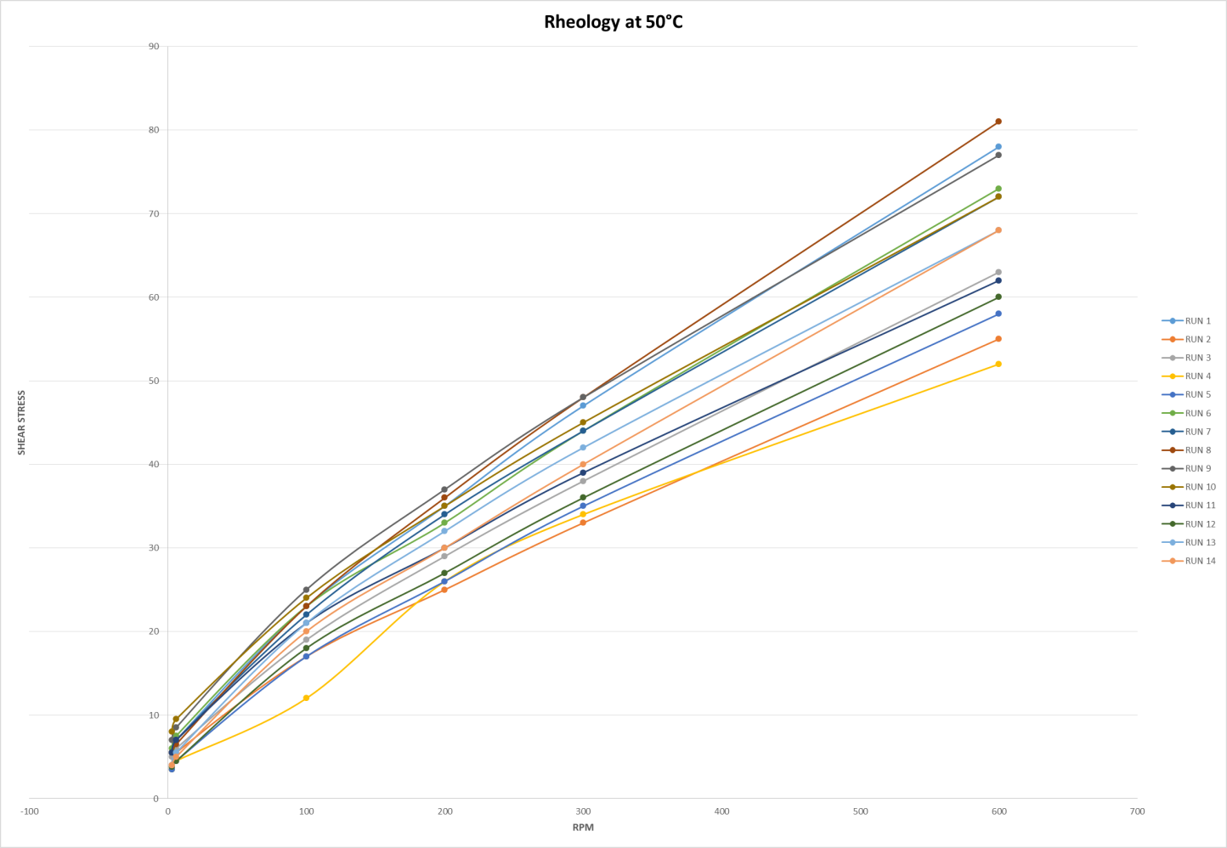

Third Design
Table 47. - Third design results at 50°C.

Response 1  600 RPM | Model | Linear x Linear model
 | Equation | 600 RPM = 112.65 A + 90.48 B + 80.49 C + 34.71 AD + 21.92 BC + 19.79 CD
 | Comments | New component added, Clay (Contaminant).
Response 2  300 RPM | Model | Linear x Linear model
 | Equation | 300 RPM = 65.06 A + 51.46 B + 48.26 C + 19.13 AD + 10.88 BD + 13.46 CD
 | Comments | New component added, Clay (Contaminant).
Response 3  200 RPM | Model | Linear x Linear model
 | Equation | 200 RPM = 48.73 A + 38.32 B + 36.95 C + 14.23 AD + 7.68 BD + 11.31 CD
 | Comments | New component added, Clay (Contaminant).
Response 4  100 RPM | Model | Linear x Linear model
 | Equation | 100 RPM = 31.36 A + 23.85 B + 24.51 C + 9.07 AD + 3.79 BD + 8.21 CD
 | Comments | New component added, Clay (Contaminant).
Response 5  6 RPM | Model | Mean x Linear model
 | Equation | 6 RPM = 5.44912 + 0.1389 D
 | Comments | New component added, Clay (Contaminant).
Response 6  3 RPM | Model | Mean x Linear model
 | Equation | 3 RPM = 6.86 + 2.40 D
 | Comments | New component added, Clay (Contaminant).
Elaborated by: Santiago Aguayo
Figure 97. - Rheology Profile at 50°C for the Third Design.

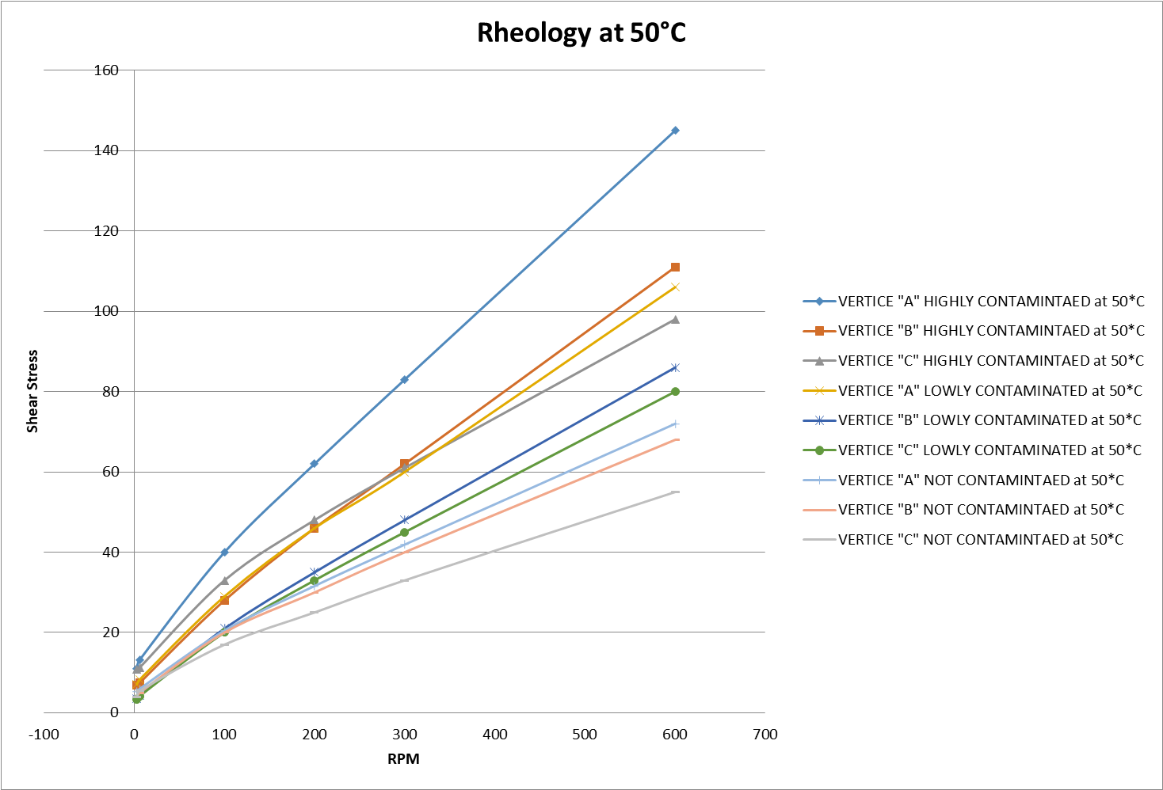

Table 48. - Third design results at 80°C.

Response 8  600 RPM | Model | Linear x Quadratic model
 | Equation | 600 RPM = 77.55 A + 50.41 B + 45.65 C + 19.50 AD + 0.25 BD + 4.50 CD – 1.05 AD² + 16.345 BD² + 17.85 CD²
 | Comments | New component added, Clay (Contaminant).
Response 9  300 RPM | Model | Linear x Quadratic model
 | Equation | 300 RPM = 46.175 A+26.0125 B+25.375 C+12 AD-4.25 BD+0.999 CD-0.175 AD²+17.2375 BD²+16.625 CD²
 | Comments | New component added, Clay (Contaminant).
Response 10  200 RPM | Model | Linear x Quadratic model
 | Equation | 200 RPM = 34.6375 A+17.8625 B+18.6 C+8.75 AD-4.75 BD+0.999 CD+0.6125 AD²+16.8875 BD²+15.4 CD²
 | Comments | New component added, Clay (Contaminant).
Response 11  100 RPM | Model | Linear x Quadratic model
 | Equation | 100 RPM AHR = 22.625 A+8.9375 B+10.525 C+6.5 AD-5.25 BD+0 CD+0.875 AD²+15.3125 BD²+13.475 CD²
 | Comments | New component added, Clay (Contaminant).
Response 12  6 RPM | Model | Mean x Quadratic
 | Equation | 6 RPM AHR = 3.4583 – 0.05 D + 5.192 D²
 | Comments | New component added, Clay (Contaminant).
Response 13  3 RPM | Model | Mean x Quadratic
 | Equation | 3 RPM AHR = 2.99333 + 0.009996 D + 4.5967 D²
 | Comments | New component added, Clay (Contaminant).
Elaborated by: Santiago Aguayo
Figure 98. - Rheology Profile at 80°C for the Third Design.

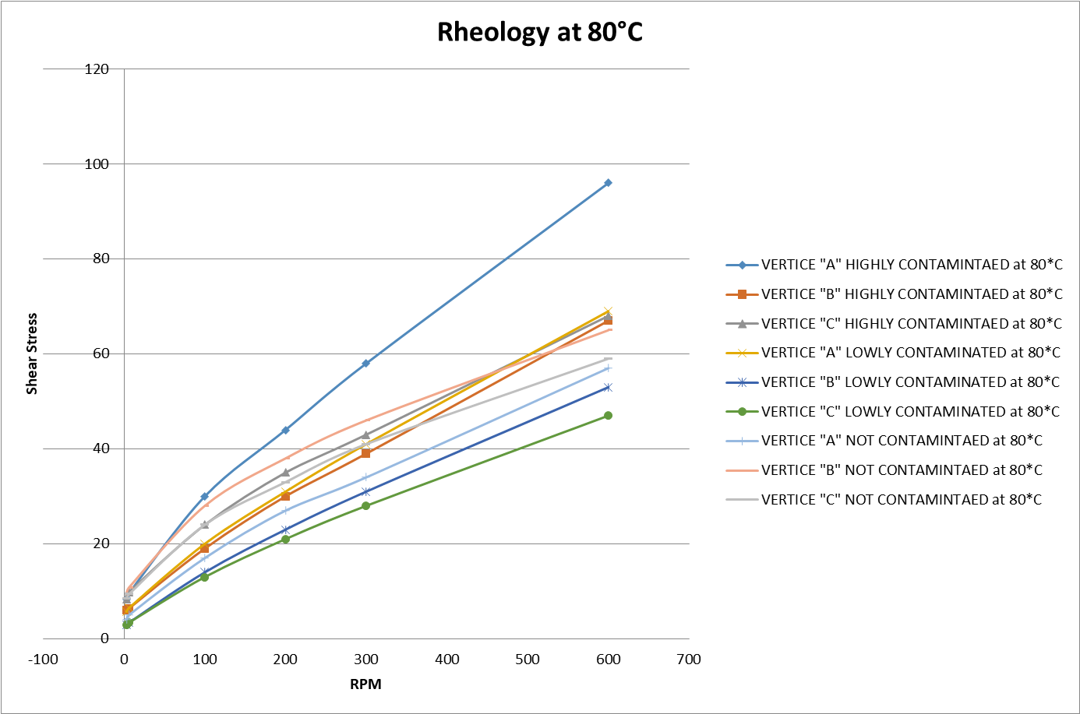

Fourth Design
Table 49. - Fourth design results at 50°C.

Response 1  600 RPM | Model | Linear x Linear model
 | Equation | 600 RPM = 111.17 A + 86.46 B + 76.77 C + 33.63 AD + 19.80 BC + 18.64 CD
 | Comments | Two extra internal Points analyzed. Medium contamination analysis (Vertices and Internal points)
Response 2  300 RPM | Model | Linear x Linear model
 | Equation | 300 RPM = 64.39 A + 49.06 B + 46.39 C + 19.0 AD + 10.03 BD + 12.78 CD
 | Comments | Two extra internal Points analyzed. Medium contamination analysis (Vertices and Internal points)
Response 3  200 RPM | Model | Linear x Linear model
 | Equation | 200 RPM = 48.07 A + 36.09 B + 35.31 C + 14.07 AD + 6.79 BD + 10.57 CD
 | Comments | Two extra internal Points analyzed. Medium contamination analysis (Vertices and Internal points)
Response 4  100 RPM | Model | Linear x Quadratic model
 | Equation | 100 RPM = 31.108 A + 19.726 B + 21.278 C + 9.150 AD + 3.7119 BD + 8.0375 CD – 0.01309 AD² + 4.574 BD²+ 3.764 CD²
 | Comments | Two extra internal Points analyzed. Medium contamination analysis (Vertices and Internal points)
Response 5  6 RPM | Model | Linear x Quadratic model
 | Equation | 6 RPM = 9.372 A + 4.062 B + 5.380 C + 3.638 AD + 1.154 BD + 3.468 CD + 0.920 AD² + 2.765 BD² + 2.99 CD²
 | Comments | Two extra internal Points analyzed. Medium contamination analysis (Vertices and Internal points)
Response 6  3 RPM | Model | Linear x Quadratic model
 | Equation | 3 RPM = 8.323 A + 3.504 B + 4.783 C + 3.113 AD + 1.231 BD + 3.868 CD + 0.440 AD² + 2.696 BD² + 2.813 CD²
 | Comments | Two extra internal Points analyzed. Medium contamination analysis (Vertices and Internal points)
Elaborated by: Santiago Aguayo

Figure 99. - Rheology Profile at 50°C for the Fourth Design.

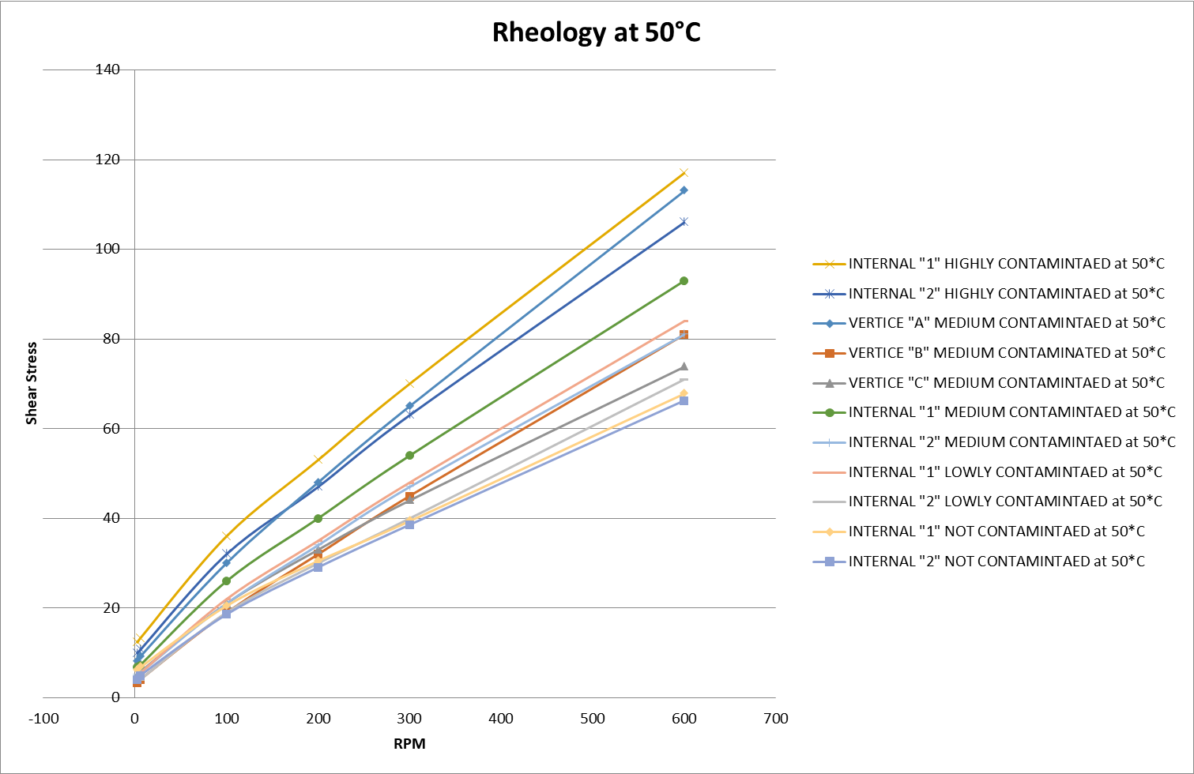
Table 50. - Fourth design results at 80°C.

Response 8  600 RPM | Model | Linear x Quadratic model
 | Equation | 600 RPM = 73.02 A + 50.03 B + 47.76 C + 18.68 AD – 0.5367 BD + 4.55 CD + 2.29 AD² + 15.68 BD² + 14.04 CD²
 | Comments | Two extra internal Points analyzed. Medium contamination analysis (Vertices and Internal points)
Response 9  300 RPM | Model | Linear x Cubic model
 | Equation | 300 RPM = 42.97 A + 30.63 B + 31.63 C + 7.46 AD + 9.54 BD + 18.33 CD + 2.72 AD² + 12.45 BD² + 9.83 CD² + 4.43 AD³-14.25 BD³-17.42 CD³
 | Comments | Two extra internal Points analyzed. Medium contamination analysis (Vertices and Internal points)
Response 10  200 RPM | Model | Linear x Cubic model
 | Equation | 200 RPM = 33.07 A + 21.86 B + 23.86 C + 7.318 AD + 6.64 BD + 15.24 CD + 2.04 AD² + 12.82 BD² + 9.94 CD² + 1.5 AD³ - 11.6 BD³ - 14.42 CD³
 | Comments | Two extra internal Points analyzed. Medium contamination analysis (Vertices and Internal points)
Response 11  100 RPM | Model | Linear x Cubic model
 | Equation | 100 RPM = 21.84 A + 13.269 B + 16.269 C + 5.279 AD + 5.62 BD + 14.154 CD + 1.83 AD² + 11.19 BD² + 7.91 CD² + 1.557 AD³ -10.857 BD³ -14.109 CD³
 | Comments | Two extra internal Points analyzed. Medium contamination analysis (Vertices and Internal points)
Response 12  6 RPM | Model | Linear x Cubic model
 | Equation | 6 RPM = 7.07 A + 3.52 B + 5.12 C + 1.44 AD + 4.73 BD + 7.92 CD + 0.43 AD² + 6.15 BD² + 4.85 CD² + 1.45 AD³ -7.48 BD³ - 7.57 CD³
 | Comments | Two extra internal Points analyzed. Medium contamination analysis (Vertices and Internal points)
Response 13  3 RPM | Model | Linear x Cubic model
 | Equation | 3 RPM = 6.0 A + 2.97 B + 4.27 C + 0.87 AD + 4.26 BD + 6.79 CD + 0.43 AD² + 5.72 BD² + 4.47 CD² + 1.79 AD³ -6.45 BD³ -6.64 CD³
 | Comments | Two extra internal Points analyzed. Medium contamination analysis (Vertices and Internal points)
Elaborated by: Santiago Aguayo

Figure 100. - Rheology Profile at 80°C for the Fourth Design.

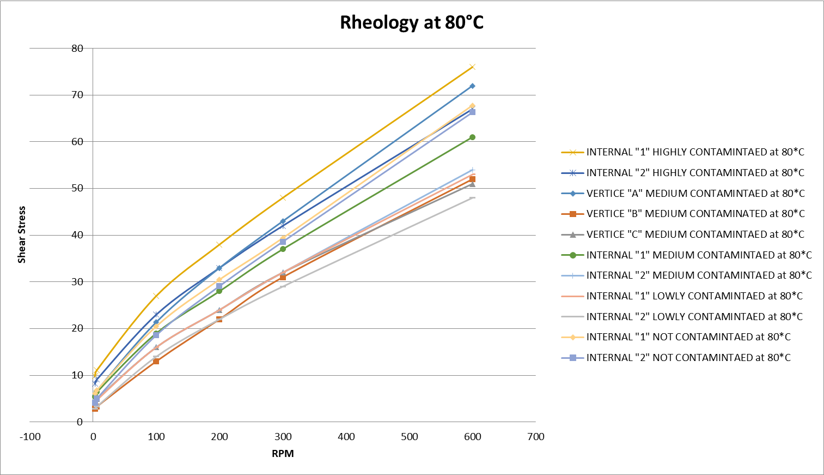

Fifth Design
Table 51. - Fifth design results at 50°C.

Response 1  600 RPM | Model | Linear x Linear model
 | Equation | 600 RPM = 117.19 A + 87.19 B + 77.03 C + 37.26 AD + 21.41 BC + 19.60 CD
 | Comments | Re-run 4 points: Vertice A (Low, medium and high contaminated), Vertice B and C (High contaminated).
Response 2  300 RPM | Model | Linear x Linear model
 | Equation | 300 RPM = 68.84 A + 49.57 B + 46.13 C + 22.05 AD + 11.13 BD + 12.82 CD
 | Comments | Re-run 4 points: Vertice A (Low, medium and high contaminated), Vertice B and C (High contaminated).
Response 3  200 RPM | Model | Linear x Quadratic model
 | Equation | 200 RPM = 53.71 A + 32.59 B + 33.05 C + 14.20 AD + 7.42 BD + 10.51 CD – 5.87 AD² + 5.83 BD²+ 3.20 CD²
 | Comments | Re-run 4 points: Vertice A (Low, medium and high contaminated), Vertice B and C (High contaminated).
Response 4  100 RPM | Model | Linear x Quadratic model
 | Equation | 100 RPM = 34.55 A + 19.30 B + 20.78 C + 10.85 AD + 3.63 BD + 7.39 CD – 1.73 AD² + 4.93 BD²+ 3.61 CD²
 | Comments | Re-run 4 points: Vertice A (Low, medium and high contaminated), Vertice B and C (High contaminated).
Response 5  6 RPM | Model | Linear x Quadratic model
 | Equation | 6 RPM = 10.56 A + 3.89 B + 5.24 C + 3.77 AD + 1.03 BD + 3.55 CD – 0.0952 AD² + 2.80 BD² + 3.21 CD²
 | Comments | Re-run 4 points: Vertice A (Low, medium and high contaminated), Vertice B and C (High contaminated).
Response 6  3 RPM | Model | Linear x Quadratic model
 | Equation | 3 RPM = 9.58 A + 3.33 B + 4.59 C + 3.77 AD + 1.03 BD + 3.57 CD – 0.1334 AD² + 2.66 BD² + 2.70 CD²
 | Comments | Re-run 4 points: Vertice A (Low, medium and high contaminated), Vertice B and C (High contaminated).
Elaborated by: Santiago Aguayo

Figure 101. - Rheology Profile at 50°C for the Fifth Design.

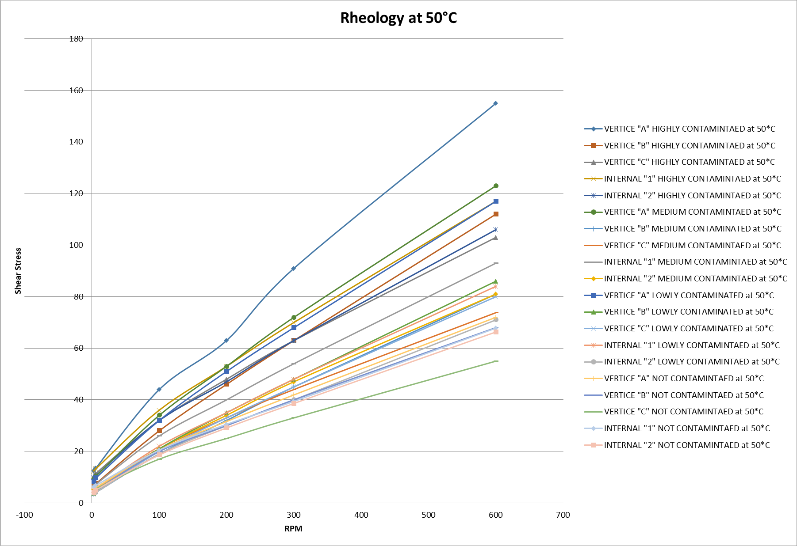

Table 52. - Fifth design results at 80°C.

Response 8  600 RPM | Model | Linear x Quadratic model
 | Equation | 600 RPM = 71.57 A + 50.22 B + 47.96 C + 15.73 AD – 0.1410 BD + 4.95 CD + 0.3296 AD² + 15.92 BD² + 14.28 CD²
 | Comments | Re-run 4 points: Vertice A (Low, medium and high contaminated), Vertice B and C (High contaminated).
Response 9  300 RPM | Model | Linear x Cubic model
 | Equation | 300 RPM = 43.81 A + 30.52 B + 31.52 C + 13.63 AD + 8.72 BD + 17.17 CD + 0.0036 AD² + 12.75 BD² + 8.99 CD² - 3.62 AD³-13.25 BD³-17.21 CD³
 | Comments | Re-run 4 points: Vertice A (Low, medium and high contaminated), Vertice B and C (High contaminated).
Response 10  200 RPM | Model | Linear x Cubic model
 | Equation | 200 RPM = 33.92 A + 21.75 B + 23.75 C + 11.25 AD + 6.05 BD + 14.27 CD – 0.1736 AD² + 12.84 BD² + 8.68 CD² - 3.77 AD³ - 11.20 BD³ - 14.82 CD³
 | Comments | Re-run 4 points: Vertice A (Low, medium and high contaminated), Vertice B and C (High contaminated).
Response 11  100 RPM | Model | Linear x Cubic model
 | Equation | 100 RPM = 22.34 A + 13.20 B + 16.20 C + 6.12 AD + 5.44 BD + 13.82 CD + 0.24 AD² + 11.14 BD² + 7.37 CD² - 0.378 AD³ -10.78 BD³ -14.39 CD³
 | Comments | Re-run 4 points: Vertice A (Low, medium and high contaminated), Vertice B and C (High contaminated).
Response 12  6 RPM | Model | Linear x Cubic model
 | Equation | 6 RPM = 7.74 A + 3.43 B + 5.03 C + 3.24 AD + 4.44 BD + 7.59 CD – 0.235 AD² + 6.04 BD² + 4.61 CD² - 0.3513 AD³ -7.38 BD³ - 7.57 CD³
 | Comments | Re-run 4 points: Vertice A (Low, medium and high contaminated), Vertice B and C (High contaminated).
Response 13  3 RPM | Model | Linear x Cubic model
 | Equation | 3 RPM = 6.34 A + 2.93 B + 4.23 C + 2.15 AD + 4.01 BD + 6.52 CD + 0.16 AD² + 5.47 BD² + 4.16 CD² + 0.58 AD³ -6.51 BD³ -6.72 CD³
 | Comments | Re-run 4 points: Vertice A (Low, medium and high contaminated), Vertice B and C (High contaminated).
Elaborated by: Santiago Aguayo

Figure 102. - Rheology Profile at 80°C for the Fifth Design.

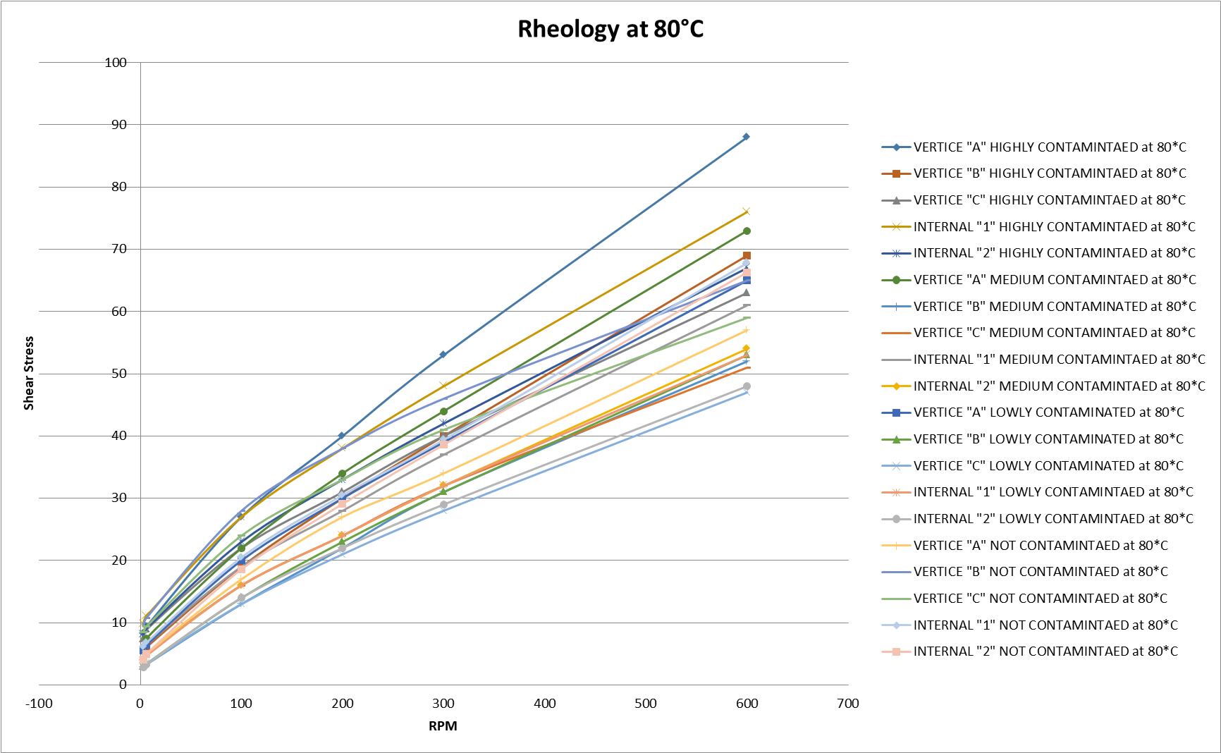

CHAPTER 5: CONCLUSIONS

After performing the first experiment with all its designs, going through the methodology, and analyzing the diagnostic plots, as well the rheology model profiles (Shear Stress vs. Shear Rate), some interesting results has come clearly from this study.
Three components where selected to study how the variation of each one of them in the formulation affects the rheological behavior of the mud.
All the components have a direct relationship with the shear stress, it means that if the percentage of them increases then the shear stress will increase and in the same way when they decrease. If we compare between the components, the viscosifier will always increase the shear stress more than the modifiers would. When analyzing the vertexes of the contour plot it is possible to notice this behavior, three scenarios are clear, Vertex A (VG Supreme) has higher values of the shear stress than Vertex B (Versamod), and this last one has higher values than Vertex C (EMI-1945).
When adding an extra component to the original mixture design, it turned into a combined design. This component, which was studied in three levels, affects the mud behavior as much as the other components. The clay used as the contaminant has a direct relationship with the shear stress values, when either of them increases the other will too, and the same when decreasing.
There is not a big difference between the low (10 grams) and medium level (17.5 grams) of contamination.
Regarding the models for each design, it is possible to see that the data for the Electrical Stability does not fit any model; the components do not have any effect on this response. For the rest of the responses there is a model for each one.
The models get more complex when increasing the temperature of the mud, and decreasing the shear rate. The contaminant has a higher effect on the behavior of the mud when increasing the temperature.

REFERENCES

- Ali, A., Schmidt, D., & Harvey III, J. (1987). Investigation of the Electrical Stability Test for Oil Muds. SPE/IADC Drilling Conference , 15.
- Anderson, M., & Whitcomb, P. (2015). Mixture Design. In DOE Simplified (Third Edition ed., pp. 155-159). Taylor & Francis Group.
- Aramendiz, J., Imqam, A. H., & Fakher, S. (2019, March). Design and Evaluation of a Water-Based Drilling Fluid Folrmulation using SiO2 and Graphene Oxide Nanoparticles for Unconventional Shales. International Petroleum Technology Conference , 17.
- Bland , R., Mullen, G., Gonzalez, Y., Harvey, F., & Pless, M. (2006). HP/HT Drilling Fluids Challenges. IADC/SPE Asia Pacific Drilling Technology Conference and Exhibition (p. 11). Bangkok: Society of Petroleum Engineer .
- Bower, K. (2020, January 20). American Society for Quality. Retrieved from WHAT IS DESIGN OF EXPERIMENTS (DOE): https://asq.org/quality-resources/design-of-experiments
- Caenn, R., Darley, H., & Gray, G. R. (2011). Types of drilling fluids. (Sixth Edition ed.). ELSEVIER.
- Deminskaya, N., Molokanov, D., Sledkov, V., & Kuznecov, A. (2014). Oil-base Mud to Improve Quality of Pay Penetration. SPE Russian Oil and Gas Exploration and Production Technical Conference and Exhibition (p. 9). Moscow: Society of Petroleum Engineers .
- Ebeltoft, H., Yousif, M., & Soergaard, E. (1997). Hydrate Control during Deep Water Drilling: Overview and New Drilling Fluids Formulations. SPE Annual Technical Conference and Exhibition (p. 7). San Antonio: Society of Petroleum Engineers .
- Fireman, J. (2019). How Design of Experiments Can Improve Formulation Development. Retrieved from Stat-Ease: https://cdn.statease.com/media/public/documents/how_doe_can_improve_formulation_dev.pdf
- Gallardo, F. (2018). OPTIMIZACION DE FLUIDOS DE PERFORACION BASE AGUA PARA SHALES. Buenos Aires: Instituto Tecnologico de Buenos Aires.
- Geehan, T., Forbes , D., & Moore, D. (1991). Control of Chemical Usage in Drilling Fluid Formulations to Minimize Discharge to the Enviroment. First International Conference on Health, Safety and Environment (p. 7). The Netherlands : Society of Petroleum Egineers .
- Growcock, F., Ellis, C., & Schmidt, D. (1990, September). Electrical Stability, Emulsion Stability, and Wettability of Invert Oil-Based Muds. SPE Annual Technical Conference and Exhibition , 8.
- Guven, N., Panfil, D., & Carney, L. (1988). Comparative Rheology of Water-Based Drilling FLuids with Various Clays. SPE Interrnational Meeting on Petroleum Engineering , 9.
- Hestad, V., & Gulbrandsen, A. (2018). Drilling Fluids Automix. SPE/IADC Middle East Drilling Technology Conference and Exhibition (p. 7). Abu Dhabi: Society of Petroleum Engineers.
- Houwen, O., & Geehan, T. (1986). Rheology of Oil-Base Muds. 61st Annual Technical Conference and Exhibition of the Society of Petroleum Engineers , 12.
- Karimi Vajargah, A., & Van Oort, E. (2015). Automated Drilling Fluid Rheology Characterization with Downhole Pressure Sensor Data. SPE/IADC Drilling Conference and Exhibition (p. 22). London: Society of Petroleum Engineers.
- Luyster, M., Anez, M., Brzezinski, M. A., Nguyen, C., Ravitz, R., & Bumala, P. (2014). Rig Time was Saved in a Remote Two-Rig Operation Completing Horizontal Openhole Wells with Expandable Sand Screen Through Careful Selection and Aggressive Juggling of Multiple Reservoir Drill-In Fluids. SPE international Symposium and Exhibition on Formation Damage Control (p. 23). Lafayette: Society of Petroleum Engineers .
- Lyons, W., & Plisga, G. (2004). Stabdar Handbook of Petroleum and Natural Gas Engineering. Gulf Proffesional Publishing.
- MI-SWACO. (n.d.).
- MI-SWACO. (2006). Mud Circulation and Solids Removal . In MI-SWACO, Drilling Fluids Engieering Manual (Vol. 2.1, pp. 1.12 - 1.13). United States of America , United States of America: MI- SWACO.
- Moteiro, V., Brandao, E., Mello, E., & Martins, A. (2005, March). Drilling Fluid Rheology optimization for ultra deep water wells in campos Basin, Brazil. Offshore Mediterranean Conference and Exhibition , 9.
- Moussa, M. M. (1988, June). Rheology of drilling fluids in Deep Wells - Measurements and Evaluation . The 39th Annual Technical meeting of the petroleum society of CIM, 9.
- Oil & Gas Editor. (2019, October 05). Oil & Gas iQ. Retrieved from What does digital transformation in oil and gas look like ?: https://www.oilandgasiq.com/oil-gas/news/what-is-digital-transformation
- Rommetveit, R., & Bjorkevoll, K. S. (1997, November ). Temperatue and Pressure Effects on Drilling-Fluid Rheology and ECD in Very Deep wells. SPE Middle East Drilling Technology Conference.
- Sandeep, K., Sharath, S., Shadaad, M., Dale, J., & Arunesh, K. (2013). Normal Stress Rheology of Drilling FLuids and Potential in Lost Circulation Control. North Africa Technical Conference and Exhibition (p. 7). Cairo: Society of Petroleum Engineers.
- Stat-Ease. (2020). Design Expert. Retrieved from Mixture Designs: file:///C:/Program%20Files/Design-Expert%2012/help/contents/mixture-designs/mixture-designs.html
- StatEase. (n.d.). Design Expert. Retrieved from Software: https://www.statease.com/software/design-expert/
- Sukhoboka, O. (2017, April). Drilling Fluid Rheology Under High Pressure High Temperature COnditions and its impact on the Rate of Penetration. SPE Bergen One Day Seminar, 9.
- Sundararajan, K. (2020). ISIXSIGMA. Retrieved from Design of Experiments - A Primer: https://www.isixsigma.com/tools-templates/design-of-experiments-doe/design-experiments-%E2%90%93-primer/
- Vikrant , W., Al-Yami, A., Aljubran, M., & Al-Bahrani, H. (2018). High Density Drilling Fluids for Managed Pressure Drilling. SPE Kingdom of Saudi Arabia Annual Technical Symposium and Exhibition (p. 18). Dammam: Society of Petroleum Engineers.
- Villaroel, L. (2014). DISEÑO DE UN FLUIDO DE PERFORACIÓN DRILL-IN COMPUESTO POR CARBONATOS DE CALCIO PARA MINIMIZAR EL DAØO EN FORMACIONES PRODUCTORAS EN EL CAMPO SACHA. Quito: Universidad Central del Ecuador.
- Wagle , V., AlYami, A., Alanqari, K., & Alkhala, S. (2019). Development of New Rheology Modifier for Invert Emulsion Drilling Fluids. SPE Kuwait Oil and Gas Conference and Show held in Mishref (p. 13). Kuwait: Society of Petroleum Engineers.
- Zheng , J., Jianzhao, W., Osama, M., Farrar, D., Cockcroft, B., Robinson, A., et al. (2011). Innovative Chemistry for Drilling Fluid Additives. SPE Middle East Oil and Gas Show and Conference (p. 10). Manama: Society of Petroleum Engineers .

ANNEXES
Fifth Design (Final), Diagnostics and Model Plots.
- Shear Stress at 600 RPM at 50°C.
- Predicted vs. Actual.
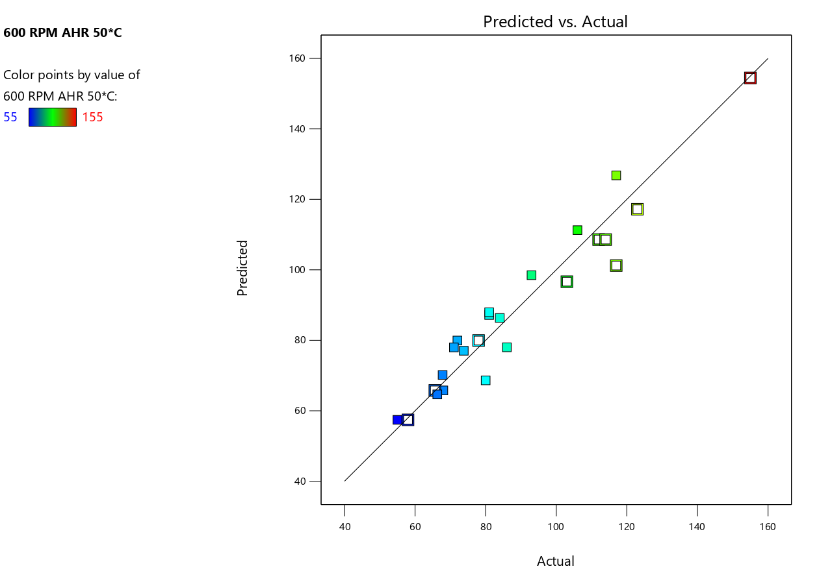
- 3D Surface Plot for No Contamination
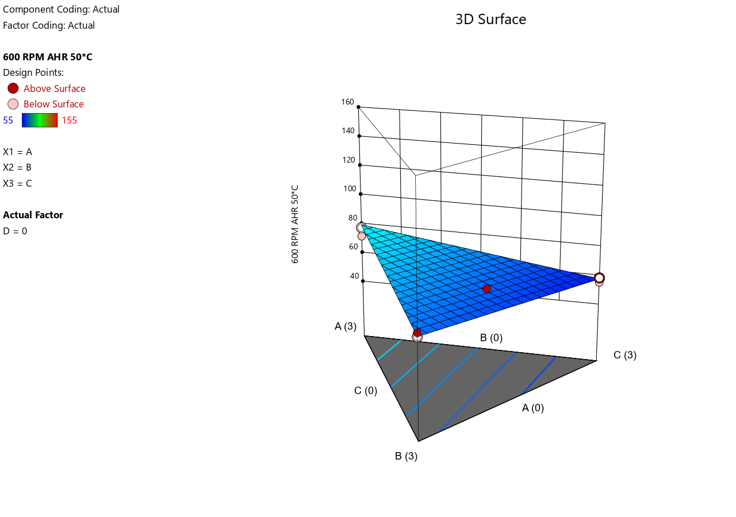
- 3D Surface Plot for Low Contamination
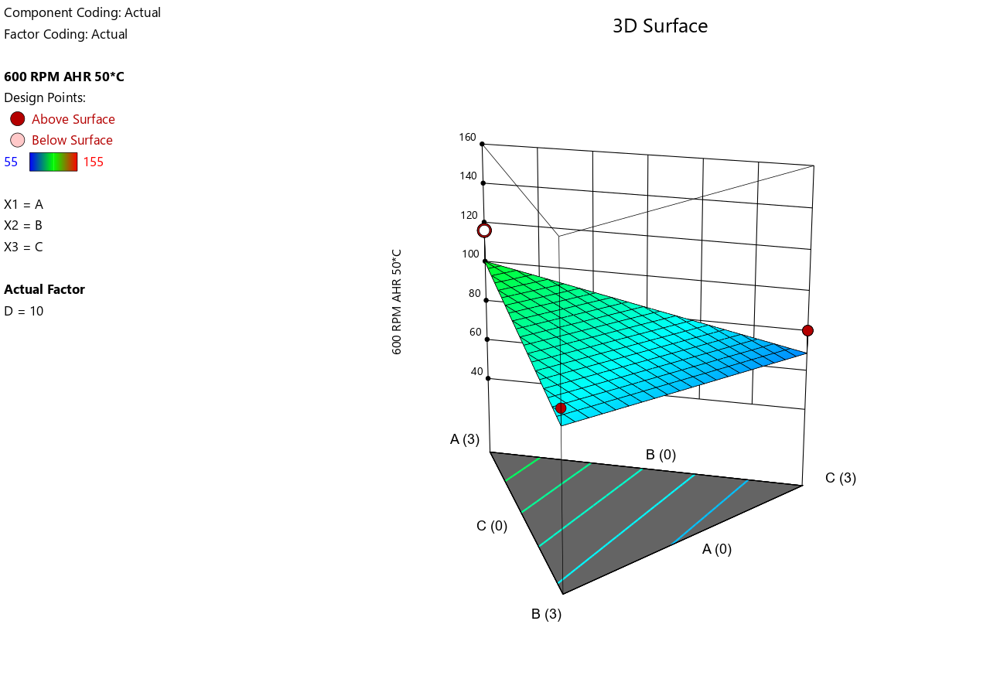
- 3D Surface Plot for Medium Contamination

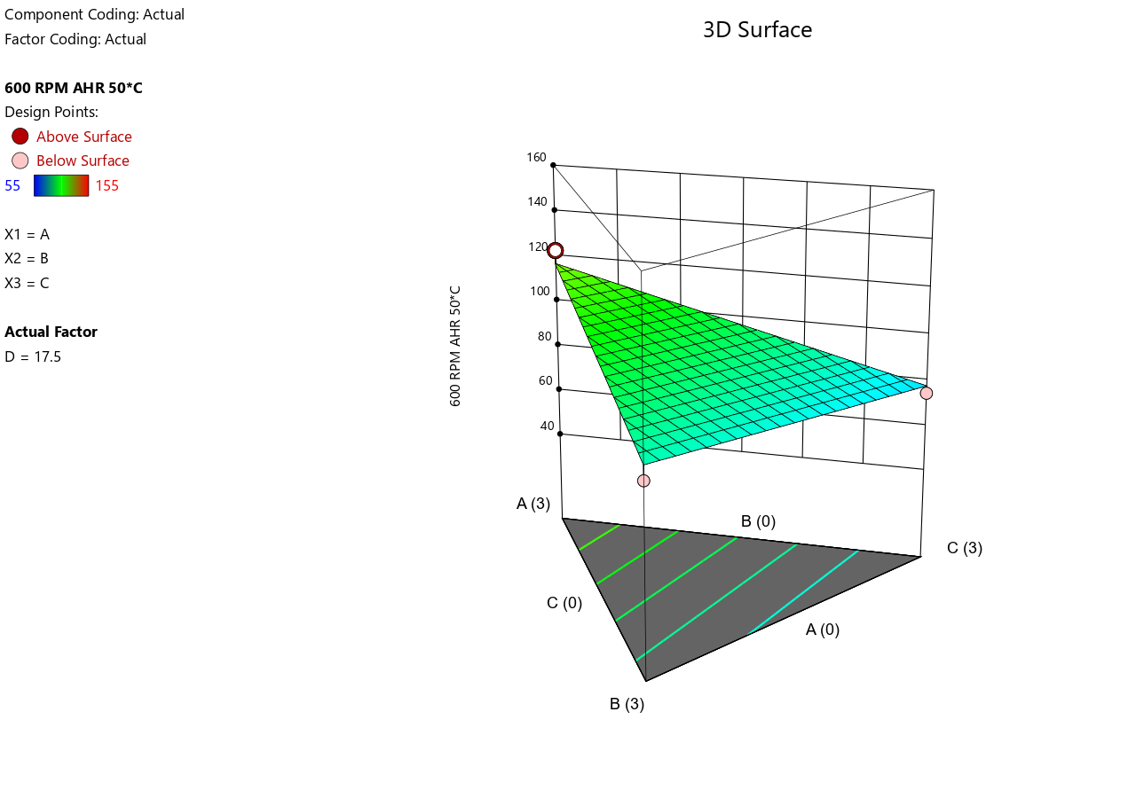
- 3D Surface Plot for High Contamination
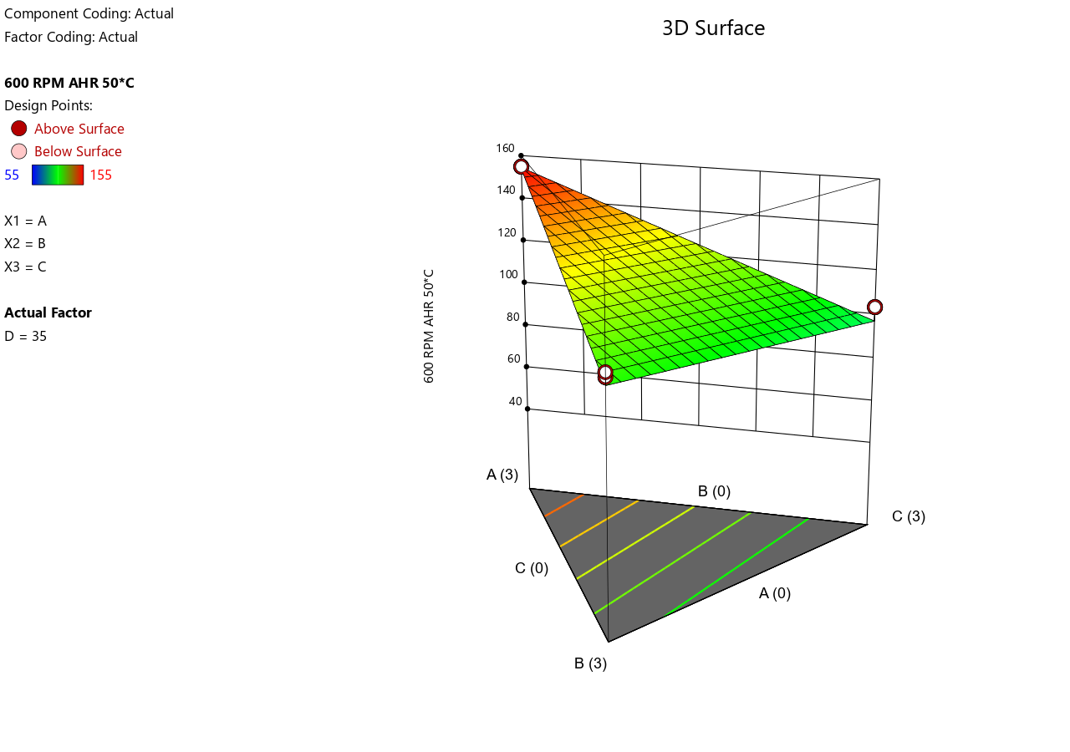
- Shear Stress at 300 RPM at 50°C.
- Predicted vs. Actual.
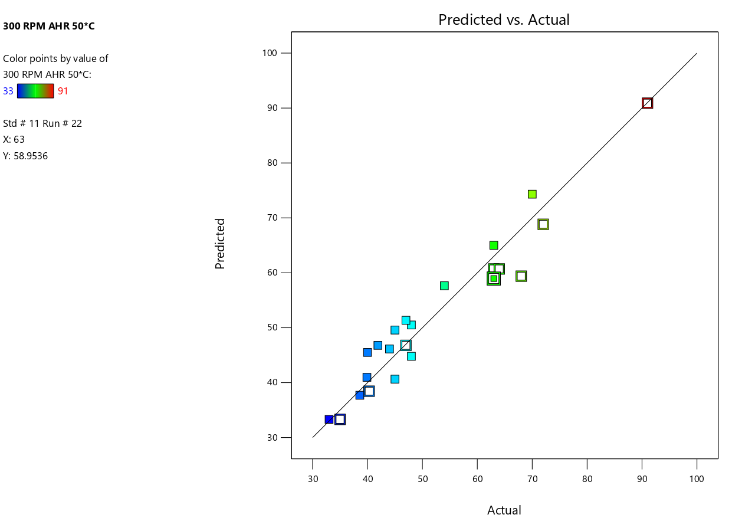

- 3D Surface Plot for No Contamination

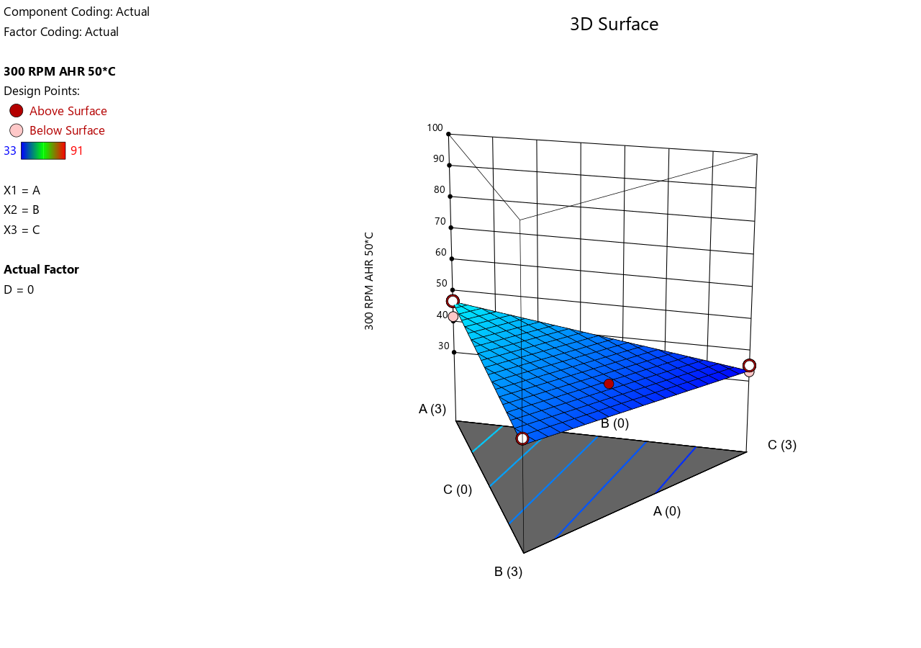
- 3D Surface Plot for Low Contamination
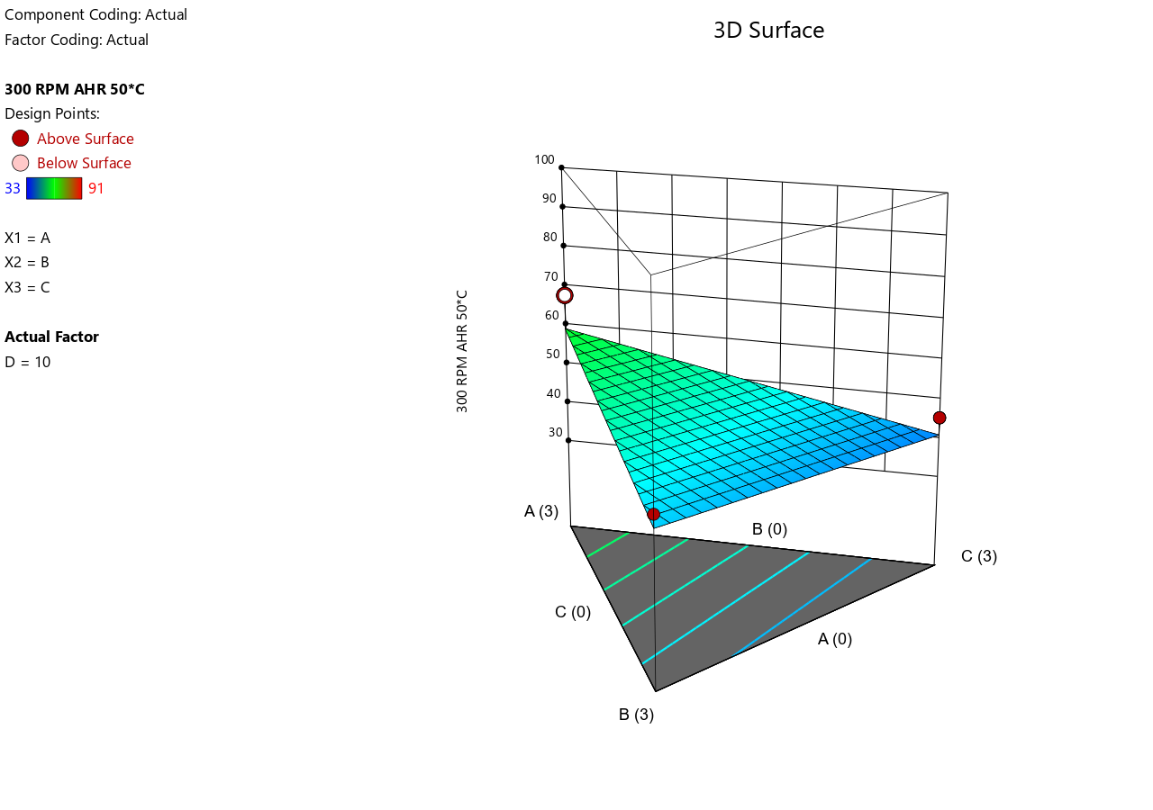
- 3D Surface Plot for Medium Contamination
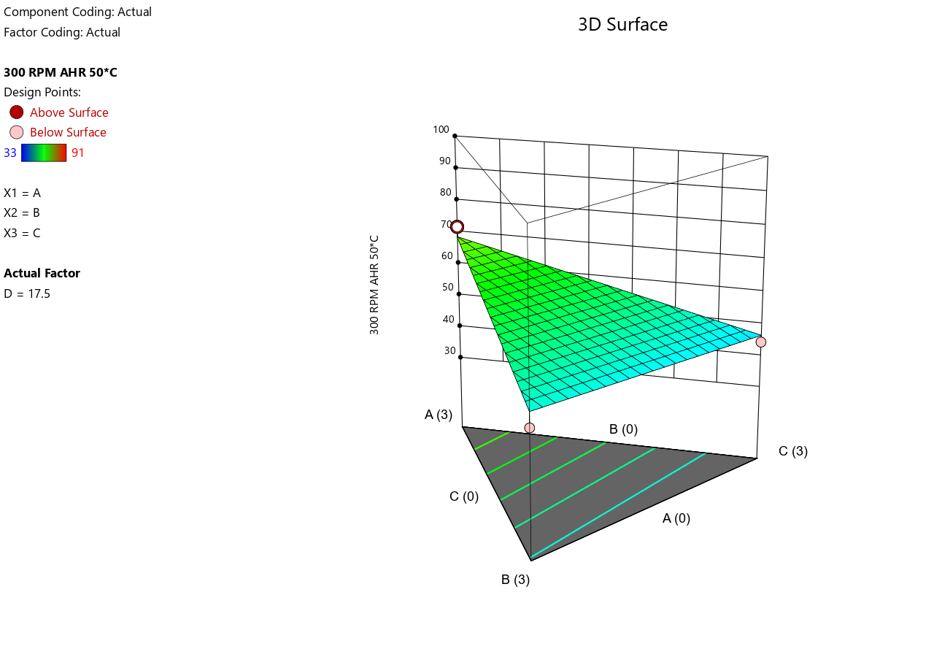
- 3D Surface Plot for High Contamination
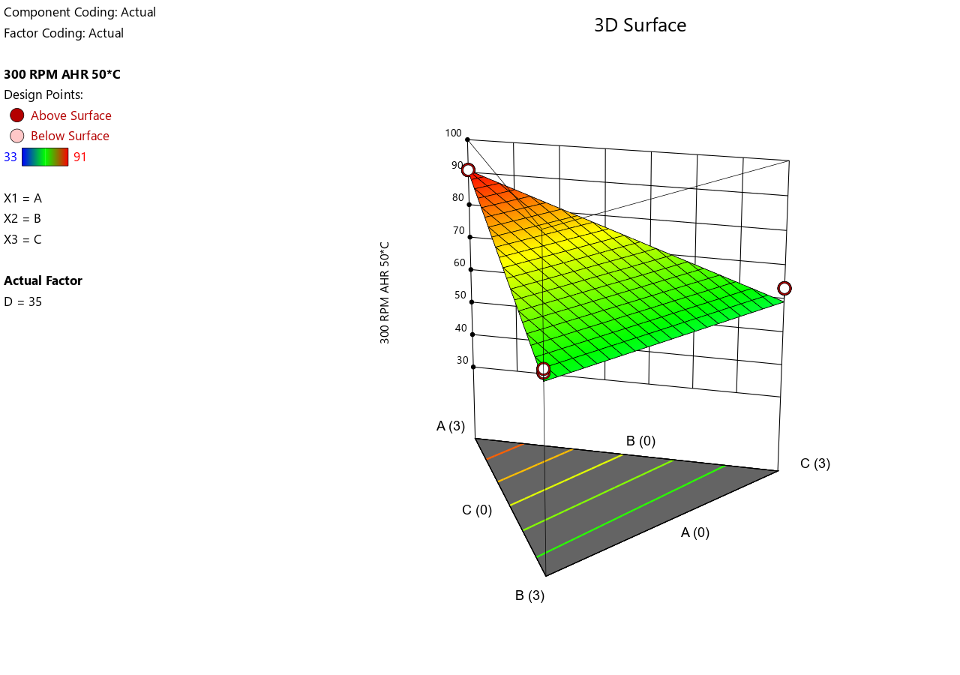

- Shear Stress at 200 RPM at 50°C.
- Predicted vs. Actual.
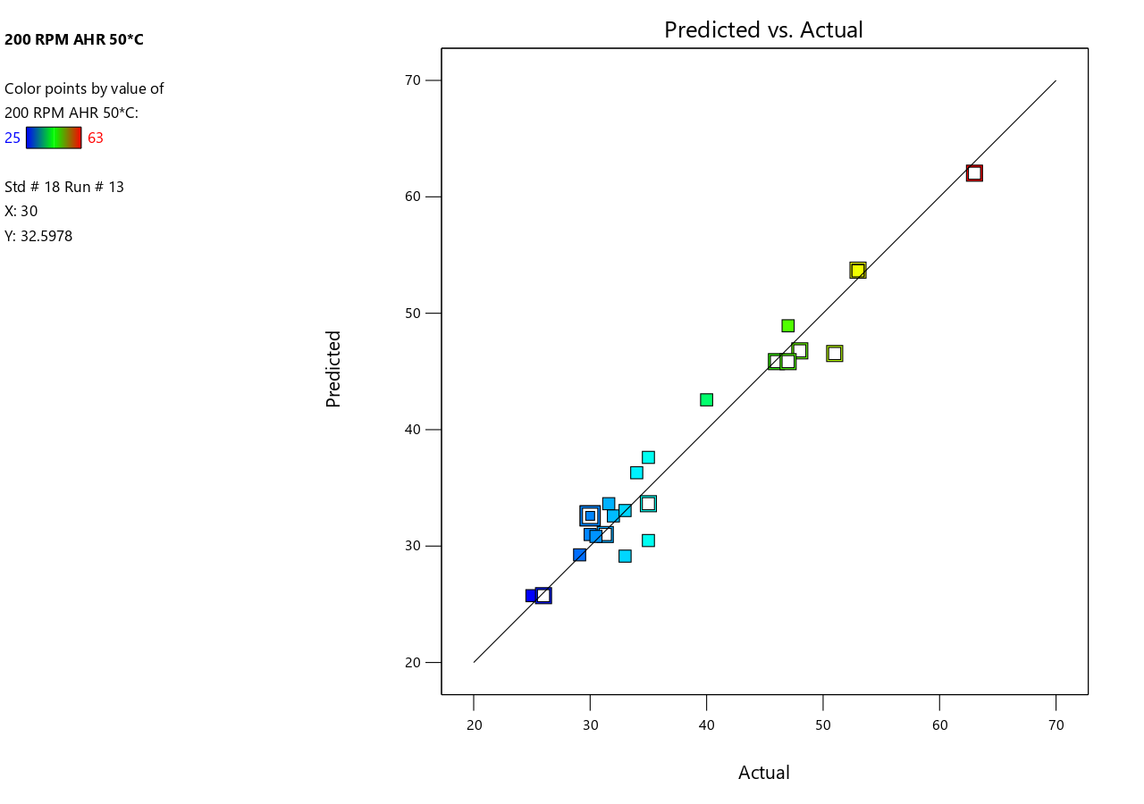
- 3D Surface Plot for No Contamination

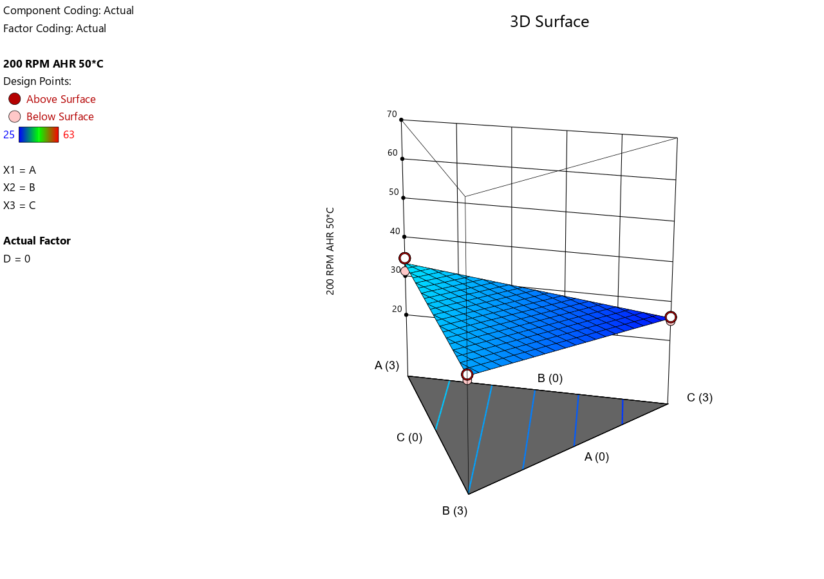

- 3D Surface Plot for Low Contamination
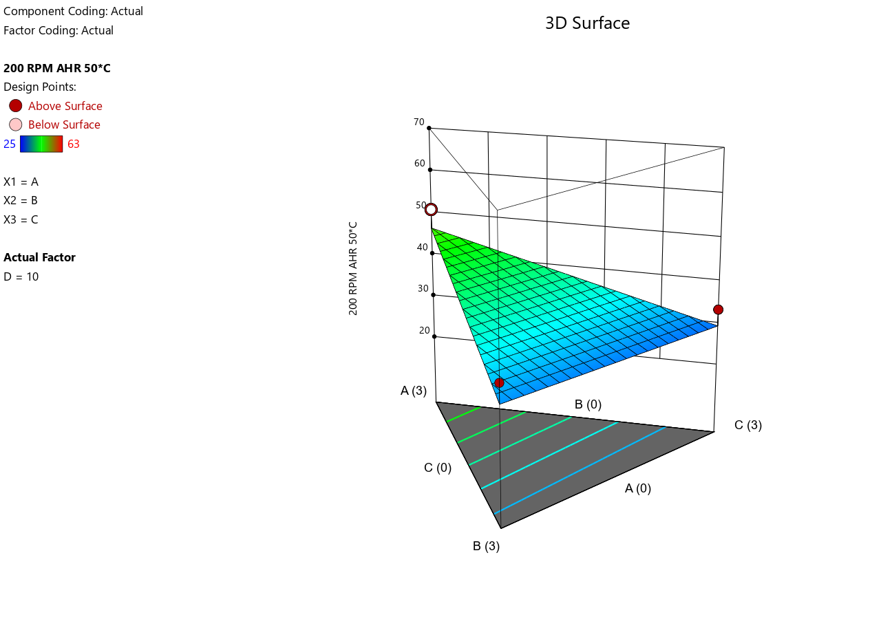
- 3D Surface Plot for Medium Contamination

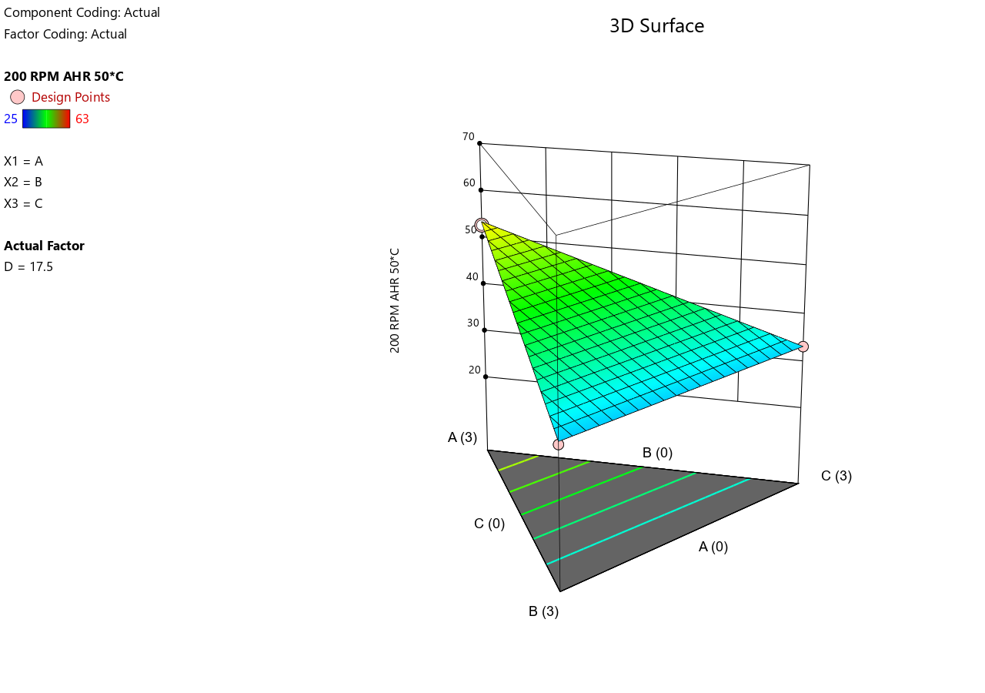
- 3D Surface Plot for High Contamination
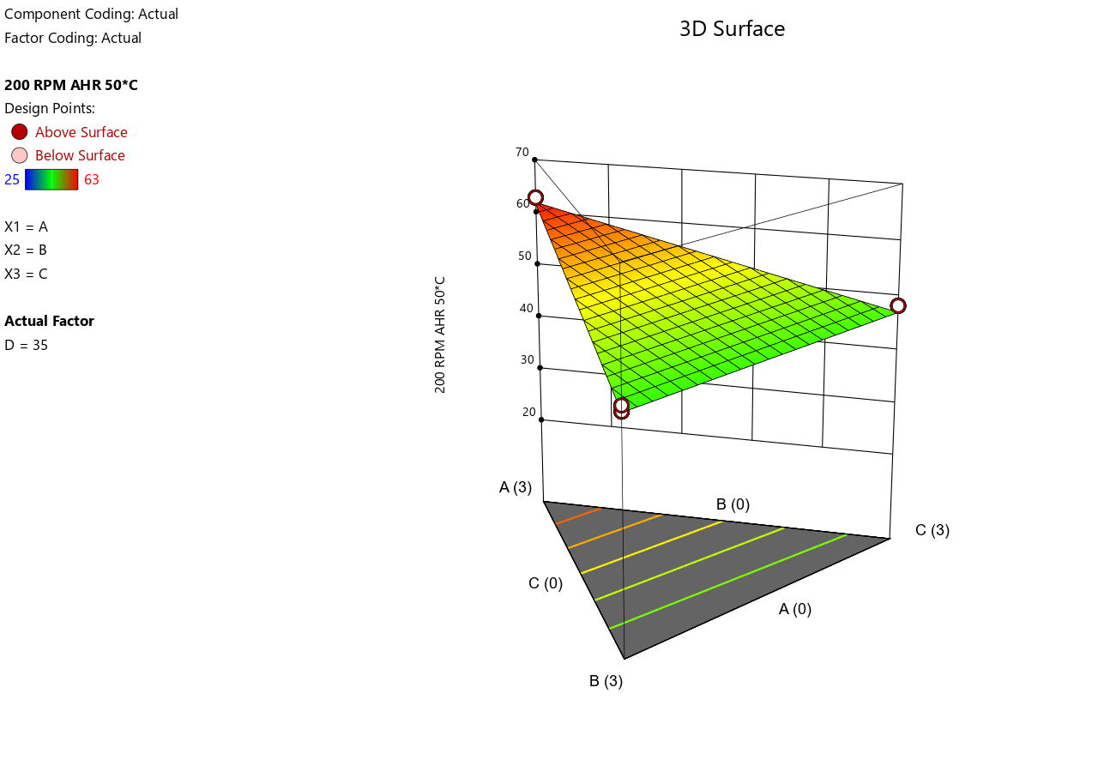

- Shear Stress at 100 RPM at 50°C.
- Predicted vs. Actual.
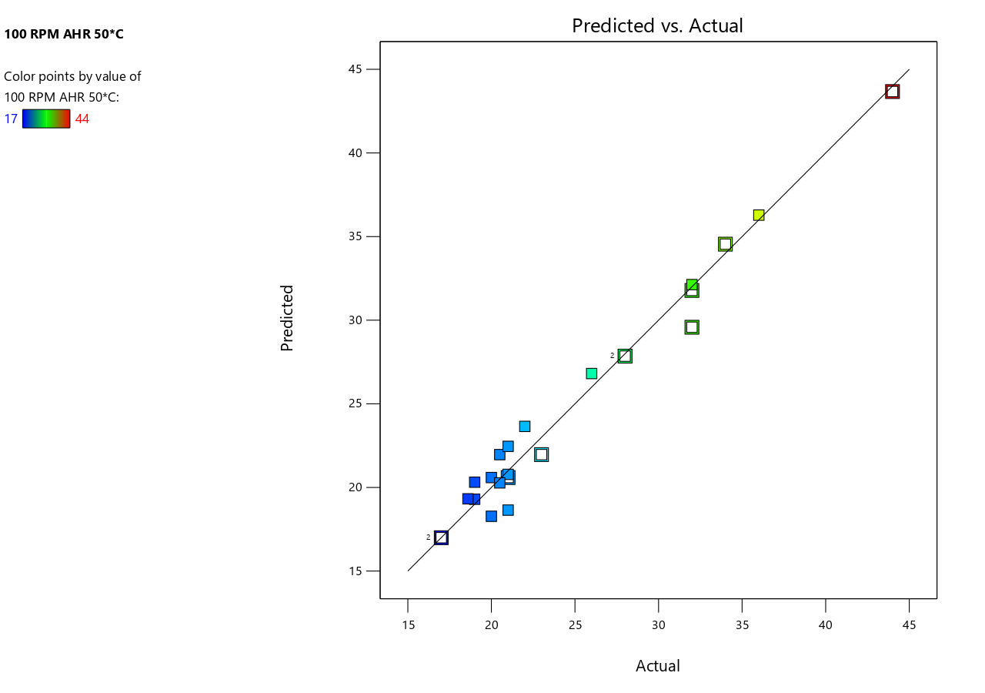
- 3D Surface Plot for No Contamination

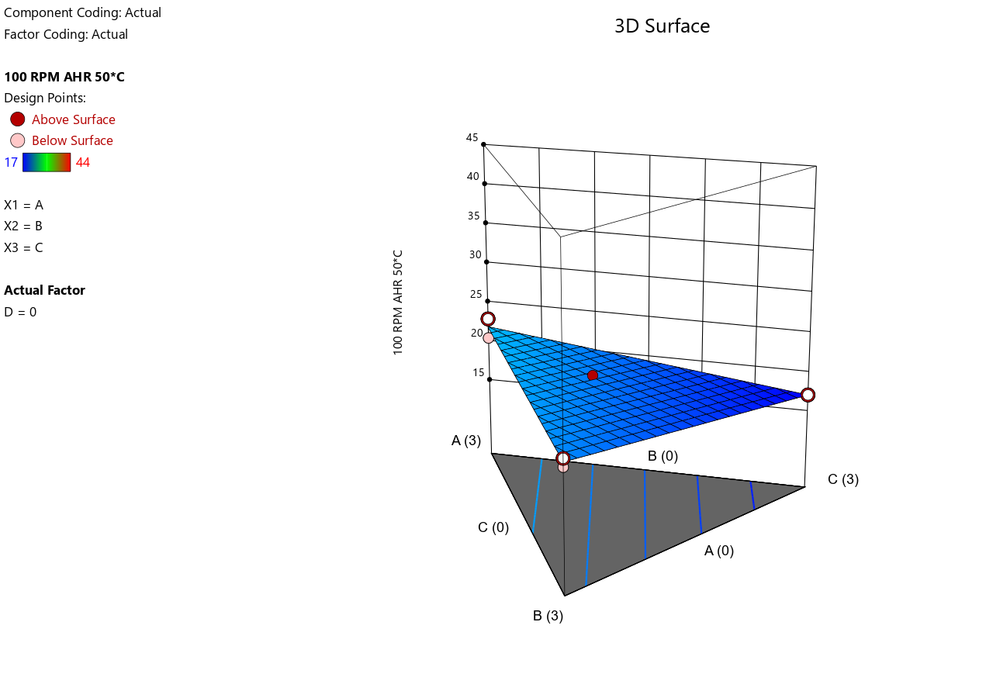
- 3D Surface Plot for Low Contamination
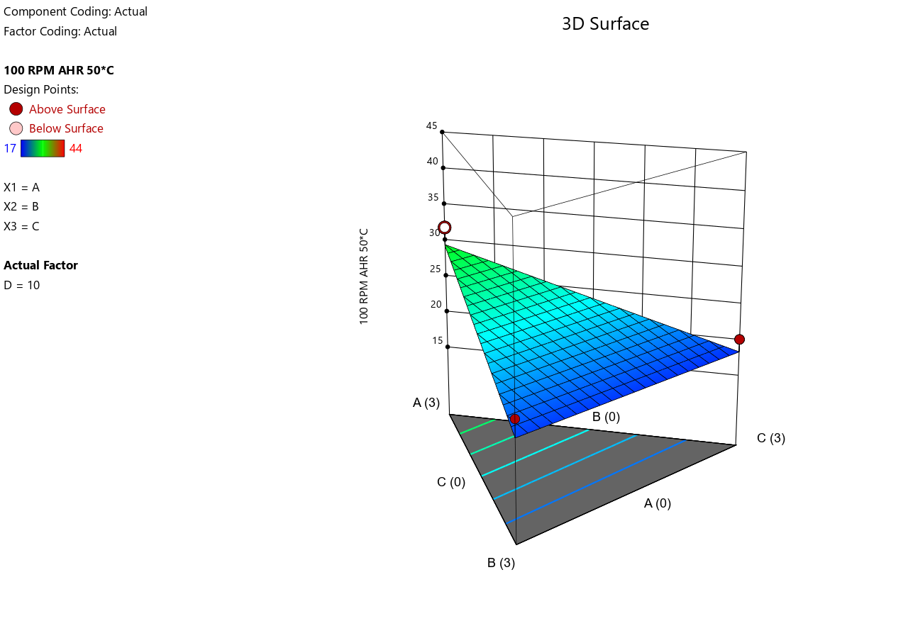
- 3D Surface Plot for Medium Contamination
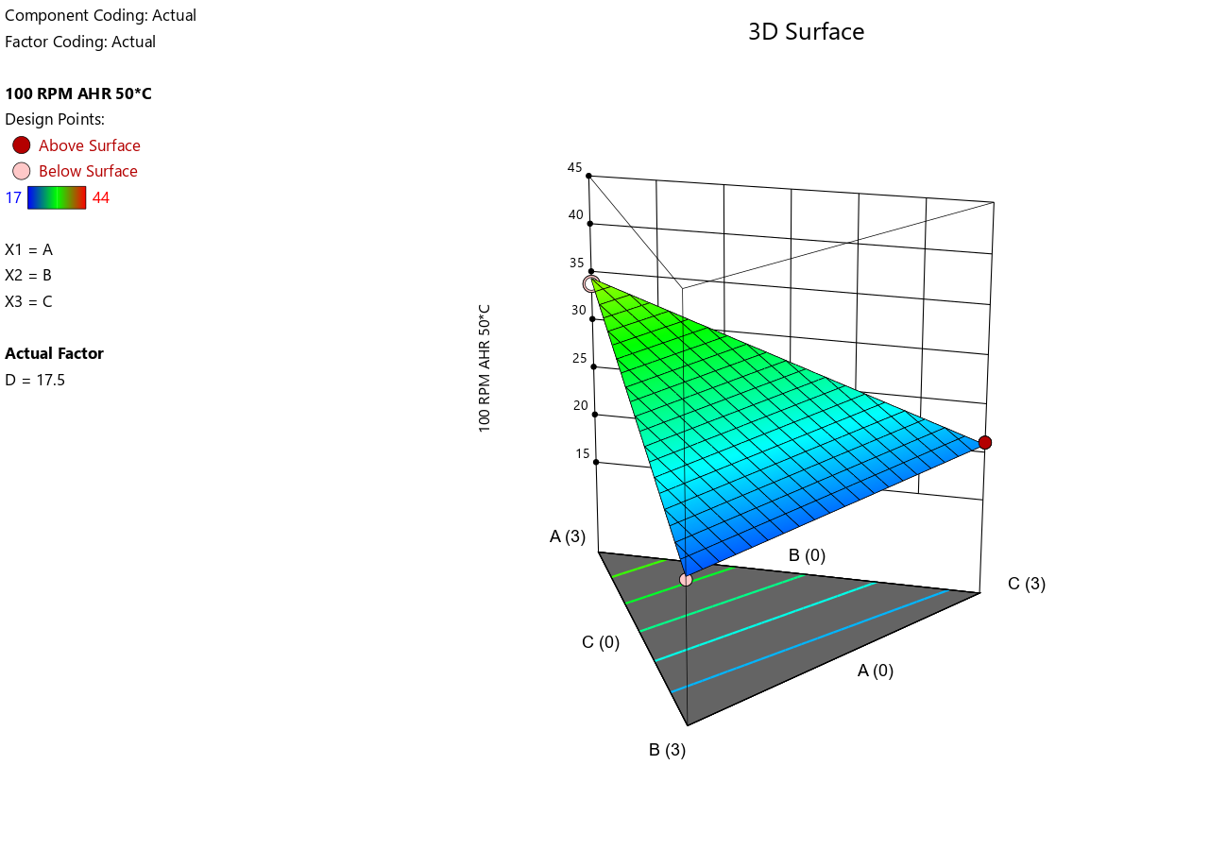

- 3D Surface Plot for High Contamination
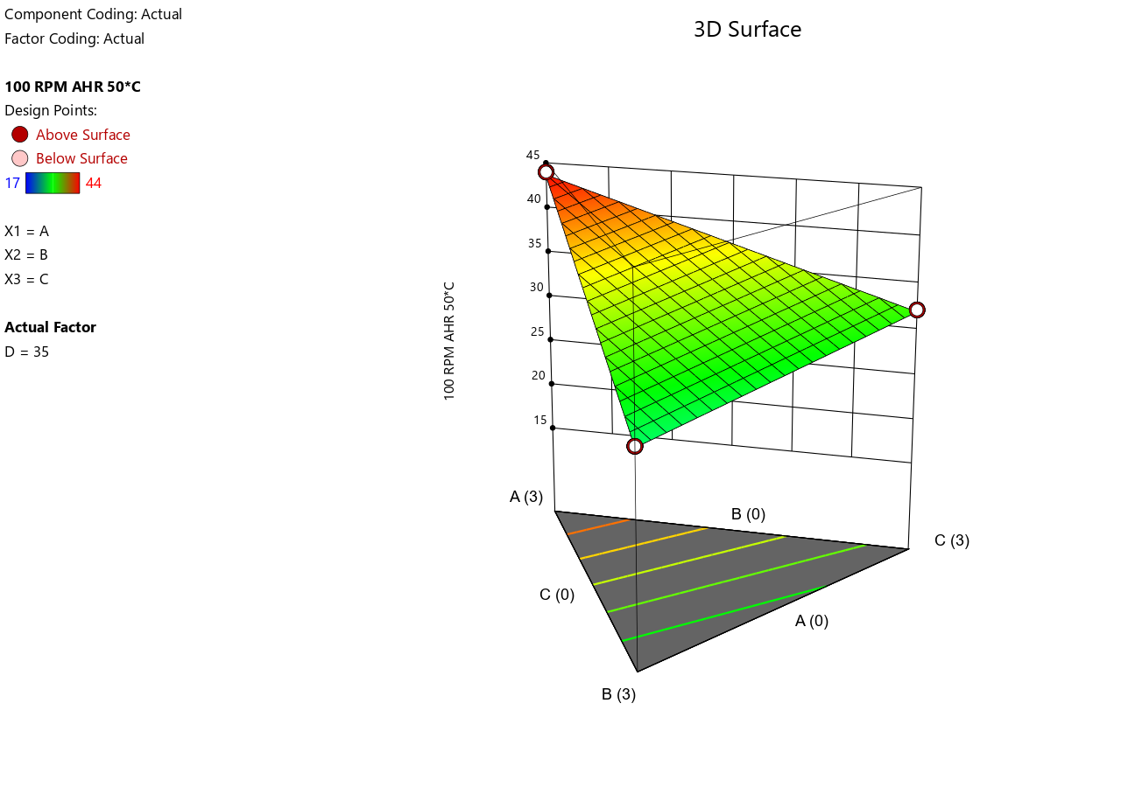
- Shear Stress at 6 RPM at 50°C.
- Predicted vs. Actual.
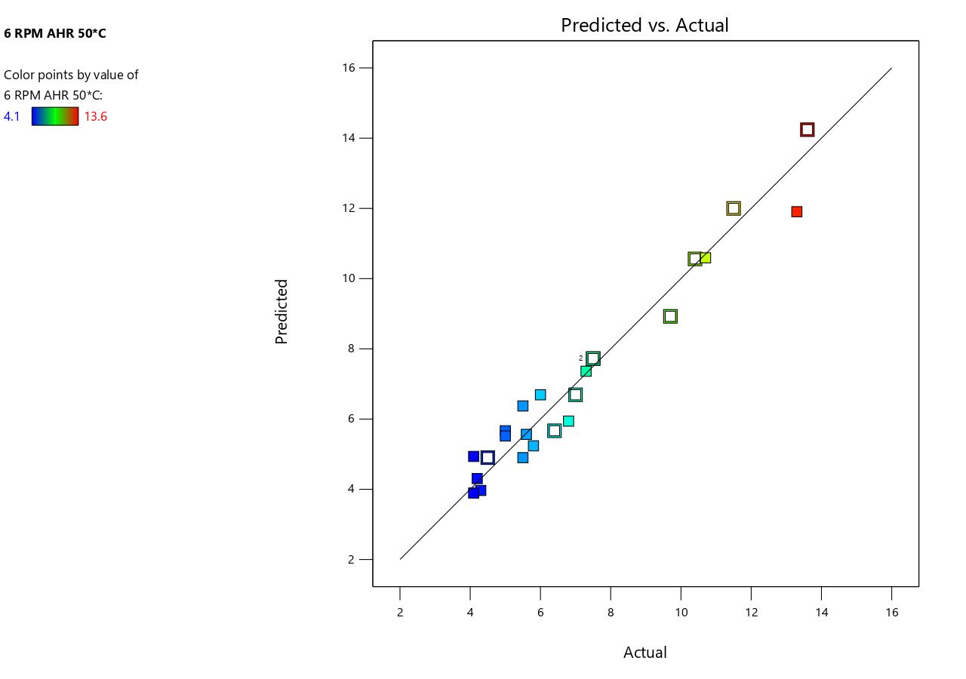
- 3D Surface Plot for No Contamination
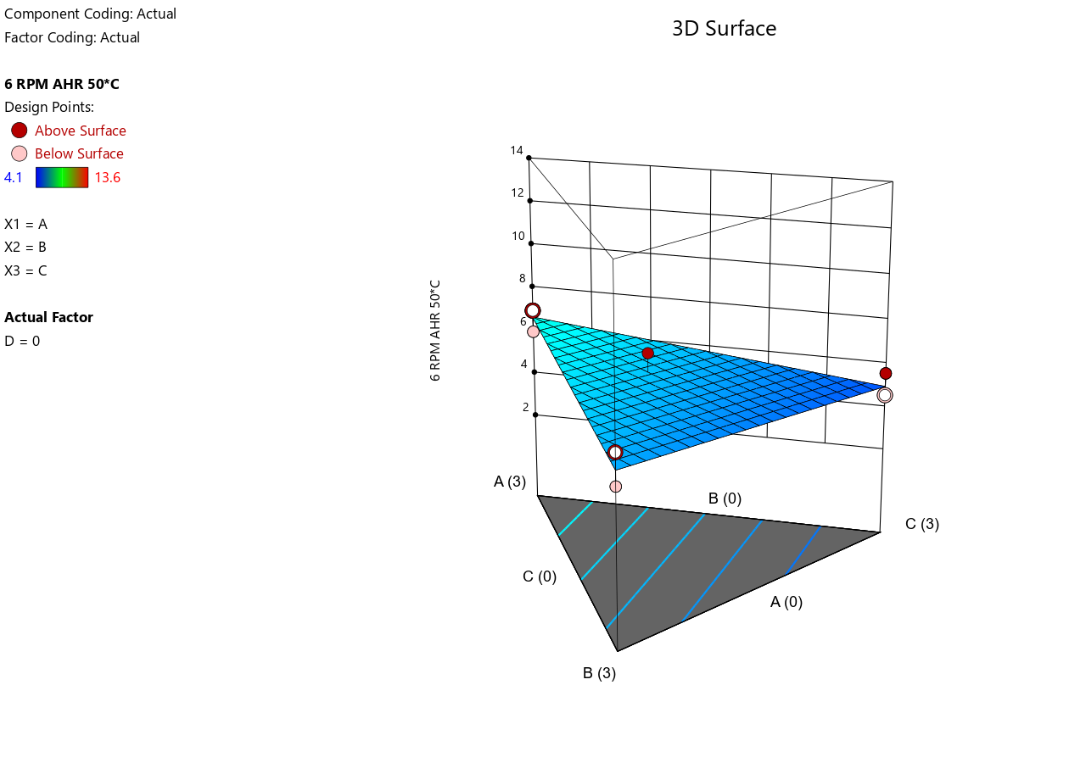
- 3D Surface Plot for Low Contamination
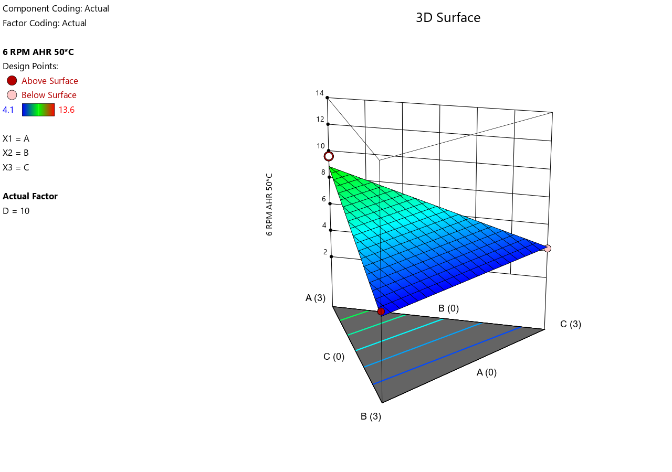
- 3D Surface Plot for Medium Contamination
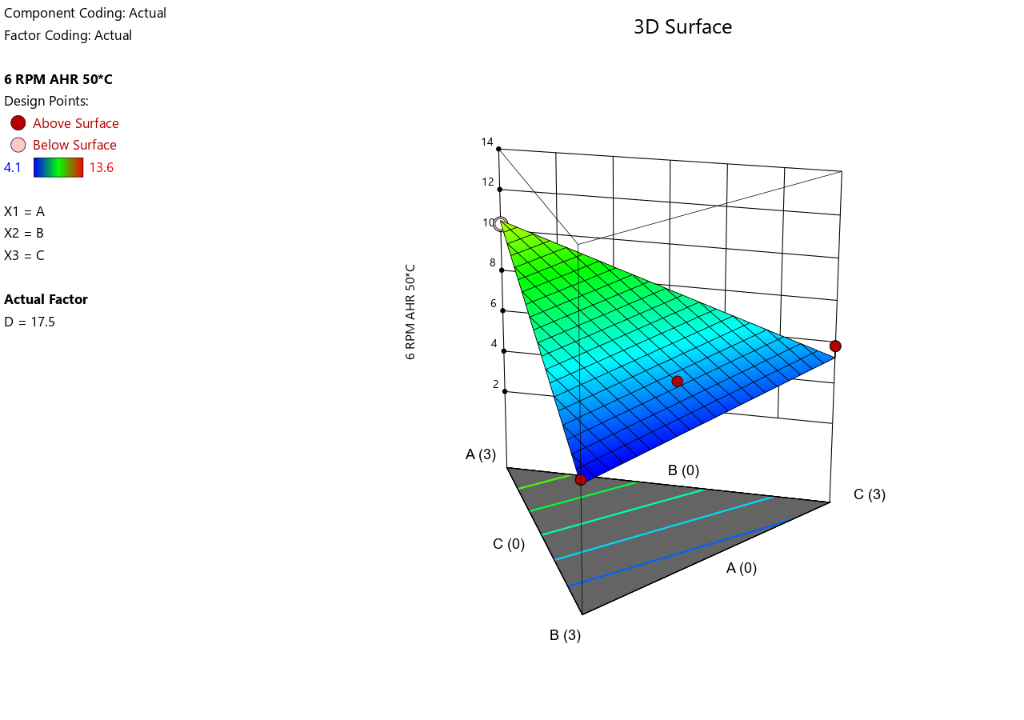
- 3D Surface Plot for High Contamination
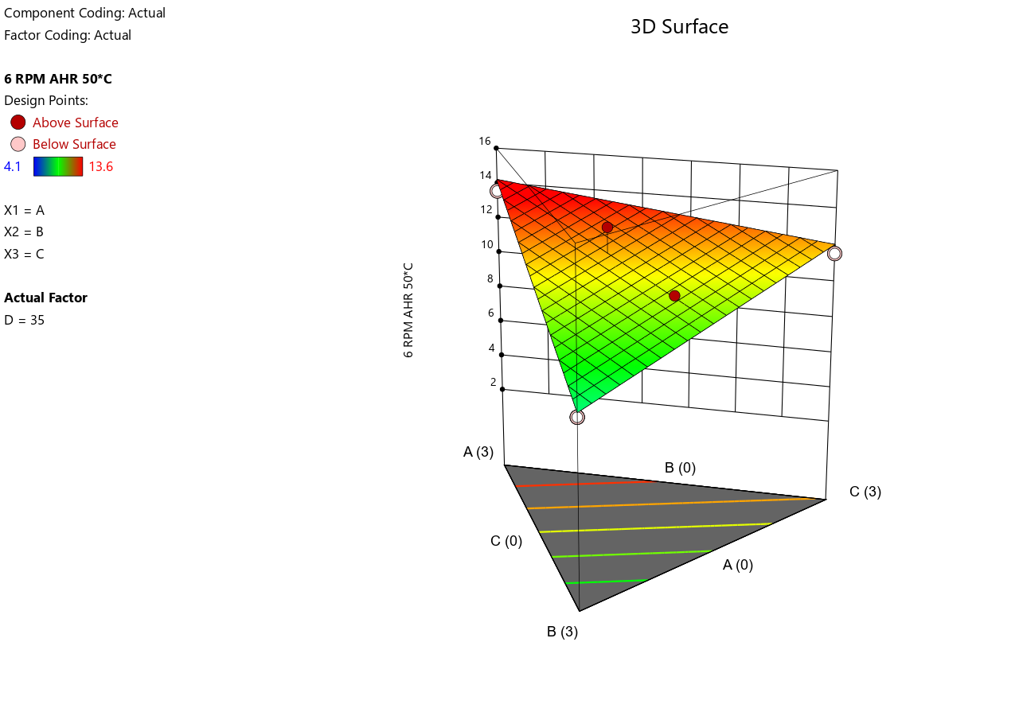
- Shear Stress at 3 RPM at 50°C.
- Predicted vs. Actual.
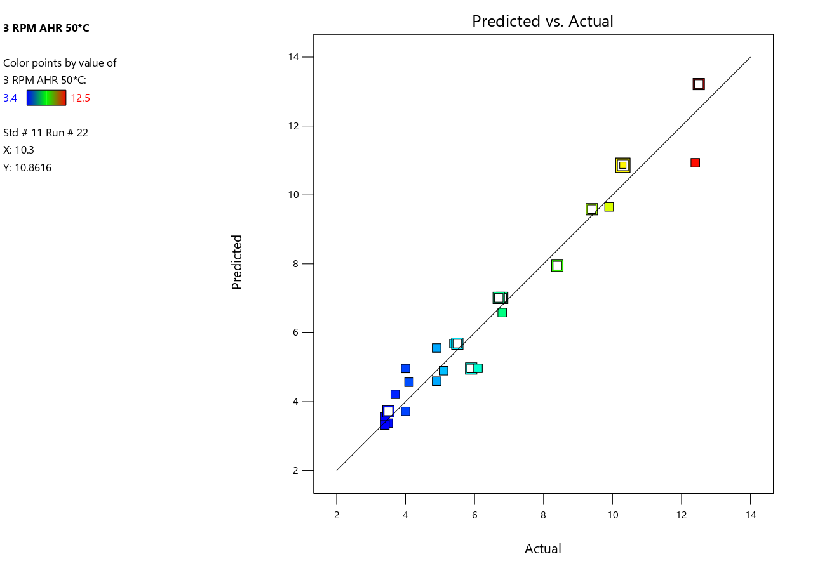
- 3D Surface Plot for No Contamination

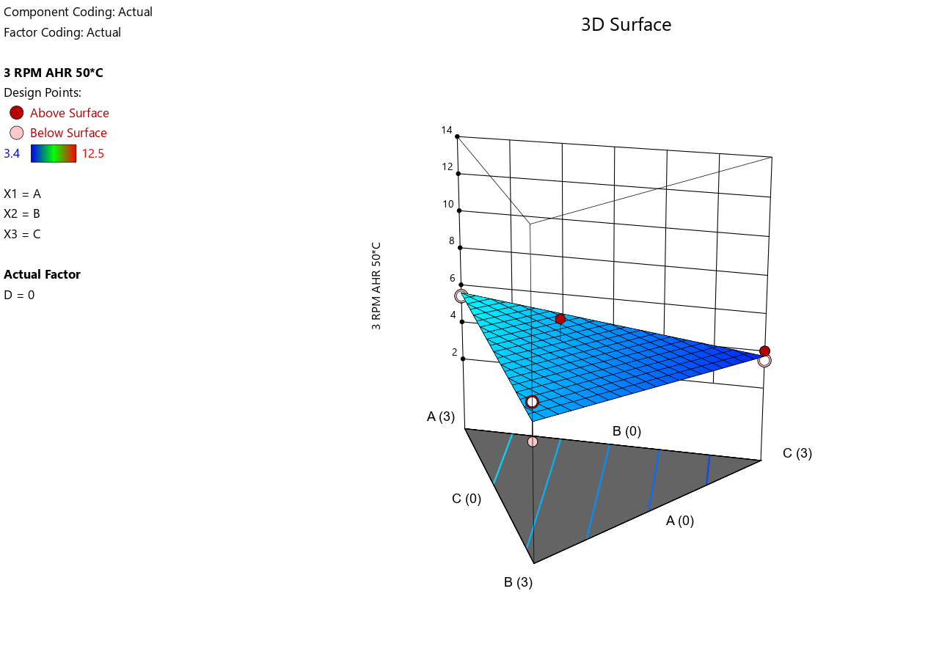
- 3D Surface Plot for Low Contamination
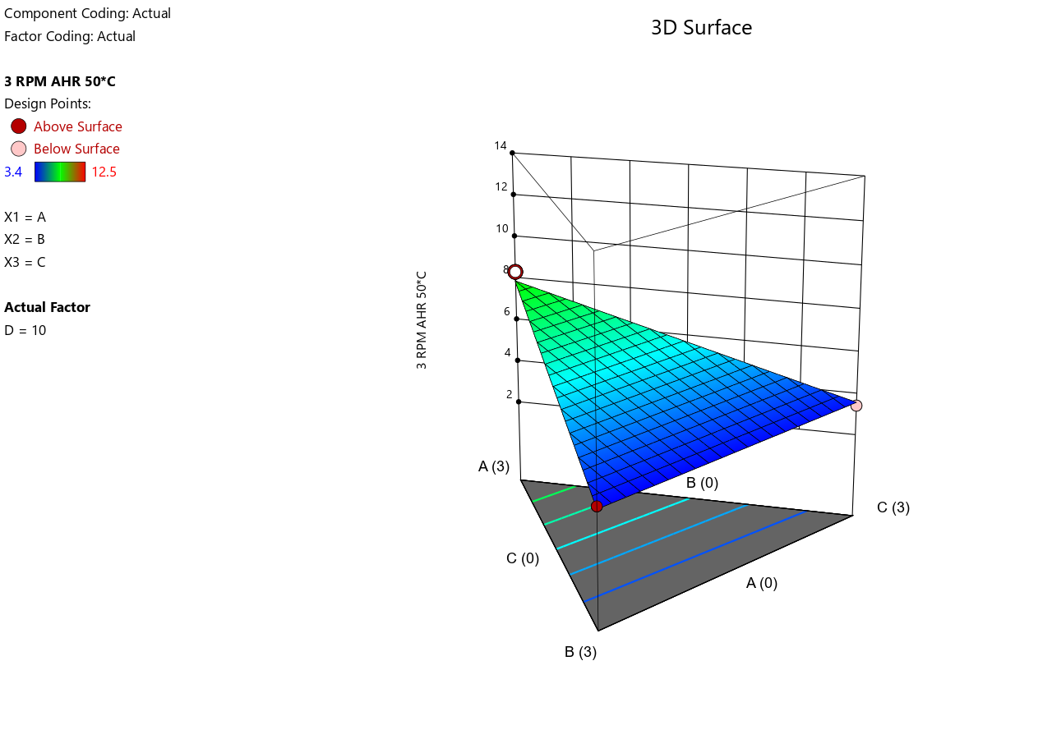

- 3D Surface Plot for Medium Contamination
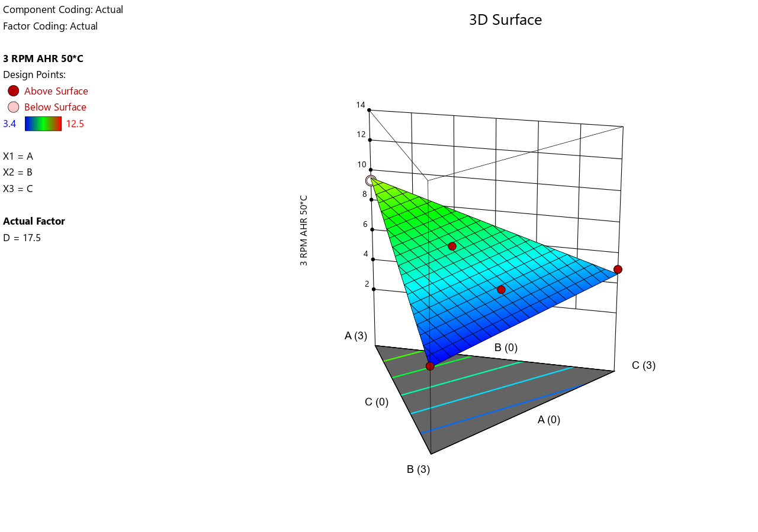
- 3D Surface Plot for High Contamination
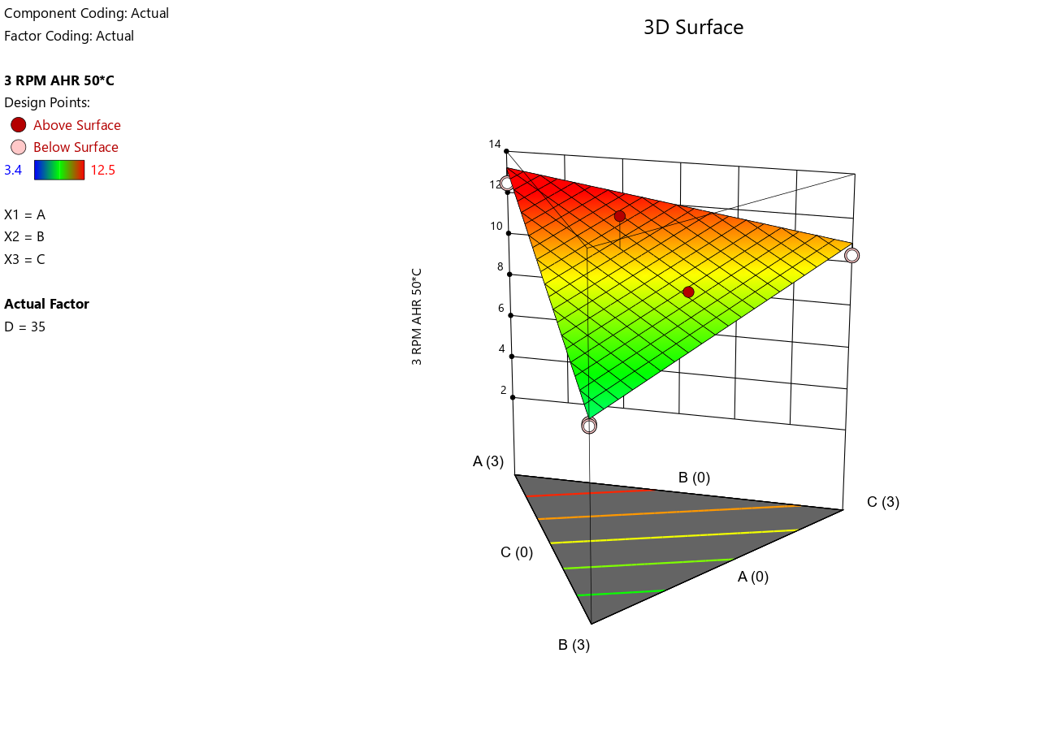
- Electrical Stability at 50 °C
- 3D Surface Plot for No Contamination
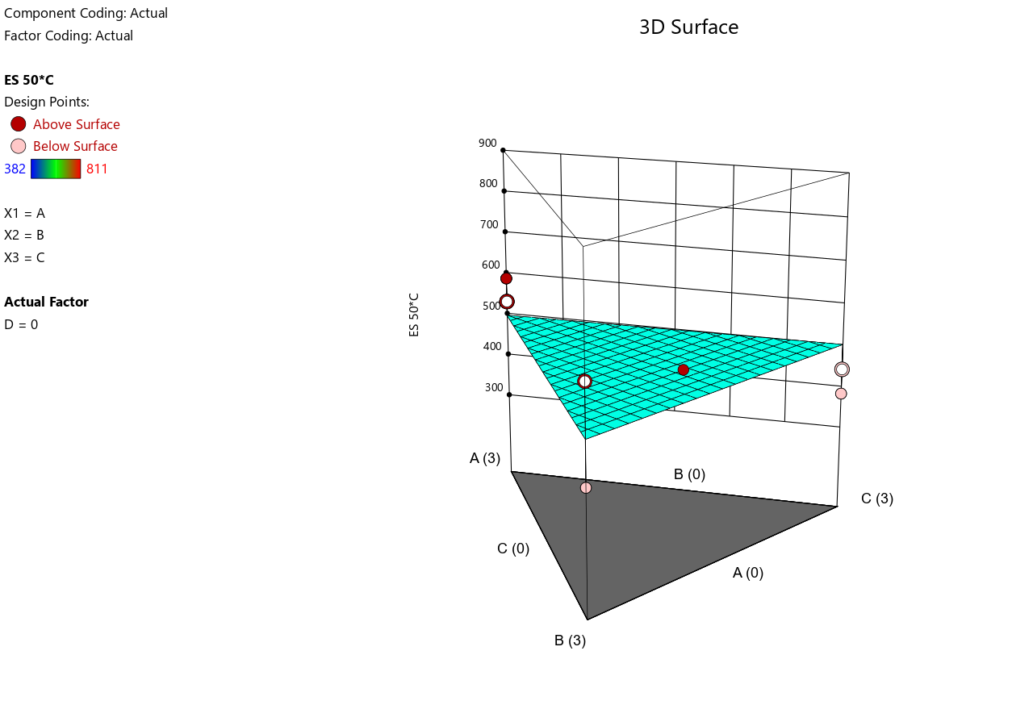
- 3D Surface Plot for Low Contamination
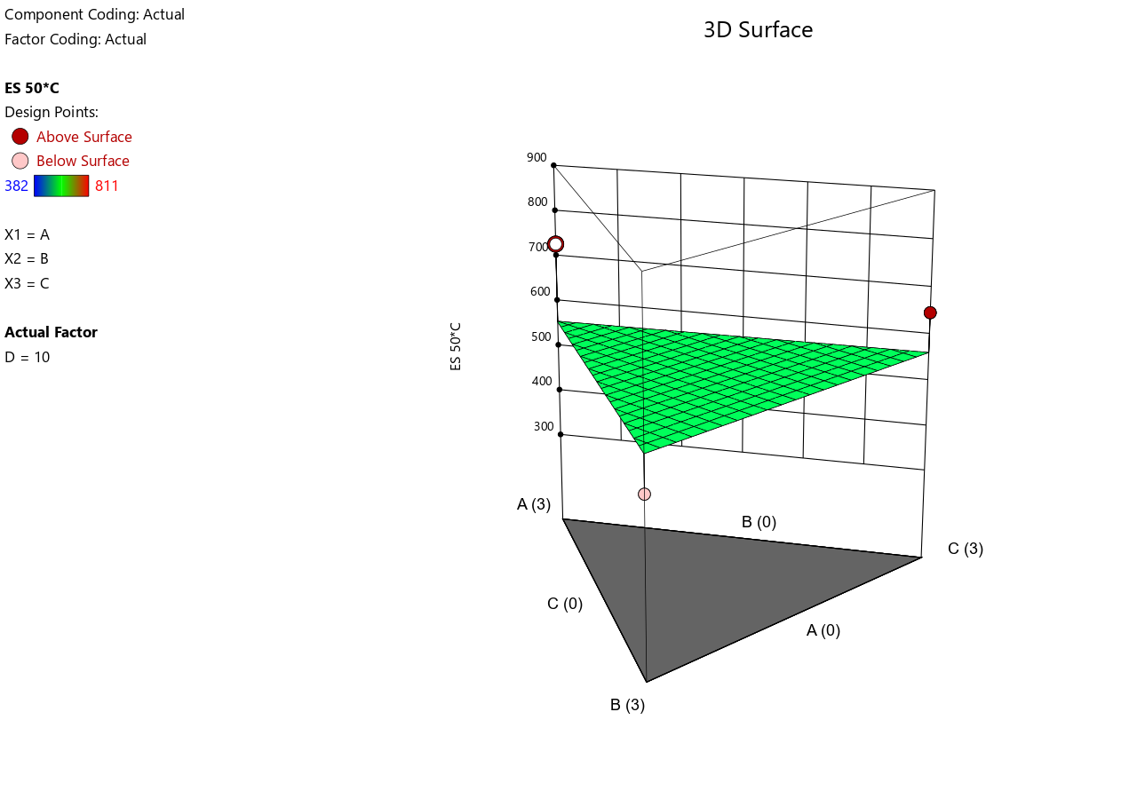
- 3D Surface Plot for Medium Contamination
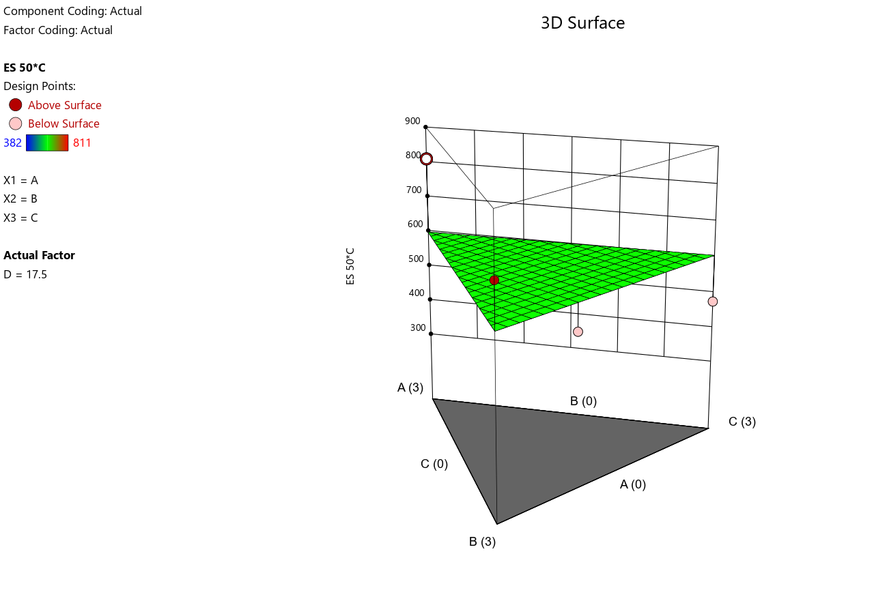
- 3D Surface Plot for High Contamination

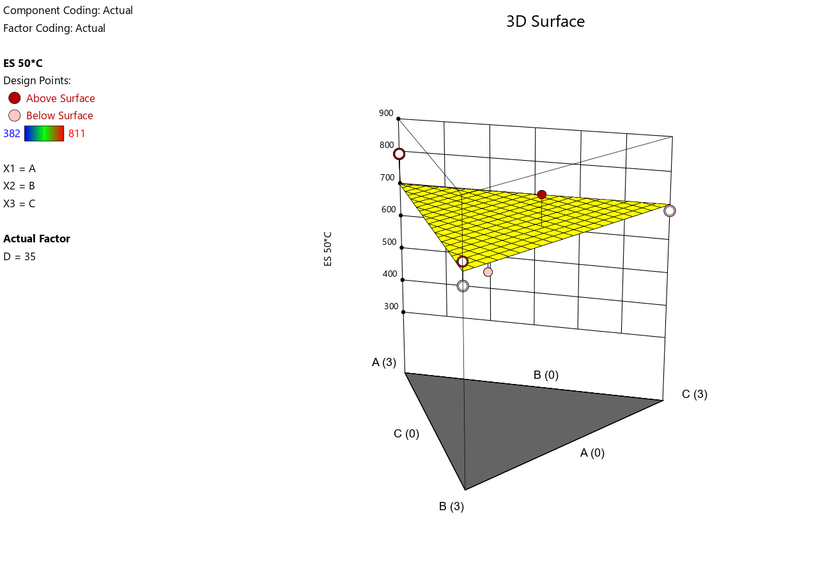
- Shear Stress at 600 RPM at 80°C.
- Predicted vs. Actual.
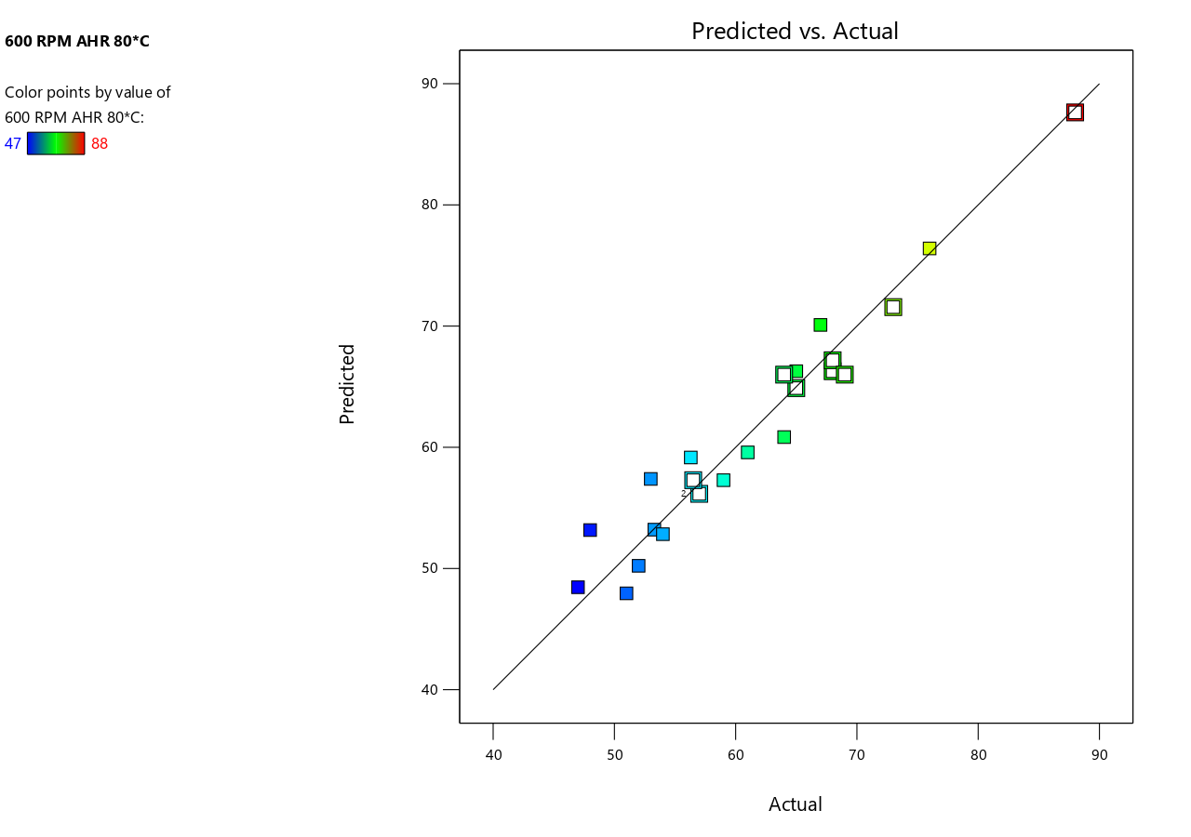
- 3D Surface Plot for No Contamination
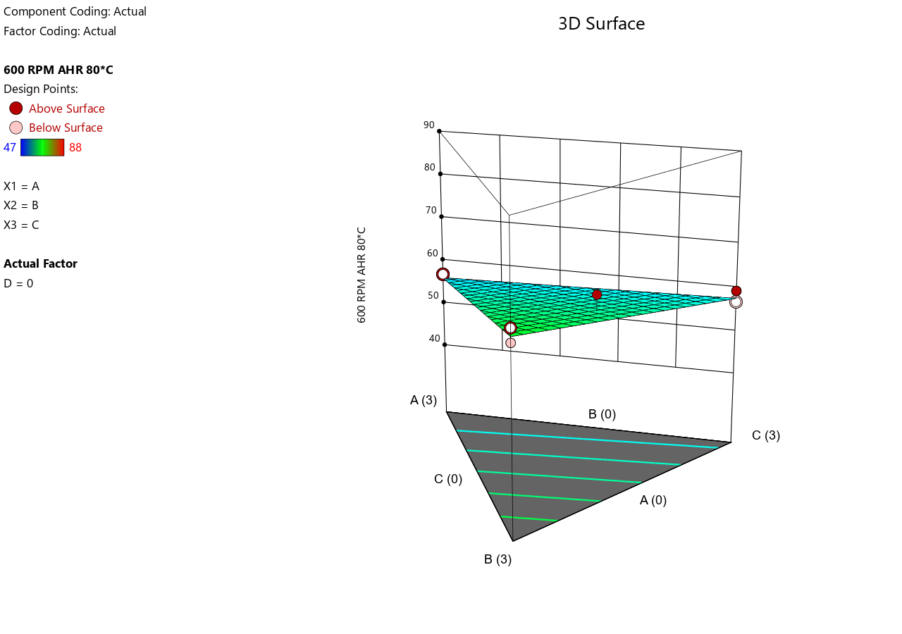
- 3D Surface Plot for Low Contamination
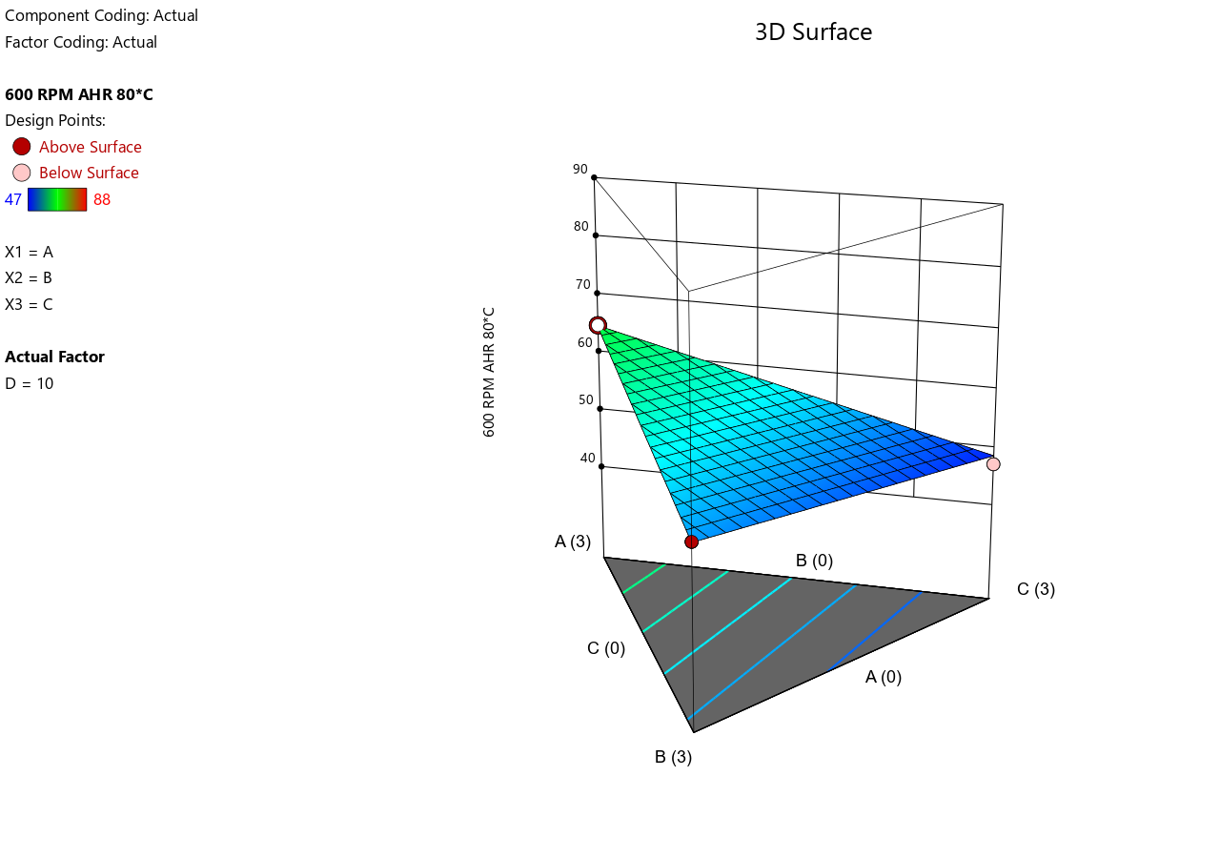
- 3D Surface Plot for Medium Contamination

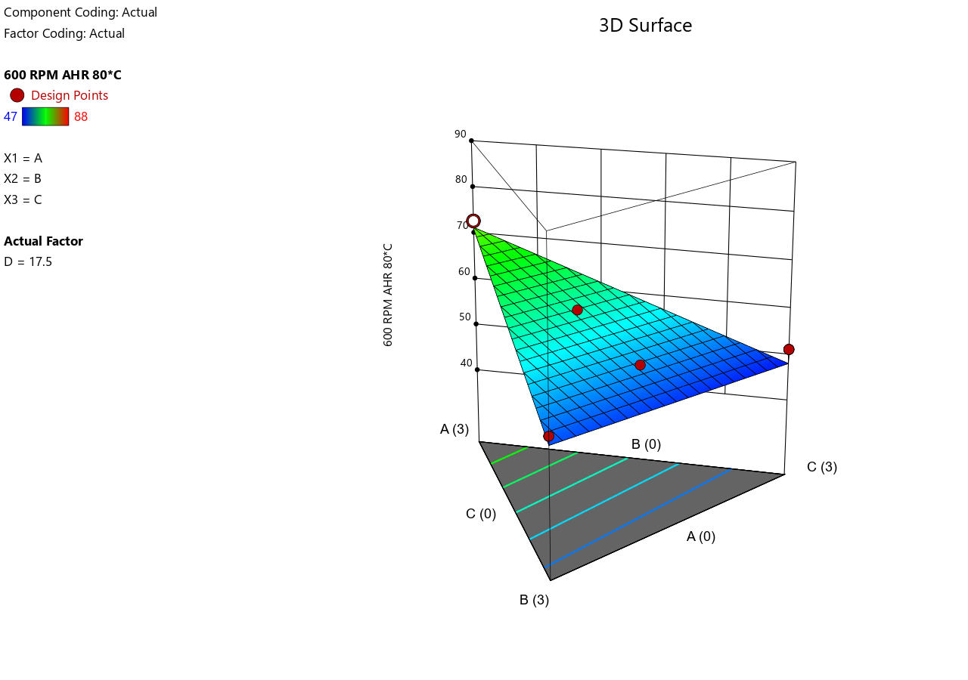
- 3D Surface Plot for High Contamination
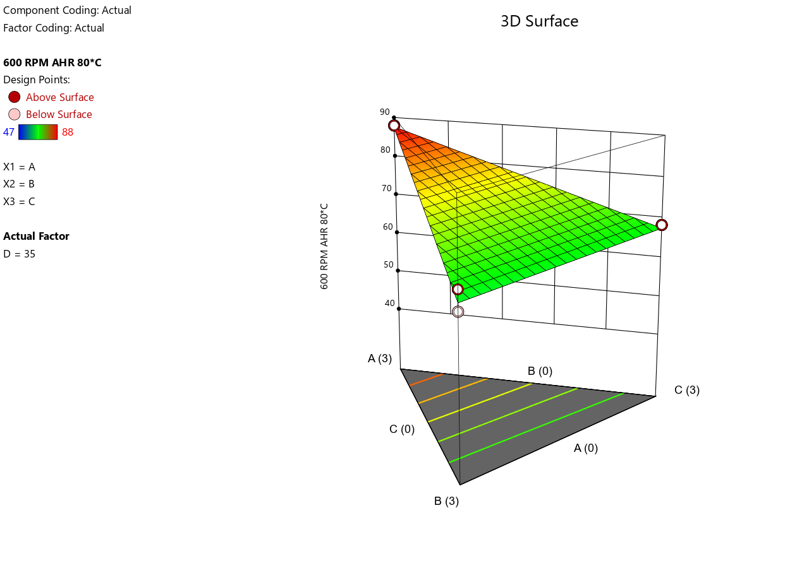
- Shear Stress at 300 RPM at 80°C.
- Predicted vs. Actual.
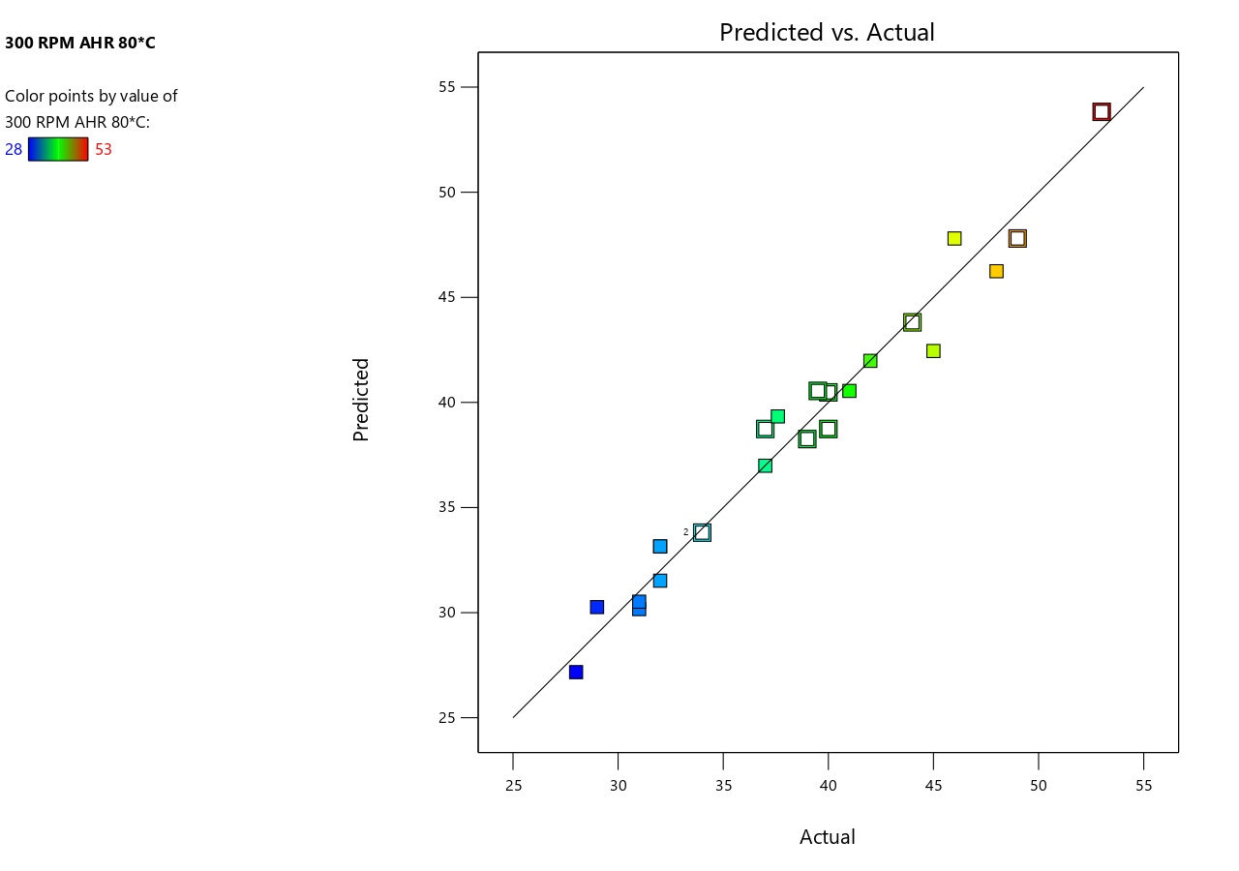
- 3D Surface Plot for No Contamination

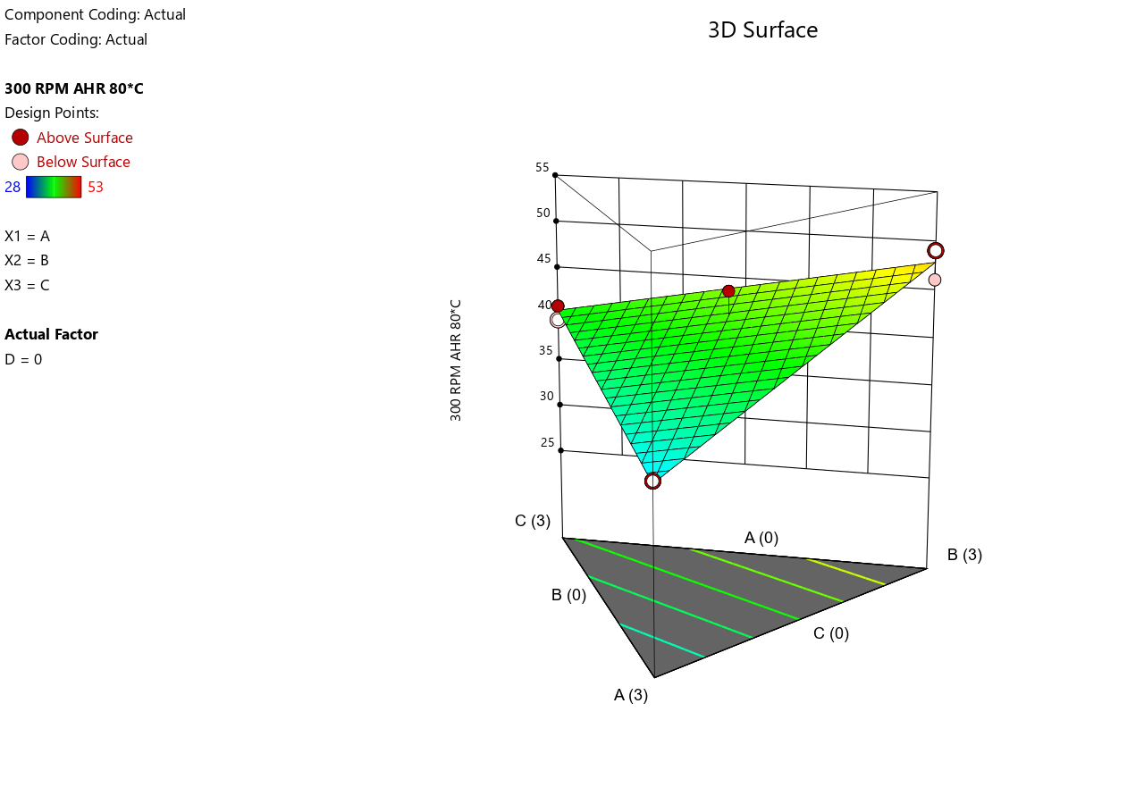
- 3D Surface Plot for Low Contamination
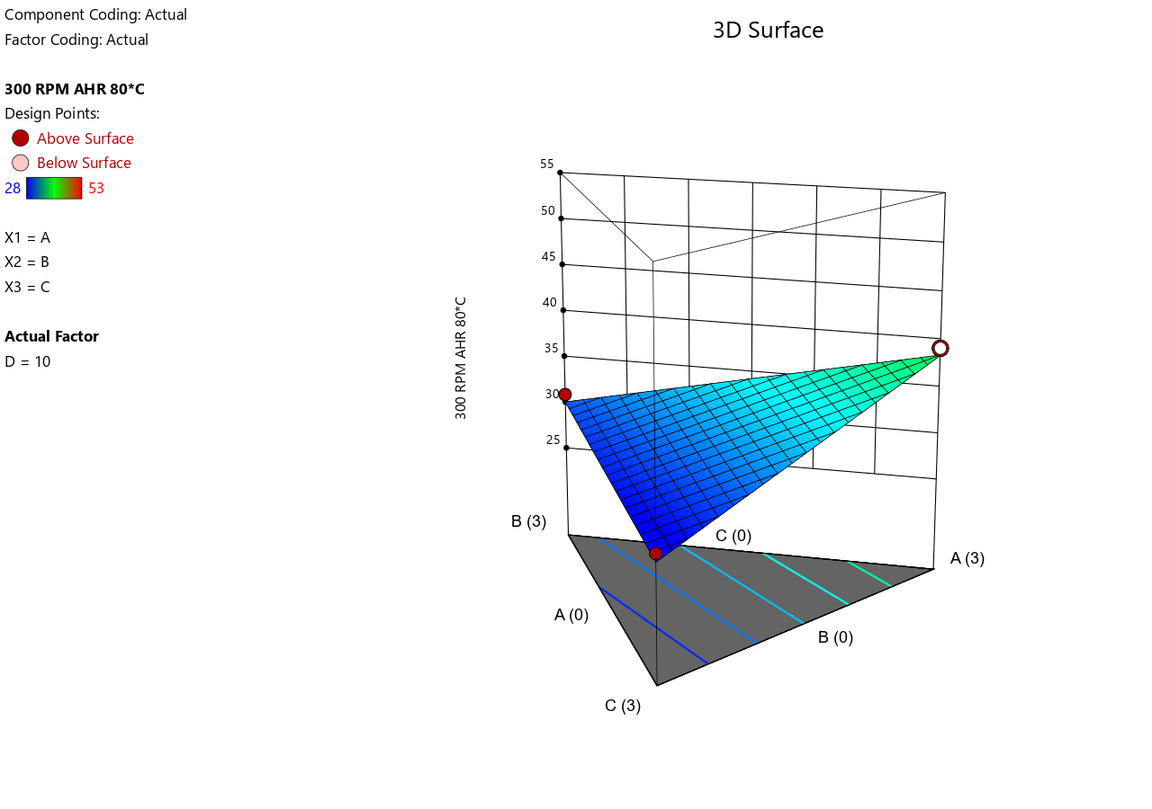
- 3D Surface Plot for Medium Contamination
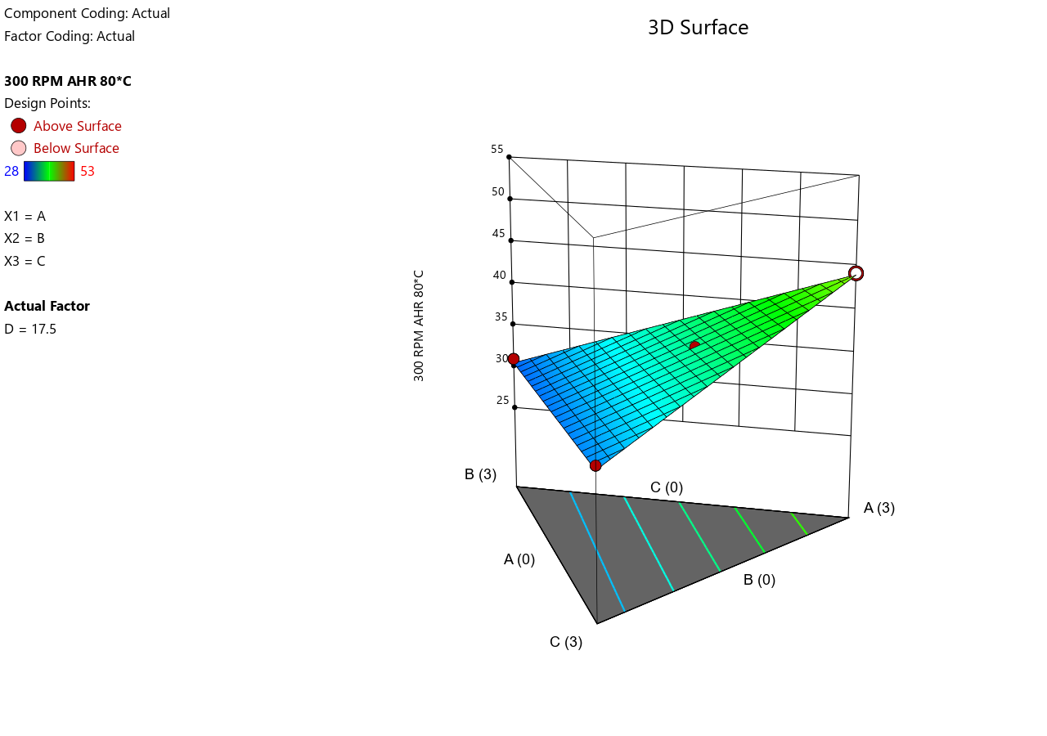
- 3D Surface Plot for High Contamination
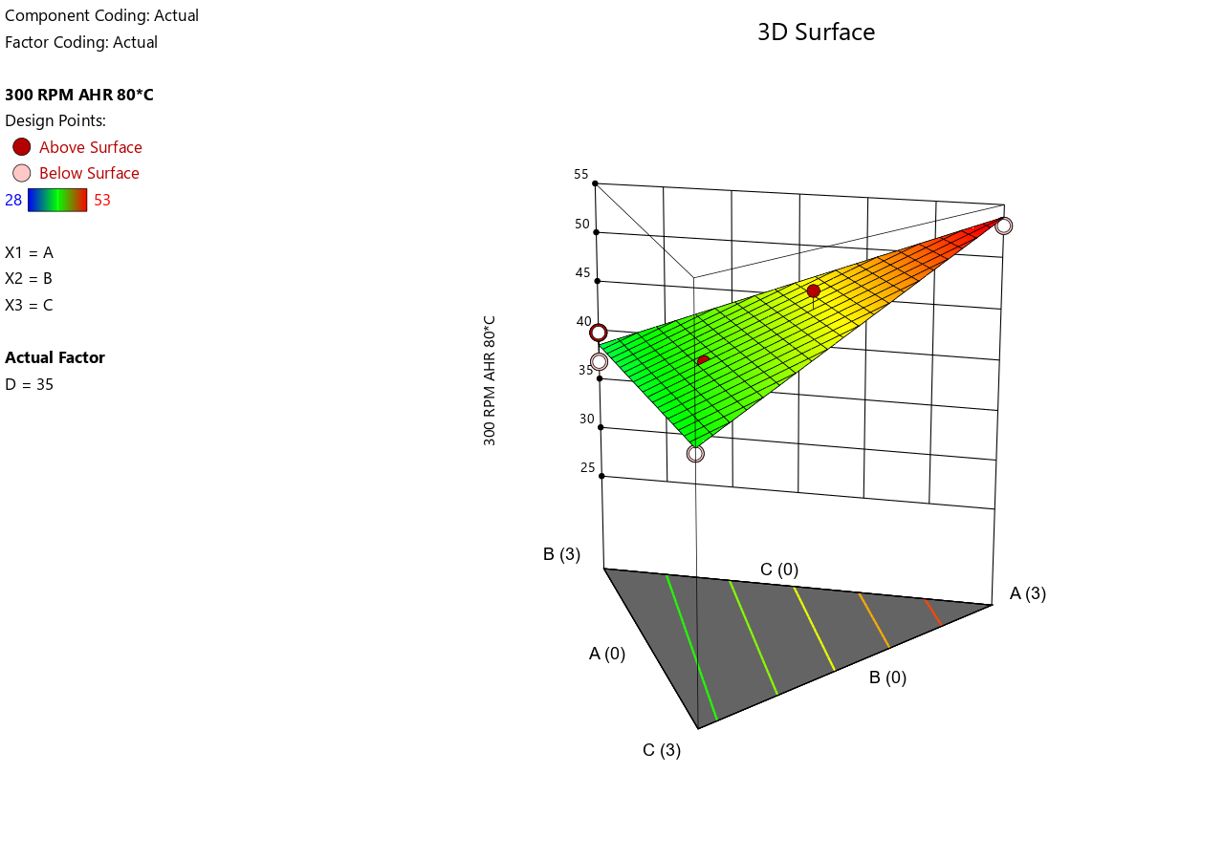

- Shear Stress at 200 RPM at 80°C.
- Predicted vs. Actual.
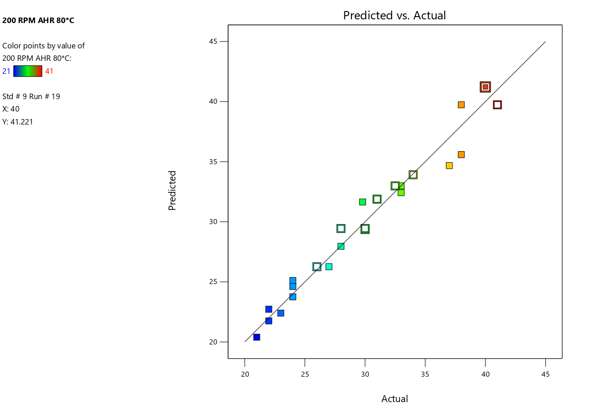
- 3D Surface Plot for No Contamination
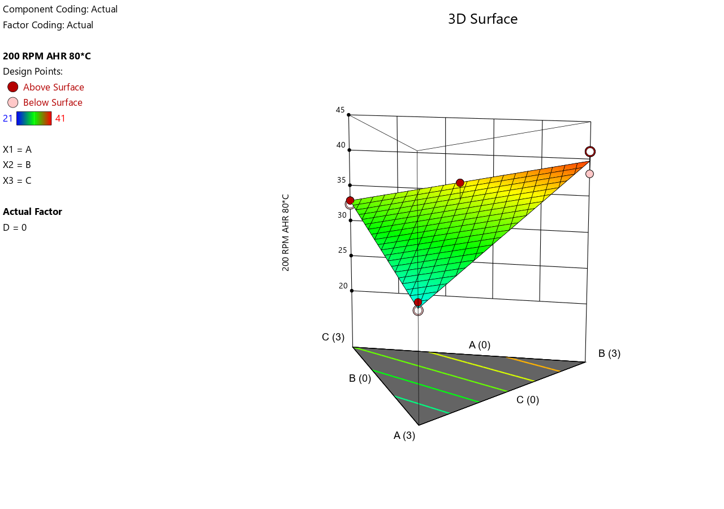
- 3D Surface Plot for Low Contamination
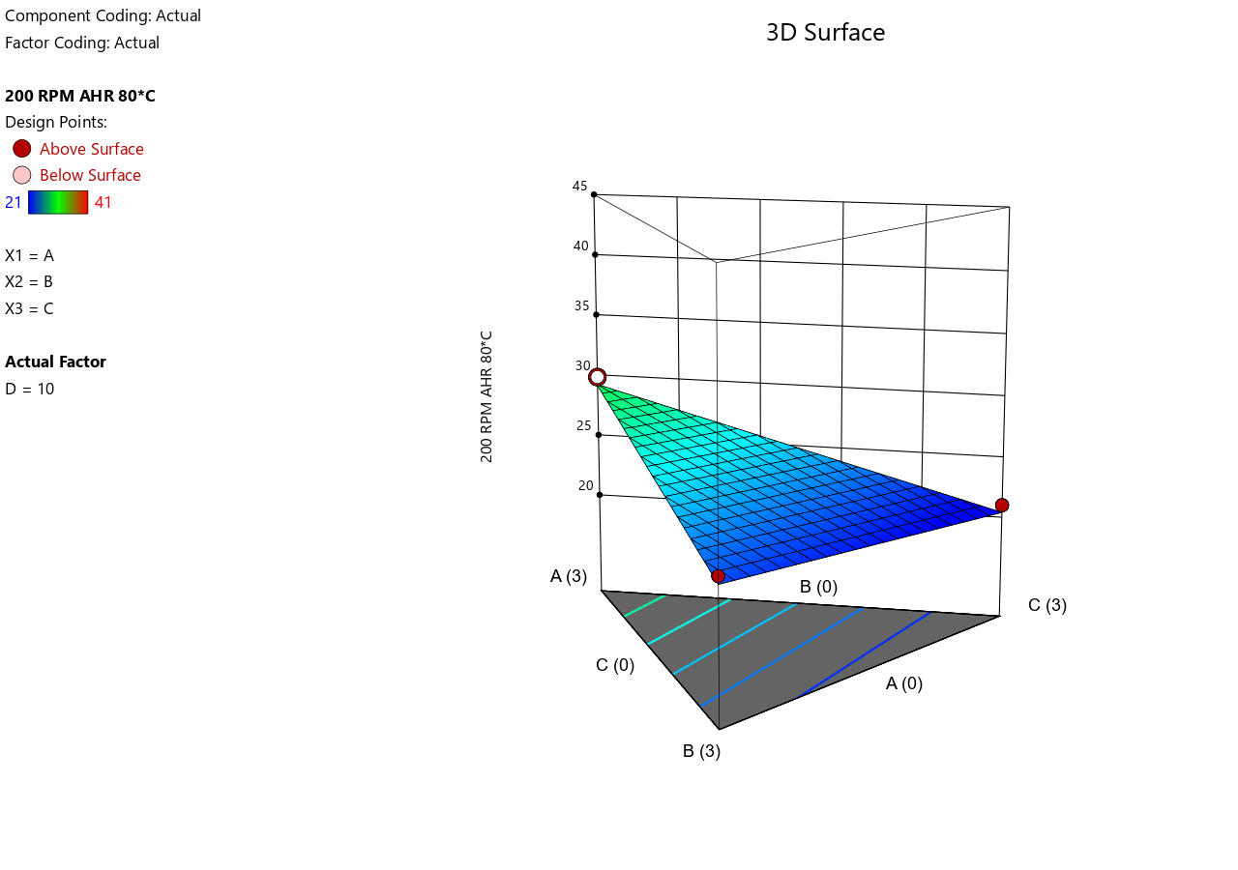
- 3D Surface Plot for Medium Contamination
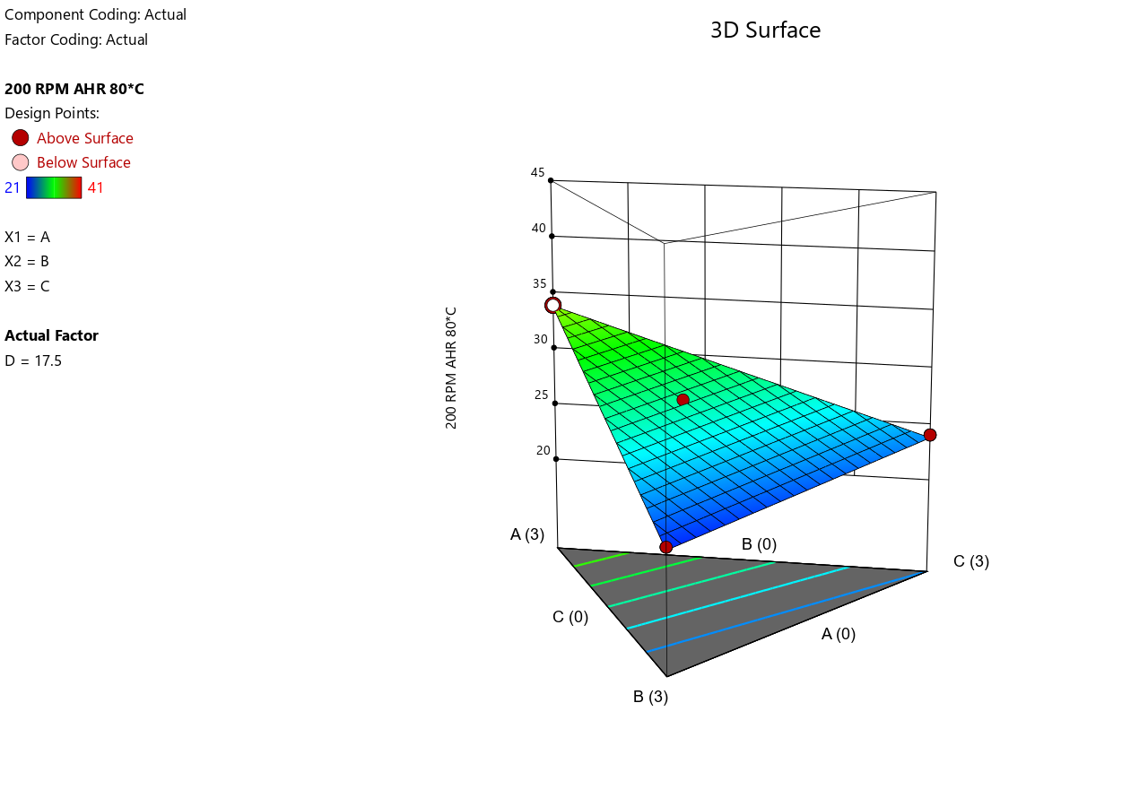
- 3D Surface Plot for High Contamination
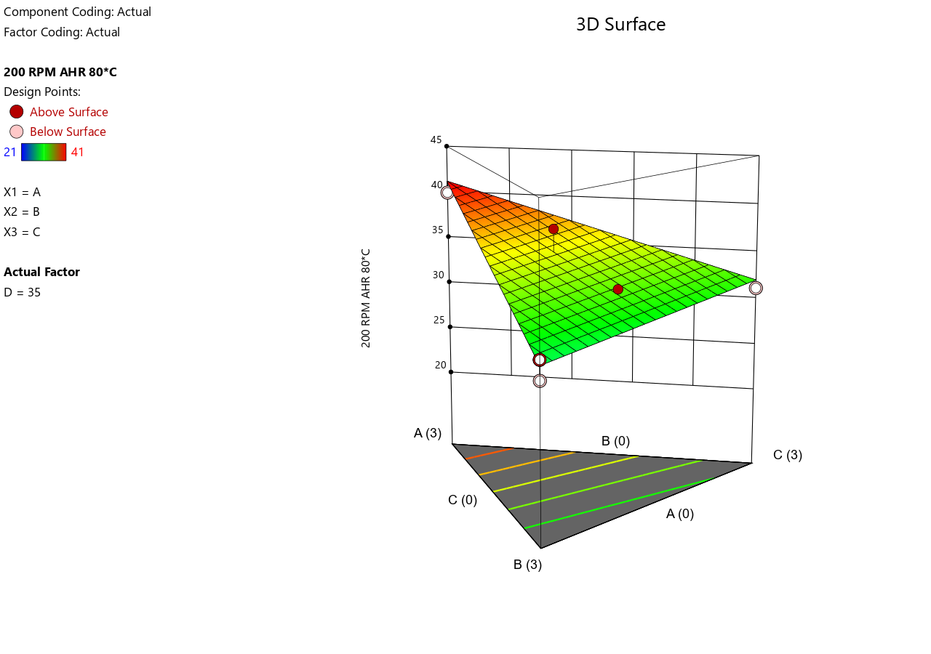
- Shear Stress at 100 RPM at 80°C.
- Predicted vs. Actual.
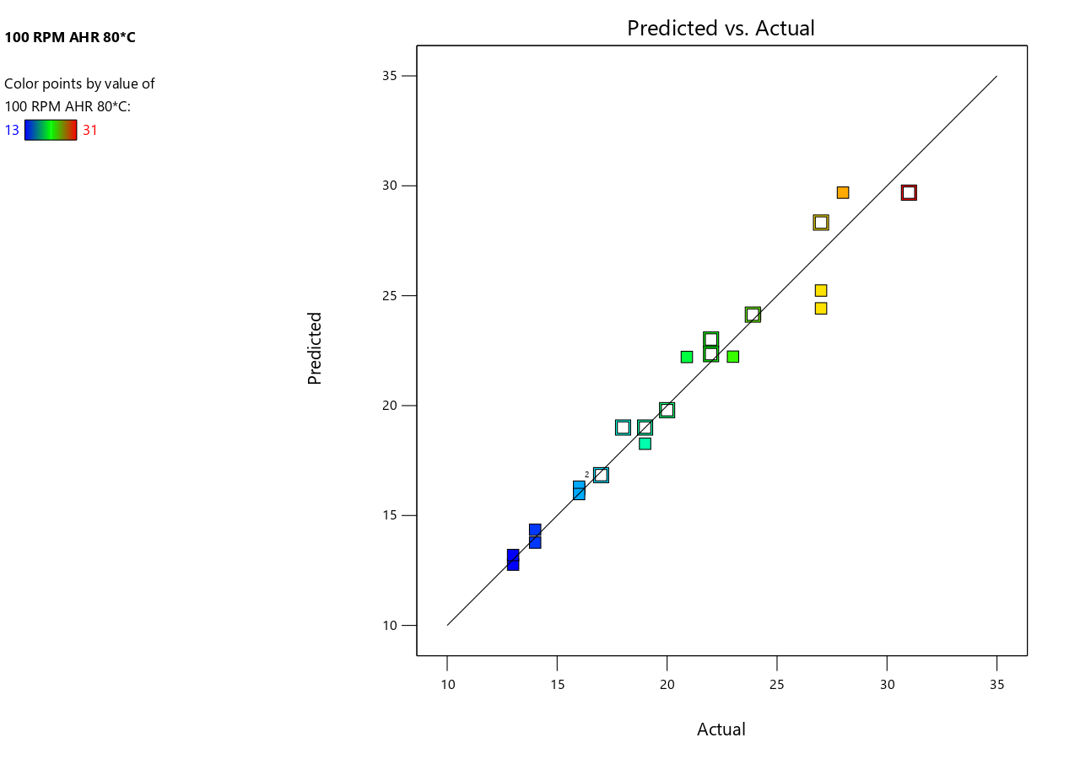
- 3D Surface Plot for No Contamination
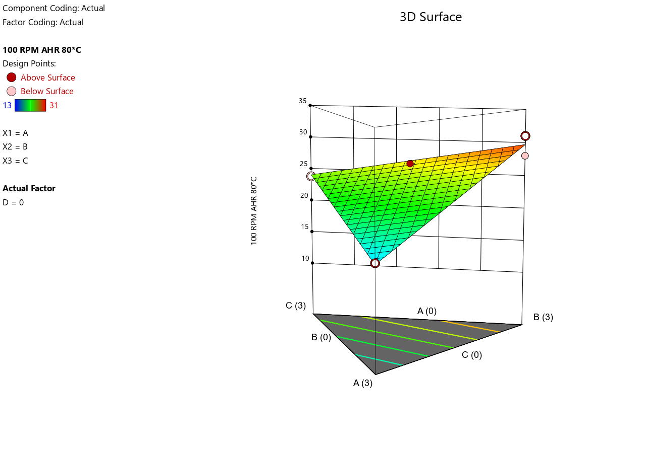
- 3D Surface Plot for Low Contamination
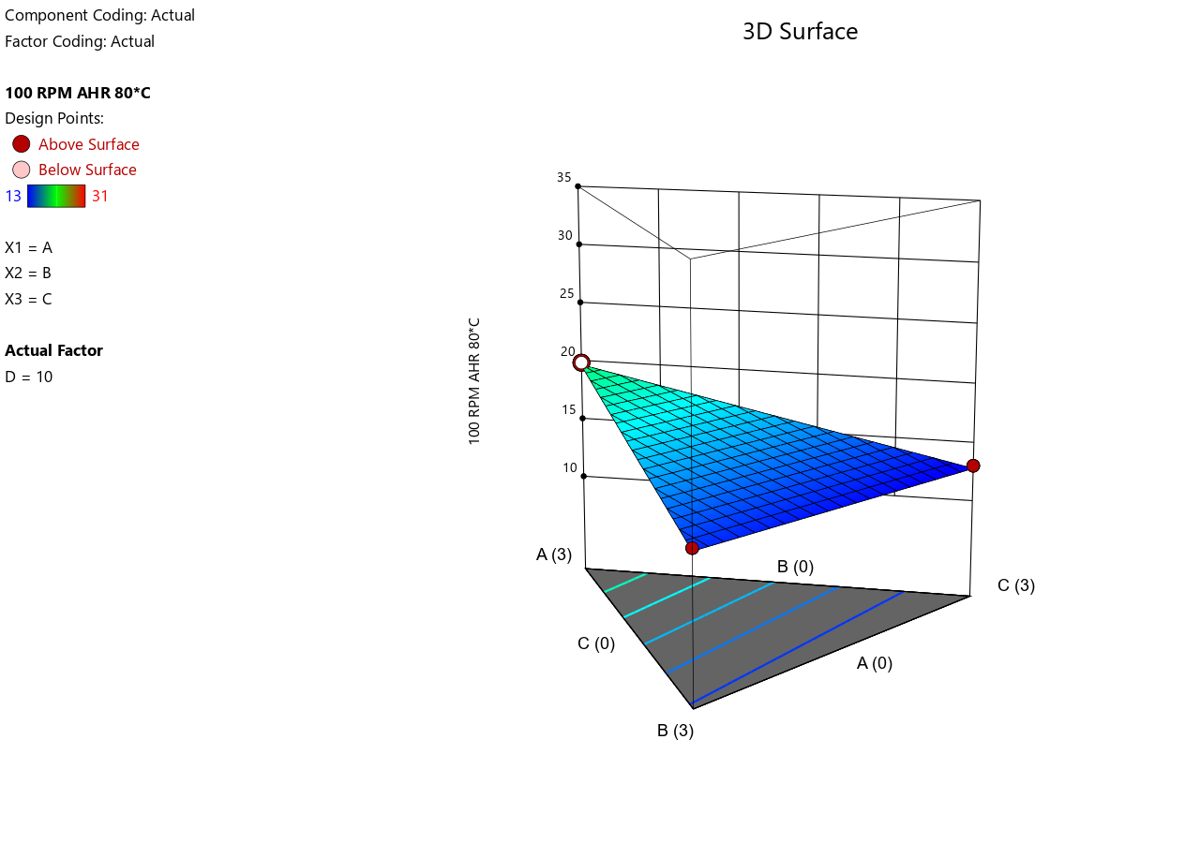
- 3D Surface Plot for Medium Contamination
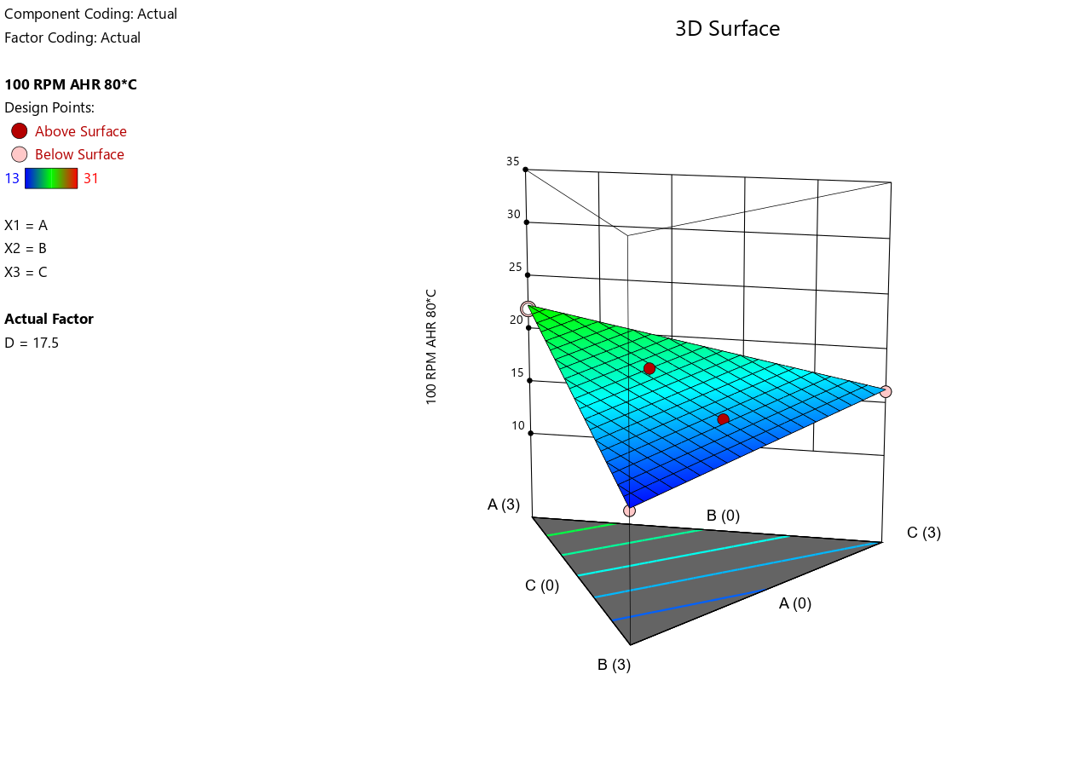
- 3D Surface Plot for High Contamination
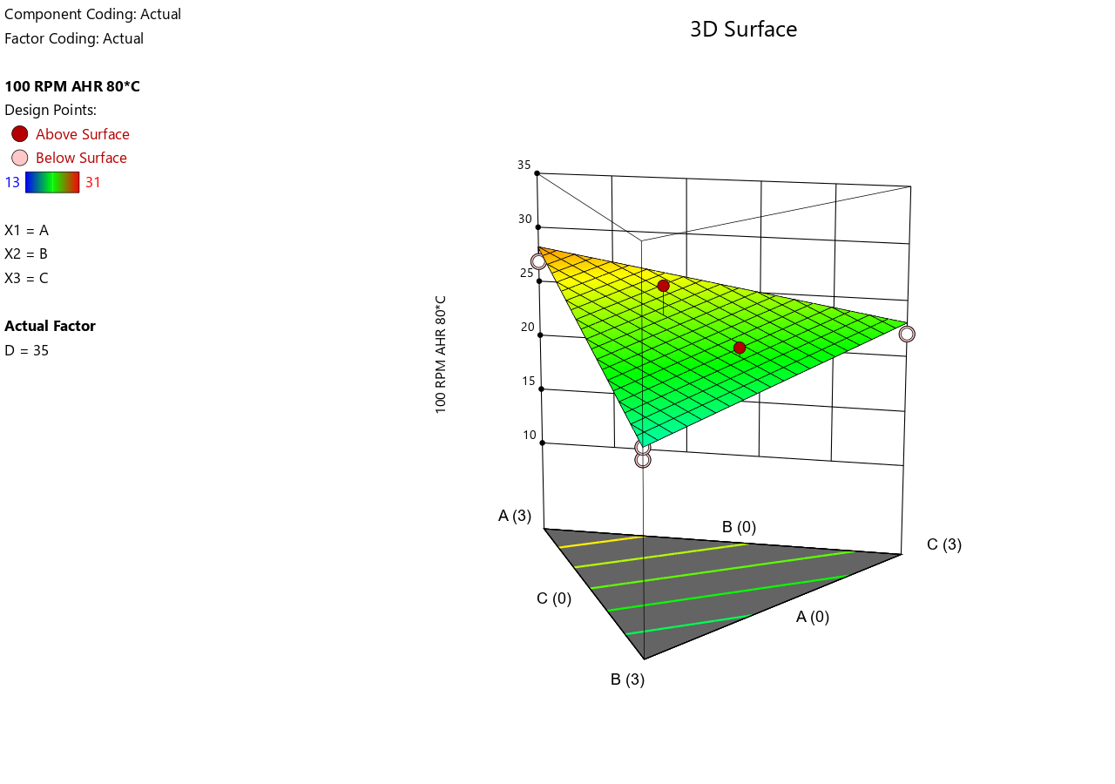
- Shear Stress at 6 RPM at 80°C.
- Predicted vs. Actual.
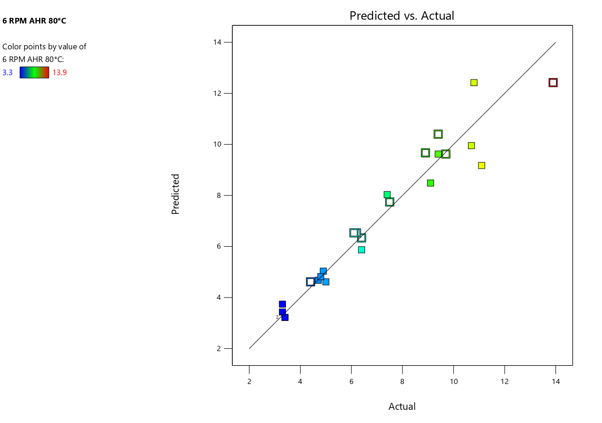
- 3D Surface Plot for No Contamination

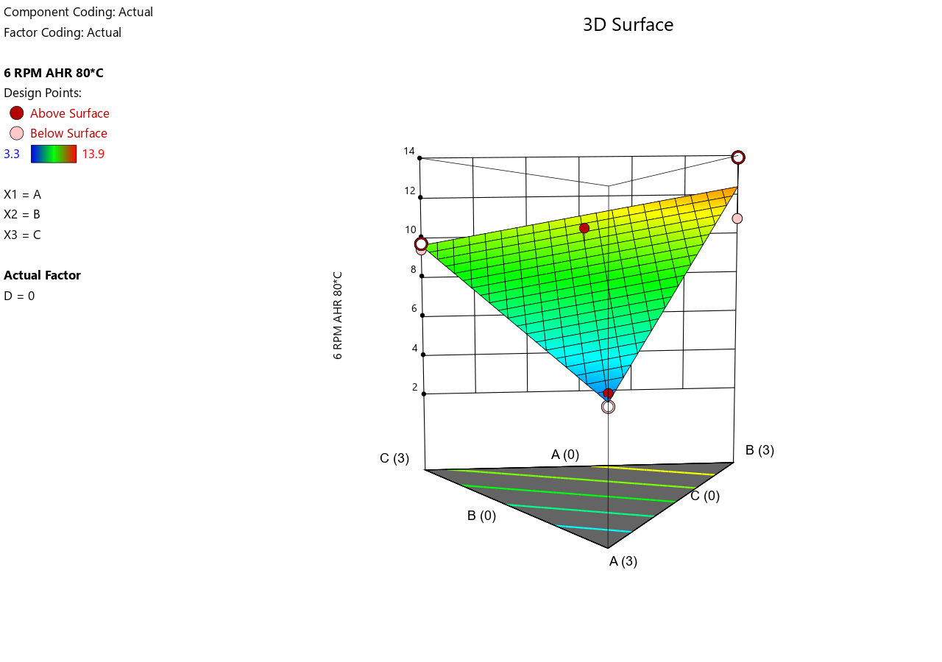
- 3D Surface Plot for Low Contamination
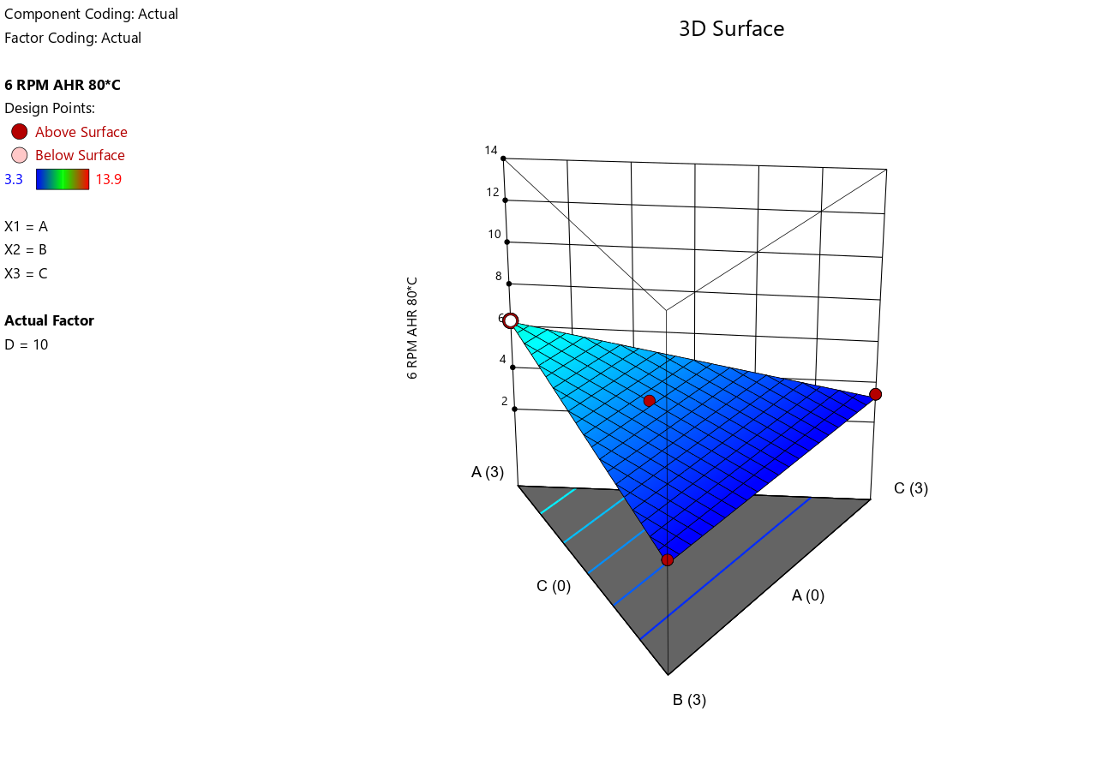
- 3D Surface Plot for Medium Contamination

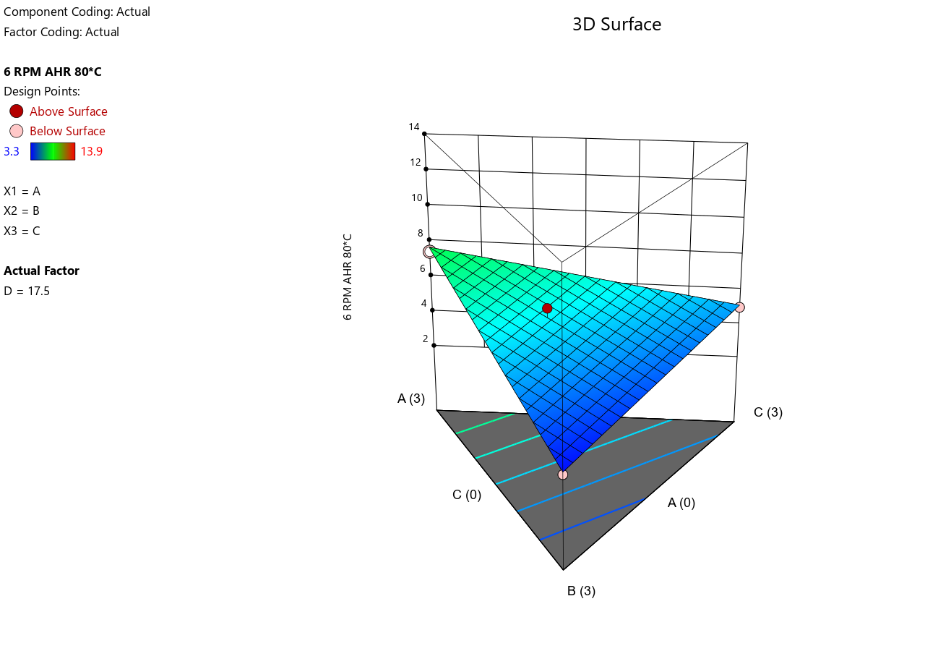
- 3D Surface Plot for High Contamination
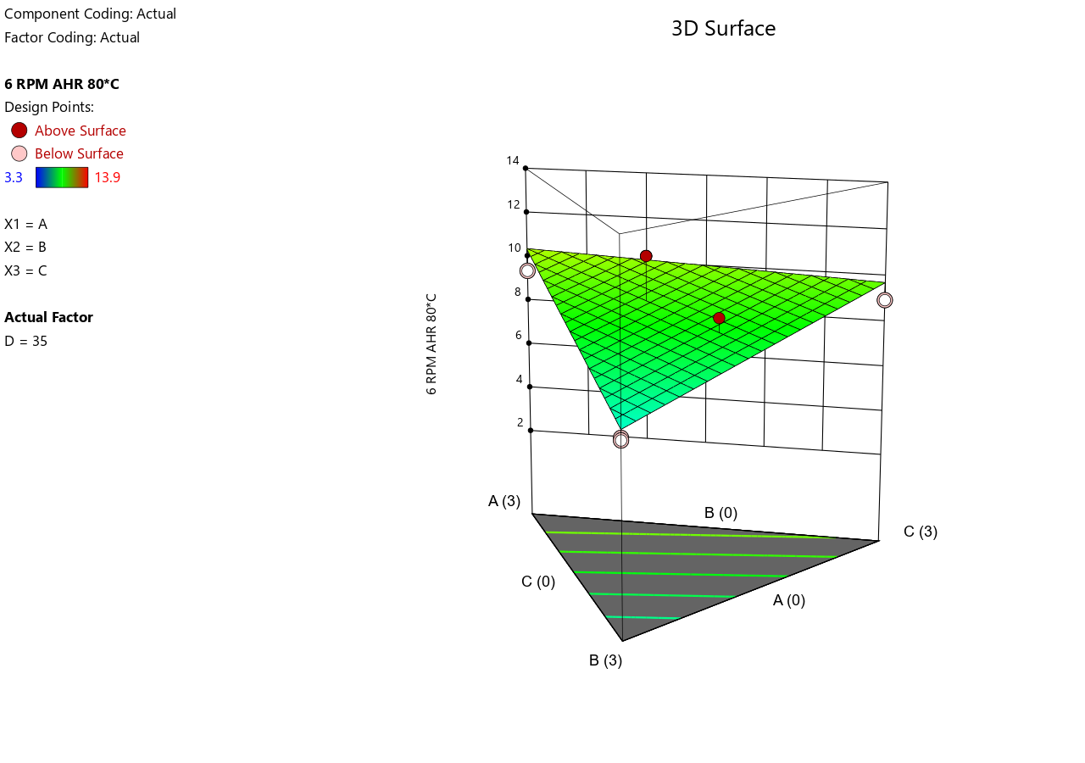
- Shear Stress at 3 RPM at 80°C.
- Predicted vs. Actual.
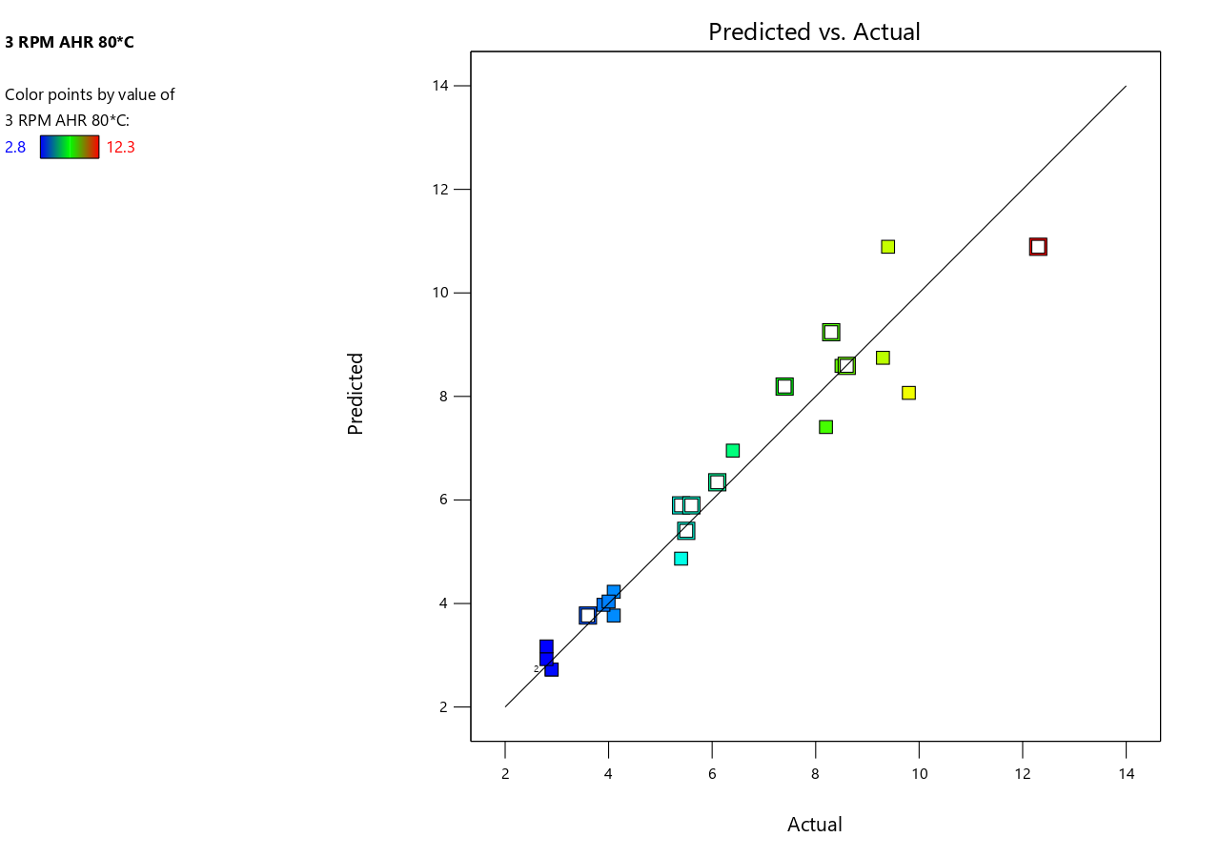
- 3D Surface Plot for No Contamination
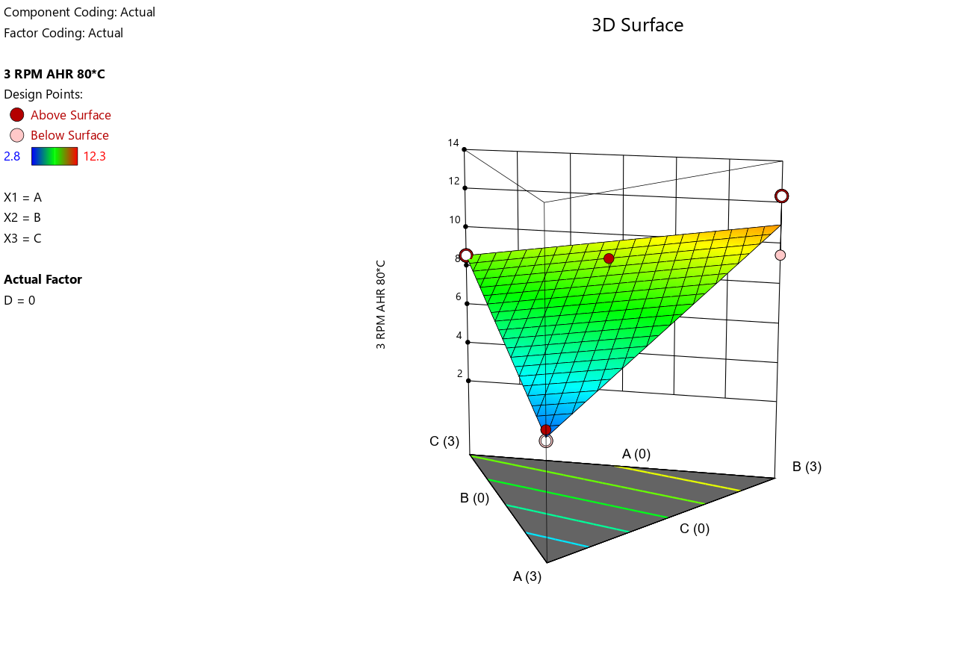
- 3D Surface Plot for Low Contamination
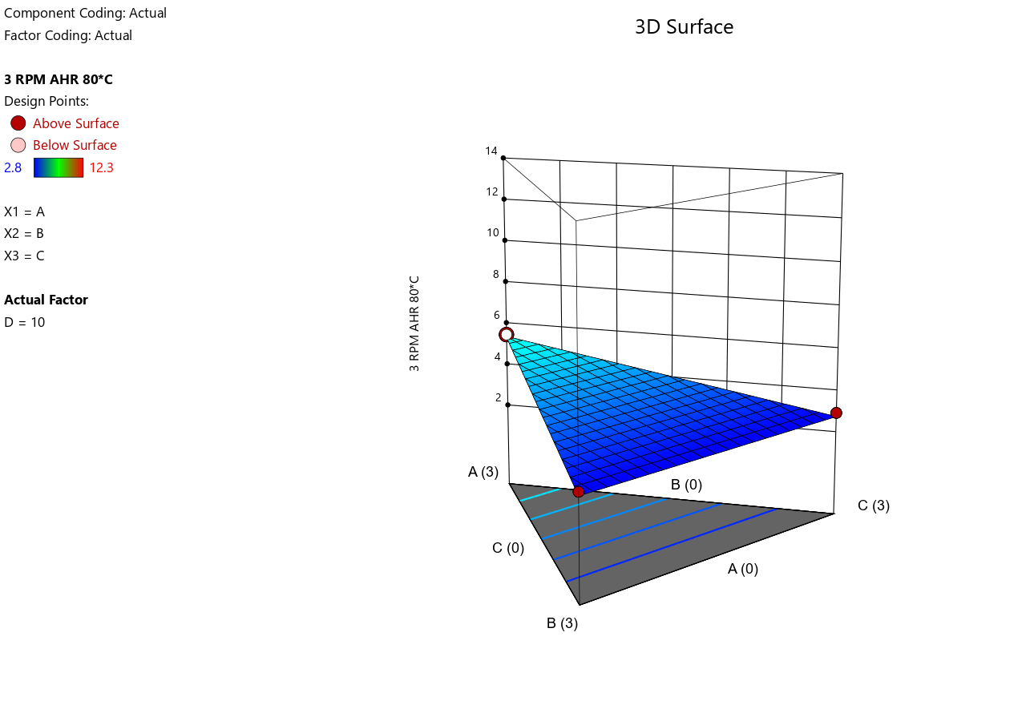
- 3D Surface Plot for Medium Contamination

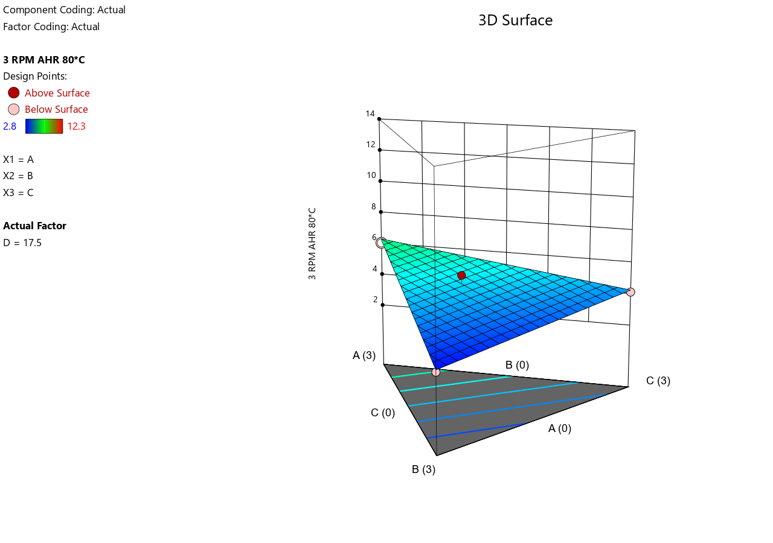
- 3D Surface Plot for High Contamination
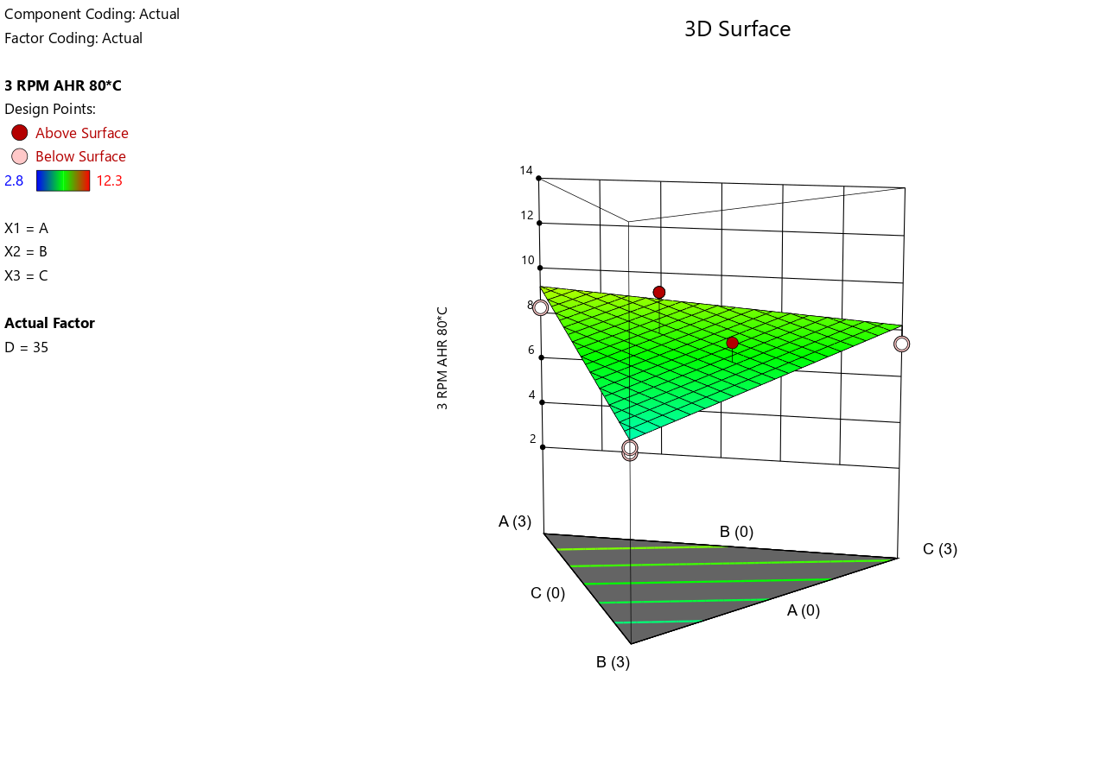
- Electrical Stability at 80 °C
- 3D Surface Plot for No Contamination
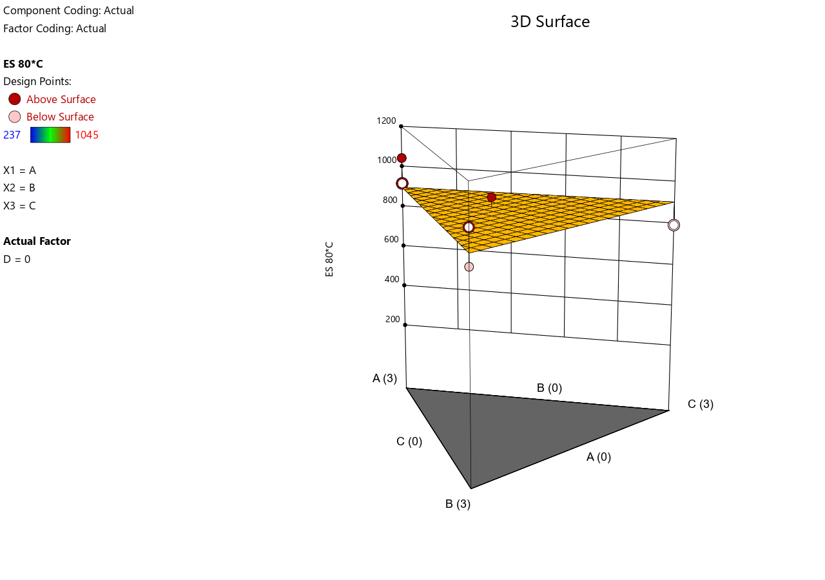
- 3D Surface Plot for Low Contamination
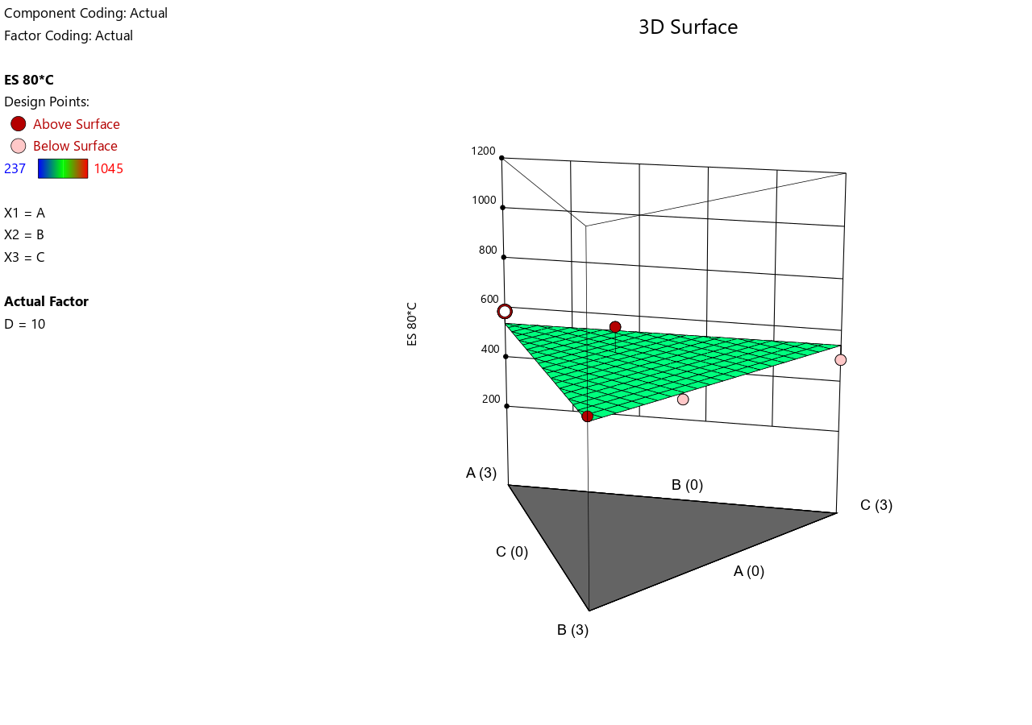
- 3D Surface Plot for Medium Contamination
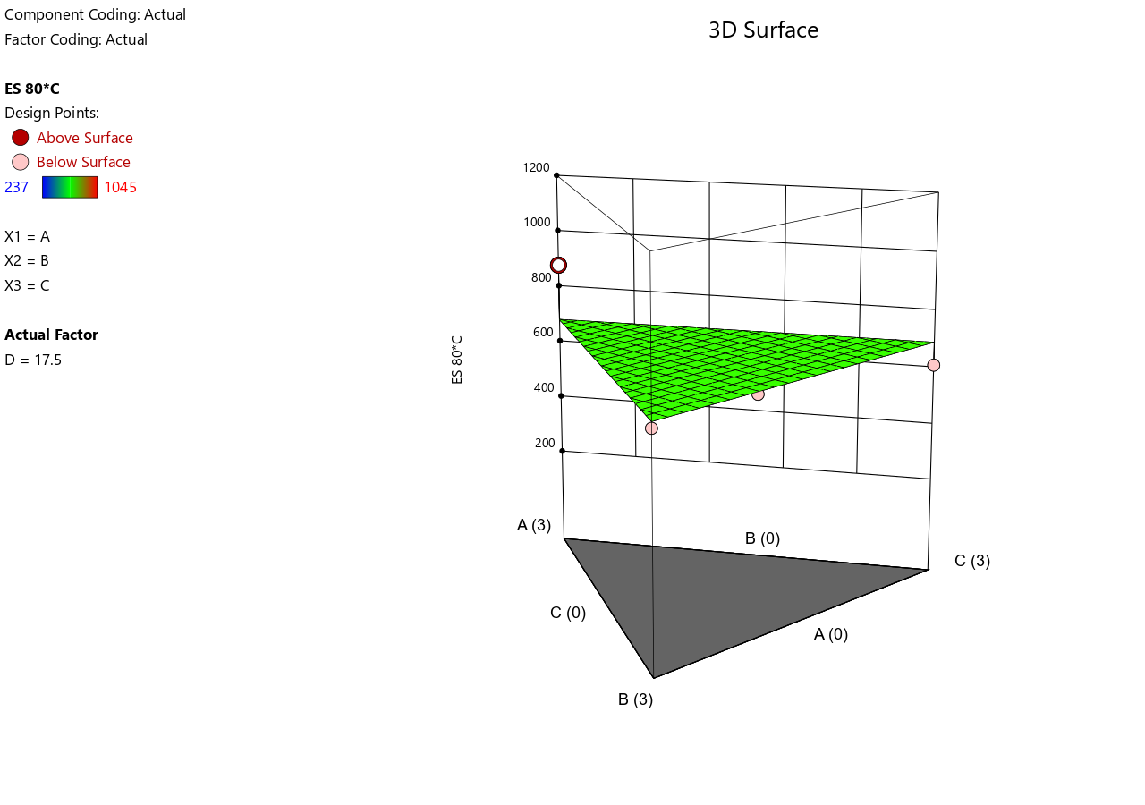
- 3D Surface Plot for High Contamination
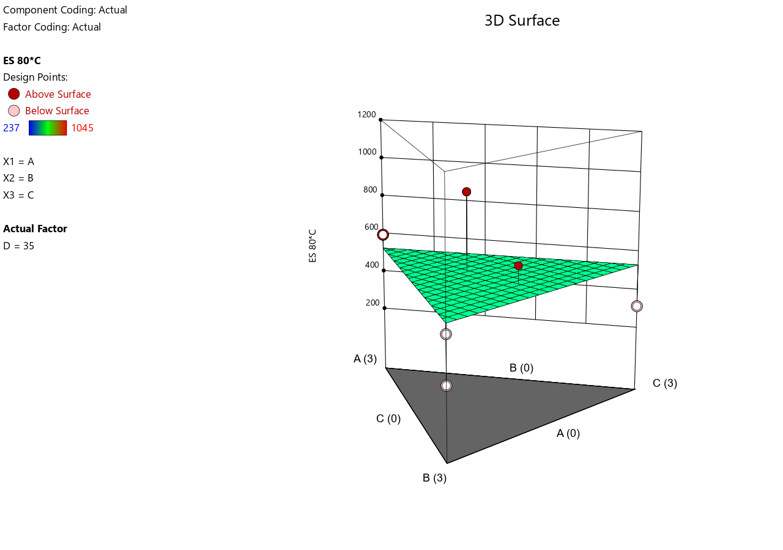

Annular space: space between the open hole and the drilling string.

