Consumer Emotional Response as a Predictor of Preferences

A Case of Hotel Style Design

Kristie Lee Korbo & Zukhra Mukhamejanova

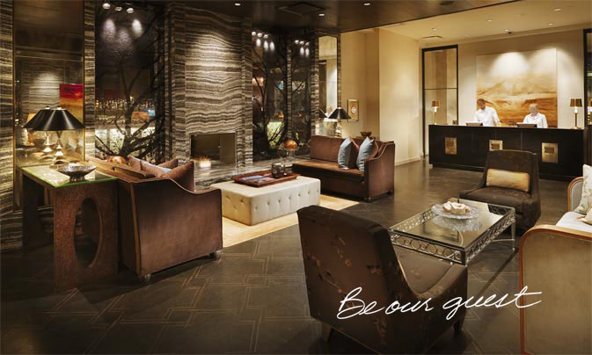

|  |  |
| --- | --- |
| **FACULTY OF SOCIAL SCIENCES,**  **NORWEGIAN SCHOOL OF HOTEL MANAGEMENT**  MASTER’S THESIS | |
| STUDY PROGRAM:  MSc. in International Hotel and Tourism Leadership | THESIS IS WRITTEN IN THE FOLLOWING SPECIALIZATION/SUBJECT:  Hotel Marketing  IS THE ASSIGNMENT CONFIDENTIAL? No. |
| TITLE: Customer Emotional Response as a Predictor of Preferences: A Case of Hotel Style Design | |

|  |  |  |
| --- | --- | --- |
| AUTHOR | | ADVISOR:  Professor Torvald Øgaard |
| Student number:  222888  …………………  223171  ………………… | Name:  Zukhra Mukhamejanova  …………………………………….  Kristie Lee Korbo  ……………………………………. |

|  |
| --- |
| ACKNOWLEDGE RECEIPT OF 2 BOUND COPIES OF THESIS  Stavanger, ……/…… 2011 Signature administration:…………………………… |
|  |

**Consumer Emotional Response as a Predictor of Preferences: A Case of Hotel Style Design**

Abstract

*As the hospitality industry grows, so does the number of consumers booking hotels online.  These consumers choose hotels based on webpage information such as hotel pictures and other promotional media.  Given the importance of visual stimuli displayed on hotel webpages, little research effort has been devoted to the guests’ emotional response to hotel design.  The aim of this study is to measure consumer’s emotional responses and how they can predict preferences in regards to hotel style design; the emotions we are referring to are those that are experienced by potential and current hotel customers and evoked by hotels.  A within subjects experiment research design was utilized with a survey conducted from a convenience sample of 120 student respondents. Photo stimuli consisting of pictures from four different hotels was used to elicit emotional responses to hotel stimuli.  A likert-type scale was utilized to measure the visual self-report of emotional responses and the corresponding hotel preferences.  Results of the research show that hotel style design elicits emotional responses, and those emotional responses can be used to predict hotel preferences.  Male respondents are more likely to report higher levels of negative emotional response than females, and non-Norwegian citizens are more likely to report higher levels of positive emotional response to hotel style design than Norwegians.  These findings support previous literature regarding emotional response and preferences, and can be useful to hotel management to encourage measurement of their potential and current consumers’ emotional response to hotel style design in order to help predict the consumers’ preferences accordingly.*

# Table of Contents

Abstract 3

Table of Contents 4

Foreword 7

Chapter 1: Introduction/Problem Statement 8

Empirical Positioning & Problem 8

Theoretical Overview and Positioning 9

Research Objectives 11

Figure 1: Research Model 12

Chapter 2: Literature Review 12

Mehrabian-Russell Model 12

Figure 2. Russell (1980) modified PAD model 14

Figure 3. A S-O-R Model of Consumer Behaviour 15

Figure 4: Research Model 15

Definitions of the Constructs 15

Hotel Style Design as Stimuli 15

Measuring Emotional Response 18

Figure 5. SAM the Self-Assessment manikin (Lang, 1985). 20

Figure 6. Emoti*Scape map of emotions Rademacher and Koschel (2006). 22

Figure 7. Product Emotion Measurement instrument interface (Desmet et al., 2000) 23

Table 1 *Eight categories of emotions* 24

Measuring Consumer Preferences 25

Hypotheses 29

RO1 29

RO2 29

RO3 30

RO4 31

Chapter 3: Method 32

Design 32

Figure 8. Causal Chain of Experiment Design 32

Sample 34

Measurements 34

Data Analysis 37

Chapter 4: Results & Findings 39

Descriptive Statistics 39

Categorical Variables 39

Table 2 *Gender Statistics* 39

Table 3 *Citizenship Statistics* 39

Table 4 *Age Statistics* 40

Table 5 *Education Level Statistics* 40

Table 6 *Purpose of Travel Statistics* 41

Continuous Variables 41

Table 7 *Descriptive Statistics* 41

Validation of scales 42

Table 8 *Table of Scales* 42

Validation of Scales – Item Level 43

Table 9 *Pearson Correlation (Positive Emotional Response)* 43

Table 10 *Pearson correlation (Negative emotional response)* 44

Table 11 *Pearson`s correlation (Preferences)* 44

Table 12 *Cronbach Alpha Score* 46

Table 13 *Correlation Matrix for Positive emotional response* 46

Table 14 *Correlation Matrix for Negative emotional response* 47

Table 15 *Correlation Matrix for Preferences* 48

Table 16 *Factor loadings for Positive and Negative emotions responses and Preferences* 48

Validation of Scales – Construct Level 49

Table 17 *Pearson`s correlation among constructs* 49

Graph 1 *Screeplot (Positive and Negative emotional responses)* 50

Table 18 *Pattern and Structure Matrix for PCA with Oblimin Rotation of Three Factor* *Solution of PrEmo Items* 51

Table 19 *Pattern and Structure Matrix for PCA with Oblimin Rotation of Two Factor Solution of PrEmo Items* 52

Hypothesis Testing 53

RO1 53

Table 20 *Descriptive Statistics for Positive Emotional Response to Hotel 1, 2, 3 & 4* 53

Table 21 *Descriptive Statistics for Negative Emotional Response to Hotel 1, 2, 3 & 4* 54

RO2 54

RO3 56

Table 22 *Descriptive Statistics for Gender Differences* 57

RO4 57

Table 23 *Descriptive Statistics for Citizenship Differences* 58

Chapter 5: Discussion 59

Reliability and Validity 59

Answers to Research Objectives 60

RO1 60

RO2 62

RO3 63

RO4 64

Theoretical Implications 65

Methodological Implications 65

Management Implications 67

Limitations of Current Research 69

Implications for Future Research 69

Chapter 6: Conclusion 71

REFERENCES 72

Appendices 75

Appendix 1: SPSS Reliability Analysis 75

Appendix 1.1: Positive Emotional responses (Item Statistics, Inter-Item Correlation Matrix, Item-Total Statistics) 75

Appendix 1.2: Negative Emotional responses (Item Statistics, Inter-Item Correlation Matrix, Item-Total Statistics) 77

Appendix 1.3: Preferences (Item Statistics, Inter-Item Correlation Matrix, Item-Total Statistics) 79

Appendix 2: SPSS Principal Components Analysis 80

Appendix 2.1: Positive and Negative Emotional Responses Correlation Matrix 80

Appendix 3: SPSS ANOVA Analysis: RO1 81

Appendix 3.1: ANOVA Table 81

Appendix 3.2: Multiple Comparisons Table 82

Appendix 3.3: Eta Squared Calculation 83

Appendix 4: SPSS Standard Multiple Regression Analysis: RO2 84

Appendix 5: SPSS MANOVA Analysis: RO3 89

Appendix 5.1: Multivariate Tests 89

Appendix 5.2: Tests of Between-Subjects Effects 90

Appendix 6: SPSS MANOVA Analysis: RO4 91

Appendix 6.1: Multivariate Tests 91

Appendix 6.2: Tests of Between-Subjects Effects 91

Appendix 7: Survey 93

# Foreword

Having an interest in the role of emotional design in the hotel style design context and how photo stimuli can elicit emotional responses we decided to conduct a study to understand the role of emotional responses in predicting the consumer`s behavioural intention in hotel style design context.

This research was conducted under the supervision of Professor Torvald Øgaard, whom we thank for his patience and provided insight and expertise that greatly assisted the research.

We thank Åsa Grahn, PhD, Olga Gjerald, Associate and Helge Jørgensen, Docentfor their assistance with organising class introduction for data collection. We also would like to thank StOr (Student union of the University of Stavanger) for allowing us to set up booths within the campus area to collect responses.

We would also like to show our gratitude to the Susa Group for granting us the access to the PrEmo tool and providing guidance.

# Chapter 1: Introduction/Problem Statement

## Empirical Positioning & Problem

The importance of staging memorable experiences and eliciting pleasant emotions for hotel guests is being increasingly recognized in the hospitality research field; however little research effort has been devoted to the guest’s emotional responses to hotel design (Lo, 2008). This study will contribute to research through a survey measuring respondents’ emotions in relation to hotel stimuli, and how those emotions can predict preferences.

The design of hotels has become afflicted with commoditization, with many hotels implementing very similar design concepts. In designing a hotel more as an experience venue rather than simply a place for people to stay overnight, it will enhance the experience of the customer (Gilmore & Pine II, 2002). By gaining a better understanding what evokes the guests’ emotions when staying at hotels and improves their experience, designers can design their accommodation as more of an experience venue as opposed to a more traditional commoditized hotel.

In order to excite, delight, and bring surprising pleasures to hotel guests, the needs and desires of the guest must be understood. If a hotel is able to build a culture of uncovering and delivering the unexpected, they will be met with great customer loyalty and satisfaction (Erdly & Kesterson-Townes, 2003). To gain more information into what the needs and desires of the guest are to enable building a culture of uncovering and delivering the unexpected, the emotion evoking qualities of hotels must be understood. Hotels will then be able to deliver the unexpected, resulting in greater customer loyalty and satisfaction.

The internet is becoming a powerful marketing medium directly connecting customers and companies (Jeong & Choi, 2004). Forecasts say that online retails sales will outpace offline growth until 2017, online sales will be a critical part of the economy, and companies will need to be more competitive to differentiate themselves (Gill & Wigder, 2013). Online booking of hotels are becoming an increasingly more predominant way in the market for consumers to search, compare and book hotels. Well-designed websites are crucial for hotels to attract and retain more business and to communicate with current and potential customers (Jeong & Choi, 2004).

The aim of the study we are conducting is to measure guest’s emotional responses and how they can predict preferences in regards to hotel style design; the emotions we are referring to are those that are experienced by potential and current hotel customers, especially those looking to make online bookings, and evoked by hotels.

## Theoretical Overview and Positioning

Emotional design involves including pleasure and usability in the design, as well as aesthetics, attractiveness and beauty (Khalid & Helander, 2006). It emphasizes the importance of eliciting users’ pleasant emotional responses and design’s emotional dimensions that enrich user experience (Lo, 2008). The emotions evoked by hotel style design will be studied, eliciting the guests’ positive and negative emotional responses and the corresponding hotel preferences in relation to emotions.

As a part of the research review it has been found that there has been two previous photo elicitation studies related to hotel design completed. The two studies were:

1. Visual Methods Using Photographs to Capture Customers' Experience with Design (2007) by Madeleine Pullman & Stephani Robson

The aim of this study was to explore the use of an image-based customer feedback method and provide the results of a pilot test at a full-service hotel. It studied the elements of a designed environment that make a significant impression on customers and what type of meanings the guests infer from the visual images. They looked at how the images are related to measures such as guests’ overall satisfaction and return intentions, and what can be learned through the photo elicitation method that wouldn’t have been revealed through other methods. They found that guests took notice of design elements that signified that the hotel was being considerate of their needs, as well as providing a functional, high-quality environment.

The similarity between this study and the Pullman & Robson (2007) study is that this study will look at qualitative measures such as guest preferences and behavioural intention in relation to the images being taken. This study differs from our study because it did not take aspects of emotional design into account. It was more intended to test the photo elicitation method in the hotel context. This study was also conducted in New York; the same study has not been conducted in the Scandinavian context.

1. Hotel stay scenarios based on emotional design research (Lo, 2008) by Kathy Pui Ying Lo

The aim of this study was to discover design opportunities for enhancing hotel stay experiences of female business travellers. The study highlighted hotel features that evoke pleasant emotions by matching female business travellers’ concerns for care, convenience, comfort, and exploration. She found that the relational message of care and the personalization of hotel features are two of the most important means of evoking pleasant guest emotions.

This study is similar to this research in that it used similar theories (emotional design) in order to discover design opportunities to enhance hotel stay experiences. However it did not determine the relationship between images taken and satisfaction/loyalty ratings. Another way in which Lo’s study differs from this study is that it is only studying female business travellers within the Hong Kong context, whereas our study will look at both male and female potential guests within a Scandinavian context, namely Stavanger, Norway.

The new insight that the current study will shed light upon is the guest’s emotional responses to hotel design style, and how those emotional responses can predict preferences. The results of the study are intended to be used by hotel management to understand the emotional response and related preferences of both potential and current customers, especially when reviewing photos online with the intention of booking a hotel.

No similar study could be found that has been done in the Scandinavian context, and since this study will be conducted in Stavanger, Norway, it will shed light on the Scandinavian context. It will also measure the emotional responses of both male and female potential hotel guests. Therefore the research to be conducted in this study has not been similarly researched in former studies.

An within subjects experimental study will be conducted to measure emotions evoked by viewing pictures of hotel style design stimuli, and the correlation between hotel preferences and the emotions evoked. Four different hotel stimuli will be utilized to study if emotions are evoked and differences between hotel stimuli. A convenience student sample will be utilized to collect the data.

## Research Objectives

1. To investigate if and how hotel style design triggers perceived emotions to be evoked (RO1).
2. To determine to what extent preferences towards hotel style design can be explained by emotional response to hotel style design (including behavioural intention, approach, avoidance, and overall evaluation) (RO2).
3. To understand differences between male and female emotional response and preferences in regards to hotel style design (RO3).
4. To understand differences between Norwegian and non-Norwegian emotional response and preferences in regards to hotel style design (RO4).

#### Figure 1: Research Model



*\* This model will be explained further in the literature review*

# Chapter 2: Literature Review

This part of the current study provides background information about the basic concept of emotions and describes theoretical definitions of the major constructs utilized in the study`s model.

## Mehrabian-Russell Model

Since approach-avoidance behaviours are components of consumer`s preferences there are three main emotional states proposed by Mehrabian & Russell (1974) that mediate approach-avoidance behaviours in environmental situations. According to Mehrabian and Russell (1974), all human emotions can be characterized into three independent, bipolar dimensions, they are mostly known as PAD:

1. Pleasure – Displeasure
2. Arousal – Non-Arousal
3. Dominance - Submissiveness

The scholars advocated that any environment will evoke emotions in an individual that can be classified within the three PAD dimensions. According to that model, a combination of these dimensions can characterize an individual’s emotional state.

Russell (1980) have modified the Mehrabian-Russell model and presented an updated version without the previous dominance dimension. They found that the two orthogonal dimensions of pleasure and arousal (pleasant-unpleasant, arousing-sleepy) were adequate to reflect people`s emotional state.

DISTRESSING

EXCITING

AROUSING

PLEASANT

UNPLEASANT

RELAXING

GLOOMY

SLEEPY

#### Figure 2. Russell (1980) modified PAD model

It has been successfully tested in several studies in different contexts. For instance, using an original PAD model, R. J. Donovan and J. R. Rossiter (1982) have suggested that the Mehrabian-Russell model is applicable as a starting point for studying approach-avoidance behaviours in the context of retail environment. It is noteworthy that the scholars tested the model only with stated behavioural intentions rather than with actual behaviours.

Environmental psychologists (Mehrabian & Russell, 1974) also have presented a theoretical model for studying effects of physical surrounding on customer behaviour. The model is presented as Stimulus-Organism-Response (S-O-R) paradigm and contains following requisites: a stimuli taxonomy, a set of intervening or mediating variables, and a taxonomy of responses (R. Donovan & J. Rossiter, 1982). According to Thang and Tan (2003) the Organism in S-O-R model is an intervening internal process between the stimuli and reaction of consumer, the process where consumer turns the stimuli into meaningful information and use them to process the environment prior to make any judgement or conclusion. Figure 3 below shows the S-O-R model.

In the S-O-R framework, the stimuli as a set of attributes that affect the perceptions of the consumer are the starting point of the consumer behavioural process (Thang & Tan, 2003). The organism refers to the mediating process between response of the consumer and stimuli. As a result of the internal mediating process the response is a final action or psychological reaction such as attitudes and behavioural reactions of the consumers towards stimuli (R. Donovan & J. Rossiter, 1982). Depending on the organism process, the final emotional state can affect consumer`s preferences towards the stimuli (Thang & Tan, 2003).

**Response**

**Organism**

**Stimulus**

#### Figure 3. A S-O-R Model of Consumer Behaviour

Applying the framework to our study the conceptual model of the present paper will be presented as follows:



#### Figure 4: Research Model

## Definitions of the Constructs

### Hotel Style Design as Stimuli

One of the main focuses of the current paper is that emotional response can be evoked by hotel style design. Design plays an important role in any hotel as it contributes to creating an atmosphere in the public areas of a hotel and makes it appealing for visitors (Ransley & Ingram, 2001).

According to Ransley and Ingram (2001) “style” is a part of design which is a combination of such physical factors as sizes, shapes, style and decorations. There are five factors that can be affected by a design:

* Image;
* Style;
* Comfort;
* Marketing;
* Ambience.

Ransley & Ingram (2001) noted that through “image and style” an entity represents its identity and quality to the consumers.

Another study suggests that all physical surroundings as opposed to the natural and social environment represent “servicescape” (Bitner, 1992). Bitner (1992) presented three dimensions of servicescape:

1. Ambient conditions (temperature, odour, air quality, noise, music etc.)
2. Space/Function (layout, equipment, furnishings etc.)
3. Signs, Symbols and Artefacts (signage, style of décor etc.)

The author underlined that physical surroundings are very important in service settings since customers often experience the organization`s facility.

Style also is a part of ambience or atmosphere which at some extent can be created by managers and employees (Heide, Lærdal, & Grønhaug, 2007). They describe ambience in hospitality management as:

“…*it goes beyond the individual, i.e. atmosphere or ambience includes elements of the environment. The individual may very well contribute to the ambience but other factors must be present as well. In fact, we view ambience as created by the interaction between individuals and their environment”* (Heide et al., 2007, p. 1316).

The authors, also, pointed out the difference between “servicescape” and “ambience”. If servicescape is the physical surroundings where services are delivered, then ambience is a consequence of interaction between service providers, customers and the physical environment. Thus, ambience could be a customer’s perception of social and physical surroundings (Heide et al., 2007). The way how ambience can be perceived is determined by several factors:

1. Atmospheric factors;
2. Social factors;
3. Design factors.

According to (Heide et al., 2007) atmospheric factors are almost the same as in Bitner`s category “ambient conditions”: music, noise, temperature etc. Social factors represent the ‘‘human’’ component of the environment. The design factors are introduced as functional and aesthetic elements (architecture, style, and layout).

It can be seen that ambience gives us more holistic understanding of how guests can perceive hotel performance. Also, ambience can be “controllable” tool that managers can “manipulate” in order to enhance provided services (Heide et al., 2007).

In examining the elements of servicescape and atmosphere, one can see that there are quite a number of elements of both to be found in the hotel industry. As Countryman & Jang (2006) discussed in their study the most related elements to the hotel settings are style, layout, colours, lightning and furnishings. The scholars found that style, colours, and lighting are the most important factors in the hotel lobby context. Although, Countryman & Jang (2006) did not provide a clear definition of “style”, they admitted that style is quite a complex concept and represents a whole combination of physical elements that ultimately create a unique style.

Regardless of the gap in academic literature of defining style within the hotel context, the reviewed literature has shown that style as a part of the physical environment is:

1. An important factor in creating a desirable ambience/atmosphere in a hotel;
2. A combination of physical elements that creates a holistic image and provides the unique qualities of a hotel.

Though, both interior and exterior design makes to add or detract from the hotel`s attractiveness. The present study aims to investigate interior style design of a hotel as a stimuli to the emotional response.

### Measuring Emotional Response

Due to the complex nature of emotions one can argue that it is quite difficult to measure emotions. According to Poels and Dewitte (2006) there are two major types of methods to measure emotions: self-report measures and autonomic measures. Both methods have been used in marketing research to measure emotional responses to advertising stimuli. The authors underlined that the two methods have focus on different aspects of the emotions. Self-report measures concentrate on introspective reflections about the emotions experienced towards to an advertising stimulus. On the contrary, autonomic measurements focus on continuous emotional reactions that are not affected by higher cognitive process (Poels & Dewitte, 2006).

***Self-report measures***

In the past decades, self-report measures have been extensively employed for measuring emotional reactions to advertising. Self-report measuring tool registers the individual's subjective feeling. In a review paper Poels and Dewitte (2006), they distinguish three types of self-report methods that all measure subjective feelings: verbal self-report, visual self-report, and moment-to-moment rating.

***Verbal self-report***

In verbal self-report tool, respondents should express their emotions verbally by employing open-ended questions or participants are asked to rate their emotions using semantic differential or Likert scales of emotion items. In general psychological emotion research, there are two main viewpoints to the study of emotions: the “dimensional" approach and the "basic emotion" approach (Poels & Dewitte, 2006).

The verbal self-report tool is very easy to conduct and has a low-cost due to its simplicity and no requirement for special equipment. However, there are a few limitations that are worth mentioning. Since emotion scales are presented in a long list of adjectives one can assume that it is quite tiring and cumbersome for respondents (Poels & Dewitte, 2006). It demands a quite high level of cognitive processing for participants to understand the emotions that they may experience or not. In the case of lower-order emotions, it may hinder the evaluation of original emotional state of individual (Poels & Dewitte, 2006). One can assume that high level complex emotions are difficult to express verbally, thus it also can be an important limitation of verbal self-report.

***Visual self-report***

Similar to verbal self-report, visual self-report instruments measure subjective feelings. In contrast to the verbal method to measure emotions, visual self-report instruments based on visual figures that represent different emotions or emotional states. In advertising literature, there are quite a few measurement solutions that can be used to capture emotional response. Among the most used one are Self Assessment Manikin, and the more recent, PrEmo (Poels & Dewitte, 2006). Since in the current study we utilized visual self-report method we will look at some tools in details.

***The Self-Assessment Manikin (SAM)***

The Self-Assessment Manikin (SAM) was presented by Lang (1985). It visually represents Mehrabian and Russell’s three PAD dimensions (see Figure 2). SAM was designed as an alternative to the verbal self-report measures (Lang, 1985).

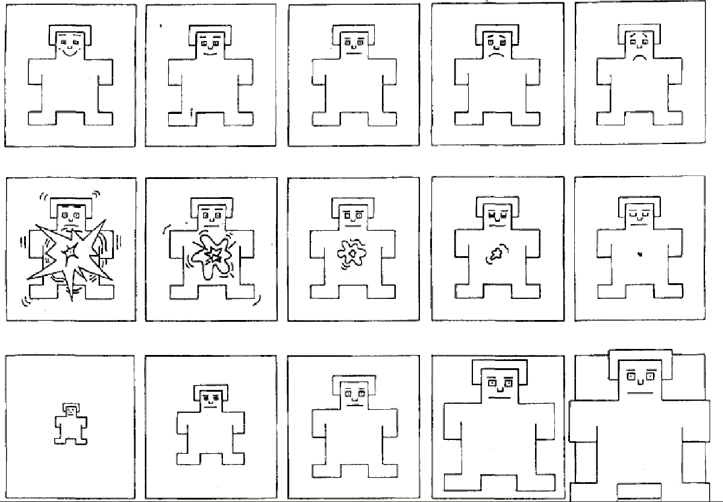

#### Figure 5. SAM the Self-Assessment manikin (Lang, 1985).

SAM expresses each PAD dimension with a graphic character presented along with a continuous nine-point scale. For every dimension there are five figures that represent different level of one dimension. For instance, for Pleasure dimension, SAM ranges from a smiling, happy figure to a frowning, unhappy figure; for Arousal, SAM ranges from sleepy with eyes closed to excited with eyes open. The Dominance scale shows SAM ranging from a very small figure representing a feeling of being controlled or submissive to a very large figure representing in-control or a powerful feeling (Lang, 1985).

The author claimed that visually oriented scales using a visual character eliminate the majority of issues associated with verbal measures. Respondents have expressed greater interest in SAM ratings versus verbal self-reports in a number of studies and have stated that SAM is more likely to hold their attention (Lang, 1985). Another advantage is that both children and adults readily identify with the SAM figure and easily understand the emotional dimensions it represents (Lang, 1985). Because SAM is a culture-free, language-free measurement it is suitable for use in different countries (Morris, 1995). Though, with the last advantages, one can disagree, since the graphic characters could be ambiguous and can be misinterpreted. For instance, for “arousal” (the second line in the Figure 5) it is quite unclear what the character represents.

***Emoti* Scape***

Another visual self-report tool was presented by Rademacher and Koschel (2006) – Emoti*Scape. The scholars aimed to create visuals that depict emotions instead of evaluating the actual elicited emotions experimentally. Emoti*Scape is basically a map of emotions, which reflects the two basic dimensions: active – passive, positive – negative, see Figure 6.

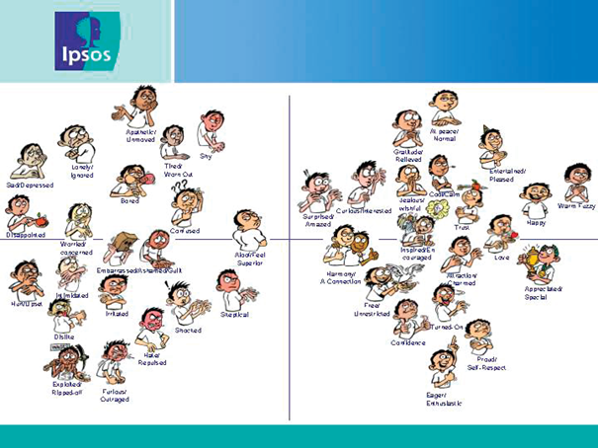

#### Figure 6. Emoti*Scape map of emotions Rademacher and Koschel (2006).

The authors claimed that Emoti*Scape can help to understand a complex world of emotions in more simple and clear way. One could assume that the main advantage of the tool is that it combines visual and verbal expression of emotions. So if respondents do not understand visual expression of Emoti*Scape map of emotions then they could always look at the verbal expression of emotions.

***PrEmo***

In the last decade, the visual measurement tool PrEmo has been presented in marketing (Desmet, Hekkert, & Jacobs, 2000). Instead of motionless graphic characters, as depicted in SAM and Emoti*Scape, PrEmo consists of 14 animations of 1-2 seconds. Each animation reflects a specific emotion. In total, PrEmo includes seven positive emotions (desire, pride, hope, joy, admiration, satisfaction, and fascination) and seven negative emotions (disgust, shame, fear, sadness, contempt, dissatisfaction, and boredom). PrEmo is presented in Figure 7. At the bottom of it there is a test stimulus shown as an example. Participants are asked to indicate how strongly the stimulus makes them experience each of the 14 emotions represented by the animated characters (Desmet et al., 2000).

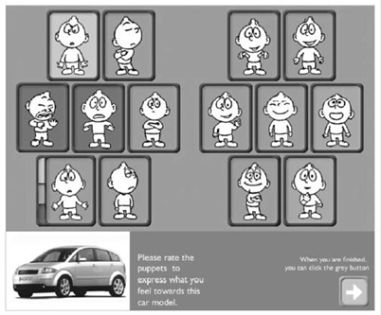

#### Figure 7. Product Emotion Measurement instrument interface (Desmet et al., 2000)

***DEVELOPMENT OF PrEmo***

The instrument is computerized; a computer interface shows a stimuli and characters that represent emotions. Figure 7 shows a preliminary version of the PrEmo interface. When conducting an experiment, respondents are asked to select one or more animations in accordance with their emotional reactions towards stimuli. In the matching process, participants can play an animation by clicking the mouse button on the character. Subsequently, they choose an animation by clicking on the evaluation 5-point scale.

The final version of PrEmo consists of 14 emotions representing two bipolar dimensions: pleasant (positive) and unpleasant (negative). The final list of emotions was developed in a series of three studies (Desmet et al., 2000). In the first study, respondents rated 305 emotions on the dimensions 'pleasantness' and 'arousal' which were investigated in the study of circumplex of affect (Russell, 1980). A three-point scale measured these two dimensions: pleasant-neutral-unpleasant, and calm-moderate excited. Based on these ratings, the emotions were categorized in eight groups (Refer to table 1). Since 38 of the 305 emotions were not rated univocally, they were deleted from the list (Desmet et al., 2000).

|  |  |  |
| --- | --- | --- |
| **Emotion categories** | | |
| Arousal-pleasantness | Number of emotions | Emotion example |
| Excited-Pleasant  Neutral-Pleasant  Calm-Pleasant  Excited-Unpleasant  Neutral-Unpleasant  Calm-Unpleasant  Excited-Neutral  Calm-Neutral | 27  49  19  45  61  33  19  14 | Euphoric  Appreciative  Content  Disgusted  Irritated  Bored  Surprised  At ease |

#### Table 1 *Eight categories of emotions*

For the second step study, the scholar aimed to investigate which emotions the subjects experience more frequently. Respondents were asked to select those emotions that they had experienced before in response to products. As some emotions were experienced more often than others, the subjects were asked to select five emotions from each category and to evaluate them from one (experienced most often) to five (experienced least often), respectively (Desmet et al., 2000). The result of the second study was a list of 54 emotions categorized in eight groups. In a third study, exploiting the multidimensional scaling analysis allowed to reduce the emotions to the final list of 14 emotions. The scholars noted that product appearance can extract more than these 14 emotions, however these are the ones that can be experienced more frequently (Desmet et al., 2000).

According to Desmet (2002) the idea of emotions expressed with a cartoon character is based on the assumption that emotional physical expressions are universal. Ekman and Friesen (1986) revealed that facial expressions of simple basic emotions (e.g., fear, joy) are accepted univocally across cultures. By incorporating body expression and movement the scholars made PrEmo more reliable since the emotions used in the tool are subtler than the basic emotions. This was the reason to design a character which shows body movement as well. With the help of professional actors the scholars created the animated characters presenting emotions and ability to measure an emotional response (Desmet et al., 2000).

In contrast to the SAM instrument, PrEmo was validated in cross cultural studies (Desmet, 2002). This solves a problem of misinterpretation and minimizes the risk of getting biased responses. Also PrEmo allows to register more than one specific emotion which provides better understanding of emotional responses. PrEmo was initially developed and applied to measure emotional responses to design (Desmet et al., 2000), though according to Poels and Dewitte (2006) PrEmo as a user friendly, valid, and comparatively cheap instrument is applicable to measure emotional reactions to advertising. It has been successfully utilized in capturing emotional responses in different contexts (Desmet, 2002; Desmet et al., 2000).

### Measuring Consumer Preferences

Consumer preferences refer to the consumers’ proclivity for certain hotels over others (Thang & Tan, 2003). Four different aspects of preferences that will be utilized in this study to measure consumer’s preferences include:

1. Approach/Avoidance Behaviour
2. Behavioural Intention
3. Overall Evaluation

***Approach / Avoidance***

Included as a part of the “Stimulus-Organism-Response (S-O-R)” paradigm, Mehrabian & Russell postulate that all responses to an environment can be considered approach or avoidance behaviours (R. Donovan & J. Rossiter, 1982). These behaviours are a result of emotional states in individual experiences within the environment. There are four aspects of approach avoidance behaviour:

1. A desire physically to stay in (approach) or get out of (avoid) the environment. This relates to behaviours of consumers within a hotel environment because physical approach and avoidance can be related to hotel patronage intentions.
2. A desire or willingness to look around and to explore the environment (approach) versus a tendency to avoid moving through or interacting with others or to ignore communication attempts from others (avoid). This relates to behaviours of consumers within a hotel environment because exploratory approach and avoidance relates to the level of comfort experienced by hotel patrons within a hotel.
3. A desire or willingness to communicate with others in the environment (approach) as opposed to a tendency to avoid interacting with others or to ignore communication attempts from others (avoidance). Communication approach or avoidance relates to behaviours of consumers within a hotel environment because it relates to interaction with front desk, room service and restaurant staff.
4. The degree of enhancement (approach) or hindrance (avoidance) of performance and satisfaction with task performances. This describes behaviours within a hotel environment as it can be related to repeat patronage and length of stay.

As part of the overall evaluation of the hotel stimuli presented, we measure how likely it is that respondents would approach or avoid the hotel environment shown. As respondents did not actually stay at the hotel, we were limited in the number of questions we could ask as they had not actually experienced the hotel environment. We asked the following questions to the respondents:

1. How likely is it that you would enjoy staying at this hotel?
2. How likely is it that you would avoid staying at this hotel?

***Behavioural Intention***

Hotel preferences can be measured by understanding the consumers’ behavioural intentions towards the various hotels presented. Customer experience is related to behavioural intention – the more positive the consumers’ experience, the more likely they are to reuse the service (Burton, Sheather, & Roberts, 2003). If consumers are satisfied and have an intention to stay with the company for a long period, this tends to impact the profitability of a company through repeated business, positive word of mouth, and by minimizing the cost to acquiring new customers (Olorunniwo, Hsu, & Udo, 2006). According to Zeithaml, Berry & Parasuraman (1996), indicators of positive behavioural intentions include:

1. Saying positive things about the company to others
2. Recommending the company or service to others
3. Paying a price premium to the company
4. Remaining loyal to the company

Loyalty behaviour includes expressing a preference for a company over others. As we were measuring preferences between hotels we chose to measure the loyalty behaviours. The question asked to respondents was:

1. How likely is it that you would be inclined to make a booking at this hotel?

By asking this question to respondents regarding all four hotels studied, we can measure which hotel they prefer by measuring which hotel they are most likely to be loyal towards.

***Overall Evaluation***

Online evaluations are one of the most common ways for consumers to provide feedback on their hotel stay experience. One of the most used sites on the internet to measure evaluations of hotel experiences, Tripadvisor.com, provides millions of travellers’ ratings, describing their experiences of staying in hotels. Perceptions of travellers’ quality and value of hotel properties are measured (Zhang, Ye, & Law, 2011). To measure the overall evaluations of each hotel by respondents we asked the same question posed to those responding to TripAdvisor evaluations, namely:

1. Based on the photos shown what is your overall rating of this hotel?
2. Terrible
3. Poor
4. Average
5. Very Good
6. Excellent

By doing so, we were able to evaluate which hotel the respondents preferred between the four hotels based on which hotel they gave a better rating to.

## Hypotheses

### RO1

In a photo-elicitation study of emotions during hotel stay by Lo (2008), research participants reported 418 cases of emotions which were evoked by things, places and events during their stay. As hotel style would have been a stimuli included in the things, places and events that the participants were exposed to during their stay, it is hypothesized that hotel style will evoke perceived emotional response. In the same study, they found that there is evidence that care (thoughtful, considerate, caring, effort, detail), convenience (convenient features and services that facilitate work), comfort (hotel features that enable guests to relax) and exploration (experience something new or learn about certain cultural elements of a different place) are sources that evoke emotions of hotel guests during hotel stay experience. All of these sources that evoke emotions can be related to hotel style. The amount of; care (detail) put into hotel design, convenience available, comfort levels, and exploration (cultural elements) in a hotel will affect the style of a hotel and be elements that cause hotel style to be different between hotels.

As a part of our hypothesis, it is predicted that there will be no significant difference in emotional response to hotel style design stimuli between Hotel 2 and Hotel 3. This is simply because the two hotels are identical chain hotels, the only difference being that they are located in two different cities in western Canada. They are both full service hotels with very similar style elements.

### RO2

A research study by Pullman & Robson (2007) which used photographs to capture consumers’ experience with design found that there were multiple relationships between images taken and satisfaction/loyalty ratings. There is evidence that the service rating had a significant relationship with loyalty behaviour. The service rating had a strong relationship with the number of negative service photographs (the more frequently the participant focused on negative service images, particularly those images that indicated lack of evidence of thoughtfulness, the worse the service rating and subsequent loyalty score). The overall satisfaction rating had a strong relationship with the number of negative service photographs. The overall satisfaction rating also had a strong relationship with the number of positive service photographs (the larger the number of photographs depicting evidence of thoughtfulness and functionality, the greater the satisfaction rating). Certain aspects of design appear to influence the satisfaction level of participants but this increase does not necessarily translate into loyalty behaviour. One can assume that hotel guests felt positive emotions when taking positive service photographs and vice versa. It also is clear that and that service rating and overall satisfaction rating are constructs that are related to hotel design preferences. Therefore it is hypothesized that emotional response will have significant correlation with preferences.

In a study of a conceptual model of relationships between the constructs of “service quality”, “emotional satisfaction” and “behavioural intention” in the hospitality industry, Ladhari (2009) found that emotional satisfaction is positively correlated with behavioural intention. Emotional satisfaction can be linked with positive emotions, and behavioural intention is an item in the construct in this research called preferences. Therefore it is hypothesized that positive emotions will have a positive correlation with hotel style preferences.

### RO3

In a study using photographs to capture customers’ experience with design by Pullman and Robson (2007), they found that women generally took more positive photos of design and service than did men, while men took more negative service photographs. This can be related to the current study in that if women are more likely to take positive photos of stimuli, then it is hypothesized that women will be more likely to experience positive emotions in relation to hotel stimuli. By the same token, it is hypothesized that men will be more likely to experience negative emotions in relation to hotel stimuli.

In a study using photographs to capture customers’ experience with design by Pullman and Robson (2007), there were no significant differences between men’s and women’s photographs and commentaries. This finding can be related to our study in that if hotel photographs and commentaries based on those photographs are not significantly different between genders, then it is hypothesized that their preferences towards hotel style should not be significantly different either.

### RO4

There is no hypothesis related to this objective as cross cultural differences have not been studied in relation to emotional response to hotels.

# Chapter 3: Method

## Design

A within subjects experimental design was implemented, the dependent variable being consumer emotions and preferences; with a causal chain as follows:

STIMULI

OUTCOME LEVEL 2 (PREFERENCES)

OUTCOME LEVEL 1 (EMOTIONAL RESPONSE)

#### Figure 8. Causal Chain of Experiment Design

The specific research instruments employed is photo stimuli presentation which will then be measured using survey questions.

In accordance with previous researches on environmental psychology studies (R. J. Donovan & J. R. Rossiter, 1982; Mehrabian & Russell, 1974) four experimental stimuli have been developed to study and understand if there any emotions which can be evoked by hotel design and how emotions can influence customer preferences and overall evaluation basing on the photos of hotels. The photos of four different hotels were chosen as stimuli. Two of them were retrieved from the website of one large chain of hotels. They were chosen due to the similarity in style, layout, design and furniture. Prior research (Jeong & Choi, 2004) has emphasized important elements of a hotel in order to make an overall evaluation: bedroom, lobby, building, restaurant, meeting rooms, and lounge. For this study four pictures of four elements of each hotel were selected: bedroom, lobby, restaurant and lounge. Meeting room and building stimuli were not considered because of three main reasons: firstly, the current study is focused on leisure tourists mainly and meeting rooms are seemed to be not important when choosing a hotel for leisure; secondly, most hotels can be recognized by the style and location based on the picture of building, thus building element was omitted in the survey; thirdly, we didn’t want the outdoor surroundings to bring bias to the ratings of perceived emotions triggered by hotel design by respondents.

Two full service “identical” hotels (called Hotel #2 and #3), in the vicinity of two Canadian cities, one upscale luxury hotel (called Hotel #4) and one economy/limited service hotel in a suburb of the major city in Canada (called Hotel #1) were selected. The two hotels (Hotel #2 and Hotel #3) were “identical” in the sense that they had exactly the same style and design, reception area, guest room layout and colours and belong to the same chain of hotels, moreover they have the similar ranking on TripAdvisor. In other words they were the most similar hotels available. Moreover, in pre-test stage, some respondents asked questions on whether these two hotel are actually the same hotel, which at some extent confirmed the right choice.

As per Mattsson (1992) the main reason for selecting two “identical” hotels was the wish to control for as much contextual variation as possible (as the most preferred). On the other hand, there was an obvious interest to check for instrument validity, i.e. the degree of consistently measuring the emotions. Therefore, the luxury and low-budget hotels were selected as a contrast in style and standard. All four hotels, however, had a normal range of services.

The pictures of hotels were retrieved from the hotel websites. During the pre-test we have received comments regarding the difficulty of answering the second section of the survey (preferences) since respondents are not aware of other characteristics of hotels which could play a significant role in a hotel choice. Therefore, in order to make respondents to be focused on a hotel style and not on other elements (such as price, location and services) one scenario was given for all four stimuli: “while completing this survey, imagine that you are planning a leisure city holiday and are searching for a hotel to stay in on the Internet. Imagine you are trying to decide between four different hotels. Imagine all four hotels have similar services, characteristics and locations, and the main difference between hotels is the style”.

## Sample

Since it is a pilot study for investigating a relationship between emotional responses and preferences in the hotel industry context, convenience sample of students was exploited. The planned sample is 120 respondents (40 respondents for each stimulus) that will be participating in evaluating all four stimuli on the matter of emotional response if any and consequent preferences. Thus, the ultimate number of cases are planned to be n=480. The unit of analysis are individuals (Neuman, 2014).

**Data Collection**

Since the PrEmo tool is based on animated characters program, respondents needed to use computers with broadband internet and a modern browser to get an access to the survey (mobile devices such as mobile phones and tablets didn`t work due to the high load impact of the animations). With these terms, for students’ recruitment different ways of collecting the data were employed. We made a short presentations on our study in various classes at the Norwegian Hotel School and sent follow up emails through the teachers of those classes. We also utilized a social media aid such as Facebook students groups pages in order to achieve the planned sample size. Additionally, we set up a booth on campus stationary spots with two computers. All participants were offered to enter a draw to have a chance to win two cinema tickets. Anonymity was warranted.

## Measurements

There two major parts in the model presented in the current study: “Stimuli and Emotions” and “Emotions and Preferences”. Therefore, the relationships between constructs were as follows as illustrated in Figure 1 (Research Model):

1. **“Stimuli (4) and emotion (2)” part of the model:**
   1. Hotel Style Stimuli (Hotels ##1, 2, 3, 4) are independent variables
   2. Emotional Responses (positive (pleasant), negative (unpleasant)) are dependent variables.
2. **“Emotional Responses (2) and Preferences (1)” part of the model:**
   1. Emotional Responses (positive (pleasant), negative (unpleasant)) – independent variables
   2. Preferences – dependent variable.

Preferences were measured using adapted 5-point scales (1 = Very Unlikely, 5 = Very Likely) measuring behavioural intention, approach, and overall evaluation including one reversed item scale measuring avoidance.

**Pre-Test**

A pre-test was conducted among 3 hotel industry professionals, 1 university professor and 8 individuals who were approached online.

**The survey**

The survey consisted of two major sections:

1) Measuring emotional responses towards four stimuli;

2) How emotions correspond with preferences (if any).

Each stimuli was rated by all respondents in both of the two major sections, where the first was measured by PrEmo, a tool built in order to measure emotions with animated characters and the second is a questionnaire based survey.

The entire interface of the survey consisted of 12 parts:

1. **Welcome**: the page contained an explanation of the purpose of the research and its authors; also it provided a scenario, rules and requirements of the survey.
2. **Animated Character Explanation**: a short introduction to animated characters and how to work with them to measure an emotion. This part also gives a brief description of how to assign an intensity value for each emotion (respondents were asked to measure each of 14 emotions), which is presented with a 5-Likert scale (4 - I do feel strongly; 3 - I do feel this; 2 – I feel this somewhat; 1 – I feel this a little; 0 – I do not feel this);
3. **Hotel #1**: This part presents Stimuli #1; four photos of one hotel were displayed to respondents. Respondents were asked to observe the shown pictures, and whenever they are ready to proceed on the next page to measure his/her emotions towards to the hotel appearance using animated characters (respondents were not able to move on to the next page until he/she had clicked and reported on each character);
4. **Questionnaire to Hotel #1**: After measuring emotions finished, respondents were asked to complete a short questionnaire about his/her preferences;
5. **Hotel #2**: Stimuli #2 – the same procedure as in “Hotel #1” part;
6. **Questionnaire to Hotel #2**: the same procedure as in “Questionnaire to Hotel #1” part;
7. **Hotel #3**: Stimuli #3 – the same procedure as in “Hotel #1” part;
8. **Questionnaire to Hotel #3**: the same procedure as in “Questionnaire to Hotel #1” part;
9. **Hotel #4**: Stimuli #4 – the same procedure as in “Hotel #1” part;
10. **Questionnaire to Hotel #4**: the same procedure as in “Questionnaire to Hotel #1” part;
11. **Demographics**: respondents were asked to give an information about themselves (age, year of birth, citizenship, education level, usual purpose of travel in past two years)
12. **Thank you**: the final part of a survey where authors of the survey express gratitude. Also, for the sake of anonymity, respondents were asked to proceed to a separate website for filling out the contact details in case if they were willing to participate in a draw.

Refer to Appendix 7 for more details of the survey.

## Data Analysis

The latest version of PrEmo tool was utilized for the research (SusaGroup, 2015) of emotional responses. Due to this, prior to running any analyses to check the hypotheses we needed to validate the tool itself. Due to the wide usage of PrEmo as a marketing tool (SusaGroup, 2015) in different companies, it can be assumed that the instrument is quite valid and reliable. However, there has not been any studies found that proved and published the statistical reliability of PrEmo. PrEmo uses seven positive (pleasant) and seven negative (unpleasant) emotions to measure emotional response. Thus, Pearson`s correlations, Cronbach alpha check and factor analyses were used to check reliability and convergent validity of the measurement tools such as PrEmo using SPSS. The same procedure was performed to check the *Preferences* construct to ensure reliability and convergent validity, as four items were used to measure preferences (i.e. behavioural intention, approach, avoidance and overall evaluation).

To test our hypotheses and answer the research objectives of our study, various data analyses were utilized.

*Research Objective 1 (RO1): To investigate if and how hotel style design triggers perceived emotions to be evoked.*

To analyse this objective, we were interested in comparing the mean scores of emotional response between more than two groups, as there were four different hotel stimuli used (Pallant, 2007). Therefore the one way analysis of variance (ANOVA) was utilized. The independent variable (factor) was hotel style design, levels used were the four different hotel stimuli, and the dependent variable utilized was emotional response.

*Research Objective 2 (RO2): To determine to what extent preferences towards hotel style design can be explained by emotional response to hotel style design (including behavioural intention, approach, avoidance, and overall evaluation),*

To analyse this objective, we were interested in the correlation and interrelationship among a set of variables (i.e. positive emotional response, negative emotional response and preferences) (Pallant, 2007). This required the use of a standard multiple regression analysis. The data analyses answered the following two questions (Pallant, 2007):

1. How well two measures of preferences (positive and negative emotions) predict which hotel is preferred? How much variance in preferences scores can be explained by scores on these two scales?
2. Which is the best predictor of preferences: control of positive emotions or control of negative emotions?

*Research Objective 3 & 4 (RO3 & RO4): To understand differences between male and female emotional response and preferences in regards to hotel style design & to understand differences in Norwegian and non-Norwegian emotional response and preferences in regards to hotel style design.*

In order to analyse the above objective, there was more than one dependent variable (i.e. gender and citizenship) to compare the mean scores between (Pallant, 2007). In order to see if there were any impacts of gender and culture on emotional responses and preferences a multivariate analysis of variance (MANOVA) was utilized. The dependent variables used were gender and citizenship respectively, and the independent variables used for both analyses were positive emotional response, negative emotional response, and preferences.

# Chapter 4: Results & Findings

## Descriptive Statistics

We utilized a non-probability convenience sample (Neuman, 2014) of 120 students (43,3% male, 56,7% female; 55.8% 18-25 years old, 37,5% 26-35 years old, 6,7% 36-45 years old; with 58,3% of Norwegian citizens, see Table 2, 3, & 4) trying to reach similar quotas of gender and nationality. Each respondent was asked to rate their emotions for four separate hotel stimuli, causing the total number of responses to be 480 (n=480; 120 x 4). For the purpose of the present study the within subjects experimental design was employed, that is why the achieved sample size was considered to be big enough, as we had reached our goal of 30-40 cases per stimuli.

### Categorical Variables

#### Table 2 *Gender Statistics*

|  |  |  |  |  |  |
| --- | --- | --- | --- | --- | --- |
| **Gender** | | | | | |
|  | | Frequency | Percent | Valid Percent | Cumulative Percent |
| Valid | Male | 52 | 43.3 | 43.3 | 43.3 |
| Female | 68 | 56.7 | 56.7 | 100.0 |
| Total | 120 | 100.0 | 100.0 |  |

#### Table 3 *Citizenship Statistics*

|  |  |  |  |  |  |
| --- | --- | --- | --- | --- | --- |
| **Citizenship** | | | | | |
|  | | Frequency | Percent | Valid Percent | Cumulative Percent |
| Valid | Norwegian | 70 | 58.3 | 58.3 | 58.3 |
| Non-Norwegian | 50 | 41.7 | 41.7 | 100.0 |
| Total | 120 | 100.0 | 100.0 |  |

#### Table 4 *Age Statistics*

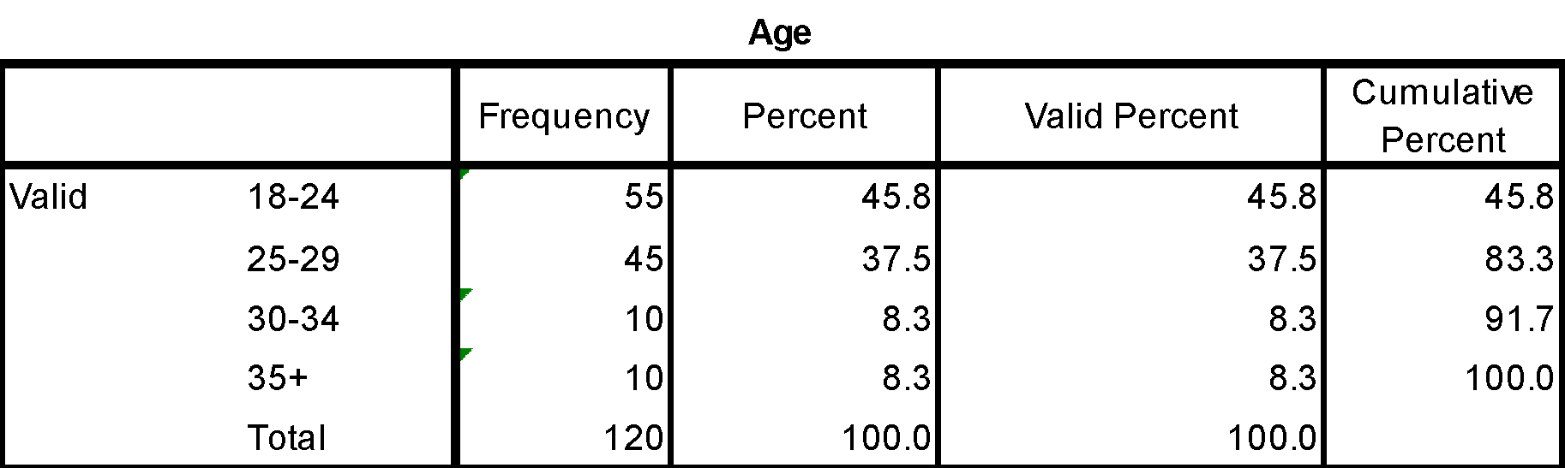

#### Table 5 *Education Level Statistics*

|  |  |  |  |  |  |
| --- | --- | --- | --- | --- | --- |
| **Education Level** | | | | | |
|  | | Frequency | Percent | Valid Percent | Cumulative Percent |
| Valid | High School Diploma | 37 | 30.8 | 30.8 | 30.8 |
| Trade/technical/vocational training | 5 | 4.2 | 4.2 | 35.0 |
| Associate degree | 2 | 1.7 | 1.7 | 36.7 |
| Bachelor's degree | 47 | 39.2 | 39.2 | 75.8 |
| Master's degree | 23 | 19.2 | 19.2 | 95.0 |
| Professional degree | 2 | 1.7 | 1.7 | 96.7 |
| Doctorate degree | 4 | 3.3 | 3.3 | 100.0 |
| Total | 120 | 100.0 | 100.0 |  |

#### Table 6 *Purpose of Travel Statistics*

|  |  |  |  |  |  |
| --- | --- | --- | --- | --- | --- |
| **Purpose of Travel** | | | | | |
|  | | Frequency | Percent | Valid Percent | Cumulative Percent |
| Valid | Business | 3 | 2.5 | 2.5 | 2.5 |
| Leisure | 86 | 71.7 | 71.7 | 74.2 |
| Both Business & Leisure | 20 | 16.7 | 16.7 | 90.8 |
| Other | 11 | 9.2 | 9.2 | 100.0 |
| Total | 120 | 100.0 | 100.0 |  |

### Continuous Variables

#### Table 7 *Descriptive Statistics*

|  |  |  |  |  |  |
| --- | --- | --- | --- | --- | --- |
| **Descriptive Statistics** | | | | | |
|  | N* | Minimum | Maximum | Mean | Std. Deviation |
| Positive Emotional Response | 480 | .00 | 4.00 | 1.9271 | 1.17586 |
| Negative Emotional Response | 480 | .00 | 3.57 | .5472 | .73708 |
| Hotel Preferences | 480 | .00 | 4.00 | 2.7823 | .85036 |
| Valid N (listwise) | 480 |  |  |  |  |

*\*n=480 because all 120 respondents rated all 4 stimuli (4 times 120 = 480)*

## Validation of scales

As depicted in the following table the main concepts of the study are measured by 18 items:

#### Table 8 *Table of Scales*

|  |  |  |
| --- | --- | --- |
| **Construct** | **Item** | **Source** |
| Preferences | 1. Approach 2. Avoidance 3. Behavioural Intention 4. Overall evaluation | R. Donovan and J. Rossiter (1982)  Olorunniwo et al. (2006)  Zhang et al. (2011) |
| Positive (Pleasant) Emotional Responses | 1. Desire 2. Satisfaction 3. Pride 4. Hope 5. Joy 6. Fascination 7. Admiration | Desmet (2002) |
| Negative (Unpleasant) Emotional Responses | 1. Disgust 2. Dissatisfaction 3. Shame 4. Fear 5. Sadness 6. Boredom 7. Contempt | Desmet (2002) |

The measures are to be validated with the help of Pearson`s correlation, Cronbach alpha checks and factor-analyses.

### Validation of Scales – Item Level

*Pearson correlation for Positive (Pleasant) emotions*

The performed Pearson correlation revealed a medium correlation between pride, fascination, satisfaction and admiration items but overall there is quite a strong relationship (Cohen, 1988) with scores varying from 0.60 to 0.81, n=480, p<0.0005 between items within Positive Emotions variable (See Table 9).

#### Table 9 *Pearson Correlation (Positive Emotional Response)*

|  |  |  |  |  |  |  |  |
| --- | --- | --- | --- | --- | --- | --- | --- |
| **Scale** | **1** | **2** | **3** | **4** | **5** | **6** | **7** |
| **1. Hotel Desire** | - | .681** | .770** | .795** | .736** | .487** | .569** |
| **2. Hotel Satisfaction** |  | - | .717** | .598** | .716** | .478** | .440** |
| **3. Hotel Pride** |  |  | - | .737** | .809** | .449** | .511** |
| **4. Hotel Hope** |  |  |  | - | .722** | .477** | .604** |
| **5. Hotel Joy** |  |  |  |  | - | .507** | .546** |
| **6. Hotel Fascination** |  |  |  |  |  | - | .738** |
| **7. Hotel Admiration** |  |  |  |  |  |  | - |

**. Correlation is significant at the 0.01 (2-tailed)

*Pearson correlation for Negative (Unpleasant) emotions*

The performed Pearson correlation revealed positive relationship (the lowest r = .211, the highest r =.712, n=480, p<.0005) between items within the negative emotions variable. The smallest correlations found between boredom and shame (r = .205) and contempt and shame (r = .211) (see Table 10).

#### Table 10 *Pearson correlation (Negative emotional response)*

|  |  |  |  |  |  |  |  |
| --- | --- | --- | --- | --- | --- | --- | --- |
| **Scale** | **1** | **2** | **3** | **4** | **5** | **6** | **7** |
| **1. Hotel Disgust** | - | .433** | .318** | .651** | .561** | .546** | .606** |
| **2. Hotel Dissatisfaction** |  | - | .696** | .391** | .337** | .312** | .350** |
| **3. Hotel Shame** |  |  | - | .349** | .302** | .205** | .211** |
| **4. Hotel Fear** |  |  |  | - | .712** | .510** | .635** |
| **5. Hotel Sadness** |  |  |  |  | - | .398** | .488** |
| **6. Hotel Boredom** |  |  |  |  |  | - | .588** |
| **7. Hotel Contempt** |  |  |  |  |  |  | - |

**. Correlation is significant at the 0.01 (2-tailed)

*Pearson correlation for Preferences*

The performed Pearson correlation revealed quite a strong relationship (between r=0.56 to r=0.70, n=480, p<.0005) between items within Preferences variable (See Table 11).

#### Table 11 *Pearson`s correlation (Preferences)*

|  |  |  |  |  |
| --- | --- | --- | --- | --- |
| **Scale** | **Intention** | **Approach** | **Avoidance** | **Overall Evaluation** |
| **Intention** | - | .695** | .558** | .561** |
| **Approach** |  | - | .639** | .680** |
| **Avoidance** |  |  | - | .608** |
| **Overall Evaluation** |  |  |  | - |

**. Correlation is significant at the 0.01 (2-tailed)

**Reliability Check Cronbach Alpha (Positive Emotions, Negative Emotions, Preferences)**

*Emotional responses (Positive, Negative)*

Both positive and negative emotional responses showed very good internal consistency (Cronbach`s alpha < .7, Nunnally (1978)). This supports a validation of a scale from Desmet (2002). The Inter-Item and Item-to-Total for positive emotions scale showed a good positive correlation (greater than .44). Noteworthy, for negative emotions scale the Inter-Item Correlation Matrix showed low correlations between boredom and shame and boredom and contempt (r = less than .3), however, considering a decent Cronbach alpha score (α = .84) it was decided to keep the items for further analysis (Pallant, 2007), for more details please see Table 12 and Appendix 1.1, 1.2.

*Preferences*

According to Pallant (2007), if there is a small number of items (less than 10) to measure a construct, it should not be expected to get a high Cronbach alpha value (Pallant, 2007). The “preferences” construct consisted of only four items (i.e. behavioural intention, approach, avoidance and overall evaluation), therefore we did not expect a high Cronbach alpha value. The “avoidance” item has been duly reversed in order to get accurate results (Pallant, 2007). The results from the reliability check of the “preferences” scales Cronbach alpha coefficient reported of 0.86 suggesting very good internal consistency reliability for the scale with this sample (Pallant, 2007). The Inter-Item Correlation Matrix showed positive values indicating that all items measure the same construct. The Corrected Item-Total Correlation values showed a positive score (greater than 0.3) which proves that all four items belong to one construct (Pallant, 2007) , for more details please see Table 12 and Appendix 1.3.

#### Table 12 *Cronbach Alpha Score*

|  |  |  |
| --- | --- | --- |
| Construct | N of items | Cronbach α |
|
| 1.Positive Emotions | 7 | 0.92 |
| 2.Negative Emotions | 7 | 0.84 |
| 3.Preferences | 4 | 0.86 |

*Factor analysis*

**Emotional Responses***:*

*Positive*

The 7 items of the positive emotional responses were subjected to principal components analysis (PCA). Prior to performing PCA, the suitability of the data for factor analysis was assessed. Inspection of correlation matrix revealed the presence of many coefficients of 0.3 and above (see Table 13). The Kaiser-Meyer-Oklin value was 0.88, exceeding the recommended value of 0.6 (Pallant, 2007) and Barlett`s Test of Sphericity reached statistical significance, supporting the factorability of the correlation matrix.

#### Table 13 *Correlation Matrix for Positive emotional response*

|  |  |  |  |  |  |  |  |
| --- | --- | --- | --- | --- | --- | --- | --- |
| Items | 1 | 2 | 3 | 4 | 5 | 6 | 7 |
| 1. Hotel Desire | 1.000 |  |  |  |  |  |  |
| 2. Hotel Satisfaction | .681 | 1.000 |  |  |  |  |  |
| 3. Hotel Pride | .770 | .717 | 1.000 |  |  |  |  |
| 4. Hotel Hope | .795 | .598 | .737 | 1.000 |  |  |  |
| 5. Hotel Joy | .736 | .716 | .809 | .722 | 1.000 |  |  |
| 6. Hotel Fascination | .487 | .478 | .449 | .477 | .507 | 1.000 |  |
| 7. Hotel Admiration | .569 | .440 | .511 | .604 | .546 | .738 | 1.000 |

As it was expected the Principal components analysis revealed the presence of one component with Eigenvalues exceeding 1, explaining 68.1 per cent of the variance (see Table 16).

*Negative*

The 7 items of the Negative emotional responses were subjected to principal components analysis (PCA). Prior to performing PCA, the suitability of the data for factor analysis was assessed. Inspection of correlation matrix revealed the presence of many coefficients of 0.3 and above (see Table 14). The Kaiser-Meyer-Oklin value was 0.88, exceeding the recommended value of 0.6 and greater (Pallant, 2007) and Barlett`s Test of Sphericity reached statistical significance, supporting the factorability of the correlation matrix.

#### Table 14 *Correlation Matrix for Negative emotional response*

|  |  |  |  |  |  |  |  |
| --- | --- | --- | --- | --- | --- | --- | --- |
| Items | 1 | 2 | 3 | 4 | 5 | 6 | 7 |
| 1. Hotel Disgust | 1.000 |  |  |  |  |  |  |
| 2. Hotel Dissatisfaction | .433 | 1.000 |  |  |  |  |  |
| 3. Hotel Shame | .318 | .696 | 1.000 |  |  |  |  |
| 4. Hotel Fear | .651 | .391 | .349 | 1.000 |  |  |  |
| 5. Hotel Sadness | .561 | .337 | .302 | .712 | 1.000 |  |  |
| 6. Hotel Boredom | .546 | .312 | .205 | .510 | .398 | 1.000 |  |
| 7. Hotel Contempt | .606 | .350 | .211 | .635 | .488 | .588 | 1.000 |

Unexpectedly, the Principal components analysis (PCA) revealed the presence of two components with Eigenvalues exceeding 1, explaining 54.1 and 17.4 per cent of the variance respectively. This outcome will be discussed later in the chapter when performing PCA on the construct level.

*Preferences*

The 4 items of the Preferences were subjected to principal components analysis (PCA). Prior to performing PCA, the suitability of the data for factor analysis was assessed. Inspection of correlation matrix revealed the presence of many coefficients of 0.3 and above (see Table 15). The Kaiser-Meyer-Oklin value was 0.82, exceeding the recommended value of 0.6 (Pallant, 2007) and Barlett`s Test of Sphericity reached statistical significance, supporting the factorability of the correlation matrix.

#### Table 15 *Correlation Matrix for Preferences*

|  |  |  |  |  |
| --- | --- | --- | --- | --- |
| Items | Intention | Approach | Avoidance (recoded) | Overall evaluation |
| Intention | 1.000 |  |  |  |
| Approach | .695 | 1.000 |  |  |
| Avoidance (recoded) | .558 | .639 | 1.000 |  |
| Overall evaluation | .561 | .680 | .608 | 1.000 |

As it was expected the Principal components analysis revealed the presence of one component with Eigenvalues exceeding 1, explaining 71.8 per cent of the variance (see Table 16).

#### Table 16 *Factor loadings for Positive and Negative emotions responses and Preferences*

|  |  |  |  |
| --- | --- | --- | --- |
| Construct | No. of items | First factor (per cent) | Loading  Highest-Lowest |
| Positive emotional response | 7 | 54.1 | .55-.85 |
| Positive emotional response | 7 | 68.1 | .70-.88 |
| Preferences | 4 | 71.8 | .82-.89 |

### Validation of Scales – Construct Level

**Correlations between Constructs**

The relationship between three variables (positive (pleasant), negative (unpleasant) emotional responses and preferences) was investigated using Pearson product-moment correlation coefficient. There was a strong positive correlation between Positive Emotional Responses and Preferences, r = .66, n=480, p<.0005, with high level of Preferences associated with high level of perceived Positive Emotions. Also, there was a strong negative correlation between Negative Emotional Responses and Preferences, r = -.54, n=480, p<.0005, with low level of Preferences associated with high level of perceived negative emotions (Table 17).

#### Table 17 *Pearson`s correlation among constructs*

|  |  |  |  |
| --- | --- | --- | --- |
| **Scale** | **Positive Emotions** | **Negative Emotions** | **Preferences** |
| **Positive Emotions** | - | -.241 | .660 |
| **Negative Emotions** |  | - | -.536 |
| **Preferences** |  |  | - |

**Factor analysis**

The 14 items of the positive and negative emotional responses were subjected to principal components analysis (PCA) using SPSS Version 21. Prior to performing PCA, the suitability of the data for factor analysis was assessed. Inspection of correlation matrix revealed the presence of many coefficients of 0.3 and above (for information please see Appendix 2.1).

The Kaiser-Meyer-Oklin value was 0.88, exceeding the recommended value of 0.6 (Pallant, 2007) and Barlett`s Test of Sphericity reached statistical significance, supporting the factorability of the correlation matrix.

Principal components analysis revealed the presence of three components with Eigenvalues exceeding 1, explaining 39.3%, 23% and 12.3% of the variance respectively (see Table 18). Scree Plot investigation showed the clear break after the fourth factor, but with Eigenvalue less than 1. It is interesting to note that with pleasant and unpleasant emotions it was to be expected to reveal two factors, however three items (shame, dissatisfaction and fascination) fell out from the range of two factors, revealing three factors overall (Refer to graph 1 and table 18).

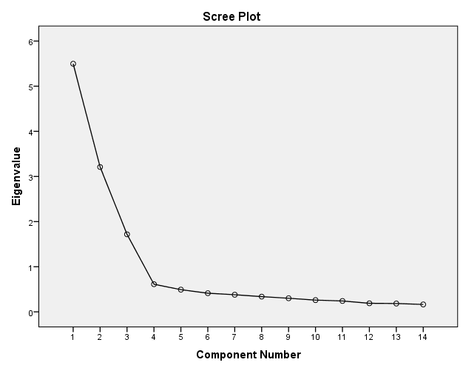

#### Graph 1 *Screeplot (Positive and Negative emotional responses)*

#### Table 18 *Pattern and Structure Matrix for PCA with Oblimin Rotation of Three Factor* *Solution of PrEmo Items*

|  |  |  |  |  |  |  |  |
| --- | --- | --- | --- | --- | --- | --- | --- |
|  | *Pattern Coefficients (above .3)* | | | *Structure coefficients (above .3)* | | | *Communalities* |
| *Factor loading* | *1*  *39.26%* | *2*  *22.92%* | *3*  *12.27%* | *1*  *39.26%* | *2*  *22.92%* | *3*  *12.27%* |
| *Items* |
| Desire | **.893** |  |  | **.894** |  |  | .804 |
| Joy | **.887** |  |  | **.892** |  |  | .808 |
| Pride | **.884** |  |  | **.886** |  |  | .799 |
| Hope | **.891** |  |  | **.879** |  |  | .778 |
| Satisfaction | **.779** |  |  | **.805** | -.320 |  | .695 |
| Admiration | **.646** |  | .568 | **.694** |  | .610 | .808 |
| Fear |  | **.869** |  |  | **.876** |  | .771 |
| Disgust |  | **.802** |  |  | **.831** |  | .709 |
| Contempt |  | **.781** |  |  | **.800** |  | .660 |
| Sadness |  | **.801** |  |  | **.792** |  | .642 |
| Boredom |  | **.657** |  |  | **.700** |  | .570 |
| Shame |  |  | **-.834** |  | **.341** | **-.839** | .802 |
| Dissatisfaction |  | .310 | **-.793** |  | **.448** | **-.834** | .798 |
| Fascination | .560 |  | **.636** |  |  | **.680** | .780 |

This unexpected outcome is quite difficult to explain. The preceding validation showed good face validity and reliability with quite high score of Cronbach alpha (.84). We could not find in the previous research (Desmet, 2002; Desmet et al., 2000) any similar factor reduction analysis to compare with. One can assume that three factors outcome could be due the peculiarity of our sample that is why it was decided to follow standard two bipolar dimensions model of PrEmo and perform the analysis extracting two factors.

Performed PCA with two-component solution showed that Component 1 contributing 39.3% and Component 2 contributing 23%. To aid in the interpretation of these two components, oblimin rotation was performed. The rotated solution revealed the presence of simple structure (Thrustone, 1947), with both components revealing a number of strong loading substantially on only one component (see Table 19) which indicate convergent and discriminant validity. There was a weak negative correlation between two components (r= -.19).

#### Table 19 *Pattern and Structure Matrix for PCA with Oblimin Rotation of Two Factor Solution of PrEmo Items*

|  |  |  |  |  |  |
| --- | --- | --- | --- | --- | --- |
|  | *Pattern Coefficients (above .3)* | | *Structure coefficients (above .3)* | | *Communalities* |
| *Factor loading* | *1*  *39.27%* | *2*  *22.92%* | *1*  *39.27%* | *2*  *22.92%* |
| *Item* |
| Desire | **.896** |  | **.888** |  | .790 |
| Hope | **.893** |  | **.868** |  | .770 |
| Joy | **.889** |  | **.888** |  | .789 |
| Pride | **.883** |  | **.880** |  | .775 |
| Satisfaction | **.786** |  | **.812** |  | .678 |
| Admiration | **.730** |  | **.726** |  | .528 |
| Fascination | **.653** |  | **.669** |  | .455 |
| Fear |  | **.850** |  | **.847** | .717 |
| Disgust |  | **.785** |  | **.808** | .668 |
| Sadness |  | **.783** |  | **.761** | .592 |
| Contempt |  | **.728** |  | **.757** | .594 |
| Dissatisfaction |  | **.681** |  | **.674** | .456 |
| Shame |  | **.616** |  | **.588** | .366 |
| Boredom |  | **.613** | -.409 | **.669** | .529 |

## Hypothesis Testing

### RO1

A one-way between-groups analysis of variance (ANOVA) was conducted to explore the impact of hotel stimuli on emotional response to hotel design style, as measured by the PrEmo Emotional Response test. Stimuli were divided into four groups according to the hotel number (Hotel 1, Hotel 2, Hotel 3 and Hotel 4). There was statistically significant differences at the p<0.05 level in positive emotional response PrEmo scores for the four hotel stimuli [F(3, 476)=43.46, p=0.00] and negative emotional response PrEmo scores for the four hotel stimuli [F(3, 476)=22.77, p=0.00]. The actual difference in mean scores between the groups was quite large according to the effect size. The effect size, calculated using eta squared, was 0.22 for positive emotional response, and 0.13 for negative emotional response. The means and standard deviations are presented in Table 20 and 21. Post-hoc comparisons using the Tukey HSD test indicated that the mean score for positive emotional response between Hotel 1 was not significantly different from Hotel 3. Post-hoc comparisons using the Tukey HSD test indicated that the mean score for negative emotional response between Hotel 1 was not significantly different from Hotel 3. There was also no significant difference between Hotel 2 and Hotel 4 in mean scores for negative emotional response to hotel style design.

#### Table 20 *Descriptive Statistics for Positive Emotional Response to Hotel 1, 2, 3 & 4*

|  |  |  |  |
| --- | --- | --- | --- |
| Hotel stimuli | N | Mean | Standard Deviation |
| hotel #1 | 120 | 1.30 | 1.03 |
| hotel #2 | 120 | 2.11 | 1.13 |
| hotel #3 | 120 | 1.57 | 0.84 |
| hotel #4 | 120 | 2.73 | 1.15 |

#### Table 21 *Descriptive Statistics for Negative Emotional Response to Hotel 1, 2, 3 & 4*

|  |  |  |  |
| --- | --- | --- | --- |
| Hotel stimuli | N | Mean | Standard Deviation |
| hotel #1 | 120 | 0.80 | 0.90 |
| hotel #2 | 120 | 0.29 | 0.58 |
| hotel #3 | 120 | 0.82 | 0.57 |
| hotel #4 | 120 | 0.29 | 0.67 |

### RO2

Prior to perform linear regression analysis, the following assumptions should be checked (Pallant, 2007).

**Multicollinearity**

The **Correlations** table showed that our independent variable has relationship with our dependent variables (positive and negative emotions) with scores (.66 and -.54 respectively) above .3. And the correlation between the dependent variables does not show bivariate correlation (-.24) which is less than 0.7 (Pallant, 2007).

The performed collinearity diagnostics in the table Coefficients showed the tolerance value for each independent variable is .94, which is not less than .10; therefore, we have not violated the multicollinearity assumption. This is also supported by the VIF value, which is 1.06, which is well below the cut-off of 10.

***Outliers, normality, linearity, homoscedasticity, independence of residuals***

To check this assumption we inspect the **Normal Probability Plot (P-P) of the Regression Standardized Residual** and the **Scatterplot.** In the Normal P-P Plot, our points lie in a reasonable straight diagonal line from bottom left to top right. This suggests no major deviations from normality. In the **Scatterplot** of the standardized residuals we could see that the residuals are roughly rectangularly distributed, with most of the scores concentrated in the centre (along the 0 point) (Pallant, 2007).

Although the **Casewise Diagnostics** revealed four unusual cases to be fallen outside of the standard range of residual values (above 3.0 or below -3.0) the maximum value for **Cook`s Distance** is .042 (less than 1) which suggest that these strange cases do not have an influence on the results for our model (Tabachnik & Fidell, 2007).

**Evaluating the model**

The Regression analysis showed a value of R square as .586, which indicates that 58.6 per cent of the variance in the preferences is explained by the model which, according to Pallant (2007), is considered to be a respectable result. The value of **Adjusted R square** is close to **R square** (.584) which can suggest that our sample is quite enough for our study. Results of **ANOVA** showed that our model reaches statistical significance (**Sig**. =.000, p<.0005).

For more details and proves of standard multiple regression analysis please see Appendix 4.

***Evaluating each of the independent variables***

The largest Standardized Beta coefficient is 0.56, which is for Total Positive Emotions. The Standardized Beta value for Total Negative Emotions was slightly lower (-0.40), indicating that it made less of a contribution. **Sig.** value for both dependent variables is less than 0.05, which suggests a significant contribution to the prediction of Preferences.

The results of the analyses showed that our model, which includes control of positive emotions and control of negative emotions explains 58.4 per cent of the variance in preferences. Of these two variables, positive emotions make the largest contribution (beta= 0.56), although negative emotions also made a statistically significant contribution (beta= -0.40).

### RO3

A one-way between-groups multivariate analysis of variance was performed to investigate gender differences in hotel design style emotional response and preferences. Three dependent variables were used: positive emotional response, negative emotional response and hotel preferences. The independent variable was gender. Preliminary assumption testing was conducted to check for normality, linearity, univariate and multivariate outliers, homogeneity of variance-covariance matrices, and multicollinearity, with no serious violations noted. There was a statistically significant difference between males and females on the combined dependent variables: F(3, 476) = 5.37, p = 0.001; Wilks’ Lambda = 0.97; partial eta squared = 0.033. When the results for the dependent variables were considered separately, the only difference to reach statistical significance using a Bonferroni adjusted alpha level of 0.017, was negative emotional response: F(1, 478)=12.81, p=0.000, partial eta squared = 0.026. The means and standard deviations are presented in Table 22. An inspection of the mean scores indicated that males reported slightly higher levels of negative emotional response to hotel design style (M=0.683, SD=0.050) than females (M=0.443, SD=0.44).

#### Table 22 *Descriptive Statistics for Gender Differences*

|  |  |  |  |  |
| --- | --- | --- | --- | --- |
| Construct | Gender | M | Mean | Standard Deviation |
| Positive Emotional Response | Male | 208 | 1.92 | 1.11 |
|  | Female | 272 | 1.93 | 1.23 |
| Negative Emotional Response | Male | 208 | 0.68 | 0.83 |
|  | Female | 272 | 0.44 | 0.64 |
| Preferences | Male | 208 | 2.76 | 0.82 |
|  | Female | 272 | 2.80 | 0.87 |

### RO4

A one-way between-groups multivariate analysis of variance was performed to investigate citizenship differences in hotel design style emotional response and preferences. Three dependent variables were used: positive emotional response, negative emotional response and hotel preferences. The independent variable was citizenship. Preliminary assumption testing was conducted to check for normality, linearity, univariate and multivariate outliers, homogeneity of variance-covariance matrices, and multicollinearity, with no serious violations noted. There was a statistically significant difference between Norwegian citizens and non-Norwegian citizens on the combined dependent variables: F(3, 476)=3.88, p=0.009; Wilks’ Lambda=0.98; partial eta squared=0.02. When the results for the dependent variables were considered separately, the only difference to reach statistical significance using a Bonferroni adjusted alpha level of .017, was positive emotional response: F(1, 478)=7.33, p=0.007, partial eta squared=.015. The means and standard deviations are presented in Table 23. An inspection of the mean scores indicated that non-Norwegian citizens reported slightly higher levels of positive emotional response to hotel design style (M=2.10, SD=0.083) than Norwegian citizens (M=1.80, SD=0.70).

#### Table 23 *Descriptive Statistics for Citizenship Differences*

|  |  |  |  |  |
| --- | --- | --- | --- | --- |
| Construct | Citizenship | N | Mean | Standard Deviation |
| Positive Emotional Response | Norwegian | 280 | 1.80 | 1.18 |
|  | Non-Norwegian | 200 | 2.10 | 1.15 |
| Negative Emotional Response | Norwegian | 280 | 0.56 | 0.72 |
|  | Non-Norwegian | 200 | 0.54 | 0.76 |
| Preferences | Norwegian | 280 | 2.77 | 0.88 |
|  | Non-Norwegian | 200 | 2.80 | 0.81 |

# Chapter 5: Discussion

## Reliability and Validity

According to our results revealed through a reliability and validation check, the measures were found to be quite reliable and valid. On the item level there was shown a significant Pearson`s correlation between the items within positive emotional responses, negative emotional responses and preferences and quite high score of Cronbach alpha (above .7 within all three constructs). According to Pallant (2007) such results suggest a good internal consistency for positive emotional responses scale, negative emotional responses scale and preferences scale.

The interpretation of the results of principal component analysis for PrEmo scales revealed three factors instead of expected two factors. Six out of seven (Desire, Joy, Pride, Hope Satisfaction and Admiration) of positive emotional responses items loaded strongly on Factor 1, five out of seven (Fear, Disgust, Contempt, Sadness and Boredom) of negative emotional responses loaded strongly on Factor 2 and the rest (Shame, Dissatisfaction and Fascination) emotional responses surprisingly loaded on Factor 3.  We have not found any similar analysis to be inspected for validation of PrEmo in the previous research (Desmet, 2002; Desmet et al., 2000). This makes it quite difficult to discuss and explain the unexpected outcome of factor-analysis. One can assume that this outcome weakens a construct validity of PrEmo tool. However, with a face validity inspection and the reliability analysis, we assumed that three-factor outcome could be due to peculiarities of convenience sample exploited in the current study. After rerunning the principal component analysis with two-factor option, the results showed that all pleasant emotions strongly loaded on Factor 1 and unpleasant emotions strongly loaded on Factor 2 with a weak negative correlation between two components (r= -.19). It is assumed to be an optimal final solution for PrEmo scales.

Since four items of Preferences construct were adapted from different studies (Table 8) the same procedure was performed for validation of Preferences construct. As a result of factor analysis it was revealed that all four items strongly loaded with one factor, which was expected, which suggests good discriminant and convergent validity.

During the validation of the measures used in the current study it was revealed that PrEmo scales are quite reliable and valid, this supports the findings in the previous research (Desmet, 2002; Desmet et al., 2000) and Preferences scale also showed good reliability and validity. Thus, the findings of the current study on emotional responses evoked by hotel style design are expected to be reliable and valid and could be considered for further investigation of emotions.

## Answers to Research Objectives

### RO1

According to our findings revealed through the one way analysis of variance (ANOVA), hotel style design does trigger perceived emotions to be evoked. For the four different hotels studied, there was an overall significant difference between mean scores for both positive and negative emotional responses. This supports our hypothesis that hotel style design would trigger perceived emotions to be evoked. This hypothesis was based on the study by Lo (2008). In her study of emotions evoked during hotel stay, research participants reported 418 cases of emotions which were evoked by things, places and events during their stay.

As a part of our hypothesis we also predicted that there would be no significant difference between emotional response to Hotel 2 and Hotel 3. This however was not supported in our analysis; the means for emotional response for both positive and negative emotions showed significant difference. In our pre-test of the study, we found that most respondents thought the two hotels were identical. Therefore the manipulation of stimuli to have hotel 2 and 3 be perceived as similar did not work as hypothesized. The reason for the significant difference between hotel 2 and 3 cannot be determined as we did not aim to study the specific aspects of hotel style design, but it can be assumed that respondents somehow found some style elements to vary between the two hotels enough to evoke a significantly different emotional response.

Our results showed that there was no significant difference between emotions evoked by hotel style design stimuli in the following scenarios:

1. Positive Emotions – No significant difference between Hotel 1 and 3
2. Negative Emotions – No significant difference between Hotel 1 and 3
3. Negative Emotions – No significant difference between Hotel 2 and 4

Hotel 1 is classified as an economy/limited service hotel, while hotel 3 is classified as a full service hotel. This makes the finding that there was no significant difference in emotional response for both positive and negative emotions very interesting. As Hotel 1 is classified as an economy/limited service hotel, we can assume that there is a not a large budget directed towards hotel style design. As for the full service hotel, we can assume that there would be a relatively higher budget for hotel style design. However, the emotional response to the hotel style was not significantly different. This finding could suggest that spending more on hotel style design does not necessarily translate into having more positive emotional response from consumers.

At the same time, Hotel 2 most likely has a similar hotel style design budget as for Hotel 3, and the emotional response was significantly different in a positive way than for Hotel 1. This could suggest that Hotel 2 has done a more efficient and effective job at designing their hotel’s style than Hotel 3.

Hotel 2 is classified as a full service hotel, while hotel 4 is classified as an upscale luxury hotel. The finding that there was no significant difference between negative emotions between the two hotels, and the fact that the mean score for both hotels negative emotional response was very low (M=0.29 for both hotels) suggests that participants did not experience negative emotions in response to both hotel’s design. This could mean that they found very few flaws in the hotel style of both hotels. It is interesting to note that hotel 4 is an upscale luxury hotel that technically should spend more time and effort on hotel style than a full service hotel. Hotel 4 was able to generate a significantly higher positive emotional response than all other hotel stimuli studied, however in this case it seems the effort by Hotel 4 spent on hotel style to generate a significantly lower negative emotional response was in vain. One could assume however that this low negative emotional response could also be due to the efficient work by Hotel 2 to style their hotel in a way that consumers respond to in a relatively positive way.

### RO2

The results of the standard multiple regression analysis showed that emotional response to hotel style plays a quite significant role in predicting preferences (R squared=0.586). The positive emotional response is a stronger predictor of preferences than negative emotional response (β =0.56 and β=-0.40 respectively). This finding supports our hypothesis that preferences could be explained by emotional response to hotel style. In a study by Pullman and Robson (2007) of customers experience with design they found multiple relationships between images taken and satisfaction/loyalty ratings. In a study of service quality, emotional satisfaction and behavioural intention by Ladhari (2009) he found that emotional satisfaction linked with behavioural intention within the hospitality industry. Thus, the current findings supports previous research.

According to the results the positive correlation of positive emotional response and preferences suggests that if people perceive the stimuli in more positive way then they are more likely to prefer the stimuli. The negative correlation between negative emotional response and preference suggests that if people perceive the stimuli in more negative way then they are less likely to prefer the stimuli.

### RO3

According to our findings revealed through a one-way between-groups multivariate analysis of variance (MANOVA), there was a statistically significant difference between males and females emotional response and preferences on the combined dependent variables. The only difference to reach statistical significance was negative emotional response; males reported slightly higher levels of negative emotional response to hotel design style than females. These findings partially support the hypotheses.

The first hypothesis was that women would be more likely to experience positive emotions in relation to hotel stimuli than men, and men would be more likely to experience negative emotions in relation to hotel stimuli. This is based on a study of customers’ experience with hotel design by Pullman and Robson (2007) that found that women generally took more positive photos of design and service than men, while men took more negative service photographs. The findings did not show significant difference between women and men for positive emotional response, so this part of the hypothesis was not supported. However, the findings did show a significant difference on negative emotional response in that males reported higher ratings of negative emotional response than females.

The second hypothesis was that preferences towards hotel style would not be significantly different between genders. This was also based on the same Pullman and Robson (2007) as used in the first hypothesis as they found that there was no significant difference between men and women’s photograph commentaries. This hypothesis was supported by the findings; there was no significant difference shown between males and females related to preferences.

The reason why females did not experience a more positive emotional response to hotel style than males is unknown. However it could be due to the stimuli chosen; perhaps the stimuli chosen in the Pullman & Robson study happened to be stimuli that women responded to in a more positive way than the stimuli chosen in the current study.

### RO4

According to our findings revealed through a one-way between-groups multivariate analysis of variance (MANOVA), there was a statistically significant difference between Norwegian and non-Norwegian citizens’ emotional response and preferences on the combined dependent variables. The only difference to reach statistical significance was positive emotional response; non-Norwegian citizens reported slightly higher levels of positive emotional response to hotel design style than Norwegian citizens.

The reason why non-Norwegians experience a more positive emotional response to hotel style than Norwegian citizens is unknown. Perhaps it is due to expectations that differ between cultures in relation to hotel design. It could also be due to the willingness of different cultures to react in a positive way to hotel style.

## Theoretical Implications

Mehrabian-Russell postulated that any environment will evoke emotions in an individual and those emotions can be classified into “PAD” (pleasure, arousal and dominance) dimensions, which include both positive and negative aspects of all dimensions. The factor analysis conducted in this study has supported that positive and negative emotions are two different factors. However three of the fourteen emotional items studied (fascination, shame and dissatisfaction) fell into a third factor category. This may be due to peculiarities in our sample, and the reasons are unexplainable for this third factor. We decided to continue with the PrEmo measure of emotions as it has been used in many other studies, and those studies did not describe any factor analysis issues such as this.

Donovan & Rossiter (1982) formulated the S-O-R (stimulus, organism, response) framework that suggested stimuli affect the customers’ emotional states (organism) whose response can be observed in their behaviour (response). As a part of the S-O-R theory, it is stated that the emotional state can influence the response to stimuli. This study supports this framework in the hotel industry context. When respondents were presented with stimuli (hotel style design photos), it evoked emotions in the respondents (positive and negative emotional response). Our study also supports this theory as it is found that emotional response is a strong predictor of preferences (response).

## Methodological Implications

The current study aimed to understand if and how hotel style design evokes emotions that could affect customer`s preferences. The stimuli used in the current studies are internet picture presentations of different hotels’ design that are utilized to elicit emotions. The choice of using pictures from hotels websites is based on the fact that hotel customers nowadays are exposed to Internet advertising and prefer to book online. With growing number of hotels and search engines that provide various options for accommodation, Web is becoming a major communication channel between customers and hotels (Jeong & Choi, 2004). The current study shows that it is possible to evoke emotional responses in consumers using online pictures of hotel style design as a stimuli. These emotional responses can then be utilized to predict preferences.

According to Poels and Dewitte (2006) self-report measures mainly focus on introspective reflections about emotions evoked by advertising stimulus. The findings of the study showed that emotional responses can be evoked by hotel style design and visual self-report measures can be utilized as a method to capture emotional response. The study revealed that emotions towards hotel style design can contribute to the preferences. The more positive emotional responses hotel style can evoke the more a hotel would be preferred.  Noteworthy, one can assume that utilizing the self-report tools for measuring emotions does not always allow for the capturing of more complex emotions. Therefore emotional response ratings can be biased and may weaken the understanding of their possible effects. However, according to Desmet (2002) one of the advantages of PrEmo tool is that it allows to choose more emotions than one when reacting on one stimulus. This could aid to understand emotional responses on a more advanced level. As it has been noted in Poels and Dewitte (2006) review paper, when reacting to advertisements, mainly basic emotions are evoked that are spontaneous emotional reactions. Since the current studie`s aim was not to investigate what specific emotions are evoked, the usage of basic emotions was sufficient.

It is interesting to note that the findings from the current study did not show support for some of the hypotheses, and the reason for this seems to be due to the stimuli selection method used. Firstly, when implementing a manipulation check by using two “identical” stimuli (Hotel 2 and Hotel 3) did not seem to have an expected effect, since results revealed significantly different emotional responses between those hotels. The pre-test of the experiment showed that participants’ ratings of Hotel 2 and Hotel 3 were very similar which ascertained that the two stimuli chosen would produce responses in the actual experiment that were not significantly different. However, the findings of the actual experiment suggests that very similar stimuli does not necessarily elicit homogeneous responses. It also suggests that the chosen stimuli were not similar enough to evoke similar emotional responses. A second example that demonstrates the weakness of the current study stimuli is the fact that hotel 1 (economy hotel) and hotel 3 (full service hotel) received emotional response ratings that were not significantly different. This finding was not as expected.  The same outcome was found between hotel 2 (full service) and hotel 4 (upscale luxury); there was no significant difference in negative emotional response ratings, which was also not expected.

## Management Implications

Managers should ensure that they fully understand the emotional response that potential consumers experience when being exposed to the hotel style design stimuli used to promote hotel. The current study has shown that there are emotions evoked in relation to hotel style stimuli, and that these emotions can be used to predict consumer preferences. The more positive this response is, the more likely it is that their hotel will be preferred over other hotels. They would be more likely to stay at your hotel, remain loyal to it, and give the hotel a good overall evaluation.

Managers must optimize the positive emotional response their customers’ experience when being subjected to their hotel style design stimuli. This study has shown the importance of ensuring that photos exhibited to the public to promote hotels are representing the hotel style in such a way that elicits the most positive emotions possible. If managers are able to elicit positive emotions, this will lead to the hotel being preferred over others.

Managers can use multiple tools to measure customers’ emotional response to their hotel style design stimuli. The PrEmo tool used to measure consumer emotions and product experience has been validated through this study, so it is a recommended tool for managers to use. It has been designed as a tool for use both by academia and in a business context. Managers should do marketing research with this tool to survey both current and potential customers to fully understand and optimize the customers’ emotional response and product experience with their hotel stimuli. Managers can then take this information and use it to both promote their hotel through images on their webpage and other promotional tools and to make decisions regarding the style of their hotel.

Managers need to ensure that their hotel style design elicits a positive emotional response in males more than in females. This is due to the finding that men are more likely to negatively react to hotel style design stimuli. If the hotel’s main clients are male, even more effort should be dedicated to hotel style by managers and the promotion of the associated visual stimuli.

Managers need to ensure that they are aware of cross-cultural differences in consumers’ emotional response to their hotel style design. This is due to the finding that non-Norwegians are more likely to positively react to hotel style design stimuli. In this case, if the hotel’s main clients are Norwegian citizens as opposed to foreign visitors, even more effort should be dedicated to hotel style and the promotion of the associated visual stimuli. If other cross-cultural differences are detected through the survey of a hotel’s current and potential customers, then they should promote their hotel through stimuli accordingly to the segment of the market that they are trying to attract.

## Limitations of Current Research

The use of a convenience, nonprobability sample in this study means that there is no way to estimate how representative of the population the convenience sample is. Therefore it is not possible for us to estimate the population parameters that the study is trying to say something about.

The PrEmo software used to measure emotions had a limitation because the order of stimuli presented could not be randomized. There was a feature to randomize the order of the stimuli, but we had corresponding questionnaires that had to follow the showcasing of each stimuli, which would not have been properly randomized along with the stimuli. This is a limitation to the study as the lack of manipulation of stimuli could have changed how respondents rated stimuli due to the order it was presented in.

The use of only photos as opposed to actual customers of the hotel who would be able to get a full experience of hotel style, not just the pictures that were chosen in this study to showcase the hotel style. This study is more applicable to consumers who book hotels online or by looking at photos prior to booking. The findings cannot be easily said to say something about consumers who actual visit the hotel and experience the hotel style in real life.

## Implications for Future Research

One can assume that utilized stimuli in the current study were not different enough to produce expected emotional responses to support the hypotheses. From the other hand this could suggest that stimuli may result in different responses from different samples. Therefore it is recommended for the future study prior to conduct the experiment to investigate stimuli more carefully in order to scrutinize emotional responses in more predictable way.

It would be recommended to investigate the internal validity of PrEmo since the findings of the present studies revealed some problems with convergent and discriminant validity of the scales which again might occurred due to the peculiarity of the used sample.

Since the present study did not aim to investigate the role of elements or attributes in hotel style design it would be recommended to investigate further their role in evoking of emotional response.

Also it would be recommended for the future research when conducting an experiment to show all stimuli at first in the survey. This way this will minimize the chance that respondents rate the stimuli based on only the previous stimuli shown, as opposed to rating the stimuli in relation to all the stimuli they have already seen and will see in the next part of the survey.

# Chapter 6: Conclusion

This paper has elaborated on emotional responses towards four hotel style design stimuli basing on the findings of research studies on consumer`s behaviour. These stimuli highlight hotel features that evoke emotional responses by matching consumer`s concerns for their preferences. The relationship of emotional response to hotel style design may serve as references and inspirations for hoteliers and designers in terms of improving hotel presentation marketing for potential and existing consumers. Research findings of the current paper suggest that the relational message of hotel style design development is one of the important means of evoking pleasant consumer`s emotional response and making the hotel more preferable. Further effort in research on investigating what those specific attributes in the hotel style design that evoke more pleasant emotions is therefore highly recommended.

# REFERENCES

Bitner, M. J. (1992). Servicescapes: The Impact of Physical Surroundings on Customers and Employees. *Journal of Marketing, 56*, 57-71.

Burton, S., Sheather, S., & Roberts, J. (2003). Reality or perception? The effect of actual and perceived performance on satisfaction and behavioral intention. *Journal of Service Research, 5*(4), 292-302.

Cohen, J. W. (1988). *Statistical power analysisnfor the behavrioral sciences* (Vol. 2nd edn.). Hillsdale, NJ: Lawrence Erlbaum Associates.

Countryman, C. C., & Jang, S. (2006). The effects of atmospheric elements on customer impression: the case of hotel lobbies. *International Journal of Contemporary Hospitality Management, 18*(7), 534-545.

Desmet, P. M. A. (2002). *Designing emotion*. Unpublished doctoral thesis. Technische Universiteit. Delft.

Desmet, P. M. A., Hekkert, P., & Jacobs, J. J. (2000). When a Car Makes You Smile: Development and Application of an Instrument to Measure Product Emotions. *Advances in Consumer Research, 27*, 111-117.

Donovan, R., & Rossiter, J. (1982). Store atmosphere-an environmental psychology approach. *Journal of retailing, 58*(1), 34-57.

Donovan, R. J., & Rossiter, J. R. (1982). Store Atmosphere: An Environmental Psychology Approach. *Journal of retailing, 58 (Spring)*, 34-57.

Ekman, P., & Friesen, W. V. (1986). A new pan-cultural facial expression of emotion. *Motivation and emotion, 10*(2), 159-168.

Erdly, M., & Kesterson-Townes, L. (2003). “Experience rules”: a scenario for the hospitality and leisure industry circa 2010 envisions transformation. *Strategy & Leadership, 31*(3), 12-18.

Gill, M., & Wigder, Z. D. (2013). European Online Retail Forecast, 2012 To 2017. Retrieved June 11, 2015, from https://<http://www.forrester.com/European+Online+Retail+Forecast+2012+To+2017/fulltext/-/E-RES93341?docid=93341>

Gilmore, J. H., & Pine II, B. J. (2002). Differentiating hospitality operations via experiences: why selling services is not enough. *The Cornell Hotel and Restaurant Administration Quarterly, 43*(3), 87-96.

Heide, M., Lærdal, K., & Grønhaug, K. (2007). The Design and Management of Ambience - Implications for Hotel Architecture and Service. *Tourism management, 28*, 1315-1325.

Jeong, M., & Choi, J. (2004). Effects of Picture Presentations on Customers` Behavioral Intentions on the Web. *Journal of Travel & Tourism Marketing, 17*(2/3), 193-204.

Khalid, H. M., & Helander, M. G. (2006). Customer emotional needs in product design. *Concurrent Engineering, 14*(3), 197-206.

Ladhari, R. (2009). Service quality, emotional satisfaction, and behavioural intentions: A study in the hotel industry. *Managing Service Quality: An International Journal, 19*(3), 308-331.

Lang, P. J. (1985). *The Cognitive Psychophysiology of Emotion: Anxiety and the Anxiety Disorders*. Hillsdale, NJ: Lawrence Erlbaum.

Lo, K. P. Y. (2008). Hotel stay scenarios based on emotional design research.

Mattsson, J. (1992). A Service Quality Model Based on an Ideal Value Standard. *International Journal of Service Industry, 3*(3), 18-33.

Mehrabian, A., & Russell, J. A. (1974). *An approach to environmental psychology*: the MIT Press.

Morris, J. D. (1995). Observations: SAM: The Self-Assessment Manikin An Effeicient Cross-Cultural Measurement of Emotional Response. *Journal of Advertising Research*.

Neuman, W. L. (2014). *Understanding Research*. Essex: Pearson.

Nunnally, J. O. (1978). *Pschometric theory*. New York: McGraw-Hill.

Olorunniwo, F., Hsu, M. K., & Udo, G. J. (2006). Service quality, customer satisfaction, and behavioral intentions in the service factory. *Journal of Services Marketing, 20*(1), 59-72.

Pallant, J. (2007). *SPSS survival manual: A step-by-step guide to data analysis using SPSS version 15*. Nova Iorque: McGraw Hill.

Poels, K., & Dewitte, S. (2006). *How to capture the heart? Reviewing 20 years of emotion measurement in advertising*. (MO0605). K.U.Lueven-Faculty of Economics and Applied Economics.

Pullman, M. E., & Robson, S. K. A. (2007). Visual Methods Using Photographs to Capture Customers' Experience with Design. *Cornell Hotel and Restaurant Administration Quarterly, 48*(2), 121-144.

Rademacher, U., & Koschel, K. V. (2006). *Coming to Terms with Emotions*. Paper presented at the Esomar Qualitative, Athens.

Ransley, J., & Ingram, H. (2001). What is "good" hotel design? *Facilities, 19*(1/2), 79-86.

Russell, J. A. (1980). A Circumplex Model of Affect. *Journal of personality and social psychology, 39*(6), 1161-1178.

SusaGroup. (2015). Susa Group. Retrieved February 1, 2015, from <http://www.susagroup.com/>

Tabachnik, B., & Fidell, L. (2007). *Using multivariate statisctics* (Vol. 5th edn.). Boston: Pearson Education.

Thang, D. C. L., & Tan, B. L. B. (2003). Linking consumer perception to preference of retail stores: an empirical assessment of the multi-attributes of store image. *Journal of retailing and consumer services, 10*(4), 193-200.

Thrustone, L. L. (1947). *Multiple factor analysis*. Chicago: University of Chicago Press.

Zeithaml, V. A., Berry, L. L., & Parasuraman, A. (1996). The behavioral consequences of service quality. *the Journal of Marketing*, 31-46.

Zhang, Z., Ye, Q., & Law, R. (2011). Determinants of hotel room price: An exploration of travelers' hierarchy of accommodation needs. *International Journal of Contemporary Hospitality Management, 23*(7), 972-981.

# Appendices

## Appendix 1: SPSS Reliability Analysis

### Appendix 1.1: Positive Emotional responses (Item Statistics, Inter-Item Correlation Matrix, Item-Total Statistics)

|  |  |  |  |
| --- | --- | --- | --- |
| **Item Statistics** | | | |
|  | Mean | Std. Deviation | N |
| Hotel Desire | 1.96 | 1.456 | 480 |
| Hotel Satisfaction | 2.44 | 1.271 | 480 |
| Hotel Pride | 2.01 | 1.448 | 480 |
| Hotel Hope | 1.69 | 1.462 | 480 |
| Hotel Joy | 2.19 | 1.426 | 480 |
| Hotel Fascination | 1.69 | 1.467 | 480 |
| Hotel Admiration | 1.50 | 1.472 | 480 |

|  |  |  |  |  |  |  |  |
| --- | --- | --- | --- | --- | --- | --- | --- |
| **Inter-Item Correlation Matrix** | | | | | |  |  |
|  | Hotel Desire | Hotel Satisfaction | Hotel Pride | Hotel Hope | Hotel Joy | Hotel Fascination | Hotel Admiration |
| Hotel Desire | 1.000 | .681 | .770 | .795 | .736 | .487 | .569 |
| Hotel Satisfaction | .681 | 1.000 | .717 | .598 | .716 | .478 | .440 |
| Hotel Pride | .770 | .717 | 1.000 | .737 | .809 | .449 | .511 |
| Hotel Hope | .795 | .598 | .737 | 1.000 | .722 | .477 | .604 |
| Hotel Joy | .736 | .716 | .809 | .722 | 1.000 | .507 | .546 |
| Hotel Fascination | .487 | .478 | .449 | .477 | .507 | 1.000 | .738 |
| Hotel Admiration | .569 | .440 | .511 | .604 | .546 | .738 | 1.000 |

|  |  |  |  |  |  |
| --- | --- | --- | --- | --- | --- |
| **Item-Total Statistics** | | | | | |
|  | Scale Mean if Item Deleted | Scale Variance if Item Deleted | Corrected Item-Total Correlation | Squared Multiple Correlation | Cronbach's Alpha if Item Deleted |
| Hotel Desire | 11.53 | 48.901 | .822 | .731 | .901 |
| Hotel Satisfaction | 11.05 | 52.720 | .727 | .604 | .911 |
| Hotel Pride | 11.48 | 49.223 | .809 | .745 | .902 |
| Hotel Hope | 11.80 | 49.228 | .799 | .705 | .903 |
| Hotel Joy | 11.30 | 49.294 | .820 | .727 | .901 |
| Hotel Fascination | 11.80 | 52.471 | .618 | .580 | .922 |
| Hotel Admiration | 11.99 | 51.234 | .681 | .635 | .915 |

### Appendix 1.2: Negative Emotional responses (Item Statistics, Inter-Item Correlation Matrix, Item-Total Statistics)

|  |  |  |  |
| --- | --- | --- | --- |
| **Item Statistics** | | | |
|  | Mean | Std. Deviation | N |
| Hotel Disgust | .43 | .921 | 476 |
| Hotel Dissatisfaction | .83 | 1.221 | 476 |
| Hotel Shame | .81 | 1.218 | 476 |
| Hotel Fear | .37 | .867 | 476 |
| Hotel Sadness | .29 | .780 | 476 |
| Hotel Boredom | .63 | 1.123 | 476 |
| Hotel Contempt | .40 | .897 | 476 |

|  |  |  |  |  |  |  |  |
| --- | --- | --- | --- | --- | --- | --- | --- |
| **Inter-Item Correlation Matrix** | | | | | |  |  |
|  | Hotel Disgust | Hotel Dissatisfaction | Hotel Shame | Hotel Fear | Hotel Sadness | Hotel Boredom | Hotel Contempt |
| Hotel Disgust | 1.000 | .426 | .302 | .652 | .539 | .534 | .599 |
| Hotel Dissatisfaction | .426 | 1.000 | .692 | .389 | .329 | .305 | .342 |
| Hotel Shame | .302 | .692 | 1.000 | .348 | .287 | .194 | .197 |
| Hotel Fear | .652 | .389 | .348 | 1.000 | .713 | .511 | .635 |
| Hotel Sadness | .539 | .329 | .287 | .713 | 1.000 | .379 | .482 |
| Hotel Boredom | .534 | .305 | .194 | .511 | .379 | 1.000 | .584 |
| Hotel Contempt | .599 | .342 | .197 | .635 | .482 | .584 | 1.000 |

|  |  |  |  |  |
| --- | --- | --- | --- | --- |
| **Item-Total Statistics** | | | | |
|  | Scale Mean if Item Deleted | Scale Variance if Item Deleted | Corrected Item-Total Correlation | Squared Multiple Correlation |
| Hotel Disgust | 3.33 | 19.211 | .687 | .533 |
| Hotel Dissatisfaction | 2.93 | 18.059 | .584 | .541 |
| Hotel Shame | 2.95 | 19.143 | .467 | .499 |
| Hotel Fear | 3.39 | 19.304 | .728 | .667 |
| Hotel Sadness | 3.48 | 20.747 | .598 | .519 |
| Hotel Boredom | 3.14 | 19.033 | .542 | .404 |
| Hotel Contempt | 3.36 | 19.794 | .627 | .528 |

### Appendix 1.3: Preferences (Item Statistics, Inter-Item Correlation Matrix, Item-Total Statistics)

|  |  |  |  |
| --- | --- | --- | --- |
| **Item Statistics** | | | |
|  | Mean | Std. Deviation | N |
| Intention | 2.63 | 1.098 | 480 |
| Approach | 2.91 | .937 | 480 |
| Avoidance_Recoded | 2.77 | 1.120 | 480 |
| Overall evaluation | 2.82 | .864 | 480 |

|  |  |  |  |  |
| --- | --- | --- | --- | --- |
| **Inter-Item Correlation Matrix** | | | | |
|  | Intention | Approach | Avoidance_Recoded | Overall evaluation |
| Intention | 1.000 | .695 | .558 | .561 |
| Approach | .695 | 1.000 | .639 | .680 |
| Avoidance_Recoded | .558 | .639 | 1.000 | .608 |
| Overall evaluation | .561 | .680 | .608 | 1.000 |

|  |  |  |  |  |
| --- | --- | --- | --- | --- |
| **Item-Total Statistics** | | | | |
|  | Scale Mean if Item Deleted | Scale Variance if Item Deleted | Corrected Item-Total Correlation | Squared Multiple Correlation |
| Intention | 8.50 | 6.497 | .690 | .511 |
| Approach | 8.22 | 6.821 | .791 | .634 |
| Avoidance_Recoded | 8.36 | 6.423 | .685 | .479 |
| Overall evaluation | 8.31 | 7.484 | .707 | .519 |

## Appendix 2: SPSS Principal Components Analysis

### Appendix 2.1: Positive and Negative Emotional Responses Correlation Matrix

|  |  |  |  |  |  |  |  |  |  |  |  |  |  |  |
| --- | --- | --- | --- | --- | --- | --- | --- | --- | --- | --- | --- | --- | --- | --- |
| Items | 1 | 2 | 3 | 4 | 5 | 6 | 7 | 8 | 9 | 10 | 11 | 12 | 13 | 14 |
| 1.Hotel Desire | - |  |  |  |  |  |  |  |  |  |  |  |  |  |
| 2.Hotel Satisfaction | .681 | - |  |  |  |  |  |  |  |  |  |  |  |  |
| 3.Hotel Pride | .770 | .717 | - |  |  |  |  |  |  |  |  |  |  |  |
| 4.Hotel Hope | .795 | .598 | .737 | - |  |  |  |  |  |  |  |  |  |  |
| 5.Hotel Joy | .736 | .716 | .809 | .722 | - |  |  |  |  |  |  |  |  |  |
| 6.Hotel Fascination | .487 | .478 | .449 | .477 | .507 | - |  |  |  |  |  |  |  |  |
| 7.Hotel Admiration | .569 | .440 | .511 | .604 | .546 | .738 | - |  |  |  |  |  |  |  |
| 8.Hotel Disgust | -.256 | -.367 | -.244 | -.168 | -.255 | -.132 | -.053 | - |  |  |  |  |  |  |
| 9.Hotel Dissatisfaction | .001 | -.137 | -.015 | .048 | -.019 | -.370 | -.333 | .433 | - |  |  |  |  |  |
| 10.Hotel Shame | .092 | .021 | .070 | .139 | .096 | -.341 | -.247 | .318 | .696 | - |  |  |  |  |
| 11.Hotel Fear | -.126 | -.227 | -.173 | -.070 | -.167 | -.045 | -.014 | .651 | .391 | .349 | - |  |  |  |
| 12.Hotel Sadness | -.060 | -.116 | -.068 | -.004 | -.075 | -.003 | .058 | .561 | .337 | .302 | .712 | - |  |  |
| 13.Hotel Boredom | -.330 | -.397 | -.333 | -.271 | -.375 | -.212 | -.196 | .546 | .312 | .205 | .510 | .398 | - |  |
| 14.Hotel Contempt | -.232 | -.351 | -.243 | -.172 | -.265 | -.146 | -.094 | .606 | .350 | .211 | .635 | .488 | .588 | - |

## Appendix 3: SPSS ANOVA Analysis: RO1

Impact of Hotel Stimuli on Emotional Response to Hotel Design Style

### Appendix 3.1: ANOVA Table

In the following ANOVA table, the significance values show if there are significant differences among the mean scores on dependent variables at a p<0.05 level. The significance value for both positive and negative emotional response is <0.05, indicating a statistically significant result somewhere amongst the groups. To find out where this result is, refer to the next “multiple comparisons” table.

|  |  |  |  |  |  |  |
| --- | --- | --- | --- | --- | --- | --- |
| **ANOVA** | | | | | | |
|  | | Sum of Squares | df | Mean Square | F | Sig. |
| Positive Emotion | Between Groups | 142.406 | 3 | 47.469 | 43.462 | .000 |
| Within Groups | 519.878 | 476 | 1.092 |  |  |
| Total | 662.285 | 479 |  |  |  |
| Negative Emotion | Between Groups | 32.655 | 3 | 10.885 | 22.767 | .000 |
| Within Groups | 227.582 | 476 | .478 |  |  |
| Total | 260.237 | 479 |  |  |  |

### Appendix 3.2: Multiple Comparisons Table

In the following table, an asterisk next to the values listed in the mean difference column indicates a statistically significant difference at the p<0.05 level.



*. The mean difference is significant at the 0.05 level.

### Appendix 3.3: Eta Squared Calculation

Eta squared calculates the effect size for this result. A large effect is approximately 0.14, therefore both positive and negative emotions have a large effect.

*Eta squared=Sum of squares between-groups/Total sum of squares*

Positive emotional response eta squared = 142.4/662.3= 0.22

Negative emotional response eta squared = 32.7/227.6= 0.13

## Appendix 4: SPSS Standard Multiple Regression Analysis: RO2

|  |  |  |  |  |
| --- | --- | --- | --- | --- |
| **Model Summaryb** | | | | |
| Model | R | R Square | Adjusted R Square | Std. Error of the Estimate |
| 1 | .766a | .586 | .584 | .54815 |

|  |  |  |  |  |
| --- | --- | --- | --- | --- |
| a. Predictors: (Constant), HOTEL-AVERAGE-NEGATIVE-EMOTION, HOTEL-AVERAGE-POSITIVE-EMOTION | | | | |
| b. Dependent Variable: HOTEL-AVERAGE-PREFERENCES | | | | |
| **ANOVAa** | | | | | | | |
| Model | | Sum of Squares | df | Mean Square | | F | Sig. |
| 1 | Regression | 203.051 | 2 | 101.525 | | 337.889 | .000b |
| Residual | 143.324 | 477 | .300 | |  |  |
| Total | 346.374 | 479 |  | |  |  |

|  |
| --- |
| a. Dependent Variable: HOTEL-AVERAGE-PREFERENCES |
| b. Predictors: (Constant), HOTEL-AVERAGE-NEGATIVE-EMOTION, HOTEL-AVERAGE-POSITIVE-EMOTION |

|  |  |  |  |  |
| --- | --- | --- | --- | --- |
| **Coefficientsa** | | | | |
| Model | | Unstandardized Coefficients | | Standardized Coefficients |
| B | Std. Error | Beta |
| 1 | (Constant) | 2.250 | .056 |  |
| HOTEL-AVERAGE-POSITIVE-EMOTION | .407 | .022 | .563 |
| HOTEL-AVERAGE-NEGATIVE-EMOTION | -.462 | .035 | -.400 |
|  |  |  |  |  |

|  |  |  |  |  |
| --- | --- | --- | --- | --- |
| **Coefficientsa** | | | | |
| Model | | t | Sig. | 95.0% Confidence Interval for B |
| Lower Bound |
| 1 | (Constant) | 39.947 | .000 | 2.140 |
| HOTEL-AVERAGE-POSITIVE-EMOTION | 18.556 | .000 | .364 |
| HOTEL-AVERAGE-NEGATIVE-EMOTION | -13.192 | .000 | -.531 |

|  |  |  |  |  |  |
| --- | --- | --- | --- | --- | --- |
| **Coefficientsa** | | | | | |
| Model | | 95.0% Confidence Interval for B | Correlations | | |
| Upper Bound | Zero-order | Partial | Part |
| 1 | (Constant) | 2.361 |  |  |  |
| HOTEL-AVERAGE-POSITIVE-EMOTION | .450 | .660 | .647 | .547 |
| HOTEL-AVERAGE-NEGATIVE-EMOTION | -.393 | -.536 | -.517 | -.389 |

|  |  |  |  |
| --- | --- | --- | --- |
| **Coefficientsa** | | | |
| Model | | Collinearity Statistics | |
| Tolerance | VIF |
| 1 | (Constant) |  |  |
| HOTEL-AVERAGE-POSITIVE-EMOTION | .942 | 1.062 |
| HOTEL-AVERAGE-NEGATIVE-EMOTION | .942 | 1.062 |

|  |
| --- |
| a. Dependent Variable: HOTEL-AVERAGE-PREFERENCES |

|  |  |  |  |  |  |  |
| --- | --- | --- | --- | --- | --- | --- |
| **Collinearity Diagnosticsa** | | | | | | |
| Model | Dimension | Eigenvalue | Condition Index | Variance Proportions | | |
| (Constant) | HOTEL-AVERAGE-POSITIVE-EMOTION | HOTEL-AVERAGE-NEGATIVE-EMOTION |
| 1 | 1 | 2.258 | 1.000 | .04 | .04 | .07 |
| 2 | .626 | 1.900 | .01 | .11 | .69 |
| 3 | .116 | 4.406 | .95 | .85 | .25 |

|  |  |  |  |  |  |
| --- | --- | --- | --- | --- | --- |
| a. Dependent Variable: HOTEL-AVERAGE-PREFERENCES | | | | | |
| **Casewise Diagnosticsa** | | | | |
| Case Number | Std. Residual | HOTEL-AVERAGE-PREFERENCES | Predicted Value | Residual |
| 102 | -3.041 | .75 | 2.4169 | -1.66694 |
| 221 | -3.428 | 2.00 | 3.8793 | -1.87929 |
| 250 | -4.048 | .00 | 2.2190 | -2.21899 |
| 466 | -4.708 | 1.00 | 3.5806 | -2.58058 |

|  |
| --- |
| a. Dependent Variable: HOTEL-AVERAGE-PREFERENCES |

|  |  |  |  |  |  |
| --- | --- | --- | --- | --- | --- |
| **Residuals Statisticsa** | | | | | |
|  | Minimum | Maximum | Mean | Std. Deviation | N |
| Predicted Value | .6006 | 3.8793 | 2.7823 | .65108 | 480 |
| Std. Predicted Value | -3.351 | 1.685 | .000 | 1.000 | 480 |
| Standard Error of Predicted Value | .025 | .107 | .041 | .013 | 480 |
| Adjusted Predicted Value | .6145 | 3.8960 | 2.7826 | .65087 | 480 |
| Residual | -2.58058 | 1.37374 | .00000 | .54701 | 480 |
| Std. Residual | -4.708 | 2.506 | .000 | .998 | 480 |
| Stud. Residual | -4.721 | 2.509 | .000 | 1.001 | 480 |
| Deleted Residual | -2.59515 | 1.37687 | -.00026 | .55036 | 480 |
| Stud. Deleted Residual | -4.830 | 2.523 | -.001 | 1.005 | 480 |
| Mahal. Distance | .004 | 17.281 | 1.996 | 2.248 | 480 |
| Cook's Distance | .000 | .042 | .002 | .004 | 480 |
| Centered Leverage Value | .000 | .036 | .004 | .005 | 480 |

|  |
| --- |
| a. Dependent Variable: HOTEL-AVERAGE-PREFERENCES |

**Charts**

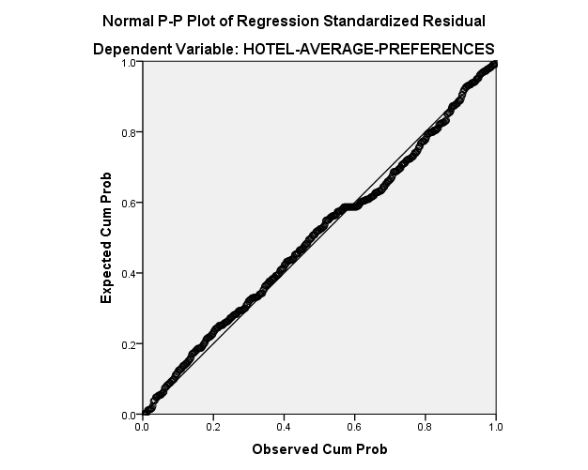

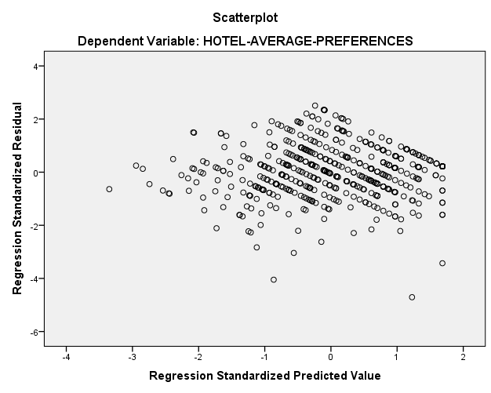

## Appendix 5: SPSS MANOVA Analysis: RO3

Differences Between Male and Female Emotional Response and Preferences in Reaction to Hotel Style Design

### Appendix 5.1: Multivariate Tests

The following table indicates whether there are statistically significant differences among the groups on a linear combination of dependent variables. Wilks Lambda results are one of the most commonly used. Next to the row labelled gender, and in the row labelled Wilks Lambda, if the significance value is <0.05, then there is a significant difference among groups.

|  |
| --- |
|  |

### Appendix 5.2: Tests of Between-Subjects Effects

The following table shows which dependent variables had a significantly different result. The significant value is 0.017 (0.05 divided by 3 dependent variables). Beside the row labelled gender, the dependent variables with a significant value with p<0.017 are considered significant.



## Appendix 6: SPSS MANOVA Analysis: RO4

Differences Between Norwegian and Non-Norwegian Citizen Emotional Response and Preferences in Reaction to Hotel Style Design

### Appendix 6.1: Multivariate Tests

The following table indicates whether there are statistically significant differences among the groups on a linear combination of dependent variables. Wilks Lambda results are one of the most commonly used. Next to the row labelled citizenship, and in the row labelled Wilks Lambda, if the significance value is <0.05, then there is a significant difference among groups.



### Appendix 6.2: Tests of Between-Subjects Effects

The following table shows which dependent variables had a significantly different result. The significant value is 0.017 (0.05 divided by 3 dependent variables). Beside the row labelled citizenship, the dependent variables with a significant value with p<0.017 are considered significant.



## Appendix 7: Survey

Welcome!

Hello! Thank you so much for taking the time to do this survey! This study is very interactive and will measure your emotions evoked by different hotel styles through animated characters. Your assistance in completing this study will help contribute to knowledge regarding consumer emotions, preferences and how they relate to hotel design.

The survey is completely anonymous, and if requested the results of the survey can be provided to you.

SCENARIO: While completing this survey, imagine that you are planning a leisure city holiday and are searching for a hotel to stay in on the Internet. Imagine you are trying to decide between four different hotels. Imagine all four hotels have similar services, characteristics and locations, and the main difference between hotels is the style.

WHAT YOU WILL DO: You will be asked to look at photos of the four hotels, and then rate your emotional response to each particular hotel's style. After rating your emotional response, you will then be asked to give your overall evaluation of the hotel based on the photos presented. There will be 14 animated characters to respond to for each hotel, this portion of the survey may seem repetitive, but it is **very important** to evaluate each character in order to measure your emotions.

REQUIREMENTS FOR SURVEY COMPLETION:

1) Use of a personal computer (PC) or a laptop computer (software does not function properly on mobile devices).

2) Mozilla Firefox or Google Chrome web browsers.

3) Computer sound enabled before you begin.

If you experience any technical problems while conducting the survey, please exit your browser and re-start the survey from the beginning. If you are still experiencing any issues, you can contact us at kkorbo@gmail.com.

Top of Form

Bottom of Form

Top of Form

Bottom of Form

Animated Character Explanation

Top of Form

To express your responses you can use a set of animated characters (see picture below).

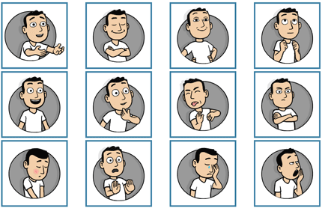

Before the actual study starts, we will start with a short introduction to the animated characters.

Bottom of Form

Top of Form

Bottom of Form

Animated Character Explanation

Top of Form

Each animated character expresses a particular feeling. You can see what feeling it expresses by clicking on it with the mouse. Please TRY this with the character displayed below. Please turn up the sound on your PC, the sounds made on this website are very important!



Bottom of Form

Please click on the character

Animated Character Explanation

Top of Form

|  |  |
| --- | --- |
| I do feel this strongly | http://measuringemotions.com/premo/assets/premo2/scale.png |
| I do feel this |
| I feel this somewhat |
| I feel this a little |
| I do not feel this |

You can express your response with the use of these animated characters. For this, you can use the scales on the right side of the characters. These scales appear as soon as you click on the character.  
  
You can use the scale to report to what degree the feeling expressed by the character matches your own feeling.  
  
If you strongly feel this, click on the four on top of the scale;  
or  
If you feel this to some extent, click on the two in the middle of the scale;  
or  
If you do not feel this at all, click on the zero at the bottom of the scale;  
etcetera...  
  
You can alter your choices at any time.  
  
Please TRY this with the character displayed below.

Bottom of Form

Please click on the character and the scale

Top of Form

Hotel #1

This is an overview of the stimuli you will be asked to rate in this experiment.

Top of Form

Hotel #1

The following photos are images of a hotel room, lounge, lobby and restaurant **within the same hotel.**

Please look at these photos for a few seconds.  
When you have seen the photos, click on "next" to continue.

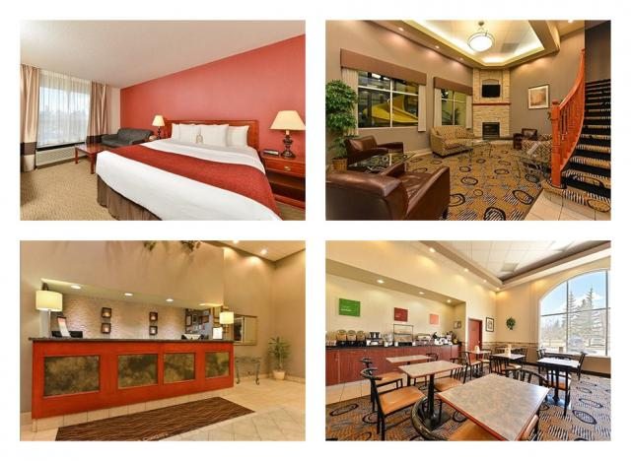

Top of Form

Hotel #1

|  |  |
| --- | --- |
| I do feel this strongly | http://measuringemotions.com/premo/assets/premo2/scale.png |
| I do feel this |
| I feel this somewhat |
| I feel this a little |
| I do not feel this |

Hotel #1

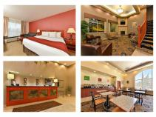

Click on each character. Use the scales to report if the feelings expressed by the characters correspond with your own feelings towards the hotel style shown in the picture. You will not be able to move on to the next page until you have clicked and reported on each character.

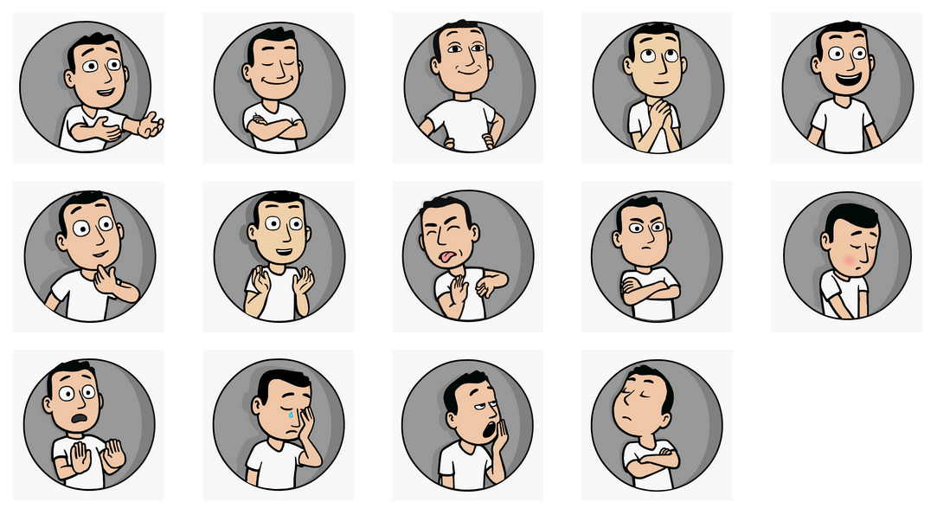

Bottom of Form

Top of Form

Questionnaire for Hotel #1

How likely is it that you would be inclined to make a booking at this hotel?

* Very Unlikely
* Unlikely
* Neutral
* Likely
* Very Likely

How likely is it that you would enjoy staying at this hotel?

* Very Unlikely
* Unlikely
* Neutral
* Likely
* Very Likely

How likely is it that you would avoid staying at this hotel?

* Very Unlikely
* Unlikely
* Neutral
* Likely
* Very Likely

Based on the photos shown what is your overall rating of this hotel?

* Terrible
* Poor
* Average
* Very Good
* Excellent

Great! You have already completed 25% of the survey!

Top of Form

Hotel #2

The following photos are images of a hotel room, lounge, lobby and restaurant **within the same hotel.**

Please look at these photos for a few seconds.  
When you have seen the photos, click on "next" to continue.

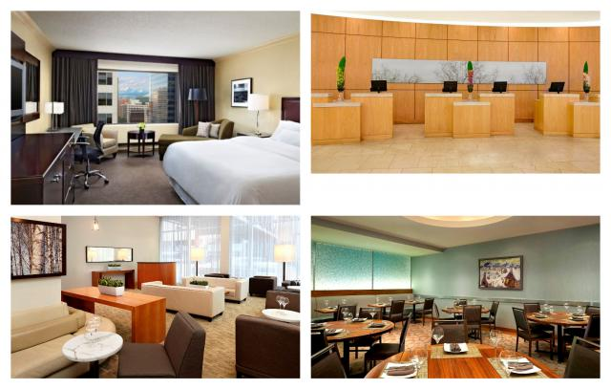

Top of Form

Hotel #2

|  |  |
| --- | --- |
| I do feel this strongly | http://measuringemotions.com/premo/assets/premo2/scale.png |
| I do feel this |
| I feel this somewhat |
| I feel this a little |
| I do not feel this |

Hotel #2



Click on each character. Use the scales to report if the feelings expressed by the characters correspond with your own feelings towards the hotel style shown in the picture. You will not be able to move on to the next page until you have clicked and reported on each character.

Bottom of Form

Top of Form

Bottom of Form

Bottom of Form

Top of Form

Bottom of Form

Bottom of Form

Top of Form

Bottom of Form

Bottom of Form

**Questionnaire for Hotel #2**

How likely is it that you would be inclined to make a booking at this hotel?

* Very Unlikely
* Unlikely
* Neutral
* Likely
* Very Likely

How likely is it that you would enjoy staying at this hotel?

* Very Unlikely
* Unlikely
* Neutral
* Likely
* Very Likely

How likely is it that you would avoid staying at this hotel?

* Very Unlikely
* Unlikely
* Neutral
* Likely
* Very Likely

Based on the photos shown what is your overall rating of this hotel?

* Terrible
* Poor
* Average
* Very Good
* Excellent

Great! You have already completed 50% of the survey!

Top of Form

**Hotel #3**

This is an overview of the stimuli you will be asked to rate in this experiment.

Top of Form

Hotel #3

The following photos are images of a hotel room, lounge, lobby and restaurant **within the same hotel.**

Please look at these photos for a few seconds.  
When you have seen the photos, click on "next" to continue.

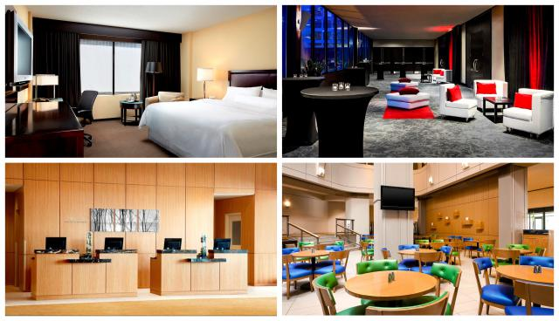

Top of Form

Hotel #3

|  |  |
| --- | --- |
| I do feel this strongly | http://measuringemotions.com/premo/assets/premo2/scale.png |
| I do feel this |
| I feel this somewhat |
| I feel this a little |
| I do not feel this |

Hotel #3

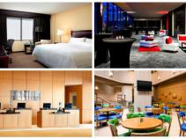

Click on each character. Use the scales to report if the feelings expressed by the characters correspond with your own feelings towards the hotel style shown in the picture. You will not be able to move on to the next page until you have clicked and reported on each character.

Bottom of Form

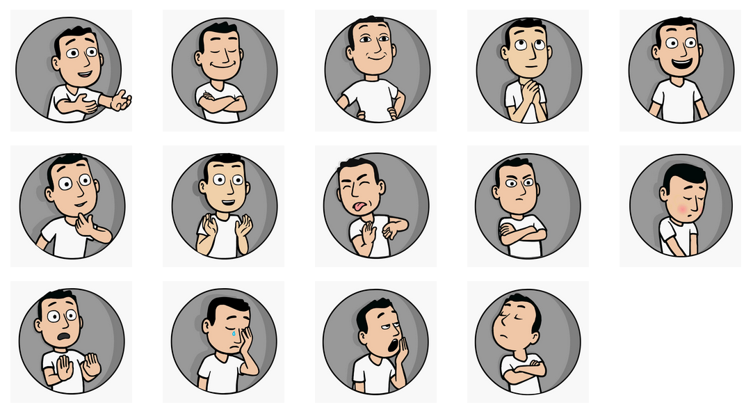Top of Form

Bottom of Form

**Questionnaire for Hotel #3**

How likely is it that you would be inclined to make a booking at this hotel?

* Very Unlikely
* Unlikely
* Neutral
* Likely
* Very Likely

How likely is it that you would enjoy staying at this hotel?

* Very Unlikely
* Unlikely
* Neutral
* Likely
* Very Likely

How likely is it that you would avoid staying at this hotel?

* Very Unlikely
* Unlikely
* Neutral
* Likely
* Very Likely

Based on the photos shown what is your overall rating of this hotel?

* Terrible
* Poor
* Average
* Very Good
* Excellent

Great! You have already completed 75% of the survey!

Top of Form

Hotel #4

The following photos are images of a hotel room, lounge, lobby and restaurant **within the same hotel.**

Please look at these photos for a few seconds.  
When you have seen the photos, click on "next" to continue.

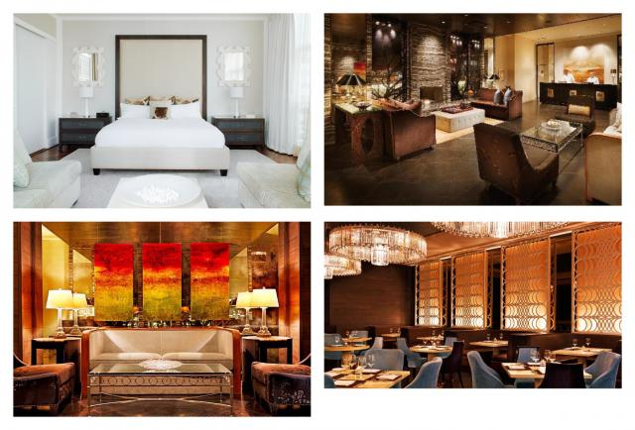

Top of Form

Hotel #4

|  |  |
| --- | --- |
| I do feel this strongly | http://measuringemotions.com/premo/assets/premo2/scale.png |
| I do feel this |
| I feel this somewhat |
| I feel this a little |
| I do not feel this |

Hotel #4



Click on each character. Use the scales to report if the feelings expressed by the characters correspond with your own feelings towards the hotel style shown in the picture. You will not be able to move on to the next page until you have clicked and reported on each character.

Bottom of Form



**Questionnaire for Hotel #4**

How likely is it that you would be inclined to make a booking at this hotel?

* Very Unlikely
* Unlikely
* Neutral
* Likely
* Very Likely

How likely is it that you would enjoy staying at this hotel?

* Very Unlikely
* Unlikely
* Neutral
* Likely
* Very Likely

How likely is it that you would avoid staying at this hotel?

* Very Unlikely
* Unlikely
* Neutral
* Likely
* Very Likely

Based on the photos shown what is your overall rating of this hotel?

* Terrible
* Poor
* Average
* Very Good
* Excellent

Great! You have already completed 95% of the survey!

**Demographics**

What is your gender?

* Male
* Female

What is your year of birth?

What is the highest level of education you have obtained?

* Less than High School Diploma
* High School Diploma
* Trade/technical/vocational training
* Associate degree
* Bachelor's degree
* Master's degree
* Professional degree
* Doctorate degree

What is your country of citizenship?

What has been your usual purpose of travel in the past 2 years?

* Business
* Leisure
* Both Business & Leisure
* OtherBottom of Form